Karunya Institute of Technology and Sciences
Division of Data Science and Cyber Security
25DC2012 – Quantum Computing and Cryptography

Internal Assessment III – Quantum Algorithm Project
Project Report (Parts A and B)

Case 11: Bernstein–Vazirani Algorithm
Variant: s = 011

Team members
No. | Name | Register number
1 | [Name 1] | [Register number 1]
2 | [Name 2] | [Register number 2]
3 | [Name 3 – delete row if team of 2] | [Register number 3]

Submitted to: [Faculty name]
Date of submission: [Date]

2. Aim and Circuit

Aim
The aim is to find a hidden 3-bit string s, where the oracle computes f(x) = s · x (mod 2), using only one oracle call. Our hidden string is s = 011 (s0 s1 s2, matching q[0] q[1] q[2]), so f(x) = x1 ⊕ x2.

Circuit
- Four qubits are used: inputs q[0], q[1], q[2] and the ancilla y. All start in |0⟩.
- X(y) changes y to |1⟩. H is then applied to all four qubits, which puts the inputs in equal superposition and the ancilla in |−⟩.
- The oracle computes f(x) = s · x (mod 2) with one CNOT from each q[i] where si = 1. For s = 011 it is CNOT(q[1], y) and CNOT(q[2], y).
- H is applied to q[0], q[1], q[2] again and they are measured. The result is s.
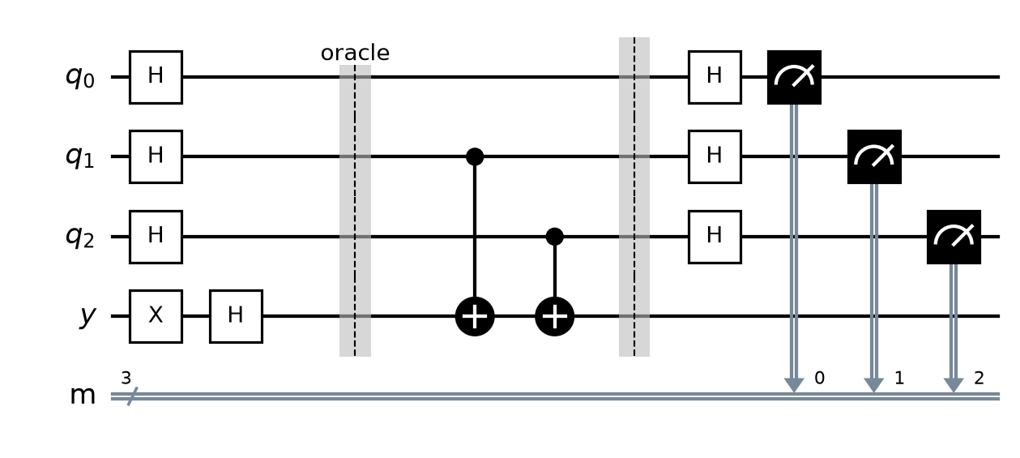
Figure 1: Bernstein–Vazirani circuit for s = 011. The oracle is between the barriers.

3. Code
Full Q# program (file: [RegNo]_Case11.qs). The oracle is in its own operation, and the first line of output prints the register numbers of all team members.
// 25DC2012 IA3 - Case 11: Bernstein-Vazirani Algorithm, s = 011
// Before submitting: rename this file to <YourRegNo>_Case11.qs and
// replace REG_NO_1, REG_NO_2, REG_NO_3 with your team's register numbers.

// Run with Histogram, at least 100 shots. Every shot should give 011.

operation Main() : Result[] {
Message("Register numbers: REG_NO_1, REG_NO_2, REG_NO_3");

use q = Qubit[3];
use y = Qubit();

// Circuit: X(y) -> H on all 4 qubits -> oracle -> H on q[0], q[1], q[2] -> measure q
X(y);
for i in 0..2 {
H(q[i]);
}
H(y);

Oracle(q, y);

for i in 0..2 {
H(q[i]);
}

let results = [M(q[0]), M(q[1]), M(q[2])];
Message($"Measured s = {BitString(results)}");

ResetAll(q + [y]);
return results;
}

// Hidden string s = 011 (s0 s1 s2 matching q[0] q[1] q[2]).
// f(x) = s . x (mod 2): one CNOT from each q[i] with si = 1 -> CNOT(q[1], y) and CNOT(q[2], y)
operation Oracle(q : Qubit[], y : Qubit) : Unit {
CNOT(q[1], y);
CNOT(q[2], y);
}

// Turns [q[0], q[1], ...] results into a string like "101" (q[0] first).
function BitString(results : Result[]) : String {
mutable s = "";
for r in results {
set s += r == One ? "1" | "0";
}
return s;
}

4. Output
The program was run using the Histogram option with [number of shots, at least 100] shots.
[Insert screenshot: Q# code in VS Code]
Figure 2: Q# program in VS Code.
[Insert screenshot: output and histogram – register numbers must be visible]
Figure 3: Output and histogram.

Observed result
- All [number of shots] shots gave q[0]q[1]q[2] = 011. The histogram has a single bar at 011, and no other result appeared.
- This matches the hidden string s = 011.

5. Answers

Q1. Explain why the measured result is exactly s. Use the phase (−1)^(s·x) in your answer. (3 marks)
With the ancilla in |−⟩, phase kickback turns the oracle into a phase on the inputs: |x⟩ → (−1)^f(x) |x⟩ = (−1)^(s·x) |x⟩. After the first Hadamards and the oracle, the input register is:
(1/√8) Σₓ (−1)^(s·x) |x⟩
For our s = 011, s·x = x1 ⊕ x2, so the phase is −1 exactly for the inputs 001, 010, 101, 110 and +1 for the rest.
This state is exactly what H⊗3 produces from |s⟩: H⊗3|s⟩ = (1/√8) Σₓ (−1)^(s·x) |x⟩. Since H is its own inverse (H·H = I), the final H⊗3 changes the state back to |s⟩. All the other amplitudes cancel by destructive interference, so we measure s with probability 1. That is why every shot gave 011.

Q2. How many oracle calls does a classical computer need to find a 3-bit s? How many did you use? (2 marks)
Each classical query gives one bit of information about s. Querying x = 100 gives s0, x = 010 gives s1 and x = 001 gives s2, so a classical computer needs 3 calls (n calls for n bits).
Our quantum circuit used 1 oracle call and recovered all three bits at once.

6. Conclusion and References

Conclusion
We implemented the Bernstein–Vazirani algorithm in Q# and recovered the hidden string s = 011 in every shot with a single oracle call, compared with 3 calls classically. We learned how phase kickback encodes s · x as a phase and how the Hadamard transform decodes that phase pattern back into s. The same idea of reading a global property from a phase pattern appears again in Simon's and Shor's algorithms.

References
- [Course textbook – author, title, publisher, year], Chapter 10, pp. 197–210.
- 25DC2012 lecture notes – Module 3 lectures (Bernstein–Vazirani algorithm).
- M. A. Nielsen and I. L. Chuang, Quantum Computation and Quantum Information, 10th anniversary ed., Cambridge University Press, 2010.
- Microsoft, "Azure Quantum Development Kit and Q# documentation," learn.microsoft.com/azure/quantum.
- IBM Quantum Learning, "Fundamentals of quantum algorithms," quantum.cloud.ibm.com/learning/en/courses/fundamentals-of-quantum-algorithms.
- E. Bernstein and U. Vazirani, "Quantum complexity theory," SIAM J. Comput., vol. 26, no. 5, pp. 1411–1473, 1997.

