Karunya Institute of Technology and Sciences
Division of Data Science and Cyber Security
25DC2012 – Quantum Computing and Cryptography

Internal Assessment III – Quantum Algorithm Project
Project Report (Parts A and B)

Case 21: Simon's Algorithm
Variant: s = 11

Team members
No. | Name | Register number
1 | [Name 1] | [Register number 1]
2 | [Name 2] | [Register number 2]
3 | [Name 3 – delete row if team of 2] | [Register number 3]

Submitted to: [Faculty name]
Date of submission: [Date]

2. Aim and Circuit

Aim
The aim is to find a hidden 2-bit string s such that f(x) = f(x ⊕ s) for every input x, using quantum queries to the oracle and a little classical linear algebra. Our function is f(00) = 00, f(01) = 01, f(10) = 01, f(11) = 00, so the hidden string is s = 11.

Circuit
- Four qubits are used: inputs x[0], x[1] and outputs y[0], y[1]. All start in |0⟩.
- H on x[0] and x[1] creates a superposition of all four inputs.
- The oracle writes f(x) into the output register: CNOT(x[0], y[1]) and CNOT(x[1], y[1]).
- H is applied to x[0] and x[1] again, and they are measured to get y. Every measured y satisfies y · s = 0 (mod 2).
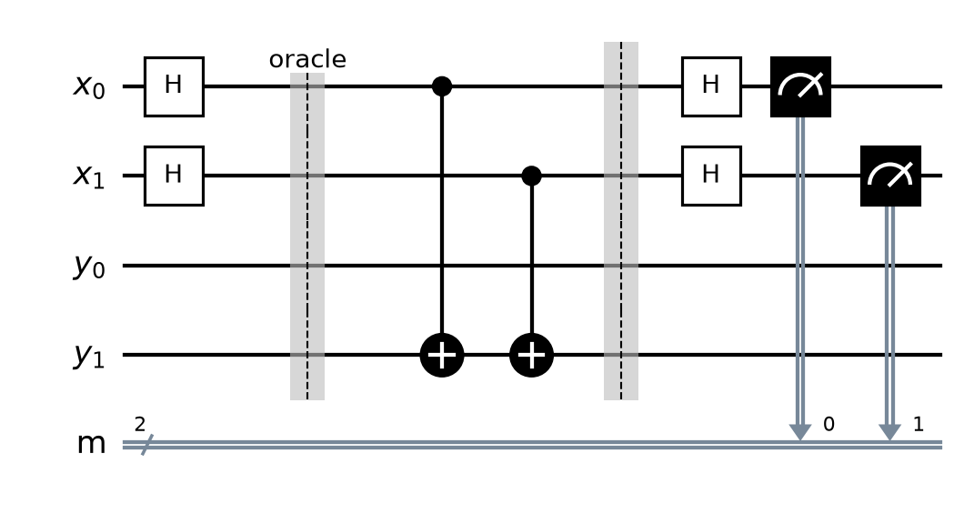
Figure 1: Simon circuit for s = 11. The oracle is between the barriers.

3. Code
Full Q# program (file: [RegNo]_Case21.qs). The oracle is in its own operation, and the first line of output prints the register numbers of all team members.
// 25DC2012 IA3 - Case 21: Simon's Algorithm, s = 11
// Before submitting: rename this file to <YourRegNo>_Case21.qs and
// replace REG_NO_1, REG_NO_2, REG_NO_3 with your team's register numbers.

// Run with Histogram, at least 100 shots. Remove y = 00 and solve y . s = 0 (mod 2) by hand.

operation Main() : Result[] {
Message("Register numbers: REG_NO_1, REG_NO_2, REG_NO_3");

use x = Qubit[2];
use y = Qubit[2];

// Circuit: H on x[0], x[1] -> oracle -> H on x[0], x[1] -> measure x[0], x[1] to get y
H(x[0]);
H(x[1]);

Oracle(x, y);

H(x[0]);
H(x[1]);

let results = [M(x[0]), M(x[1])];
Message($"Measured y = {BitString(results)}");

ResetAll(x + y);
return results;
}

// f(00) = 00, f(01) = 01, f(10) = 01, f(11) = 00
// Hidden string s = 11, so f(x) = f(x XOR 11). Recipe: CNOT(x[0], y[1]) and CNOT(x[1], y[1])
operation Oracle(x : Qubit[], y : Qubit[]) : Unit {
CNOT(x[0], y[1]);
CNOT(x[1], y[1]);
}

// Turns [q[0], q[1], ...] results into a string like "101" (q[0] first).
function BitString(results : Result[]) : String {
mutable s = "";
for r in results {
set s += r == One ? "1" | "0";
}
return s;
}

4. Output
The program was run using the Histogram option with [number of shots, at least 100] shots.
[Insert screenshot: Q# code in VS Code]
Figure 2: Q# program in VS Code.
[Insert screenshot: output and histogram – register numbers must be visible]
Figure 3: Output and histogram.

Observed result
- Only two outcomes appeared, about 50% each: 00 ([count] shots) and 11 ([count] shots). The outcomes 01 and 10 never appeared.
- After removing y = 00, the only useful result is y = 11, which gives s = 11 (see Q1).

5. Answers

Q1. Show how you found s from your results. Write y · s = 0 (mod 2) for your non-zero y and solve it. (3 marks)
After the oracle, the output register holds f(x). Since f(x) = f(x ⊕ s), each output value is shared by the pair of inputs x and x ⊕ s, so the input register is (|x⟩ + |x ⊕ s⟩)/√2. After the final H gates, the amplitude of outcome y is proportional to (−1)^(x·y) [1 + (−1)^(s·y)]. This is zero unless y · s = 0 (mod 2), which is why only some outcomes appear.
Our histogram showed y = 00 and y = 11. Using the non-zero result y = 11:
y · s = 1·s0 + 1·s1 = s0 ⊕ s1 = 0 (mod 2), so s0 = s1.
The candidates are 00 and 11. s = 00 is ruled out because f is not one-to-one, so s = 11.
Check: f(00) = f(11) and f(01) = f(10) from the function table, so f(x) = f(x ⊕ 11) is true.

Q2. Why does the result y = 00 give no information about s? (2 marks)
For y = 00 the equation is y · s = 0·s0 + 0·s1 = 0 (mod 2). This is true for every possible s (00, 01, 10 and 11), so it doesn't rule out any candidate and gives no information.
y = 00 always satisfies y · s = 0, so it appears in about half of the shots for any s. It must be removed before solving, and only non-zero results give equations that narrow down s.

6. Conclusion and References

Conclusion
We implemented Simon's algorithm in Q# and, from the measured result y = 11, solved y · s = 0 (mod 2) to recover the hidden string s = 11. We learned how the quantum part only ever outputs strings orthogonal to s, and how classical post-processing (solving linear equations mod 2) finishes the job. Simon's algorithm was the first exponential quantum speed-up over probabilistic classical algorithms and directly inspired Shor's period-finding algorithm.

References
- [Course textbook – author, title, publisher, year], Chapter 10, pp. 197–210.
- 25DC2012 lecture notes – Module 3 lectures (Simon's algorithm).
- M. A. Nielsen and I. L. Chuang, Quantum Computation and Quantum Information, 10th anniversary ed., Cambridge University Press, 2010.
- Microsoft, "Azure Quantum Development Kit and Q# documentation," learn.microsoft.com/azure/quantum.
- IBM Quantum Learning, "Fundamentals of quantum algorithms," quantum.cloud.ibm.com/learning/en/courses/fundamentals-of-quantum-algorithms.
- D. R. Simon, "On the power of quantum computation," SIAM J. Comput., vol. 26, no. 5, pp. 1474–1483, 1997.

