Karunya Institute of Technology and Sciences
Division of Data Science and Cyber Security
25DC2012 – Quantum Computing and Cryptography

Internal Assessment III – Quantum Algorithm Project
Project Report (Parts A and B)

Case 25: Shor's Factoring Algorithm
Variant: N = 15, a = 13

Team members
No. | Name | Register number
1 | [Name 1] | [Register number 1]
2 | [Name 2] | [Register number 2]
3 | [Name 3 – delete row if team of 2] | [Register number 3]

Submitted to: [Faculty name]
Date of submission: [Date]

2. Aim and Circuit

Aim
The aim is to factor N = 15 with Shor's algorithm. A quantum circuit finds the period r of f(x) = 13^x mod 15, using phase estimation and the inverse quantum Fourier transform. The factors are then calculated classically with gcd(13^(r/2) ± 1, 15).

Circuit
- There are 3 counting qubits c[0], c[1], c[2] and 4 work qubits w[0]–w[3] (w[0] is the lowest bit). X(w[0]) sets the work register to 1.
- H on all counting qubits puts them in superposition.
- c[0] controls multiplication by 13 (mod 15) and c[1] controls multiplication by 13² mod 15 = 4. Since 13⁴ mod 15 = 1, no gate is needed for c[2]. The powers are 13^1 mod 15 = 13, 13^2 mod 15 = 4, 13^3 mod 15 = 7, 13^4 mod 15 = 1.
- The inverse QFT is applied to c: SWAP(c[0], c[2]) → H(c[0]) → controlled R1(−π/2) from c[0] to c[1] → H(c[1]) → controlled R1(−π/4) from c[0] to c[2] → controlled R1(−π/2) from c[1] to c[2] → H(c[2]).
- c is measured, and each result is read as y = c[0] + 2·c[1] + 4·c[2].
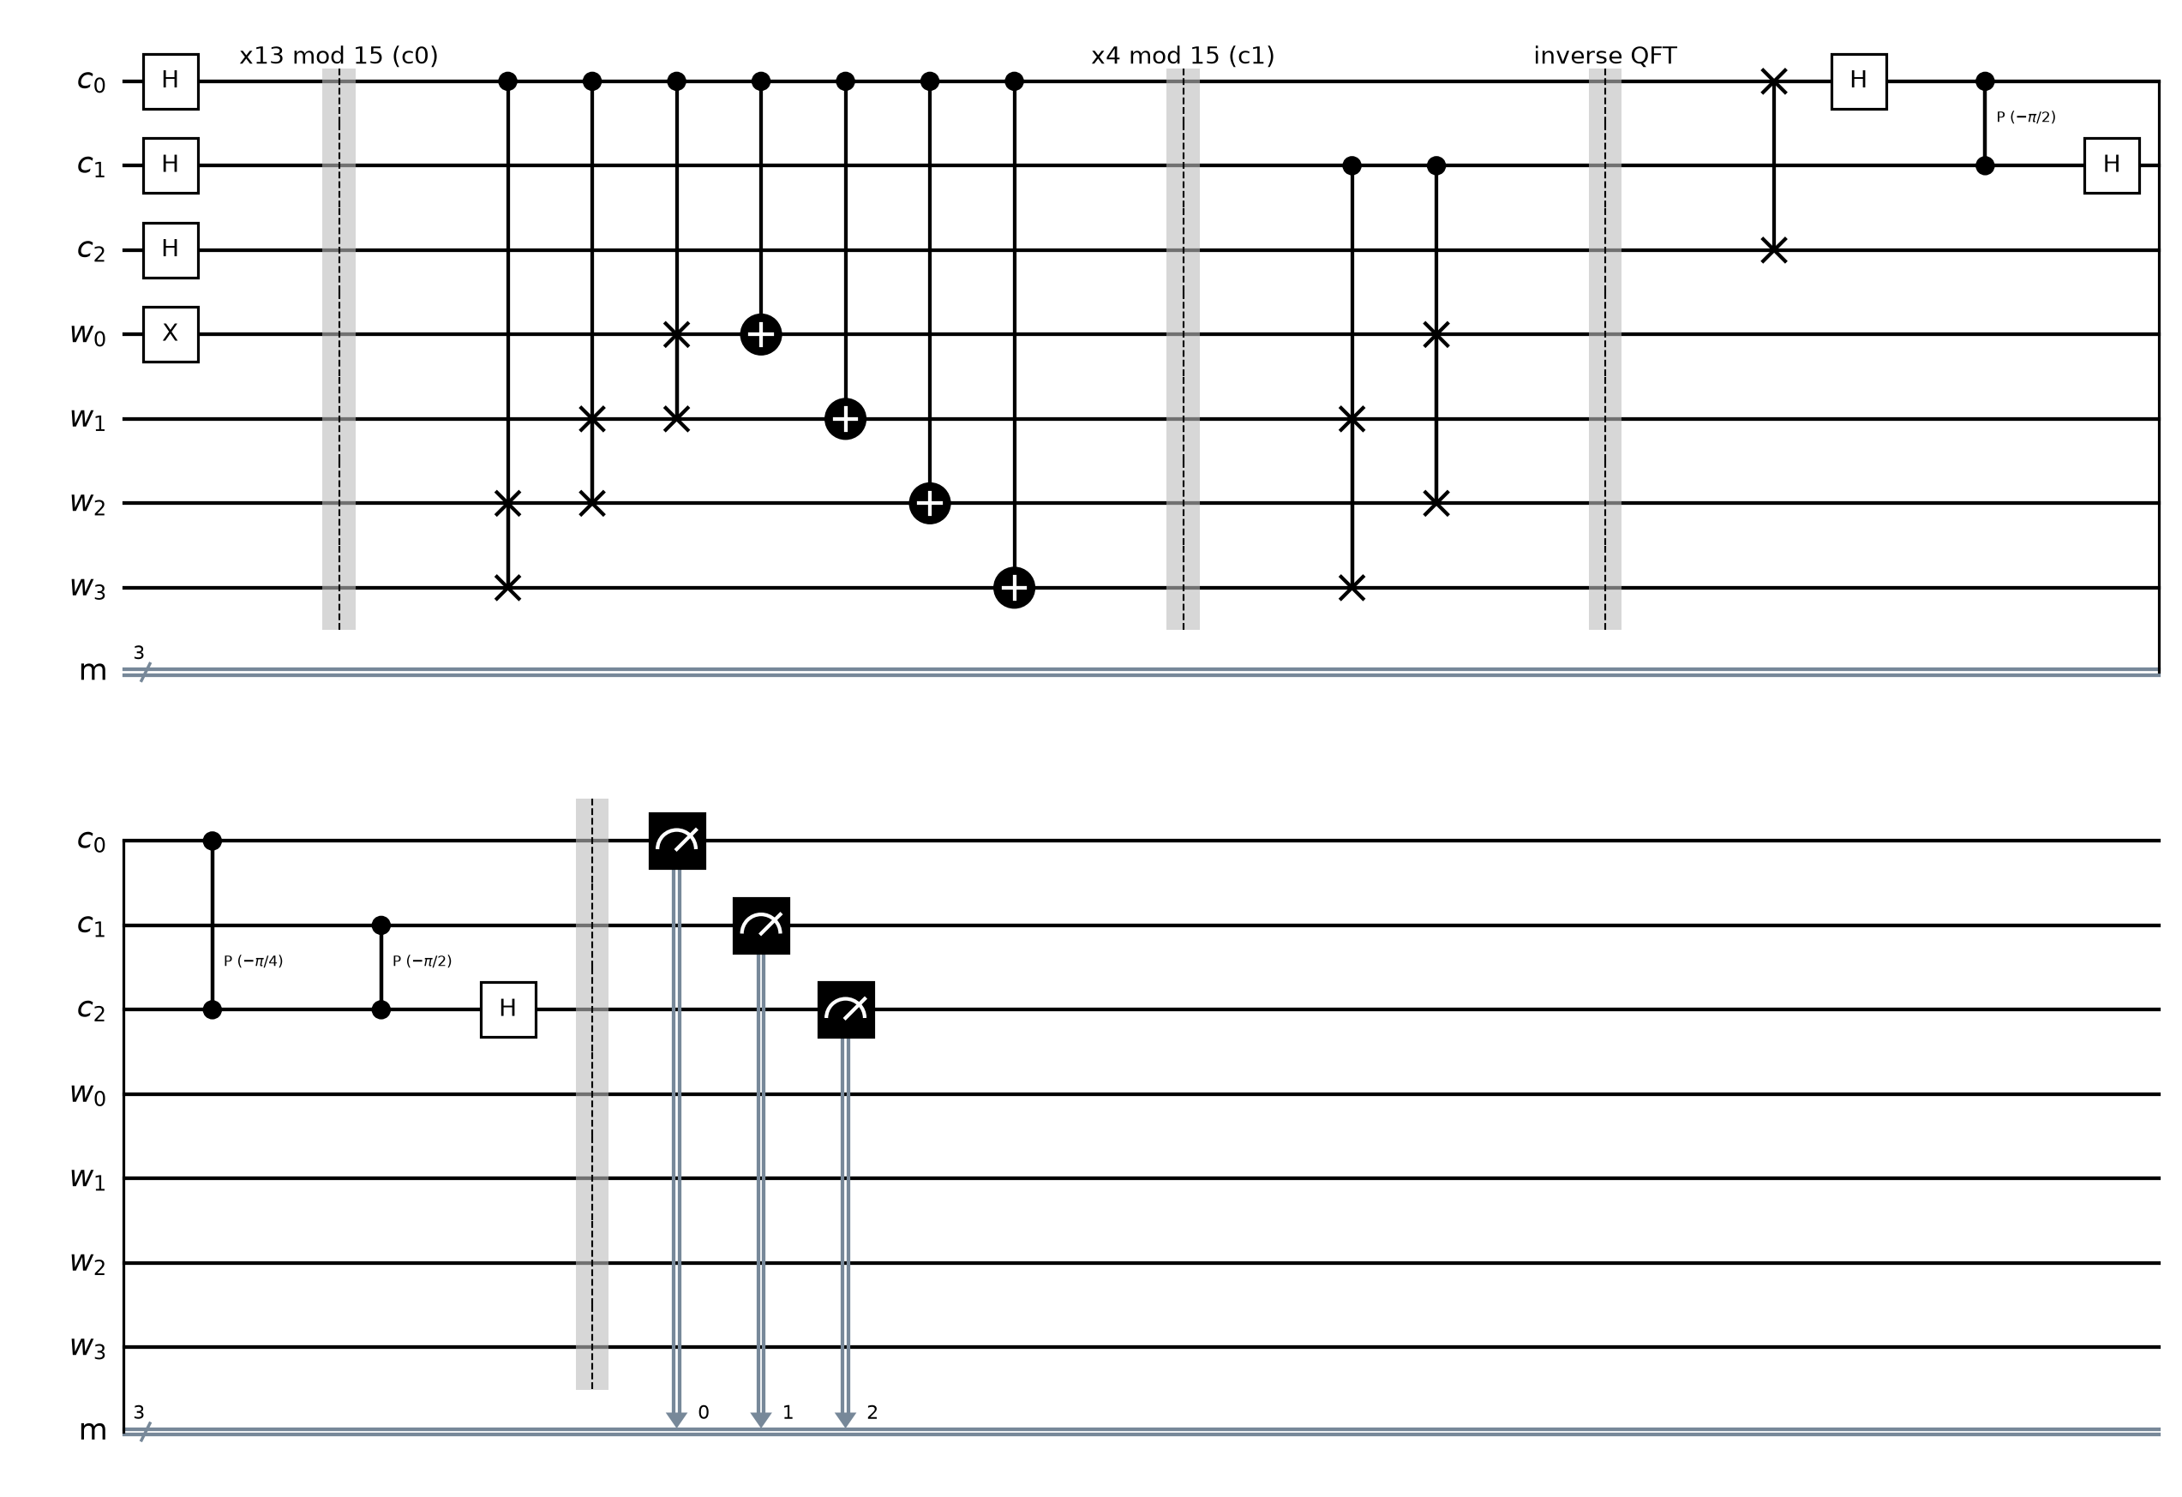
Figure 1: Shor period-finding circuit for N = 15, a = 13. Controlled-SWAPs and CNOTs implement the modular multiplications, and P(θ) is the controlled R1 phase gate.

3. Code
Full Q# program (file: [RegNo]_Case25.qs). The oracle is in its own operation, and the first line of output prints the register numbers of all team members.
// 25DC2012 IA3 - Case 25: Shor's Factoring Algorithm, N = 15, a = 13
// Before submitting: rename this file to <YourRegNo>_Case25.qs and
// replace REG_NO_1, REG_NO_2, REG_NO_3 with your team's register numbers.

// Run with Histogram, at least 200 shots. Convert results to y = c[0] + 2*c[1] + 4*c[2],
// find the period r from y / 8 ~ k / r, then compute the factors with gcd.
// Powers of 13 mod 15: 13^1 = 13, 13^2 = 4, 13^3 = 7, 13^4 = 1

operation Main() : Result[] {
Message("Register numbers: REG_NO_1, REG_NO_2, REG_NO_3");

use c = Qubit[3]; // counting qubits
use w = Qubit[4]; // work qubits, w[0] is the lowest bit

// Start the work register at 1
X(w[0]);

// H on all counting qubits
for i in 0..2 {
H(c[i]);
}

// Controlled modular multiplications
MultiplyBy13Mod15(c[0], w);
MultiplyBy4Mod15(c[1], w); // 13^2 mod 15 = 4
// 13^4 mod 15 = 1, so nothing is needed for c[2]

InverseQFT(c);

let results = [M(c[0]), M(c[1]), M(c[2])];
let y = (results[0] == One ? 1 | 0) + 2 * (results[1] == One ? 1 | 0) + 4 * (results[2] == One ? 1 | 0);
Message($"Measured c = {BitString(results)} -> y = {y}");

ResetAll(c + w);
return results;
}

// Multiply-by-13 (mod 15), controlled by c
operation MultiplyBy13Mod15(c : Qubit, w : Qubit[]) : Unit {
Controlled SWAP([c], (w[2], w[3]));
Controlled SWAP([c], (w[1], w[2]));
Controlled SWAP([c], (w[0], w[1]));
for i in 0..3 {
CNOT(c, w[i]);
}
}

// Multiply-by-4 (mod 15), controlled by c
operation MultiplyBy4Mod15(c : Qubit, w : Qubit[]) : Unit {
Controlled SWAP([c], (w[1], w[3]));
Controlled SWAP([c], (w[0], w[2]));
}

// Inverse QFT on 3 qubits:
// SWAP(c[0], c[2]) -> H(c[0]) -> controlled R1(-pi/2) from c[0] to c[1] -> H(c[1])
// -> controlled R1(-pi/4) from c[0] to c[2] -> controlled R1(-pi/2) from c[1] to c[2] -> H(c[2])
operation InverseQFT(c : Qubit[]) : Unit {
SWAP(c[0], c[2]);
H(c[0]);
Controlled R1([c[0]], (-Std.Math.PI() / 2.0, c[1]));
H(c[1]);
Controlled R1([c[0]], (-Std.Math.PI() / 4.0, c[2]));
Controlled R1([c[1]], (-Std.Math.PI() / 2.0, c[2]));
H(c[2]);
}

// Turns [q[0], q[1], ...] results into a string like "101" (q[0] first).
function BitString(results : Result[]) : String {
mutable s = "";
for r in results {
set s += r == One ? "1" | "0";
}
return s;
}

4. Output
The program was run using the Histogram option with [number of shots, at least 200] shots.
[Insert screenshot: Q# code in VS Code]
Figure 2: Q# program in VS Code.
[Insert screenshot: output and histogram – register numbers must be visible]
Figure 3: Output and histogram.

Observed result
- Four outcomes appeared, about 25% each. Converted to y = c[0] + 2·c[1] + 4·c[2]:
c[0] c[1] c[2] | y = c[0] + 2·c[1] + 4·c[2] | y / 8 | Shots
000 | 0 | 0 | [count]
010 | 2 | 1/4 | [count]
001 | 4 | 1/2 | [count]
011 | 6 | 3/4 | [count]
- Every outcome is a multiple of 8/r = 2, which gives r = 4 (see Q1).

5. Answers

Q1. From your histogram, find the period r and compute the factors of 15 using gcd. Show your working. (3 marks)
Phase estimation with 3 counting qubits gives y/8 ≈ k/r for a random integer k. From the histogram:
y = 0 → 0/8 = 0. This gives no information (k = 0).
y = 2 → 2/8 = 1/4, so r = 4.
y = 4 → 4/8 = 1/2, which suggests r = 2. But 13² mod 15 = 4 ≠ 1, so r = 2 is wrong. This is the case k = 2, r = 4.
y = 6 → 6/8 = 3/4, so r = 4.
So the period is r = 4. Check: 13⁴ mod 15 = 1 ✓.
r is even, so compute 13^(r/2) = 13² = 169 ≡ 4 (mod 15). Since 4 ≢ −1 (mod 15), this a works:
gcd(4 − 1, 15) = gcd(3, 15): 15 = 5 × 3 + 0, so gcd = 3.
gcd(4 + 1, 15) = gcd(5, 15): 15 = 3 × 5 + 0, so gcd = 5.
Therefore 15 = 3 × 5.

Q2. a⁴ mod 15 = 1 for your a. Explain why this means no gate is needed for c[2]. (2 marks)
In phase estimation, counting qubit c[j] controls the operation U^(2^j), where U multiplies the work register by a mod 15. So c[0] controls multiplication by 13, c[1] controls multiplication by 13² mod 15 = 4, and c[2] controls multiplication by 13⁴ mod 15.
For our a, 13⁴ mod 15 = 1, so c[2] would control "multiply by 1". That is the identity operation, which leaves every work state unchanged, and a controlled identity is still the identity. It has no effect on the state, so we can leave it out. c[2] still matters, though: it is in superposition and takes part in the inverse QFT.

6. Conclusion and References

Conclusion
We implemented the quantum period-finding part of Shor's algorithm in Q# for N = 15 and a = 13. From the histogram (y ∈ {0, 2, 4, 6}) we found the period r = 4 and computed the factors 3 and 5 with gcd. We learned how modular multiplication is built from controlled SWAPs and CNOTs, how the inverse QFT converts phases into a readable period, and how the quantum and classical parts of Shor's algorithm fit together.

References
- [Course textbook – author, title, publisher, year], Chapter 10, pp. 197–210.
- 25DC2012 lecture notes – Module 3 lectures (Shor's algorithm and the quantum Fourier transform).
- M. A. Nielsen and I. L. Chuang, Quantum Computation and Quantum Information, 10th anniversary ed., Cambridge University Press, 2010.
- Microsoft, "Azure Quantum Development Kit and Q# documentation," learn.microsoft.com/azure/quantum.
- IBM Quantum Learning, "Fundamentals of quantum algorithms," quantum.cloud.ibm.com/learning/en/courses/fundamentals-of-quantum-algorithms.
- P. W. Shor, "Polynomial-time algorithms for prime factorization and discrete logarithms on a quantum computer," SIAM J. Comput., vol. 26, no. 5, pp. 1484–1509, 1997.

