Harvard Hackathon

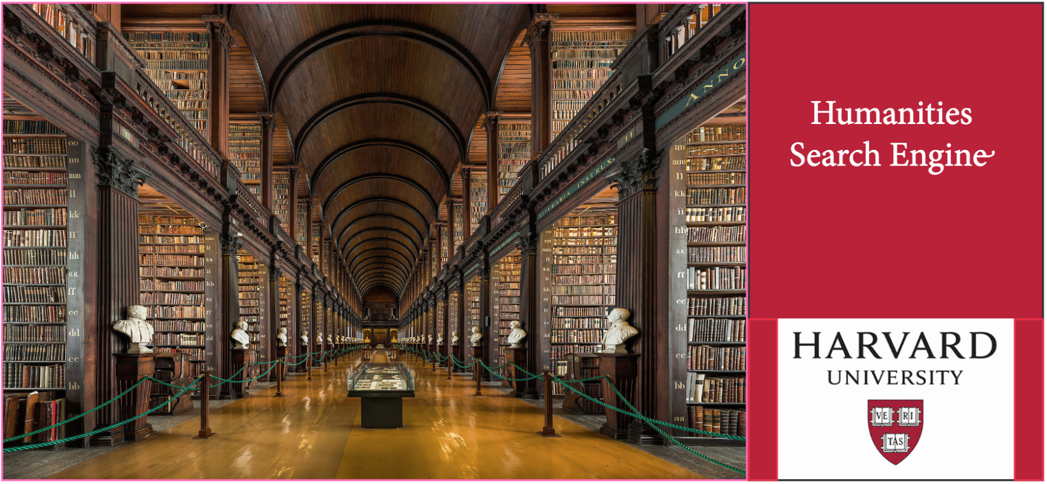

# Branding and Design Group

## Preamble

To date, the core team that has developed this search engine has been comprised of coders, literary historians, and librarians. We're not exactly visually inclined. We need your help to brand our search engine, develop its visual identity, and create thoughtfully designed explanatory materials.

## Main Goals

Your main goal is to develop the various possibilities for the branding of our search engine, including the description of its visual identity. This can be a bit difficult, because, in the short term, our prototype website will be used to search a database of English-language 18th-Century texts; in the not-so-distant future, however, we plan to add the ability to search other, much larger databases (think HathiTrust, Google Books, etc.). At that point, the search engine will be useful to researchers across the humanities. You’ll likely want to compare what we’re developing to other search platforms that already exist (Google, Eighteenth Century Collections Online, HathiTrust, JSTOR, EEBO, etc.). You may want to emphasize the fact that what sets our search engine apart is that it involves “concept search,” rather than keyword search. Feel free to play around. Talk with the Research Exploration group to find relevant eighteenth-century images for the prototype, and let your imagination run wild, when you think about how to brand future iterations of this platform!

## Other goals / instructions (in order of priority)

1. Consult with other groups, particularly the Website Development group, on UX
2. Develop promotional materials for the search engine, both in its prototype form, and for later iterations
3. Develop one-pagers, other explanatory material (print);
4. Develop tutorial material for search algorithm (video or print)
5. Develop web videos to demonstrate how to use the search engine

## What to bring

* Pens, paper, any creative tools or materials that you like;
* If you have books on design that you think would be useful, bring them, too!
* If you happen to have a SLR camera or a video camera, these could be useful for developing tutorial material!

## GitHub Contents (may be added to before and during the event):

We’ve already developed some rough promotional material. None of it is very good, but it’s available for you to consult. Included are a one-pager and a workflow diagram.

## Other groups to consult

* Website Development – you can advise them on what you’re like the website to do
* Data Visualization
* Research Exploration