 |  | 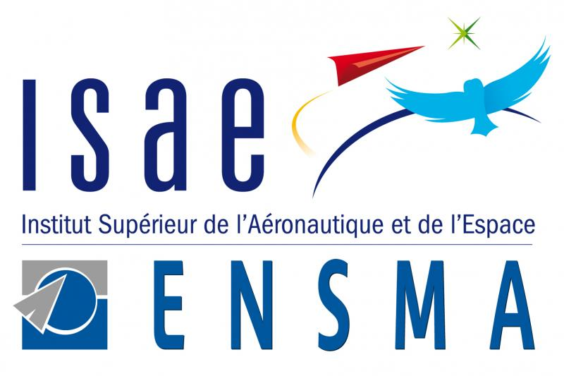
Aeronautic and space
major: Turbulence
An International Master's Programme in France
(Entirely taught in English)
imp-turbulence@centralelille.fr http://imp-turbulence.ec-lille.fr/
Admission Form.
(send to imp-turbulence@centralelille.fr)

Deadline :
March 31st 2018
(May 15st 2018 for EU applicant only)

First Name: ______________

Family Name: _______________

Date of Birth: ________________ Nationality : ________________

Full address: _________________________________________________________

Country: _________________________

Phone number: ____________________

Mobile number: ___________________

Email address: ___________________

Cursus summary for the last 5 years (Title of program, location, website, ...):

TOEFL level :

Aeronautic and space
major: Turbulence
An International Master's Programme in France
(Entirely taught in English)
imp-turbulence@centralelille.fr http://imp-turbulence.ec-lille.fr/
This admission form should be sent to imp-turbulence@centralelille.fr, accompanied by :

- A detailed CV,
- 3 letters of recommendation,
- A motivation letter
- Your marksheets

Program directors : Professor Jean-Marc FOUCAUT, PhD
Centrale Lille.
jean-marc.foucaut@centralelille.fr
+33 03 20 33 71 60

Florent MARGNAT, PhD
ENSI Poitiers
florent.margnat@univ-poitiers.fr
+33 05 49 45 38 01

Program coordinators : Professor Philippe Vanheeghe, PhD
Dean of International Affairs Centrale Lille.
international@ec-lille.fr

Aurélie COTILLON
Head of International Relations Office
+33 5 49 49 80 16
aurelie.cotillon@ensma.fr

