**ОТЧЁТ**

**ПО ЛАБОРАТОРНОЙ РАБОТЕ № 5**

**Представления (view)**

*Выполнил студент 3 курса ПМ АДМО*

*Турчанов Денис*

# Введение

*Цель работы:*

Для выполнения лабораторной работы необходимо создать по выбранной предметной области 5 представлений вида:

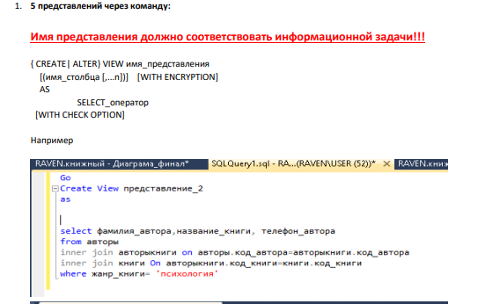

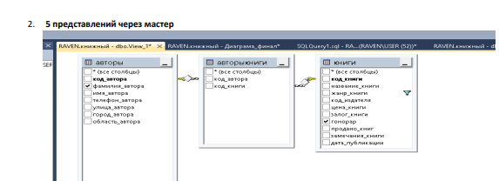

Выполнение.

Задание 1.

-- 1. Список священников с их церквями

CREATE VIEW clergy_with_churches AS  
SELECT  
 c.full_name AS clergy_name,  
 cp.title AS position,  
 ch.name AS church_name,  
 d.name AS denomination,  
 c.phone AS contact_phone  
FROM  
 clergy c  
JOIN  
 clergy_positions cp ON c.position_id = cp.position_id  
LEFT JOIN  
 churches ch ON c.church_id = ch.church_id  
LEFT JOIN  
 denominations d ON ch.denomination_id = d.denomination_id;

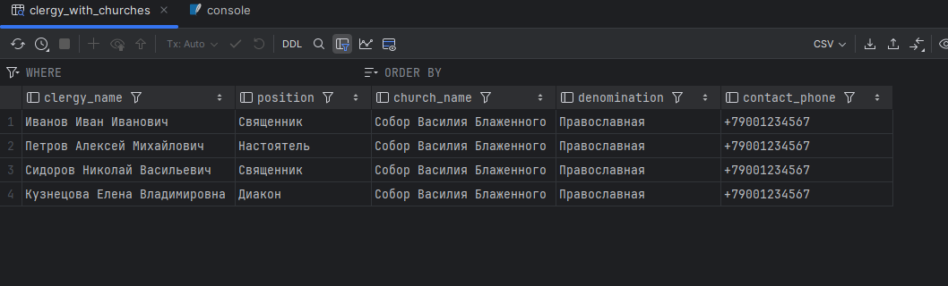

-- 2. Предстоящие службы с подробностями

CREATE VIEW upcoming_services_details AS  
SELECT  
 s.service_id,  
 st.name AS service_type,  
 s.service_date,  
 ch.name AS church_name,  
 cl.full_name AS main_clergy,  
 cp.title AS clergy_position  
FROM  
 services s  
JOIN  
 service_types st ON s.type_id = st.type_id  
JOIN  
 churches ch ON s.church_id = ch.church_id  
LEFT JOIN  
 clergy cl ON s.main_clergy_id = cl.clergy_id  
LEFT JOIN  
 clergy_positions cp ON cl.position_id = cp.position_id  
WHERE  
 s.service_date >= *date*('now')  
ORDER BY  
 s.service_date;



-- 3. Донации по церквям за текущий год

CREATE VIEW current_year_donations_by_church AS  
SELECT  
 ch.name AS church_name,  
 d.name AS denomination,  
 *SUM*(dn.amount) AS total_amount,  
 *COUNT*(dn.donation_id) AS donation_count,  
 pm.name AS most_used_payment_method  
FROM  
 donations dn  
JOIN  
 churches ch ON dn.church_id = ch.church_id  
JOIN  
 denominations d ON ch.denomination_id = d.denomination_id  
JOIN  
 payment_methods pm ON dn.method_id = pm.method_id  
WHERE  
 *strftime*('%Y', dn.donation_date) = *strftime*('%Y', *date*('now'))  
GROUP BY  
 ch.name, d.name, pm.name  
ORDER BY  
 total_amount DESC;

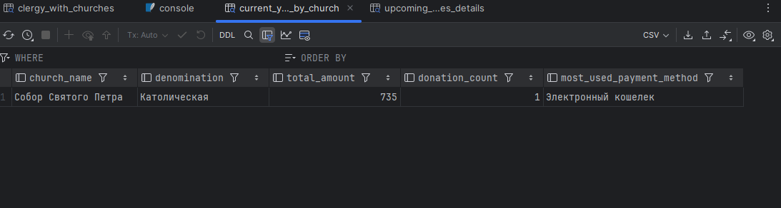

-- 4. Прихожане с их церквями и контактной информацией

CREATE VIEW parishioners_with_contacts AS  
SELECT  
 p.full_name AS parishioner_name,  
 p.birth_date,  
 p.phone,  
 ch.name AS church_name,  
 d.name AS denomination,  
 CASE  
 WHEN *date*('now') - p.birth_date < 18 THEN 'Молодежь'  
 WHEN *date*('now') - p.birth_date BETWEEN 18 AND 60 THEN 'Взрослые'  
 ELSE 'Пожилые'  
 END AS age_group  
FROM  
 parishioners p  
LEFT JOIN  
 churches ch ON p.church_id = ch.church_id  
LEFT JOIN  
 denominations d ON ch.denomination_id = d.denomination_id  
ORDER BY  
 church_name, parishioner_name;

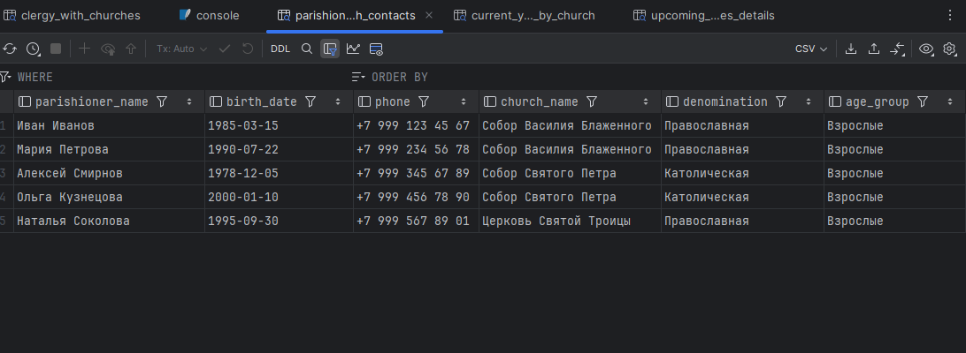

-- 5. Расписание служб по церквям на неделю

CREATE VIEW weekly_services_schedule AS  
SELECT  
 ch.name AS church_name,  
 st.name AS service_type,  
 s.service_date,  
 cl.full_name AS clergy_in_charge,  
 *GROUP_CONCAT*(p.full_name, ', ') AS assisting_clergy  
FROM  
 services s  
JOIN  
 churches ch ON s.church_id = ch.church_id  
JOIN  
 service_types st ON s.type_id = st.type_id  
LEFT JOIN  
 clergy cl ON s.main_clergy_id = cl.clergy_id  
LEFT JOIN  
 clergy c ON c.church_id = ch.church_id  
LEFT JOIN  
 parishioners p ON p.church_id = ch.church_id  
WHERE  
 s.service_date BETWEEN *date*('now') AND *date*('now', '+7 days')  
GROUP BY  
 ch.name, st.name, s.service_date, cl.full_name  
ORDER BY  
 ch.name, s.service_date;

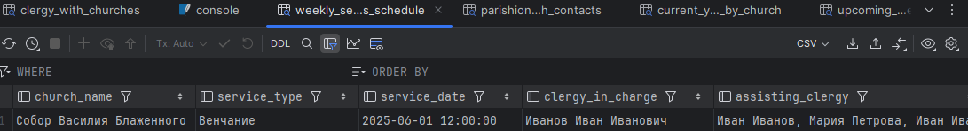

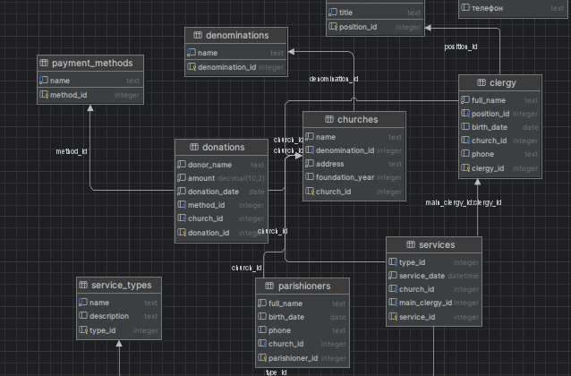

Приложение

-- 1. Список священников с их церквями

CREATE VIEW clergy_with_churches AS

SELECT

c.full_name AS clergy_name,

cp.title AS position,

ch.name AS church_name,

d.name AS denomination,

c.phone AS contact_phone

FROM

clergy c

JOIN

clergy_positions cp ON c.position_id = cp.position_id

LEFT JOIN

churches ch ON c.church_id = ch.church_id

LEFT JOIN

denominations d ON ch.denomination_id = d.denomination_id;

-- 2. Предстоящие службы с подробностями

CREATE VIEW upcoming_services_details AS

SELECT

s.service_id,

st.name AS service_type,

s.service_date,

ch.name AS church_name,

cl.full_name AS main_clergy,

cp.title AS clergy_position

FROM

services s

JOIN

service_types st ON s.type_id = st.type_id

JOIN

churches ch ON s.church_id = ch.church_id

LEFT JOIN

clergy cl ON s.main_clergy_id = cl.clergy_id

LEFT JOIN

clergy_positions cp ON cl.position_id = cp.position_id

WHERE

s.service_date >= date('now')

ORDER BY

s.service_date;

-- 3. Донации по церквям за текущий год

CREATE VIEW current_year_donations_by_church AS

SELECT

ch.name AS church_name,

d.name AS denomination,

SUM(dn.amount) AS total_amount,

COUNT(dn.donation_id) AS donation_count,

pm.name AS most_used_payment_method

FROM

donations dn

JOIN

churches ch ON dn.church_id = ch.church_id

JOIN

denominations d ON ch.denomination_id = d.denomination_id

JOIN

payment_methods pm ON dn.method_id = pm.method_id

WHERE

strftime('%Y', dn.donation_date) = strftime('%Y', date('now'))

GROUP BY

ch.name, d.name, pm.name

ORDER BY

total_amount DESC;

-- 4. Прихожане с их церквями и контактной информацией

CREATE VIEW parishioners_with_contacts AS

SELECT

p.full_name AS parishioner_name,

p.birth_date,

p.phone,

ch.name AS church_name,

d.name AS denomination,

CASE

WHEN date('now') - p.birth_date < 18 THEN 'Молодежь'

WHEN date('now') - p.birth_date BETWEEN 18 AND 60 THEN 'Взрослые'

ELSE 'Пожилые'

END AS age_group

FROM

parishioners p

LEFT JOIN

churches ch ON p.church_id = ch.church_id

LEFT JOIN

denominations d ON ch.denomination_id = d.denomination_id

ORDER BY

church_name, parishioner_name;

-- 5. Расписание служб по церквям на неделю

CREATE VIEW weekly_services_schedule AS

SELECT

ch.name AS church_name,

st.name AS service_type,

s.service_date,

cl.full_name AS clergy_in_charge,

GROUP_CONCAT(p.full_name, ', ') AS assisting_clergy

FROM

services s

JOIN

churches ch ON s.church_id = ch.church_id

JOIN

service_types st ON s.type_id = st.type_id

LEFT JOIN

clergy cl ON s.main_clergy_id = cl.clergy_id

LEFT JOIN

clergy c ON c.church_id = ch.church_id

LEFT JOIN

parishioners p ON p.church_id = ch.church_id

WHERE

s.service_date BETWEEN date('now') AND date('now', '+7 days')

GROUP BY

ch.name, st.name, s.service_date, cl.full_name

ORDER BY

ch.name, s.service_date;