Experiments and Results Section
Paper-ready tables, figures, and interpretations

1. Exploratory Findings
The exploratory analysis showed that dropout risk is strongly associated with financial stress and academic progression. These patterns motivated the later staged modeling, ablation, SHAP, clustering, and graph analyses.
Figure 2. Financial-risk indicators and dropout rate.
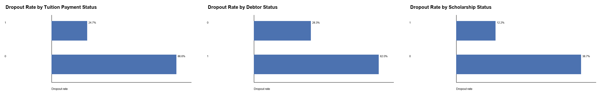
Interpretation: Students with unpaid tuition, debtor status, and no scholarship show much higher dropout risk. These variables are practical because universities can act on them.
Figure 3. Academic progression and dropout rate.
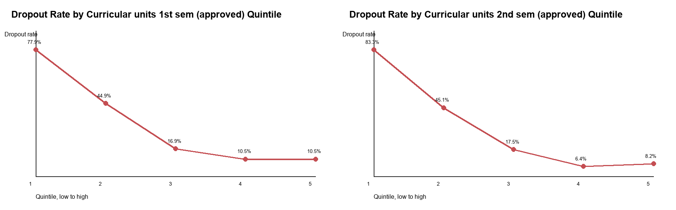
Interpretation: Low approved curricular units in the first and second semesters are among the strongest dropout signals.

2. Staged Early-Warning Models
The staged models show how predictive performance changes as more information becomes available. Stage A uses only pre-enrollment variables, Stage B adds first-semester academic information, and Stage C adds second-semester information.
Table 3. Best tuned model by early-warning stage.
Stage | Best model | Validation Macro-F1 | Validation Balanced Acc. | Validation Log-loss | Test Macro-F1 | Test Balanced Acc. | Test Log-loss
A_pre_enrollment | LightGBM | 0.583 | 0.700 | 0.849 | 0.571 | 0.689 | 0.849
B_first_semester | LightGBM | 0.679 | 0.772 | 0.659 | 0.680 | 0.773 | 0.647
C_second_semester | LightGBM | 0.712 | 0.797 | 0.595 | 0.698 | 0.784 | 0.597

Interpretation: Performance improves from Stage A to Stage C. This supports the early-warning argument: useful risk signals exist before enrollment, but academic progress sharply improves prediction.
Figure 4. Validation Macro-F1 across tuned staged models.
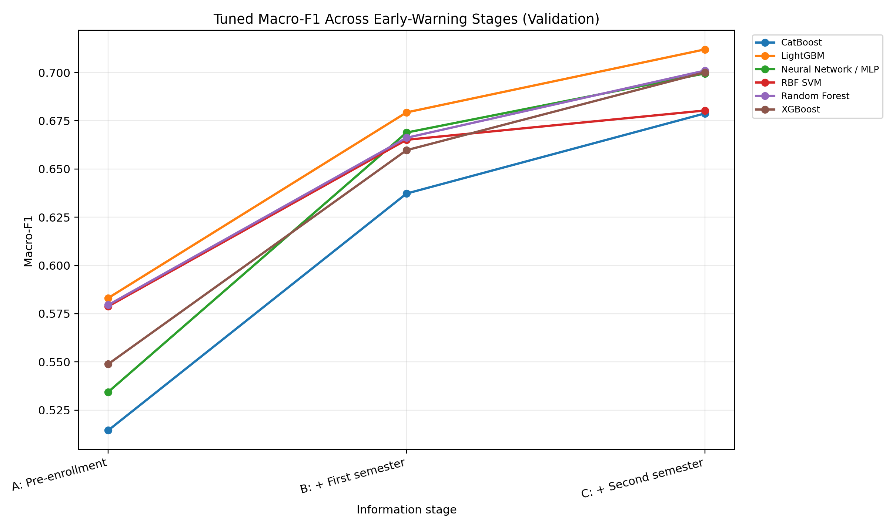
Interpretation: The figure shows the improvement in predictive strength over time, especially after semester performance variables are added.

3. Full-Feature and Ablation Experiments
The full-feature model estimates the maximum-information benchmark. Ablation models test which blocks of variables add value after academic performance.
Table 4. Tuned full-feature and ablation comparison.
Feature set | Best model | Raw features | Encoded features | Validation Macro-F1 | Test Macro-F1 | Test Balanced Acc. | Test Log-loss
Full feature | LightGBM | 36 | 244 | 0.709 | 0.702 | 0.789 | 0.590
2.Academic + demographic-financial | LightGBM | 24 | 54 | 0.702 | 0.698 | 0.785 | 0.621
3.Academic + parental education | LightGBM | 18 | 144 | 0.665 | 0.670 | 0.765 | 0.642
4.Academic + macroeconomic | Random Forest | 17 | 17 | 0.673 | 0.658 | 0.757 | 0.656
5.Academic + course-application | LightGBM | 17 | 53 | 0.672 | 0.655 | 0.754 | 0.642
1.Academic only | Random Forest | 14 | 14 | 0.665 | 0.653 | 0.752 | 0.664

Interpretation: The full-feature LightGBM is best overall, but academic plus demographic/financial variables nearly match it. This shows that financial and student-profile variables add meaningful value after academic performance.
Figure 5. Best tuned ablation models by test Macro-F1.
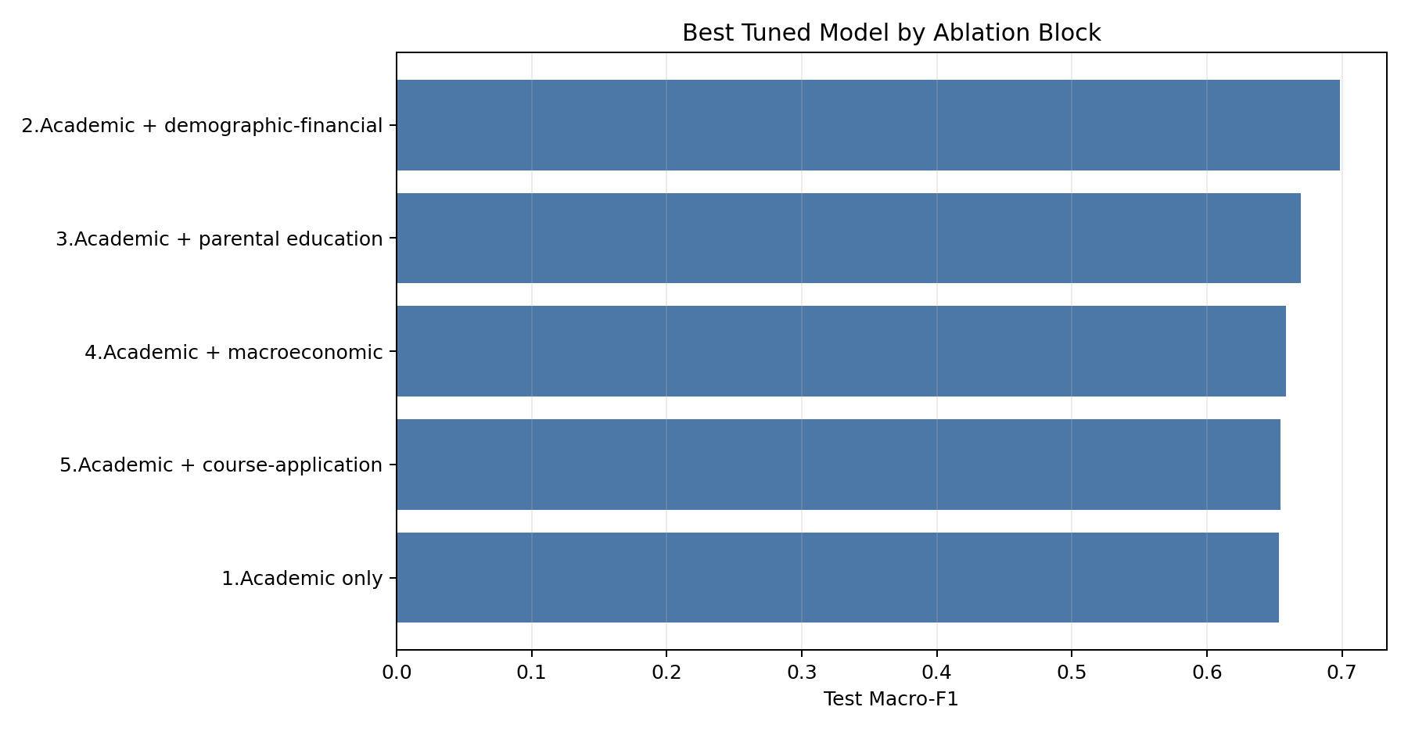
Interpretation: Academic plus demographic/financial variables form the strongest ablation block and nearly recover full-model performance.

4. Feature Importance and SHAP Interpretation
Permutation importance and SHAP were used to explain why the models predict dropout. The dropout-class SHAP plots are the most useful for policy because they focus directly on dropout risk, not only overall multiclass prediction.
Table 5. Feature importance summary for selected tuned models.
Model setting | Model | Test Macro-F1 | Top permutation feature | Top dropout SHAP feature
Stage A tuned | LightGBM | 0.571 | Tuition fees up to date | Tuition fees up to date
Stage B tuned | LightGBM | 0.680 | Curricular units 1st sem (approved) | Curricular units 1st sem (approved)
Stage C tuned | LightGBM | 0.698 | Curricular units 2nd sem (approved) | Curricular units 2nd sem (approved)
Full feature tuned | LightGBM | 0.702 | Curricular units 2nd sem (approved) | Curricular units 2nd sem (approved)
Academic + demographic-financial tuned | LightGBM | 0.698 | Curricular units 2nd sem (approved) | Curricular units 2nd sem (approved)

Interpretation: Early risk is driven by tuition status; after semester data become available, approved curricular units dominate dropout risk.
Figure 6. Dropout-class SHAP summary for the full-feature model.
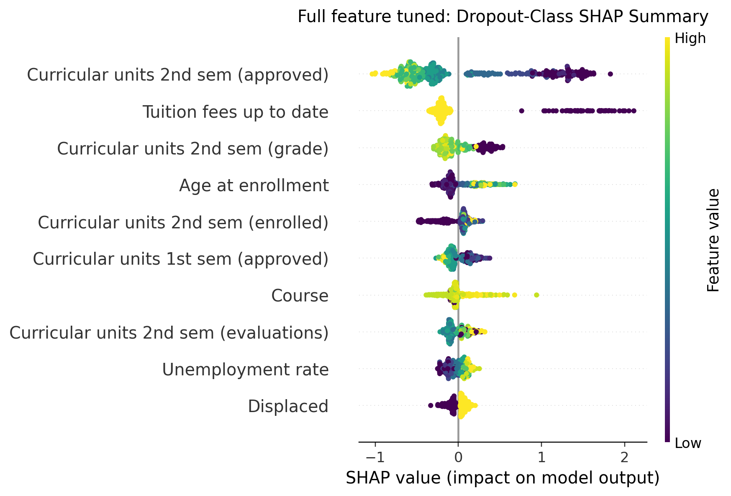
Interpretation: Low second-semester approved units and tuition not being up to date push predictions toward dropout. This connects predictive performance to actionable university signals.

5. Risk Clustering
Risk clustering converts predictions and key variables into practical intervention groups. The k=5 solution is used here because it is easier for universities to translate into action plans.
Table 6. Practical risk-cluster profiles.
Risk cluster | n | Observed dropout | Predicted risk | Mean 2nd-sem approved | Unpaid tuition | Recommended action
Severe academic non-progression risk | 720 | 81.5% | 81.4% | 0.030 | 29.3% | Mandatory academic advising and course-completion intervention
Financial-academic emergency risk | 66 | 63.6% | 63.8% | 2.290 | 34.8% | Combine financial outreach with urgent academic completion support
Academic delay with financial vulnerability | 1129 | 52.3% | 46.1% | 3.170 | 20.7% | Prioritize course-completion advising and payment-status monitoring
Older high-workload moderate risk | 249 | 20.5% | 22.1% | 10.350 | 8.4% | Offer flexible scheduling and light-touch persistence monitoring
Low-risk academically stable group | 2260 | 6.7% | 8.2% | 5.880 | 1.7% | Maintain light monitoring; use as reference profile

Interpretation: The clusters separate severe academic non-progression, financial-academic emergency risk, academic delay with financial vulnerability, older high-workload students, and low-risk stable students.
Figure 7. Observed dropout rate by practical risk cluster.
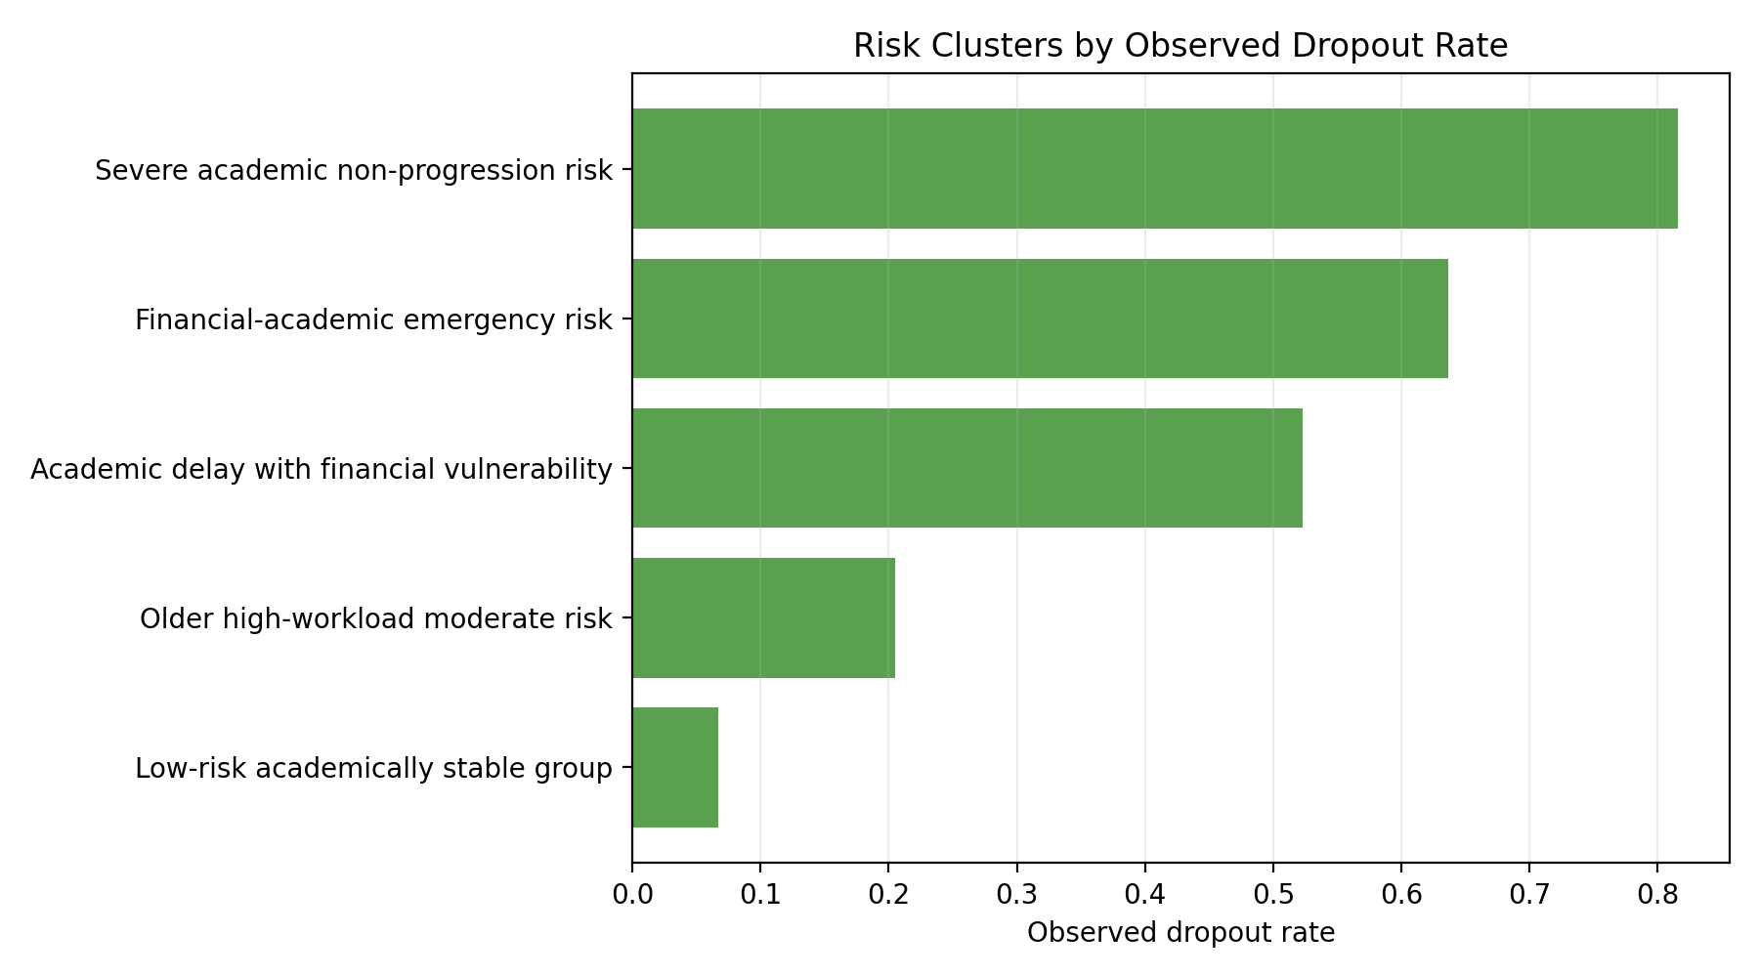
Interpretation: The severe academic non-progression group has an 81.5% dropout rate, while the low-risk stable group has only 6.7%.

6. Graph Analysis
Graph analysis tests whether dropout risk forms connected communities. The student-risk graph connects similar students, while the course-risk graph connects courses with similar risk profiles.
Table 7. Highest student graph communities by dropout risk.
Community | Label | n | Observed dropout | Predicted risk | Mean 2nd-sem approved | Unpaid tuition
2 | Collapsed academic progression community | 911 | 82.4% | 81.2% | 0.080 | 29.5%
0 | Mixed-risk community | 1280 | 29.8% | 29.8% | 6.320 | 17.4%
8 | Mixed-risk community | 37 | 29.7% | 20.9% | 3.650 | 2.7%
1 | Mixed-risk community | 1103 | 18.7% | 16.6% | 4.560 | 1.9%
5 | Mixed-risk community | 82 | 9.8% | 12.8% | 3.630 | 0.0%
7 | Stable low-risk community | 43 | 9.3% | 12.0% | 4.840 | 2.3%

Interpretation: The graph identifies a collapsed academic progression community with very high dropout risk. This supports group-level intervention rather than only individual alerts.
Figure 8. Student-risk similarity graph projected into PCA space.
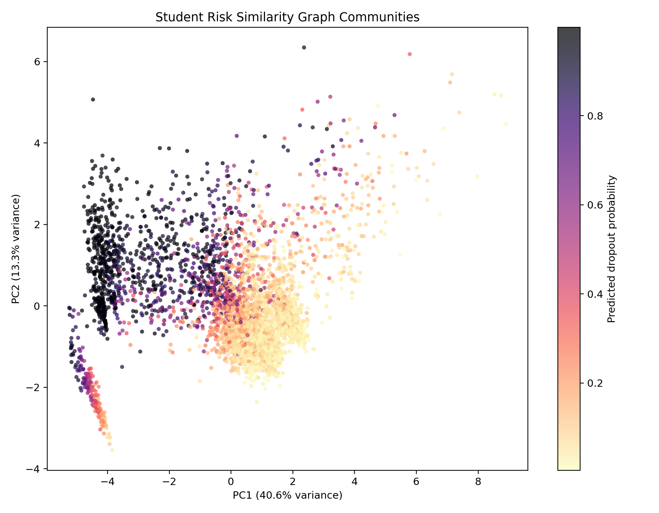
Interpretation: The plot shows a clear risk gradient, meaning similar students cluster by dropout risk profile.
Figure 9. Interpretable course-risk similarity graph.
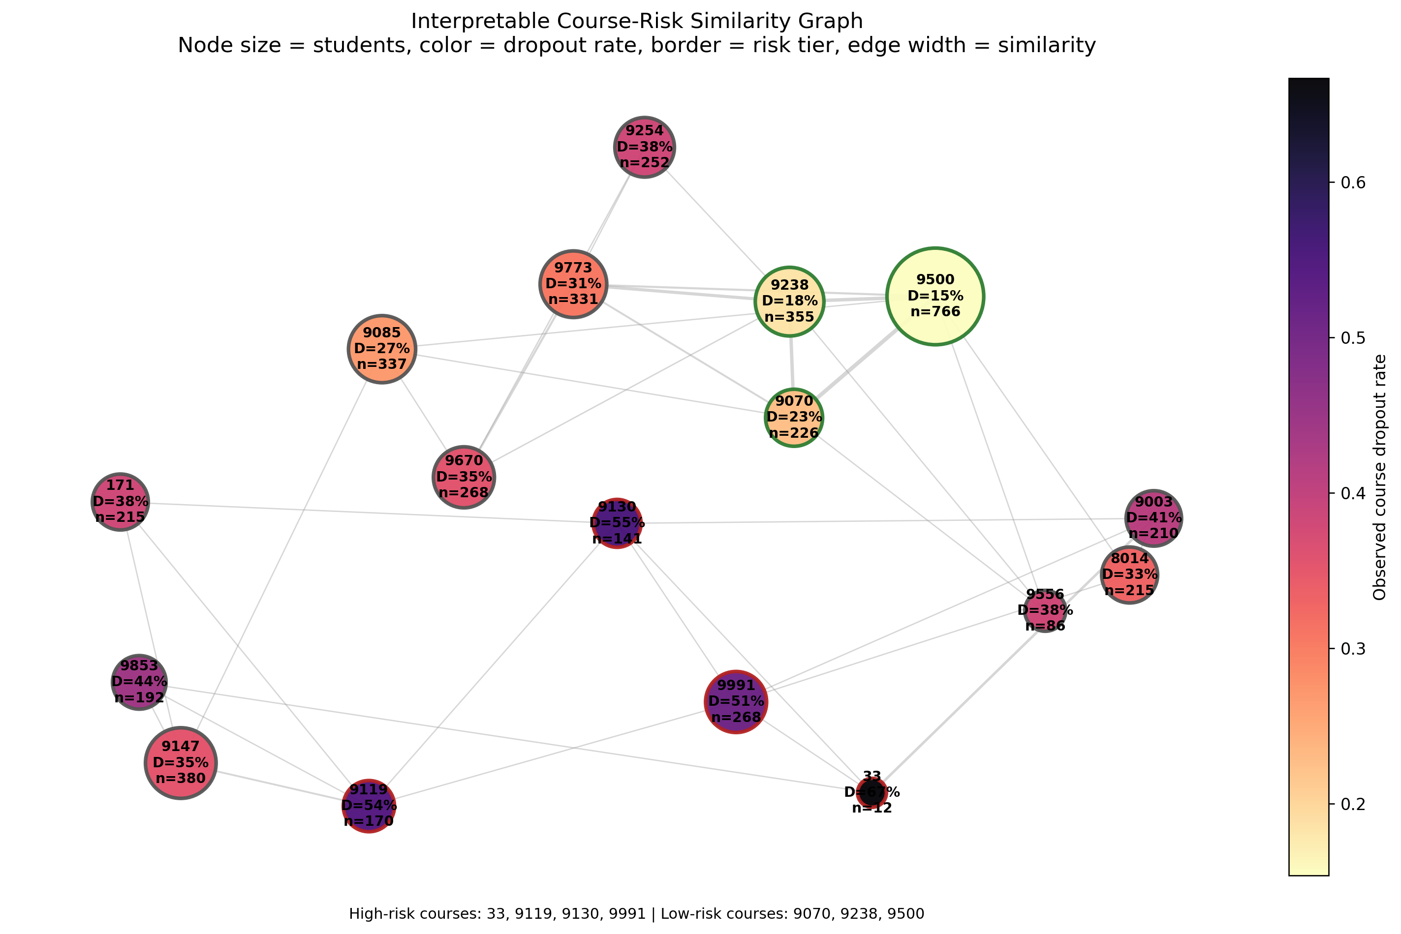
Interpretation: The graph shows high-risk and low-risk course groups. Course-level monitoring can help universities identify programs needing broader support.
Table 8. Course-risk graph communities.
Course community | Courses | Total students | Mean dropout | Mean predicted risk | Mean 2nd-sem approved | Mean unpaid tuition
0 | 33; 171; 8014; 9003; 9119; 9130; 9147; 9853; 9991 | 1803 | 46.5% | 44.6% | 3.590 | 16.9%
1 | 9070; 9085; 9238; 9254; 9500; 9556; 9670; 9773 | 2621 | 28.2% | 27.2% | 4.710 | 10.5%

Interpretation: The high-risk course community has a much higher mean dropout rate than the lower-risk community.

