Methodology Section
Student dropout determinants and early-warning modeling

1. Study Design
This study analyzes student dropout determinants using a structured machine-learning and interpretation pipeline. The aim is not only to predict dropout, but also to explain which factors matter and how universities can use the results for intervention planning.
The analysis follows a staged early-warning design. This is important because universities need to know how early useful signals appear. Therefore, the same modeling framework was tested with pre-enrollment variables, then with first-semester information, and finally with second-semester information.
Figure 1. Overview of the analysis workflow.
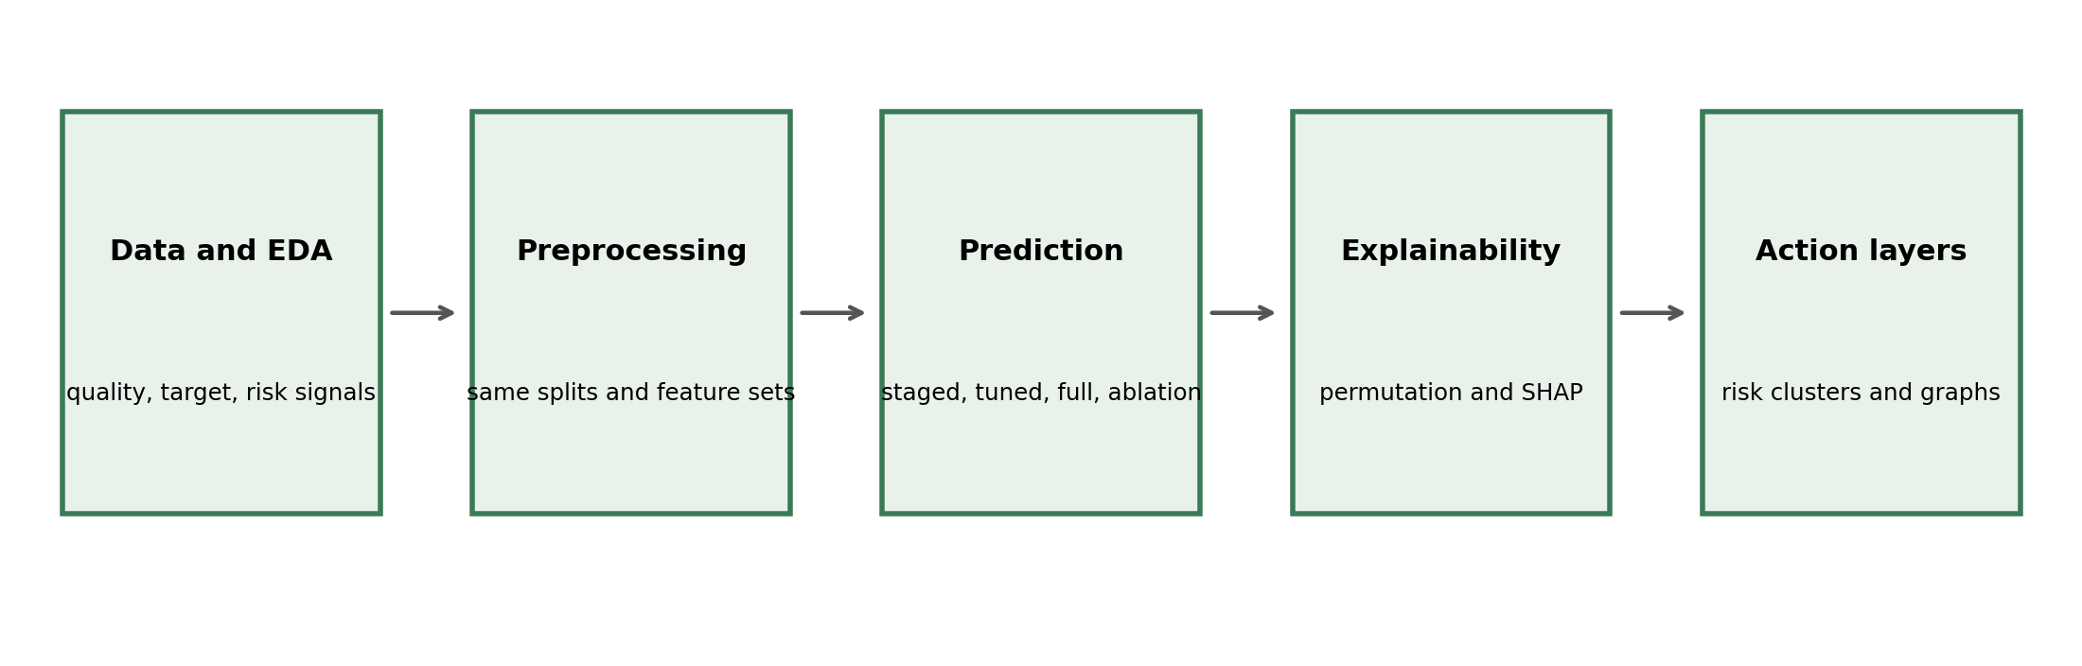
Interpretation: The workflow moves from descriptive analysis to prediction, explanation, clustering, and graph-based intervention groups.

2. Data Preparation and Targets
The source data were kept unchanged. Column labels were cleaned in memory, a student identifier was added, and target variables were created for multiclass status and dropout-focused interpretation. Missing values and duplicate rows were checked before modeling.
Table 1. Target distribution in the dataset.
Target | count | percent
Graduate | 2209 | 0.499
Dropout | 1421 | 0.321
Enrolled | 794 | 0.179

Interpretation: The dataset contains graduates, dropouts, and enrolled students. This supports multiclass modeling while keeping dropout as the main policy focus.

3. Staged Feature Sets
Three timing-based feature sets were prepared. The same train, validation, and test split was used across all supervised models to make comparisons fair.
Table 2. Staged early-warning feature windows.
Stage | Information available | Main variables | Purpose
A. Pre-enrollment | Before or at enrollment | Admission, course, demographics, parental background, financial status, macro context | Earliest warning signal
B. First semester | Stage A + first-semester performance | First-semester enrolled, evaluated, approved units and grade | Early academic monitoring
C. Second semester | Stage B + second-semester performance | Second-semester enrolled, evaluated, approved units and grade | End-of-year risk assessment

Interpretation: The staged design answers the reviewer question: how early is early warning?

4. Modeling Strategy
The modeling strategy used nonlinear classifiers including Decision Tree, Random Forest, XGBoost, LightGBM, CatBoost, RBF SVM, and Neural Network / MLP. The same encoded and scaled input representation was used for fair comparison. Encoding and scaling were fitted only on the training data and then applied to validation and test data.
Models were selected using validation Macro-F1 as the primary criterion. Balanced accuracy and log-loss were used as supporting metrics. Test results were used only after model selection to estimate final performance.

5. Ablation, Explainability, Clustering, and Graph Analysis
Ablation analysis tested whether demographic, financial, parental, macroeconomic, and course/application variables add information after academic performance. This was important for identifying which variable blocks provide practical value.
Feature importance was estimated with permutation importance on the held-out test set. SHAP analysis was then used to explain global model behavior and dropout-class-specific drivers. Risk clustering and graph analysis used the whole dataset because their goal was descriptive segmentation and intervention design, not supervised accuracy estimation.

6. Reporting Metrics
- Macro-F1 was used because the target classes are not equally distributed and each class should contribute equally to model assessment.
- Balanced accuracy was used to measure class-sensitive accuracy.
- Log-loss was used to check probability quality, not only hard-class prediction.
- Permutation importance and SHAP were used to connect model outputs to policy interpretation.

