EAST WEST UNIVERSITY


T EEE 302: Microprocessors & Interfacing

TExperiment 1: Basic Instructions in Assembly Language.

TLogical Instructions

TSome of the commonly used logical instructions are:

TThe NOT command complements all the bits

TMOV AX, 7030H; In binary AX = 0111 0000 0011 0000
TNOT AX ; In binary AX = 1000 1111 1100 1111

The AND command performs bitwise logical and of the operands and stores the result in first operand.

MOV BL, 70H ; In binary BL= 0111 0000
MOV CL, 40H ; In binary CL= 0100 0000
AND CL,BL; In binary CL= 0100 0000

The OR command performs bitwise logical or of the operands and stores the result in first operand.

MOV BL, 70H ; In binary BL= 0111 0000
MOV CL, 40H ; In binary CL= 0100 0000
OR CL,BL; In binary CL =0111 0000

The XOR command performs bitwise logical xor of the operands and stores the result in first operand.

MOV BL, 70H ; In binary BL= 0111 0000
MOV CL, 40H ; In binary CL= 0100 0000
XOR CL,BL; In binary CL =0011 0000

The TEST command performs bitwise logical and of the operands but none of the operands are changed. The result is indicated in the flag register.

MOV BL, 70H ; In binary BL= 0111 0000
MOV CL, 42H ; In binary CL= 0100 0010
TEST CL,BL; In binary CL = 0100 0010
Assembly Language Program structure

The first line is generally the title. To indicate title line you must use the key word
TITLE at the beginning. For example:

TITLE example 01

To indicate the size of code and data memory model is used. The syntax is :
.MODEL memory_model

memory model can be : SMALL, LARGE, MEDIUM, HUGE etc. For example:
.MODEL SMALL

A programs data segment contains all the variable definitions and constants. To declare a data segment we use the directive .DATA

The purpose of stack segment declaration is to set aside a block of memory to store the stack.

. STACK 100H

To indicate the code segment use the .CODE directive.

Inside the code segment the instructions are organized as procedures. The simplest procedure definition is

Name PROC

; body of procedure

Name ENDP END MAIN

The last line should be the END directive followed by the name of main procedure.

The 8086 Simulator:
In this LAB we will be using the emu8086 assembler and microprocessor emulator.

Step 1: Open the emu8086 application. You’ll see the following screen

Step 2: Click on the button and select empty work space

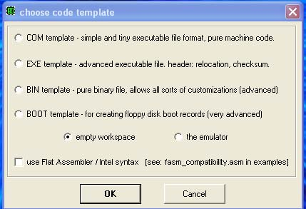

Step 3: Write your code in the workspace.

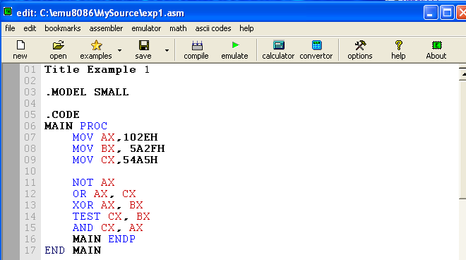

Post Lab Work:

- Verify and locate the results for each operation done in step-3. Take screenshots and save it in your computer for each operation.

- To do more analyze, you need to generate random numbers & verify them by showing accurate binary equivalent numbers for each value as done in page 1 and write down the total program in emu8086. You need to save all the screenshots for composing your post lab reports.

