|  |  |
| --- | --- |
| .Description: C:\Documents and Settings\MMAI\Desktop\EWULogo.png | **Department of Electrical and Electronic Engineering**  **EEE 302**  **MICROPROCESSORS & INTERFACING** |
|  |  |

**EXPERIMENT NO: 01**

*Introduction to the microcomputer system*

**1.1 OBJECTIVE**

This experiment aims to learn about the primary programming language of Arduino Uno and Arduino Uno itself. Also, know about how simple circuit works with Arduino Uno.

**1.2 Pre-lab Preparation**

* What is a variable in a programming language?
* What is the difference between the global variable and the local variable?
* Write (and run it in your house) a program that will add any two numbers, and it will show the result using a C programming language(Compiler or IDE: Code block or any other compiler)
  1. **Equipment**
* Arduino Uno(Atmega 328 microcontroller)
* Breadboard
* 220-ohm resistor
* LEDs
* Wires

**1.4 Theoretical background:**

ATmega 328P microcontroller operates at 5V. The input voltage of Arduino Uno can be significantly from 6V-12V. Arduino itself can supply 5V and 3.3V.

* Total 20 GPIO(or input/output) pins, 14 digital pins, and 6 analog pins
* Output voltage is 0V or 5V(logic 0 or 1)
* Analog pins can read analog data and digital data
* Digital pins can read only digital data
* It is an 8-bit microcontroller
* It has 32 kB of flash memory
* It has 2kB of SRAM
* It is capable of reaching thorough-puts of 1 MIPS per MHz.

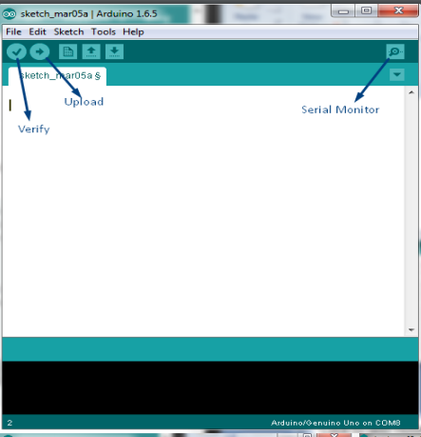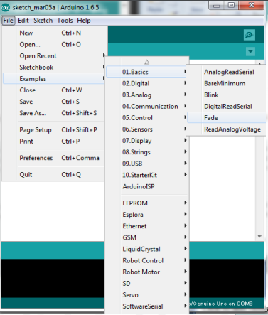

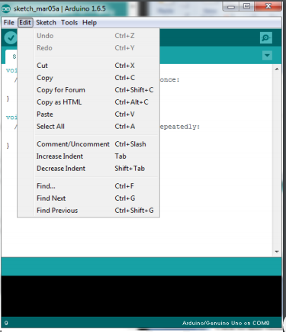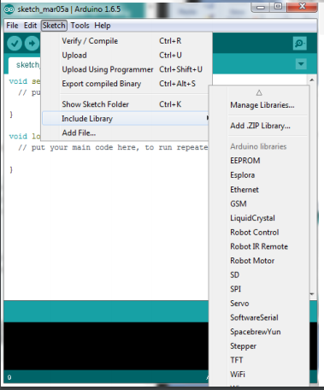

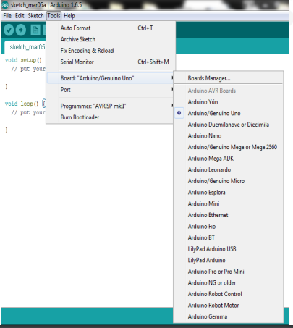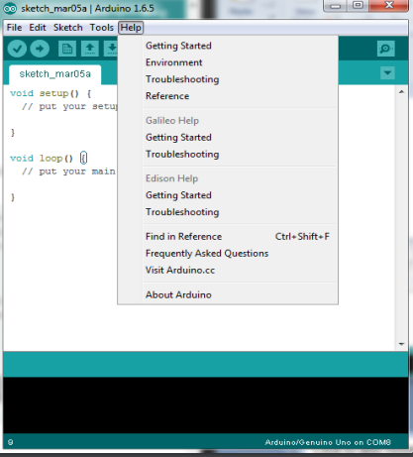

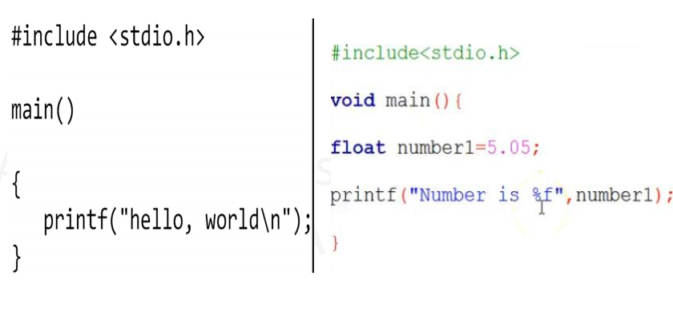

The functions we are going to use are:

1.pinMode(pin, mode)

pin: the number of the pin whose mode you wish to set

mode: INPUT, OUTPUT

2. digitalWrite(pin, value)

pin: the PIN

value: HIGH or LOW

3. delay(ms)

ms: the number of milliseconds to pause

* 1. **Procedure:**

Step1: Open the Arduino Uno IDE.

Step 2: Go To File🡪 Example🡪Basic🡪Blink and click it. The code can be seen below.

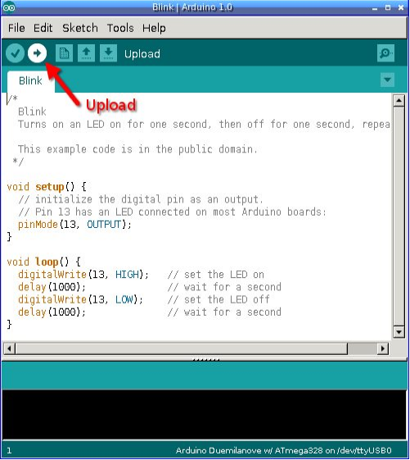

Step 3: Now, build this circuit.

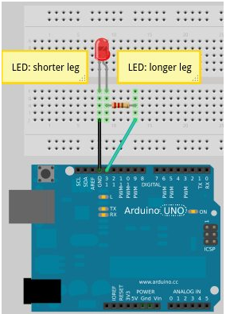

Step 4: Verify and upload this code and observe it.

Step 5: In the program, write “LED_BUILTIN” delete this line only and write here only 13

Step 6: Verify and upload the code and observe it.

Step 7: In the code, increase the delay time like:

delay(2000);

or

delay(5000);

and so on

Step 8: Verify and upload the code and observe it.

Step 9: In the code, decrease the delay time like:

delay(200);

or

delay(500);

and so on

Step 10: Verify and upload the code and observe it.

Step 11: Delete all the “delay()” and delete “digitalWrite(LED_BUILTIN, LOW);” line

Step 12: Verify and upload the code and observe it.

Step 13: Delete all the “delay()” and delete “digitalWrite(LED_BUILTIN, HIGH);” line

Step 14: Verify and upload the code and observe it.

* 1. **Post Lab Work:**
* Which IC is triggering the LED?
* If we increase the delay time of the task-1 program, what will happen?
* If we decrease the delay time, what will happen?
* If we want to “ON” the led nonstop, what will we have to do, or will the program change be changed?
* If we want to “OFF” the led nonstop, what will we have to do, or will they be the program change?