|  |  |
| --- | --- |
| .Description: C:\Documents and Settings\MMAI\Desktop\EWULogo.png | **Department of Electrical and Electronic Engineering**  **EEE 302**  **MICROPROCESSORS & INTERFACING** |
|  |  |

**EXPERIMENT NO: 03 (Microcontroller part)**

*Introduction to the algorithm for Microcontroller*

**1.1 OBJECTIVE**

This experiment aims to give on-hand practice to solve a problem by developing an algorithm.

**1.2 Equipment**

* Atmega 328 microcontroller
* Breadboard
* 220-ohm resistor
* LEDs
* Wires

**1.3 Theoretical background:**

A sorting algorithm comprises a series of instructions that takes an array as input, performs specified operations on the array, sometimes called a list, and outputs a sorted array. Sorting algorithms are often taught early in computer science classes as they provide a straightforward way to introduce other key computer science topics like Big-O notation, divide-and-conquer methods, and data structures such as binary trees and heaps. There are many factors to consider when choosing a sorting algorithm to use.

**Task 1:**

Step1: Open the Arduino Uno IDE.

Step 2: The following code will help to find the highest digits from the given input digits; try to understand the logic of the code and type it on Arduino IDE or make the logic and write it in the Arduino IDE.

/*Sorting algorithm

*/

int a[10];//keep the input digits here

int i=0;

void setup() {

Serial.begin(9600); //to enable serial monitor

Serial.println("Tyep 10 digits:");

}

void loop() {

if(Serial.available()>0){

a[i]=Serial.read();

delay();

i++;

if(i==9){

for(i=0;i<10;i++){

if(a[i]>a[i+1]){

a[i+1]=a[i];

}

else{

a[i+1]=a[i+1];

}

}

Serial.print("The highest digits is:");

Serial.println(a[9]-48);//since ASCII table start disits from 48, where 48=0

}

}

}

Step 3: Open the serial monitor and type 10 digits one by one, and press enter

To see the highest digits of the given input digits.

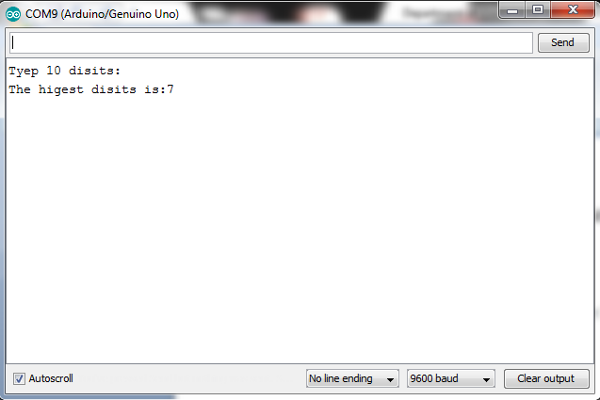

**Task 2:**

Step 1: Built a circuit like below

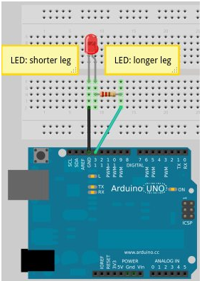

Step 2: Write a code that will take 10 digits input and find out the significant digit among them. Then the LED, which is connected with pin 13, will blink. The LED will blink equal times to the highest digit times

Hint: Modify the above code for the above step.

* 1. **Post Lab Work:**
* Write a program that will take 20 digits as input and determine if there is any repeated number in the input digits. Moreover, find if yes, then print that repeated number.