|  |  |
| --- | --- |
| .Description: C:\Documents and Settings\MMAI\Desktop\EWULogo.png | **Department of Electrical and Electronic Engineering**  **EEE 302**  **MICROPROCESSORS & INTERFACING** |
|  |  |

**EXPERIMENT NO: 02 (Microcontroller Part)**

## *Experiment on Analog to Digital Converter (ADC) of an Embedded system*

**1.1 OBJECTIVE**

The experimental objective is to understand an embedded system's Analog to Digital Converter (ADC) using a temperature sensor.

* 1. **Equipment**
* Arduino Uno/ Arduino IDE
* Temperature sensor I.C. ( LM35 or TMP36)
* Breadboard
* Wires
  1. **Circuit Diagram**

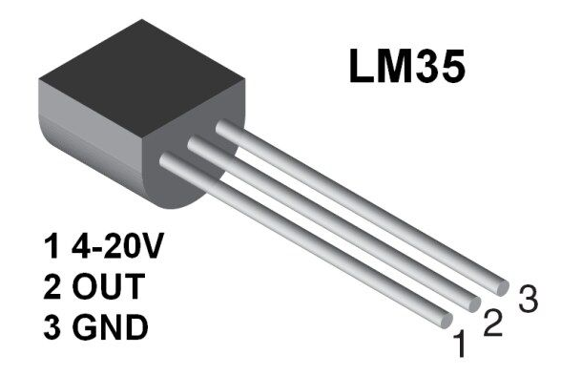

Figure 01: LM35 temperature sensor pinout

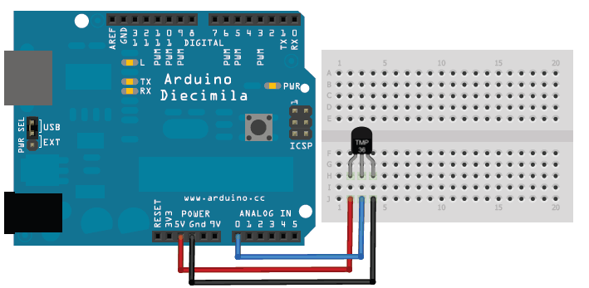

Figure 02: Circuit diagram of the temperature measurement system

**1.5 Theoretical background**

ADC means that if analog data or value is put in the ADC system, analog data will be converted into digital data.

Analog data or value or signal means it will have infinite value. For example from 0 to 5 there are infinite (0.00000, 0.00001,…………1, 1.000000000,…………….5) values. These values can be called analog values or analog data. Example: Analog Clock

Digital data or value or signal means it will have a finite value. For example, from 0 to 5 there are finite value or number that is 6(0,1,2,3,4,5) and this (0,1,2,3,4,5) numbers can be called digital number or digital value or digital data. Example: Digital Clock

So, if an analog or infinite value is entered into ADC, it will convert that value into a finite or digital value.

Atmega 328-based Arduino Uno board will be used in this experiment. It has a 10-bit ADC. 10-bit ADC means converting an analog signal into a digital signal; atmega328 microcontroller ADC will take sampling rate 10.

Arduino Uno has 6 Analog pins (A0 to A5). If an analog signal between 0Vto 5V levels gives input into the Arduino ADC pin, this will be converted into a digital value between 0 to 1023. Since Arduino has 10 bits ADC and (**210**), 1024 means 0 to 1023. Arduino Uno analog pin can take 10000 data per second or take 100us to read an analog input

analogRead(PIN), a function is used to read the analog readings

Temperature sensor I.C. names, LM34, TMP36

• LM35

– Operates from 4 to 30 volts

– + 10.0 mV/˚C scale factor

– 0.5˚C accuracy

– Rated for full −55˚ to +150˚C range

• TMP36

– Voltage Input: 2.7 V to 5.5 VDC

– 10 mV/°C scale factor

– ±2°C accuracy over temperature

– Operating Range: −40°C to +125°C

* 1. **Program**

pinMode: used for pin declaration

Serial. begin: Enable serial communication

analogRead: Read the analog data from the analog pin

Serial. print: print the serial data horizontally on the serial monitor

Serial. println: print the serial data vertically on the serial monitor

delay: to hold the code running or make the code delay

**Code:**

void setup()

{

// Declare analog pin "A0" for taking analog input from the temperature sensor

pinMode(A0,INPUT);

// initialize serial communication at 9600 bits per second:

Serial.begin(9600);

}

void loop()

{

int val = analogRead(A0); //Taking analog data using “A0” analog pin

/* Simple Algorithm to Convert analog data to Temperature Celsius */

float mv = ( val/1024.0)*5000;

float cel = mv/10;

float farh = (cel*9)/5 + 32;

//Printing the data on the serial monitor

Serial.print("TEMPRATURE = ");

Serial.print(cel);

Serial.println("*C");

//Delay to make the printing speed slow

delay(1000);

}

* 1. **Procedure**
* Give the circuit connection as shown in the circuit diagram
* Open the Arduino IDE
* Open a new window by clicking "File🡪New" and write the above code
* Write the code, and verify it: by clicking on the verify icon (√) or "Sketch🡪Verify/Compile." [N.B.: If you write the code ideally, the "Done compiling" message will have appeared on the Arduino IDE.
* Upload the code into the Arduino IDE by clicking the upload icon(🡪) or "Sketch🡪Upload."[N.B.: if everything is okay, the "Done uploading" message will appear on the Arduino IDE. If an error message is shown on the Arduino IDE, then check (1)the connection between the Arduino board and the computer or Laptop from which you are uploading the code, (2)Go to the "Tools🡪Board," and make sure "Arduino/Genuino Uno" option is selected, (3) Go to the "Tools🡪Port," make sure the proper Port is selected ]
* Now open the serial monitor by clicking the serial monitor icon or "Tools🡪Serial Monitor." Now see the temperature is being printed on the serial monitor.
* Record 20 samples of temperature data into the data sheet. Also, take the Room temperature at that moment.
  1. **Post Lab Work:**
* What is the average temperature of the collected data and the lab temperature?
* Is there any difference between these two temperature (average temperature and the lab temperature) values? If yes, why? Explain it.
* Comment on the findings during this experiment.