|  |  |
| --- | --- |
| .Description: C:\Documents and Settings\MMAI\Desktop\EWULogo.png | **Department of Electrical and Electronic Engineering**  **EEE 302**  **MICROPROCESSORS & INTERFACING** |
|  | **OPEN ENDED LAB FALL 2019** |

# [Control your light switch with Android Phone using Arduino](https://circuitdigest.com/microcontroller-projects/build-an-arduino-smart-watch-by-interfacing-oled-display-with-android-phone).

* 1. **OBJECTIVE**

The objective of this experiment is to provide on hand practice for designing a smart switch which can be controlled and will be connected to your smart phones. So, it can be turned on/off via your smartphone.

This lab will be mapped into your following course outcomes:

|  |  |  |  |
| --- | --- | --- | --- |
| **Description** | **BLOOM’S Taxonomy level** | **Delivery methods & activities** | **Assessment tools** |
| Investigate microprocessor based systems by designing and conducting experiments | Analyze, Knowledge | Lab session. | Lab performance. |

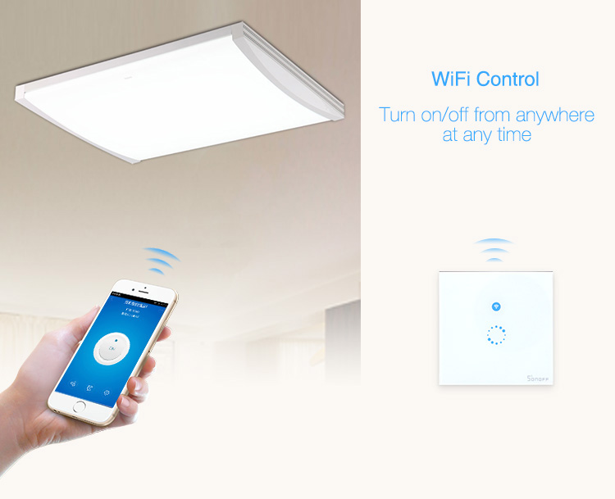

**1.3 Pre- lab Preparation**

The term OLED stands for “Organic Light emitting diode” it uses the same technology that is used in most of our televisions but has fewer pixels compared to them.  It is real fun to have these cool looking display modules to be interfaced with the Arduino since it will make our designed output look cool.

**1.4 Theoretical background**

Arduino community has already given us a lot of Libraries which can be directly used to make this a lot simpler. You will search a few libraries and found that the [Adafruit_SSD1306](https://github.com/adafruit/Adafruit_SSD1306) Library is very easy to use and had a handful of graphical options; hence you can use the same in this lab. Here you also need to install one more library in Arduino IDE which can be downloaded from here [GFX Graphics Library](https://github.com/adafruit/Adafruit-GFX-Library).