|  |  |  |
| --- | --- | --- |
| **East West University**  **Department of EEE**  **EEE 302: Microprocessors & Interfacing**  **Semester: Fall 2021**  **Final Examination**  **Course Instructor: FMA**  **Date: December 20, 2022**  **Section-1** | |  | | --- | |  | |

**Time: 90 minutes Total Marks: 80**

1. In the following diagram, you have the **minimum mode** configuration. Answer the following questions: CO2/APPLY

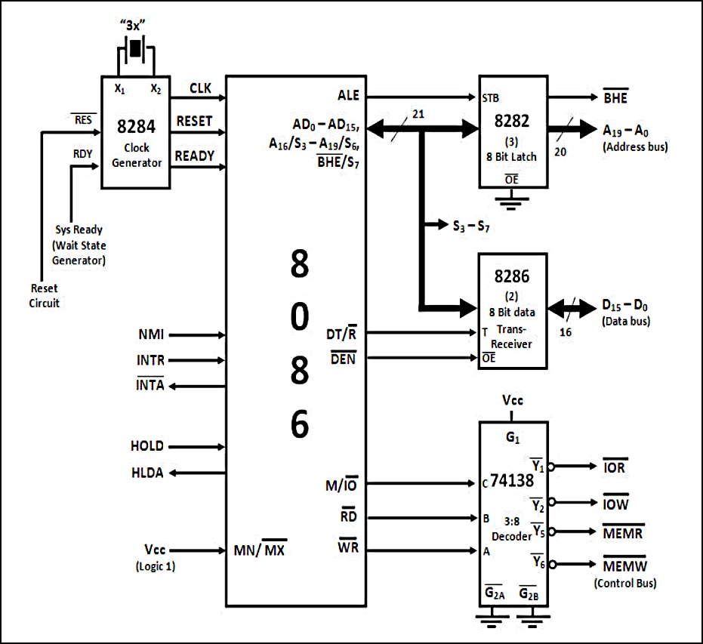

1. How do ALE and DEN pins synchronize together? How does it improve the total performances of the Intel 8086 microprocessor? [10 marks]
2. Explain the generation of control signals preferably via a truth table. What will happen to the unexploited pins for IC 74138? [10 marks]

1. Why do we need IC 8284 Clock generator? Since there is no clock out signal inside Intel 8086, how does the clock generator synchronize with Intel 8086 microprocessor? [10 marks]
2. What is the duty cycle? Why is it necessary to generate a 33% duty cycle (always) for Intel 8086 microprocessor? [10 marks]
3. In the following diagram you have the **maximum mode** configuration. Answer the following questions: CO2/APPLY

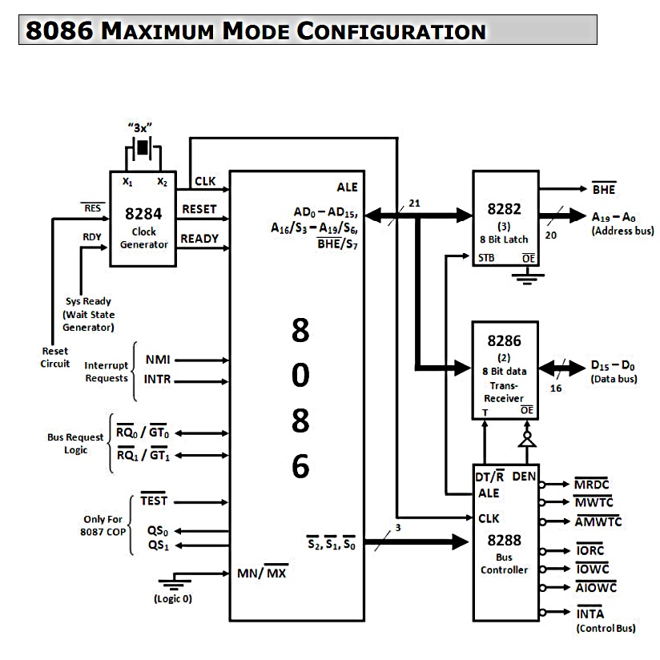

1. How does the bus controller IC 8288 control the IC 8282 and IC 8286 at a given time? Explain. [10 marks]
2. Redraw the above figure by adding **Intel 8087 coprocessor** **and Intel 8259 PIC**.

[10 marks]

1. How does Intel 8086 and Intel 8087 coprocessor set up the connection in between?

[10 marks]

1. In the following diagram, we have the **incomplete** connection diagram of DMA for the Intel 8086 microprocessor. You need to redraw the connection diagram and label the connection lines sequentially using numerical numbers only assuming Intel 8086 has responded to the DMA request. **(No explanation required)** [10 marks] CO2/APPLY

