|  |  |  |
| --- | --- | --- |
| **East West University**  **Department of EEE**  **EEE 302: Microprocessors & Interfacing**  **Semester: Fall 2021**  **Midterm-2 Examination**  **Course Instructor: FMA**  **Date: December 9, 2021**  **Section-1** | |  | | --- | |  | |

**Time: 90 minutes Total Marks: 100**

Answer all the questions. Do not use notes, books, and mobiles

1. Answer the following questions:
2. What are the processor control loops available for Intel 8086 microprocessor? Why they are useful to Intel 8086? Describe each. [ 10 marks] CO1/ Understand
3. How can a programmer **SET (**only) the trap flag? Show the whole process assuming the containment of flags is as follows:

[10 marks] CO1/ Understand

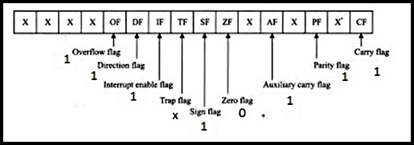

1. List the contents of the flag register according to the following figure after the computation of these following arithmetic operations: (avoid all the control flags)
2. **-1E16 + 2D16  (ii) -2316 - 1216** CO2/APPLY [10+10=20 marks]

The 8086 Microprocessor 8-55-29 PM_thumb_thumb.jpg

1. Suppose, DL contains **EFh**, CF=0 and CL contains 3. What are the values (in HEXA) of DL after the following instructions are executed? Also, mention the status of conditional flags for each case. CO2/ Apply [ 10+10=20 marks]
2. RCL DL, CL
3. SAR DL, CL
4. In the following diagram you have the interrupt vector table of Intel 8086 microprocessor. Briefly answer the following questions:

**

1. Compare the hardware interrupts of Intel 8086 microprocessor?
2. What is ISR? Why it is necessary to clear the IF and TF before servicing any ISR?
3. Why Intel 8086 microprocessor goes to memory twice whenever it gets an interrupt? Justify.
4. What is the difference between RET and IRET instructions? What will be the scenario of stack before and after servicing an interrupt? (Draw only figures with directions)

CO1/ Understand [10 x 4 =40 MARKS]