|  |  |  |
| --- | --- | --- |
| **East West University**  **Department of EEE**  **EEE 302: Microprocessors & Interfacing**  **Semester: Spring 2022**  **Midterm-2 Examination**  **Course Instructor: FMA**  **Date: April 7, 2022**  **Section-1** | |  | | --- | |  | |

**Time: 80 minutes Total Marks:70**

Answer all the questions. Do not use notes, books, and mobiles

1. How can a programmer **RESET (**only) the trap flag? Show the whole process assuming the containment of flags is as follows. [10 marks] CO1/ Understand

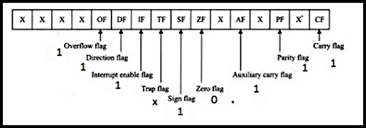

1. List the contents of the flag register according to the following figure after the computation of these following **signed** arithmetic operations: (avoid all the control flags)
2. **-4516 + 1616  (ii) -1C16 - 2A16** CO2/APPLY [10+10=20 marks]

The 8086 Microprocessor 8-55-29 PM_thumb_thumb.jpg

1. Suppose, DL contains **DCh**, CF=1 and CL contains 2. What are the values (in HEXA) of DL after the following instructions are executed? Also, mention the status of conditional flags for each case. CO2/ Apply [ 5+5=10 marks]
2. RCR DL, CL
3. SAL DL, CL
4. Suppose, we have the following values: **[5 x 4=20 marks] [CO2/APPLY]**

For registers,

**[DS] =2A0Eh [ES] = 23E0h [CS] = 41DBh [SS]= 38C6h**

**[BX] = E89Ah [SI] =25ADh**

**[DI] = 79ECh [BP]=3BA4h.**

Generate 20-bit physical address for the following commands and mention is it aligned or misaligned data transfer for each case.

1. **MOV CL, 1Eh [BX+SI]**
2. **MOV DX, 2Eh [BP]**
3. **MOV AX, CS: [BP] [SI] 11h**
4. **MOV [BX+DI], AX**
5. **MOV DX, SS: [BX] 1033h**
6. Mention the reasons of the following invalid commands: **[CO2/APPLY]**

[5x2 =10 marks]

1. **MOV AX, [ ]**
2. **MOV SS, DS**
3. **MOV EX, [BX]**
4. **MOV AX, 100**
5. **MOV [0902h], [BP]**