|  |  |  |
| --- | --- | --- |
| **East West University**  **Department of EEE**  **EEE 302: Microprocessors & Interfacing**  **Semester: Fall 2021**  **Course Instructor: FMA**  **Date: November 18, 2021**  **Section-1**  **Midterm-1** | |  | | --- | |  | |

**Time: 80 minutes Total Marks: 80**

Answer all the questions. Do not use notes, books and mobiles

1. Suppose, we have the following values: **[7 x 4=28 marks] [CO2/APPLY]**

For registers,

**[DS] =2A00h [ES] = 23B0h [CS] = 48D0h [SS]= 38C0h**

**[BX] = 089Ah [SI] =05ADh**

**[DI] = 09ECh [BP]=1BA4h.**

Generate 20-bit physical address for the following commands and mention is it aligned or misaligned data transfer for each case.

1. **MOV CL, 0Eh [BX+SI]**
2. **MOV DX, 32Eh [BP]**
3. **MOV AX, CS: [BP] [SI] 11h**
4. **MOV [BX+DI], AX**
5. **MOV DX, SS: [BX] 1033h**
6. **MOV AX, 342h [SI]**
7. **MOV DX, CS: [BP] 1Ah**
8. Mention the reasons of the following invalid commands: **[CO2/APPLY]**

[6x2 =12 marks]

1. **MOV AX, [CX]**
2. **MOV SS, DS**
3. **MOV EX, [BX]**
4. **MOV AX, 10000h**
5. **MOV ES**
6. **MOV [0902h], [BP]**
7. In the following diagram you have the architecture of Intel 8086 microprocessor. Briefly answer the following questions: **[CO1/UNDERSTAND]**

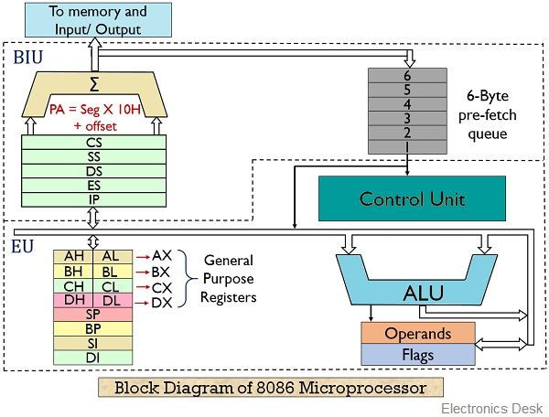

1. How many registers and other units are there inside Intel 8086? How are they aligned in two units? How the combination of two units enhances to total performance of the microprocessor?
2. Assume you have 3 consecutive commands prefetched by the BIU unit

* MOV AL, [BX]
* MOV SS, [0190h]
* MOV CL, 09h

How these commands will be pipelined by the BIU unit of Intel 8086 Microprocessor?

1. What is the function of control unit? Compare operand and opcode.
2. What is decoding means for Intel 8086 microprocessor? Explain the total process for a 4-bit microprocessor.

**[4x10 =40 marks]**