|  |  |  |
| --- | --- | --- |
| **East West University**  **Department of EEE**  **EEE 302: Microprocessors & Interfacing**  **Semester: Summer 2022**  **Course Instructor: FMA**  **Section-1 Midterm-1**  **Date: July 3, 2022** | |  | | --- | |  | |

**Time: 80 minutes Total Marks: 60**

Answer all the questions. Do not use notes, books, and mobiles

1. In the following diagram, you have the architecture of the Intel 8086 microprocessor. Briefly answer the following questions: **[CO1/UNDERSTAND]**

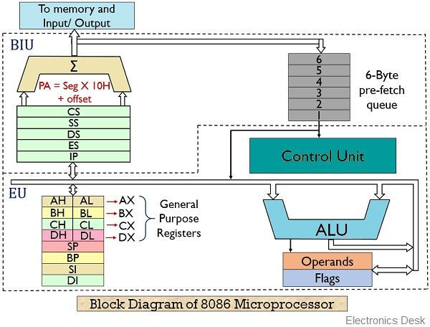

1. How many buses are there inside the architecture? Mention their working principle in terms of READ & WRITE operation.
2. How many registers are there inside Intel 8086? Why all the registers are 16 bits only? Mention the names also.
3. Assume you have 3 consecutive commands prefetched by the BIU unit

* MOV AL, [BP]
* MOV CL, [0190h]
* MOV DH, 1Ah

How these commands will be pipelined by the BIU unit of the Intel 8086 Microprocessor?

1. What is decoding means for Intel 8086 microprocessor? Explain the total process for a **2-bit** microprocessor. [4 x 10 =40 marks]
2. Suppose, we have the following values: [5 x 2=10 marks] **[CO2/APPLY]**

For registers,

**[DS] =AD00h [ES] = B3B0h [CS] = 28D0h [SS]= 88C0h [BX] = 189Ah**

**[SI] =35ADh [DI] = 4ECh [BP]=2BA4h.**

Generate 20-bit physical address for the following commands and mention is it aligned or misaligned data transfer for each case.

1. MOV DX, DEh [BP]
2. MOV AX, 3Eh [SI]
3. MOV DL, CS: [BP] [SI] 11h
4. MOV [BX], AX
5. MOV DX, SS: [BX+DI] 33h
6. Mention the reasons of the following invalid commands**: [CO2/APPLY]**

[5x2 =10 marks]

1. MOV AX, [BX+0190h+IP]
2. MOV CS, DS
3. MOV 0910h, [BX]
4. MOV AL, 1000h
5. MOV AX, [BX] [BP]