

**Medgate**

**Abstract:**

This document describes gives an overview on Medgate application, its technical architecture, interfaces and tools developed to support Medgate integration with Workday.

The Intended Audience of this document is Medgate application support analysts.

**Document Control Information**

**Document Reference:**

**Date:** **July 20, 2015**

**Approvals:**

|  |  |  |
| --- | --- | --- |
|  | **Name** | **Position** |
| **Author:** | Priyanka Cherukuri, Hari Kodaganti | Application consultants |
| **Reviewer (s):** |  |  |
| **Approver (s):** |  |  |

**Amendment Record:**

|  |  |  |  |
| --- | --- | --- | --- |
| **Issue Number** | **Date** | **By Whom** | **Pages Altered/Comments** |
|  |  |  |  |
|  |  |  |  |

**Document Distribution:**

| **Name** | **Department** |
| --- | --- |
|  |  |
|  |  |
|  |  |

**Referenced Documents:**

| **Document Name** | **Document Reference** | **Folder link** |
| --- | --- | --- |
|  |  |  |
|  |  |  |

**Table of Contents:**

1.0 Application Overview 4

**1.1 Introduction** 4

**1.2 Environments** 5

**1.2.1 Two Environment Landscape** 5

**1.2.2 Medgate Servers** 6

**1.2.3 Medgate Contact Details** 6

2.0 Medgate Infrastructure 7

**2.1 Application Architecture** 7

**2.2 Workday – Tibco – Medgate Integration** 8

**2.2.1 Medgate Employee Import Program** 8

**2.2.2 MEIP – Detailed Configuration Steps** 8

**1.** **Configuration steps for Pre-Production setup** 9

**2.** **Configuration steps for Production setup** 13

**3.** **Known Errors: (Resolved)** 15

**2.3 MEIP Log Watcher Tool** 16

**2.3.1 MEIP Log watcher tool Deployment Steps** 16

**2.4 Generic Accounts** 18

**2.5 Service accounts** 18

**2.6 Source Code Management** 18

3.0 Back Up & Disaster Recovery 19

4.0 Access to Client Software 19

**4.1 Security groups** 19

5.0 Job Monitoring 19

6.0 Additional information 20

**6.1 ServiceNow Information** 20

**6.2 Domain controller Information** 20

7.0 Accenture in scope 21

8.0 Vendor Information 21

Appendix 1: Document References 22

Related Documents 22

Document Dependencies 22

Appendix 2: Document Information 22

Document Attributes 22

Revision History 22

Document Approvals 22

# Application Overview

## **Introduction**

Medgate OHS&E is a software application designed for managing and reporting on occupational health including worker compensation for STD and LTD, Ergonomic Assessments, Audiometric Test results and Travel Vaccination and Vision history. As well, it guides in maintaining legislative compliance in these areas.

Medgate provides a common language to use in managing occupational health. Medgate as a core tool facilitates process development and manager participation in safety and health.

Medgate's Safety Suite is a powerful, intuitive, and flexible software solution that enables organizations to efficiently manage safety risks and compliance items and streamline safety programs.

Developed by Medgate’s own certified safety professionals with input from the customers, this suite supports a safety management system approach to safety and will help users manage incidents, pro-actively mitigate risks, satisfy compliance requirements, identify problem areas, and track performance.

Medgate’s advanced **Occupational Health Suite** will enable you to track medical trends, manage compliance and regulatory requirements, mitigate absences, and make informed decisions on how to improve employee health and productivity.

Developed by occupational health nurses, case managers, risk management experts, and physicians, Medgate’s integrated occupational health software offers the most intuitive and comprehensive functionality on the market. With over 25 years of experience and a client roster of fortune and global 500 companies and high-profile government organizations, Medgate is proud to lead the way in EHS data management.

**Key Benefits of Medgate’s Occupational Health Software**

With Medgate’s Occupational Health Software Suite, you can:

* Standardize employee health data management across multiple sites or countries
* Implement and/or streamline electronic medical recordkeeping, supporting accuracy and compliance of the medical record
* Measure and trend clinic utilization and employee health with robust reporting capabilities
* Easily visualize key indicators and priority activities with a personalized medical dashboard
* Increase clinic productivity with valuable features such as auto e-mail notifications, business rules, predictive text, interfaces with medical testing equipment, and more
* Submit orders and print off prescriptions, and access & print drug profiles and data sheets during the order process
* Gain one-stop access to an employee’s complete medical history via the [Medical Chart module](http://www.medgate.com/module/medical-chart-occupational-health/).

## **Environments**

Medgate Landscape at Talisman Energy consists of 2 environments. They are:

|  |  |  |
| --- | --- | --- |
| SR. No: | Environment | Description |
| 1. | User Acceptance Testing | The UAT environment is isolated from the development and customizing environment to provide a stable platform for conducting Integration, User Acceptance and Regression Testing on Maintenance enhancements and Regression Testing on Project enhancements prior to the migration of the changes to production. It is installed as a consolidation system and a delivery system and there are no changes allowed. |
| 2. | Production | Only production related tasks are performed in this environment. This environment will have tight security change management and processes tied to it. Only approved configuration data, programs and development objects are imported into this environment. Absolutely no configuration or development is allowed directly in this environment. The only changes made in this environment will be in the form of deployments that have originated in Development environment, and migrated to the UAT environment for testing. |

### **Two Environment Landscape**

As stated above, all changes in the environment originate in the Development environment and are deployed to the other environments. The following diagram shows a logical flow of changes through the environments. Medgate is available in UAT and Production environments only.

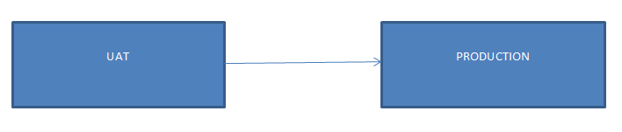

**Image**: Medgate -2 environment landscape

### **Medgate Servers**

Locally installed Medgate web servers have been made offline after Medgate GX2M version upgrade. The application is vendor-hosted.

### **Medgate Contact Details**

**Medgate business contacts:**

Demand IT: Davison, Diane ( [ddavison@repsol.com](mailto:ddavison@repsol.com))

Business Analyst: Desiree Dekuysscher ([ddekuysscher@repsol.com](mailto:ddekuysscher@repsol.com))

**IT Support team:**

Srisailam Varma Danalakota ([s.varma.danalakota@accenture.com](mailto:s.varma.danalakota@accenture.com) )

Priyanka Cherukuri ([Priyanka.cherukuri@accenture.com](mailto:Priyanka.cherukuri@accenture.com) )

Hari Kiran Kodaganti ([hari.kiran.kodaganti@accenture.com](mailto:hari.kiran.kodaganti@accenture.com) )

**Medgate vendor details:**

**Vendor name:** Medgate

**Support Contact mail-id:** [helpdesk@medgate.com](mailto:helpdesk@medgate.com)

# Medgate Infrastructure

## **Application Architecture**

Medgate architecture specification is illustrated below:

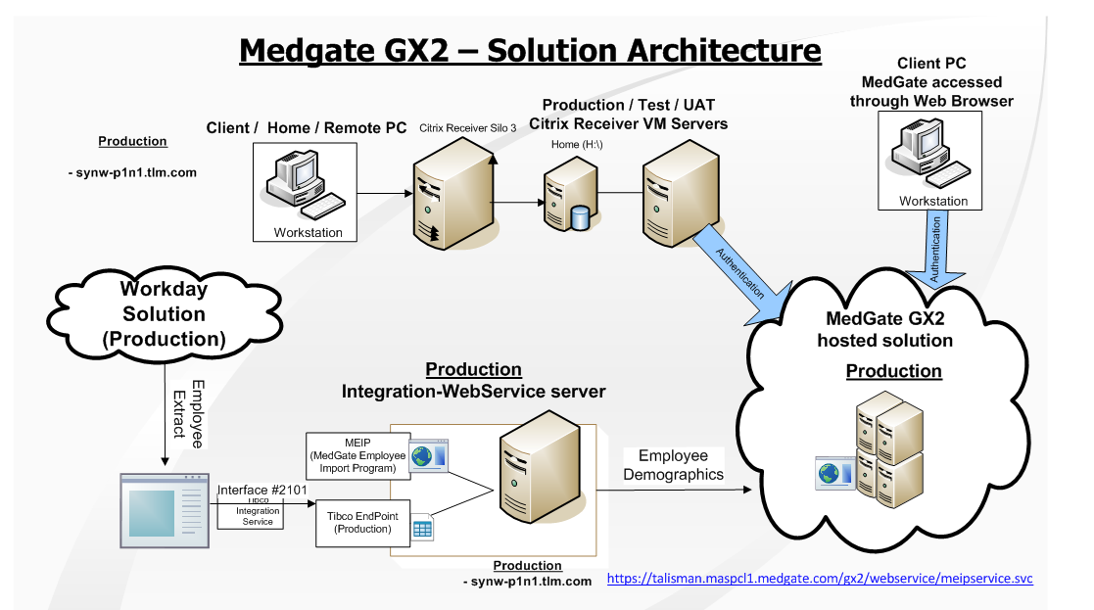

**Image**: Medgate GX2M version

## **Workday – Tibco – Medgate Integration**

### **Medgate Employee Import Program**

HSE integration (Workday –Tibco – Medgate) is implemented on the current Synergi servers as shown in above solution architecture diagram. Synergi servers are used as Tibco end points, where Tibco service (using tibco_proxy_svc account) drops an Employee Extract file in a specific folder on Synergi server.

This file is then picked up by the ‘Medgate Employee Import Program’, which consumes a Medgate web service (Vendor hosted) and imports all the employee data into Medgate.

Medgate Employee Import Program (MEIP) is configured to run every Monday at 2:00 am MT.

Solution architecture is available at the link below:

<http://sdn/Projects/Themes/Corp/MedGateUpgHost/Documents/7.%20Solution%20Design/Architecture/Medgate_future%20state%20solution%20architecture%20configuration.vsd>

**Production environment**: MEIP is configured to run using the service account CALGARY\ svc-medgate on Synergi production server synw-p1n1. It uses the web service:

<https://talisman.maspcl1.medgate.com/gx2/webservice/meipservice.svc>

**Test environment**: MEIP is configured to run using the service account CALGARY\ svc-medgatetst on Synergi UAT server synw-q1n1. It uses the web service:

<https://talisman.maspcl1.medgate.com/gx2test/webservice/meipservice.svc>

### **MEIP – Detailed Configuration Steps**

In the following section, all the configuration steps needed to achieve this integration are explained.

**Prerequisites/Dependencies**

1. Password for MedGate Service account (CALGARY\ SVC-Medgate) is available and tested.
2. SVC-Medgate should be added as the local admin for prod Synergi server (synw-p1n1)
3. SVC-Medgate should be added to Internet-Full ADSG
4. The required proxy settings are in place
5. Make sure the Employee Extract file (import file) is available.
6. MEIP setup file

1. **Configuration steps for Pre-Production setup**

**NOTE:** All the steps mentioned below are to be performed on Synergi Prod server (**SYNW-P1N1**)

1. Create a folder D:\MedGate\Interfaces
2. Share this folder as **‘**interface$’.

NOTE: Network path of this share would be \\SYNW-P1N1\interface$

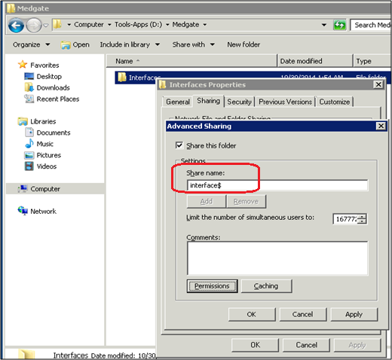

1. Provide Full Control only to the account calgary\Tibco_proxy_svcon the share mentioned above.

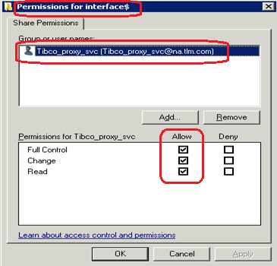

1. Provide Calgary\Tibco_proxy_svc and Calgary\svc-medgate full permissions on the folder D:\MedGate\Interfaces**.**

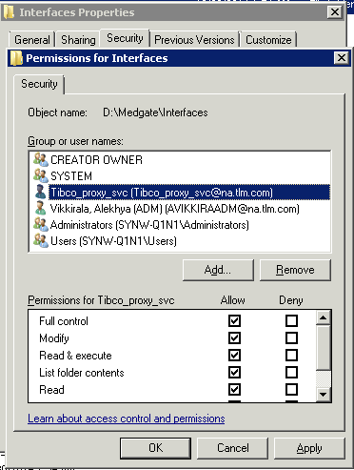 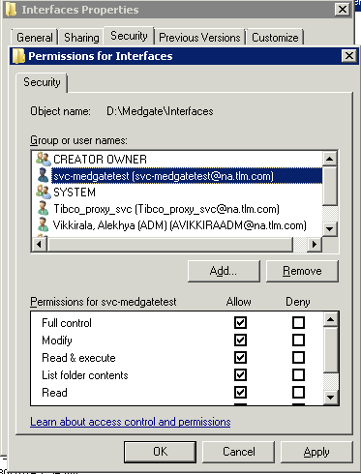

1. Install MEIP Program on the server as per the installation guide available at the following link.

<http://sdn/Projects/Themes/Corp/MedGateUpgHost/Documents/7.%20Solution%20Design/Solution%20Design/MedgateMEIPGuide_GX2.pdf>

**Note**:

* Login to server as CALGARY\ SVC-Medgate when installing the program.
* Run the setup as Administrator
* Installation path should be C:\Program Files(x86)\Medgate\Medgate Employee Import Program.

1. Once the installation is complete, provide Full permissions to the account Calgary\svc-medgateon the folder C:\Program Files(x86)\Medgate\Medgate Employee Import Program

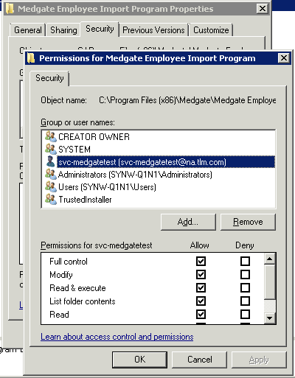

1. Copy the file ‘talisman.maspcl1.medgate.com.csv’ located at *d:\medgate\interfaces* on the server *synw-q1n1* to the location *d:\medgate\interfaces* on the server *synw-p1n1.*
2. Launch MEIP from Start menu. Enter the details as shown below and Click Save.

**Under Login Section:**

Username: Talisman_MEIP

Password: <PWD>

**Under Proxy section:**

Username: svc-medgate

Password: <PWD>

Domain: na.tlm.com

URL: <http://calproxy.na.tlm.com:8080>

**Final section (highlighted in the screenshot):**

URL: <https://talisman.maspcl1.medgate.com/gx2test/webservice/meipservice.svc>

Import File: D:\Medgate\Interfaces\talisman.maspcl1.medgate.com.csv

Check the boxes ‘Append to Log File’, ‘Update Existing Records’ and ‘Insert Non-Existent Base Tables’.

Set Batch Size value to ‘50’

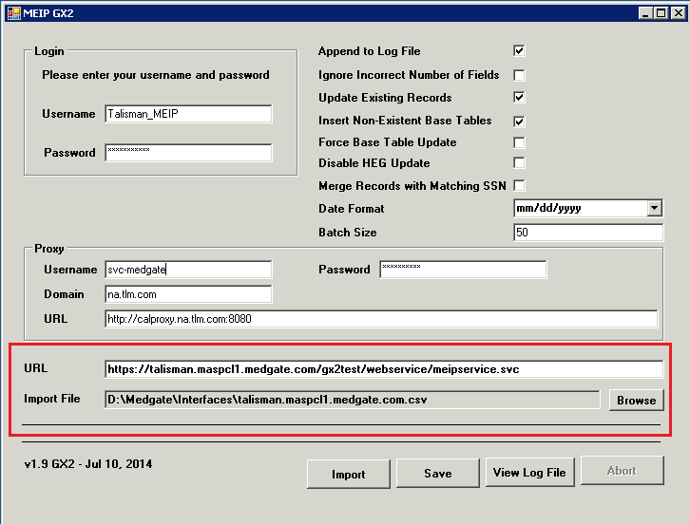

**Note**

* The Import file should be available at D:\Medgate\Interfaces\talisman.maspcl1.medgate.com.csv

1. Create a schedule task and name it as ‘Medgate Employee Import Program’. This task will execute MEIP program in silent mode.

* Browse for the Medgate.NMedgate.MEIPWindowsClient.exe available at C:\Program Files (x86)\Medgate\Medgate Employee Import Program\.
* Add an argument – ‘/s’ for silent execution of the program.

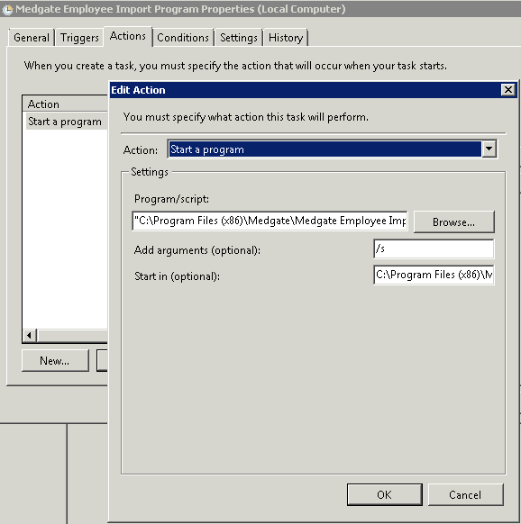

* No schedule is required.
* Disable the task once created.

1. **Configuration steps for Production setup**

Below steps are to be performed upon receiving the pre-production signoff from Demand by submitting necessary change request.

1. Login to the Production server SYNW-P1N1 as ‘CALGARY\SVC-MEDGATE’
2. Launch MEIP from Start menu.
3. Change the Medgate GX2 Test URL to Medgate GX2 Production URL : <https://talisman.maspcl1.medgate.com/gx2/webservice/meipservice.svc>
4. Click Save

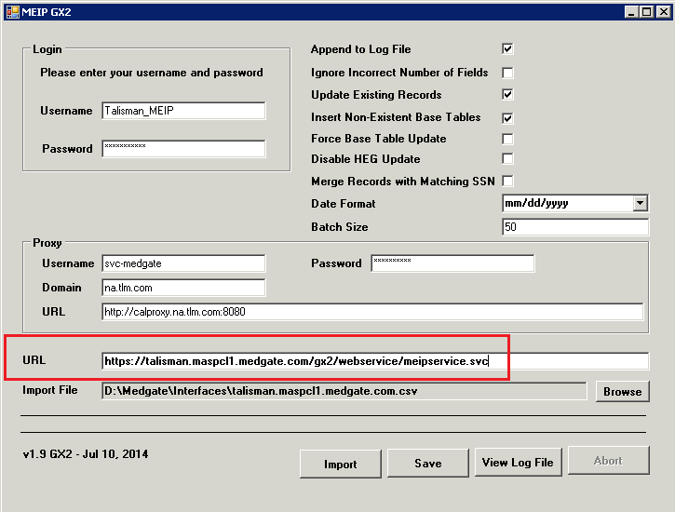

1. Edit the schedule task ‘Medgate Employee Import Program’ and schedule it to run at 2 AM every Monday starting from Dec 8th.

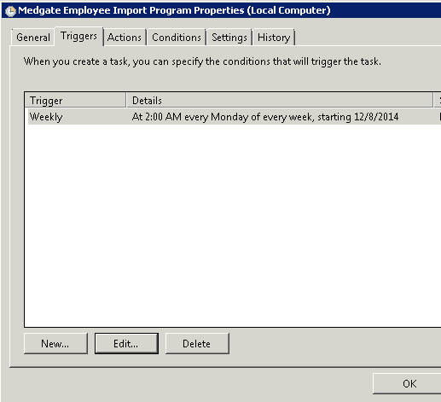

1. **Known Errors (Resolved)**
2. If Medgate service account does not have required permissions on the server, following error comes up when trying to save MEIP settings.

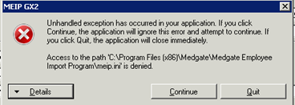

1. If batch size property is not mentioned when saving the settings of MEIP, then the following error comes up when trying to import the file.

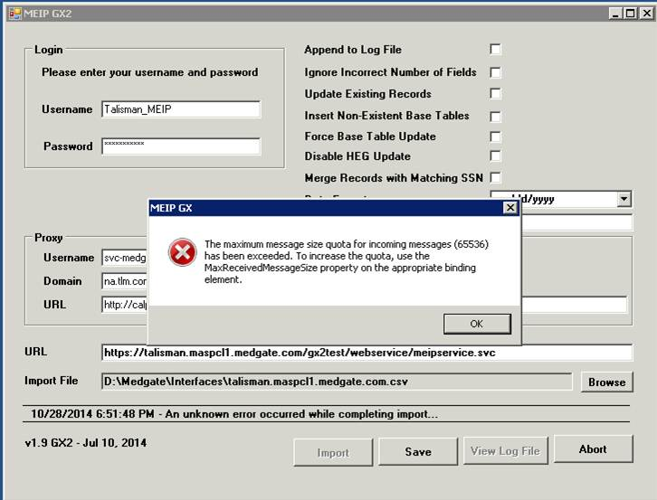

1. If Service account password is setup incorrectly under proxy settings, following error will occur when MEIP is invoked.

## **MEIP Log Watcher Tool**

MEIP Log watcher tool developed by Accenture is scheduled to run every Monday at 2:30 am MT after MEIP program runs on Synergi server. MEIP Log watcher is used to send a notification email on the success-failure status of MEIP.

### **MEIP Log watcher tool Deployment Steps**

#### Prerequisites

1. Get the latest version of MEIP files (Complied promote) from Sourcegear Vault. These files would be available in the Medgate repository under $\Medgate GX2\MEIP Log Watcher\Compiled Promote

#### Steps to deploy the MEIP Log watcher program

1. The following folders need to be created and the Medgate Service account should be given full permissions on these folders.
2. D:\Medgate\Archived Log Files
3. D:\Medgate\Log Watcher

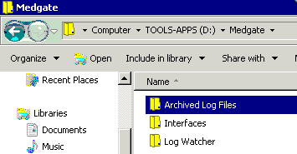

1. Copy the files ‘LogWatcher.exe’ and ‘LogWatcher.exe.config’ that were taken from the Medgate repository to the ‘Log Watcher’ folder.

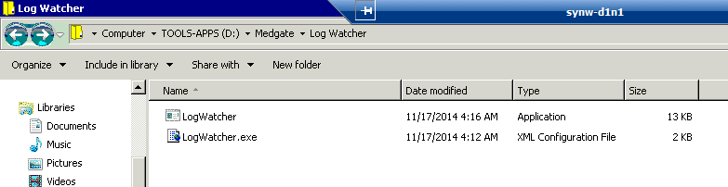

1. Success and Error folders need to be created within the Archive Log Files folder.

The Success folder contains log files that do not have any errors while the Error folder contains log files which have errors.

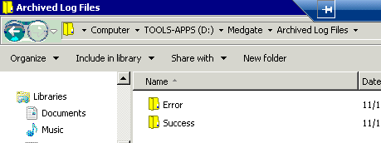

1. A scheduled task named ‘Medgate Log watcher’ should be created to run the ‘LogWatcher’ application from ‘D:\Medgate\Log Watcher’ folder.

This should be scheduled to run 30 minutes after the’ Medgate Employee Import Program’

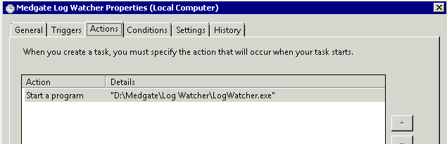

## **Generic Accounts**

Medgate GX2M application does not make use of any generic accounts.

## **Service accounts**

Medgate GX2M application does not make use of any service accounts.

## **Source Code Management**

Medgate is a vendor application and application source code is not maintained by support team. However, the source code for Medgate Log watcher tool that is used monitor Medgate integration interface is inbuilt and is maintained in SourceGear Vault under “**Medgate**” Repository.

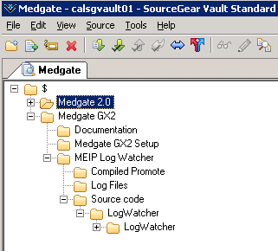

# Back Up & Disaster Recovery

Employee information is retrieved from Workday every Monday and exported to Medgate via Medgate Employee Import Program hosted on Synergi servers.

# Access to Client Software

Medgate GX2M application is vendor-hosted. Employee information is retrieved from Workday and exported to Medgate via Medgate Employee Import Program. MEIP Log watcher tool is used to monitor MEIP logs to ensure the interface is working fine.

## **Security groups**

Medgate web application (older version) is decommissioned. Medgate GX2M version is vendor-hosted and does not have dependency on security groups.

# Job Monitoring

Accenture team is responsible for monitoring the two scheduled tasks:

* Medgate Employee Import Program
* Medgate Log Watcher

Medgate Employee Import Program is scheduled to run at 2:00 AM MT every Monday that will pick up the employee file placed on synw-p1n1 server and import the data to Medgate.

Medgate Log watcher tool runs at 2:30 MT every Monday after the MEIP job completes, to read MEIP log file and send out email notifications indicating the success/failure status of MEIP job.

In case of errors in the notification log, Accenture would log a ticket with Service desk and work with infrastructure teams to troubleshoot the issue.

# Additional information

## **ServiceNow Information**

ServiceNow is used by business to maintain application, where users are able to created tickets for Support team to resolve reported issue. Change Request related to Bug fix or Enhancements are raised in ServiceNow tool and maintained.

|  |  |
| --- | --- |
| ServiceNow Classification | Medgate |
| ITSM Classification | Medgate |
| ServiceNow assignment group for incidents/change tasks | ASGN-CENRCorpLegalHSE-CACAL |
| ServiceNow assignment group for user access request | Not applicable. Medgate is vendor-hosted. Employee information is exported into Medgate from Workday through MEIP interface. |
| User access approval group | Not applicable. Medgate is vendor-hosted. Employee information is exported into Medgate from Workday through MEIP interface. |
| Change request approver group | APPR-ITCorporate-CACAL |

## **Domain controller Information**

There are no dedicated domain controller servers for Medgate. The application does not authenticate against Active directory.

# Accenture in scope

Medgate is a vendor based application and Accenture support analysts are not provided application access. User administration is not in Accenture scope.

Accenture scope of work includes supporting requests on infrastructure, interfaces, version upgrade testing activities, Medgate –Tibco - Workday integration (MEIP – Medgate Employee Import Program) and Log watcher tool.

# Vendor Information

Medgate is vendor supported and the vendor is MEDGATE. More information on Medgate application and Client support services can be found at [www.medgate.com](http://www.medgate.com)

Vendor can be contacted at [helpdesk@medgate.com](mailto:helpdesk@medgate.com).

1. Document References

Related Documents

This section lists documents that relate to this procedure or provide additional information.

| Document Name | Location/Link |
| --- | --- |
|  |  |

Document Dependencies

This section identifies other documents that have similar information and may require updating if changes are made to this document.

| Document Name | Dependency | Location/Link |
| --- | --- | --- |
|  |  |  |
|  |  |  |

1. Document Information

Document Attributes

| Attribute Type | Attribute Value |
| --- | --- |
| Document Owner | Priyanka Cherukuri |
| Review Frequency |  |
| Reviewers |  |

Revision History

| Revision | Revision Date | Revised By | Description |
| --- | --- | --- | --- |
| 2 | 7/7/2015 | Priyanka Cherukuri | Document template has been modified. Added information to sections 2.0, 3.0, 4.0 |
| 3 | 7/17/2015 | Priyanka Cherukuri | Removed reference links and updated content to section 2.0. |
| 4 | 1/21/2016 | Priyanka Cherukuri | Updated new Business Analyst name and email address in section 1.2.3. |

Document Approvals

| Name | Position/Role | Date | Signature |
| --- | --- | --- | --- |
|  |  |  |  |