Chapter 1 - use cases

Use case 1: Creating a new turing machine

* **Actor**: Member
* **Precondition**: Member in the system
* **Postcondition**: System creates the turing machine
* **Parameter**: python code
* **Actions**:

1. navigate to the turing machine creation section
2. Use the visual code editor to create the turing machine states, transitions and initial/final states
3. Create the turing machine with a unique identifier

|  |  |  |  |
| --- | --- | --- | --- |
| **Participants** | **Parameters** | **Expected Result** | **Scenario** |
| Member | username/id, code | Successfully created | Good |
| Member | empty string ,invalid code that does not compile | the system throws error message describing the error | Sad |
| Member | username/id, bad code | code with compilation error, message will be thrown | Bad |

Use case 2: Editing an Existing Turing machine

* **Actor**: Member
* **Precondition**: Created turing machine by the member
* **Postcondition**: Turing machine updated
* **Parameter**: code
* **Actions**:

1. Access the list of saved Turing machines
2. selected desired turing machine
3. user the visual code editor to make modifications
4. Save the changes

|  |  |  |  |
| --- | --- | --- | --- |
| **Participants** | **Parameters** | **Expected Result** | **Scenario** |
| Member | valid code | update turing machine code successfully and saved data | Good |
| Member | malicious code | the system detects the attack , and prevents it using several techniques like honey pot.. | Bad |
| Member | invalid code that does not compile | error message that describes the error and the lines where the compile error occurred and turing machine is not saved | sad |

case case 3: Saving a Turing machine

* **Actor**: member
* **Precondition**: Turing machine created
* **Postcondition**: system save the turing machine
* **Parameter**: user_id, code , id / name of the turing machine
* **Actions**:

1. Complete the creation or modification of a turing machine
2. choose to save the turing machine
3. provide a name or identifier for the saved turing machine
4. confirm save action

|  |  |  |  |
| --- | --- | --- | --- |
| **Participants** | **Parameters** | **Expected Result** | **Scenario** |
| Member | code of turing machine and distinct id | turing machine code is saved | good |
| Member | code of turing machine and already used id or name | system throws a message describing the problem and how to solve | sad |
| Member | malicious code | system detect malicious code inputs and  member is blocked from further usage of the system  relevant message will be thrown | Bad |

Use case 4: Running a Test on a turing machine

* **Actor**: member
* **Precondition**: Turing machine created
* **Postcondition**: system simulate the test’s input on the turing machine
* **Parameter**: test input(string)
* **Actions**:

1. Open the test execution interface
2. input a test case for the selected turing machine
3. initiate the simulation
4. view the step-by-step execution and final result

|  |  |  |  |
| --- | --- | --- | --- |
| **Participants** | **Parameters** | **Expected Result** | **Scenario** |
| Member | test input | the system runs the test and displays results | good |
| Member | test input , but the test makes infinite loop | the system runs the test, but after defined time it will throw error timeout and suggests common mistakes that may has occurred | sad |
| Member | test input not in the turing machine (abc / letters) | error message will be thrown | bad |

Use case 5: Running multiple Tests

* **Actor**: member
* **Precondition**: Turing machine created
* **Postcondition**: system simulate the tests on the turing machine
* **Parameter**: tests list
* **Actions**:

1. Select a turing machine for testing
2. input a set of test cases
3. initiate the tests
4. review the results for each test case

|  |  |  |  |
| --- | --- | --- | --- |
| **Participants** | **Parameters** | **Expected Result** | **Scenario** |
| Member | tests as lists | the system runs the tests and displays results | good |
| Member | tests as list , but at least one test makes infinite loop | the system runs the tests, but after defined time it will throw error timeout and suggests common mistakes that may has occurred | sad |
| Member | invalid tests input(contains letters not recognized by the turing machine) | error message will be thrown | bad |

Use case 8: Retrieving a saved turing machine

* **Actor**: member
* **Precondition**: Turing machine created and saved
* **Postcondition**: system retrieves turing machine
* **Parameter**: turing machine id/name
* **Actions**:

1. member enters turing machine saved list tab
2. select previously saved turing machine
3. system provide the user the relevant turing machine

|  |  |  |  |
| --- | --- | --- | --- |
| **Participants** | **Parameters** | **Expected Result** | **Scenario** |
| Member | valid saved turing machine id/name | the system provide the user the turing machine code | good |
| Member | invalid saved turing machine id/name | error message will be thrown | sad |
| Member | valid saved turing machine id/name | database connection failed, error message will be thrown | bad |

Use case 9: Viewing animated model

* **Actor**: member
* **Precondition**: valid turing machine
* **Postcondition**: animation and visualization of the turing machine
* **Parameter**: turing machine id ,word , tape , operator , r/ w head
* **Actions**:

1. member access desired turing machine
2. member provides which word to run on the machine
3. the system will display the animation of the machine running the word

|  |  |  |  |
| --- | --- | --- | --- |
| **Participants** | **Parameters** | **Expected Result** | **Scenario** |
| Member | word and id of turing machine | the system displays the animation of the machine while running the word | good |
| Member | invalid turing machine id | error message will be thrown | bad |
| Member | invalid word input(contains letters not recognized by the turing machine) | error message will be thrown | sad |

Use case 10: Deleting a turing machine

* **Actor**: member
* **Precondition**: Turing machine created and saved
* **Postcondition**: system delete the saved turing machine
* **Parameter**: user_id, id / name of the turing machine
* **Actions**:

1. user creates and saves new turing machine or accessing existing turing machine
2. user selects to delete the turing machine
3. system deletes the turing machine

|  |  |  |  |
| --- | --- | --- | --- |
| **Participants** | **Parameters** | **Expected Result** | **Scenario** |
| Member | valid turing machine id/name | turing machine code is saved | good |
| Member | invalid turing machine id/name | relevant error message will be thrown | Bad |

Use case 11: User Logout

* **Actor**: User
* **Precondition**: User registered to the system before and is currently logged in
* **Postcondition**: user logged out of the system
* **Parameter**: event logout button clicked
* **Actions**:

1. user is currently logged in
2. user selects to log out
3. system successfully logs out the user

|  |  |  |  |
| --- | --- | --- | --- |
| **Participants** | **Parameters** | **Expected Result** | **Scenario** |
| User | logout click event  and user is currently logged in | Successfully logged in to the system | Good |
| User | logout click event and user currently not logged in | relevant error message will be thrown | sad |
| User | logout click event  and user is currently logged in | system failed to update database, relevant message will be thrown | Bad |

Use case 12: User edits Account settings

* **Actor**: user
* **Precondition**: valid user
* **Postcondition**: edited account settings
* **Parameter**: user email address, password, name
* **Actions**:

1. user navigate to the account sittings
2. user updated the desired information ( email, password etc.)
3. system saves the changes

|  |  |  |  |
| --- | --- | --- | --- |
| **Participants** | **Parameters** | **Expected Result** | **Scenario** |
| Member | valid email address / password / name etc.. | the system saves the new information and updates the database | good |
| Member | invalid email address ,empty strings , illegal passwords that are easy to guess | error message will be thrown | sad |
| Member | malicious code | the system detects the attack , and prevents it using several techniques like honey pot.. | Bad |

Use case 13: Language Selection

* **Actor**: User
* **Precondition**: User enters the home page (index.html)
* **Postcondition**: website language changed
* **Parameter**: desired language
* **Actions**:

1. user select language tab
2. user selects new language (english / hebrew)
3. system successfully change the website language

|  |  |  |  |
| --- | --- | --- | --- |
| **Participants** | **Parameters** | **Expected Result** | **Scenario** |
| User | english / hebrew | Successfully changed language | Good |
| User | not valid language (not in the list we implemented) | system failed to change language, language do not change, relevant error message will be thrown | Bad |

Use case 14: Reviewing Test Results History

* **Actor**: member
* **Precondition**: Turing machine tests simulated before
* **Postcondition**: user review previous tests results
* **Parameter**: turing machine id/name
* **Actions**:

1. select a turing machine
2. access the result history section
3. review the detailed results of past test cases

|  |  |  |  |
| --- | --- | --- | --- |
| **Participants** | **Parameters** | **Expected Result** | **Scenario** |
| Member | valid turing machine id/name | the system shows all previous test cases results | good |
| Member | valid turing machine id/name  but no tests has been simulated before or implemented | the system shows all previous test cases results | sad |
| Member | invalid turing machine id/name | error message will be thrown | bad |

use case 15: System Administrator Monitoring

* **Actor**: User
* **Precondition**: user is administrator
* **Postcondition**: admin monitors system performance, and user activity and overall health of the system
* **Parameter**: desired dates activity
* **Actions**:

1. user logs in and identifies as administrator
2. admin access special tab, that is only visible to the admin
3. selecting the desired date to view

|  |  |  |  |
| --- | --- | --- | --- |
| **Participants** | **Parameters** | **Expected Result** | **Scenario** |
| admin | valid dates activity | the system displays the report | good |
| admin | invalid dates activity | error message will be thrown | sad |
| admin | malicious code | the system detects the attack , and blocks it. | Bad |

Chapter 2 - System Architecture

our system will include a server and client, the server will be implemented using react and the client will be implemented using javascript, the server mainly has 2 purposes:

1. to display the functionality and of the system interactively
2. receive data from client , process it and display results, the data will be as strings or python code, in case of python code we will use a package called pyodide, which knows how to convert python code to javascript , and gives it to the business layer to continue the process.

the client will include http client and maybe business logic and state,

the server (which represents the frontend - presentation layer) will include

the react component which interacts with the browser UI, and flows data to the business layer below which includes the core which runs on restricted runtime , and auth which is responsible for registering and signing in users , using created username and password or google , twitter , yahoo… , and below the business layer will be the persistence layer , which will be implemented as an ORM.

we added a picture to illustrate the architecture.

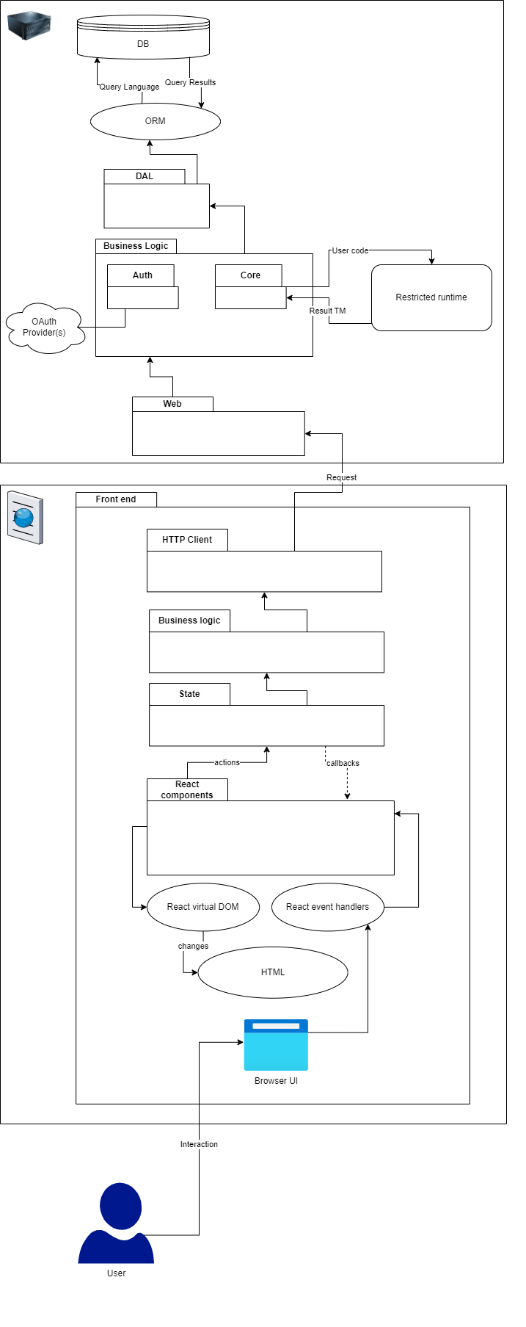

Chapter 3 - Data Model

3.1 Description of Data Objects

our system will include many entities:

1. **turing machine**, which is our main entity

attributes:

ID, name , author , creation_date , code.

the main attributes are ID which identifies this object from other turing machine objects , and the code in javascript version , which was converted to javascript from python using pyodide , and it was provided by the user , the code represents the turing machine, using this code we will test the correctness of the turing machine.

1. **challenge**, it is an entity the represents the challenges that are created by the lecturers

attributes:

ID, name , creator , creation_date , challenge_description, expiry_date , list_of_legall_words (for testing), list_of_illegal_words (for testing).

the main attributes are ID which identifies this object from other challenges objects , challenge_description will be a string and it describes the turing machine that is challenging to create, list_of_legall_words which are words in the language of the intended turning machine , and list_of_illegal_words which are words not in the language of the intended turning machine, these words will be used as tests to check the correctness of the turing machines which are provided by the users.

1. **user**, it represents the user in the system

attributes:

ID, name , register_date, role (student / lecturer / admin), password (hashed for security reasons) .

the main attribute is ID which identifies this object from other user objects, the role attribute might be implemented as state design pattern.