**C Programming Revise Schedule**

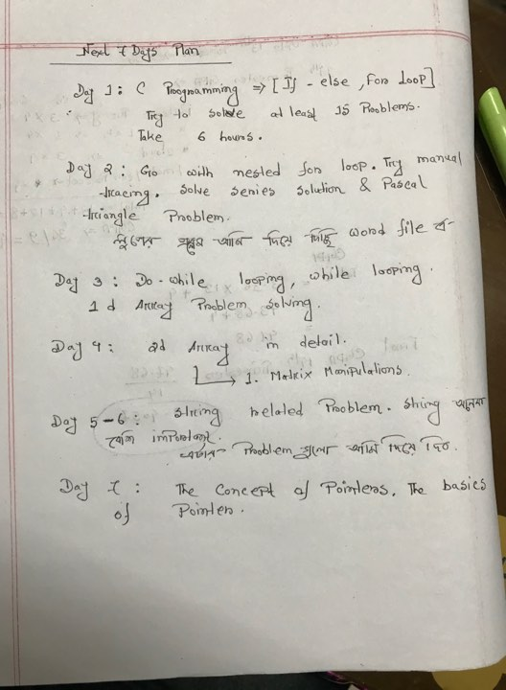

**Day-01**

**Problem Type=> Basics & If-else**

1.

Program that will use newline/tab and print the following segment:

|  |  |
| --- | --- |
| **Sample input** | **Sample output** |
|  | Hello World.  This is my first program. C is fun. |
|  |  |

2.

Program that will receive the values of an integer, a floating point number, a character from the keyboard and print those values.

|  |  |
| --- | --- |
| **Sample input** | **Sample output** |
| 5  3.141593  A | The integer value: 5  The floating point value: 3.141593  The character value: a |
| 100 1.618 z | The integer value: 100  The floating point value: 1.618000  The character value: z |

3.

Program that will take three integer numbers from keyboard but assign only the first and last inputs to variables and skip any assignment of the middle one.

|  |  |
| --- | --- |
| **Sample input** | **Sample output** |
| 20 50 100 | First Value = 20, Last Value = 100 |
| 33 75 22 | First Value = 33, Last Value = 22 |

4.

Program that will define a constant using “CONST” and print the value.

|  |  |
| --- | --- |
| **Sample input** | **Sample output** |
|  | The value of pi: 3.14 |
|  | The value of golden ratio: 1.62 |

5.

Program that will define a global and a local variable with the same name but with different values, and then do the following steps in order-

1. Print the value of the variable before defining the local variable
2. Print the value of the variable after defining the local variable
3. Explicitly print the value of the variable as global

|  |  |
| --- | --- |
| **Sample input** | **Sample output** |
|  | 1. Global: 10 2. Local: 20 3. Global: 10 |

6.

|  |  |  |  |  |
| --- | --- | --- | --- | --- |
| Program that will take an floating point number as input from the keyboard and use *printf* function to perform the followings:   1. Print the number right justified within 10 columns 2. Print the number to be right justified to 2 columns (Assuming the input has more than 2 digits) 3. Print the number rounded to two decimal places 4. Print the number rounded to integer (without using conversion or type casting) 5. Prints the number in exponential notation/scientific notation  |  |  | | --- | --- | | **Sample input** | **Sample output** | | 123.098 | (a) Val:123.098000  (b) Val:123.098000  (c) Val:123.10  (d) Val:123  (e) Val:1.230980e+02 | |

7.

Program that will take **a**, **b** & **c** as inputs and decide if the statements are True (1) of False (0)

$\left(a+b\right)≤80 \&\& c≥0$

$\left(a-b\right)==0 \left| \right| c!=0$

$a!=b \left| \right| !\left(b<c\right) \&\& c>0$

$\left(a!=b | | !\left(b<c\right) \right) \&\& c>0$

|  |  |
| --- | --- |
| **Sample input (a, b, c)** | **Sample output** |
| 10 -10 0 | 1. 0 2. 1 3. 1 4. 0 |

8.

Program that will take calculate the roots of a quadratic equation (a.x**2** + b.x + c = 0) from the formula, (here, dot (.) stands for multiplication) -

$$root=\frac{-b ±sqrt\left(b^{2}-4.a.c\right) }{2.a}$$

|  |  |
| --- | --- |
| **Sample input (a, b, c)** | **Sample output** |
| 2 4 -16 | 2.00 -4.00 |
| 1 2 3 | Imaginary |

9.

Program that will evaluate the equation

$$2\cos^{2}x- \sqrt{3}\sin{x+log\frac{x}{2}}$$

; where 1<= x <=180 [No checking needed]

|  |  |
| --- | --- |
| **Sample input (x)** | **Sample output** |
| 30 | 1.810066 |
| 120 | 0.778151 |
| 180 | 3.954243 |

10.

Program to find size of int, float, double and char of the system.

|  |  |
| --- | --- |
| **Sample input** | **Sample output** |
|  | Size of int in byte(s) = 4  Size of float in byte(s) = 4  Size of double in byte(s) = 8  Size of char in byte(s) = 1 |

**Problem Type=> For Looping**

11.

Write a program that will print “Coding is fun” 10 times, using a for loop.

12.

Write a program that will find the sum of n numbers. Example, n= 10.

13.

Write a program to reverse a given number. Use for loop!!

|  |  |
| --- | --- |
| **Sample input** | **Sample output** |
| Input a number:  *546* | In reverse:  *645* |
| Input a number:  *3180* | In reverse:  *813* |