**CSE 487 Cloud Computing Project Report**

**Summer 2019**



**Nopa Islam**

**Student Id : 011 151 062**

**Section: A**

**Sukannya Saha**

**Student Id : 011 151 079**

**Section: A**

**Nasir Uddin Ahmed**

**Student Id : 011 151 086**

**Section: A**

United International University

Dhaka, Bangladesh

August, 2019

Abstract

The report is written based on the project outcome of “Cloud Computing” course offered in United International University Summer 2019. The project name is “Online Shopping”. Basically an e-commerce web application. The main aim of this project is to develop an in-house developed project. Deploying the project in cloud platform. Following the goal of Platform as a Service, we have deployed the project in “Microsoft Azure Platform”. A virtual machine is set up using SSH(Secured Shell) for remote login in Microsoft Azure. The project has a mysql database which runs on a LAMP(Linux, Apache, Mysql, Php) server. By using public IP and project folder extension, anyone can access the project from internet.

Table of Contents

LIST OF TABLES vi

LIST OF FIGURES vii

1. Introduction 1
2. SRS 2

2.1 Purpose 2

2.2 Scope 3

2.3 System Overview 3

2.4 References 3

2.5 Functional Requirements………………………………………………………...3

2.6 Non Functional Requirements……………………………………………………3

2.7 Software…………………………………………………………………………4

2.8 Diagrams…………………………………………………………………………5

1. Deployment 6
2. Conclusion 7
3. References 7

## LIST OF TABLES

## LIST OF FIGURES

Figure 1 : Context Diagram………………………………………………………………4

Figure 2 : Activity Diagram………………………………………………………………5

Figure 3 : Dataflow Diagram……………………………………………………………..5

Figure 4 : Use case Diagram……………………………………………………………...6

Figure 5 : Use case Diagram………………………………………………………………6

Figure 6 : ER Diagram…………………………………………………………………….7

Figure 7 : System Overview………………………………………………………………8

Figure 8 : Public Key Authentication…………………………………………………….8

Chapter 1

# Introduction

Our project title is online shopping. It’s a sort of e-commerce application. But we are doing the project in cloud environment. This are the features of our project.

A user can have an account. Which can be considered as user profile. User can log in to his/her account by email & password. A new user can register him/her self. Products are maintained by category selection. Example: men, women, electrical etc. Wishlist is a features where a user can pin his/her favorite products. Merchant commission is a features by which a merchant seller can get to know about the amount of sales and his profit. User cart shows the products that are finally been bought. Shipping is the process of sending the product to the customer. It requires customer’s address. Payments can be done by card. Search option would work to help users to filter their choices.

For our project we found this two scopes. Number one electronic data interchange. Electronic Data Interchange (EDI) is the electronic interchange of business information using a standardized format; a process which allows one company to send information to another company electronically rather than with paper. Business entities conducting business electronically are called trading partners.

Chapter 2

# SRS

**2.1 Purpose**

The purpose of this document is to serve as a guide to designers, developers, and

testers who are responsible for the engineering of the **“Online Shopping”** project. It should

give the engineers all of the information necessary to design, develop, and test the software.

**2.2 Scope**

This document contains a complete description of the functionality of the **“Online Shopping”** project. It consists of use cases, functional requirements, and nonfunctional requirements, which, taken together, form a complete description of the software.

The purpose of **“Online Shopping”** is to ease online based product shopping. The system is based on a relational database. Above all, we hope to provide a comfortable user experience along with the best pricing available.

**2.3 System Overview**

The project has the following features

a. User Account [Log in / Sign Up]

b. Admin Account

c. Product Information

d. Cart

e. Shipping details

f. Merchant Commission

g. Virtual Payment

In short the projects vision is for today’s share economy business remodeling. The fundamental principle of such solution is to enable aggregation on demand from customers online.

**2.4 References**

SRS IEEE Format: <https://web.cs.dal.ca/~hawkey/3130/srs_template-ieee.doc>

SSL Commerz Documentation : <https://developer.sslcommerz.com/doc/v4/>

**2.5 Functional Requirements**

a. Server : Linux Based Server (Ubuntu 18.04 LTS)

b. Frontend : HTML/CSS, Java Script

c. Backend : Php

d. Database : Mysql

e. Platform : Microsoft Azure Student Portal

f. Authentication type : SSH encryption

g. Subscription : Student account

h. RAM : 8 GB

i. Virtual core : 2

j. Temporary storage : 16 GB

**2.6 Nonfunctional Requirements**

* **Security** – It is important to specify the level of security.
* **Privacy** – Meeting basic requirements for GDPR.
* **Scalability and performance** – Ensuring that the system can scale to meet expected traffic and order volume at normal and peak times.
* **Speed of key user journeys** – Defining how long each step with key user journeys will take.
* **Speed of web services** – Defining how long web services will take to provide a response.
* **Accessibility** – Ensuring that the platform meets the basic accessibility standards throughout.
* **Documentation** – Ensuring that the platform is sufficiently documented.
* **Quality** – Even the best e-commerce platforms can be used badly so you should insist that code is developed to a good quality standard.
* **Extensibility** – Ensuring that the platform is extended in such a way to make future development feasible.
* **Data integrity and retention** – Defining how long data should be stored and how the integrity of data is maintained.
* **Testing** – Defining how unit testing will be built into the solution.
* **Compatibility** – Ensuring that the platform can be easily integrated with 3rd party systems.
* **Search** – Defining how quickly the system will return search results.
* **Availability** – Defining the agreed uptime of the platform under normal conditions.
* **Infrastructure** – Defining the infrastructure performance thresholds (CPU and memory usage).

**2.7 Software**

* 1. Notepad++
  2. FileZilla Client
  3. Xampp

**2.8 Diagrams**

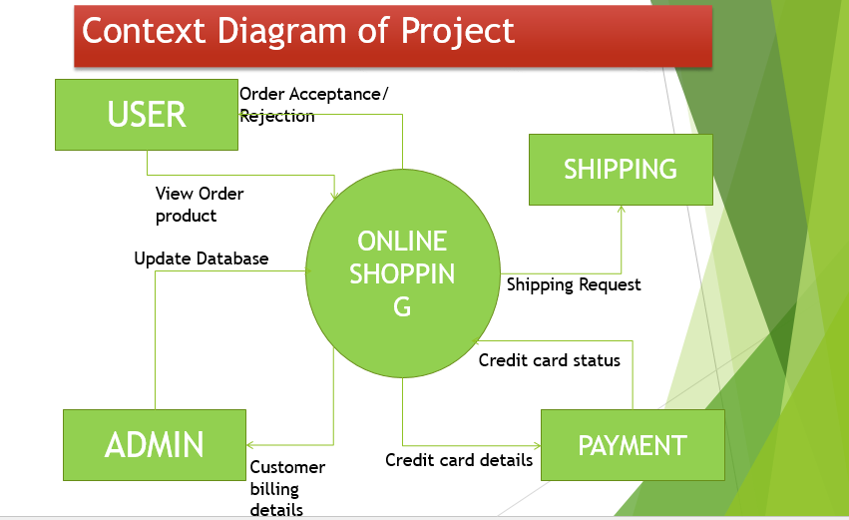

Figure 1 : Context Diagram

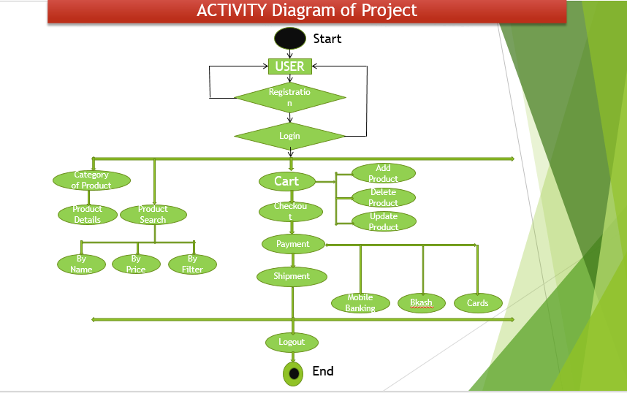

Figure 2 : Activity Diagram

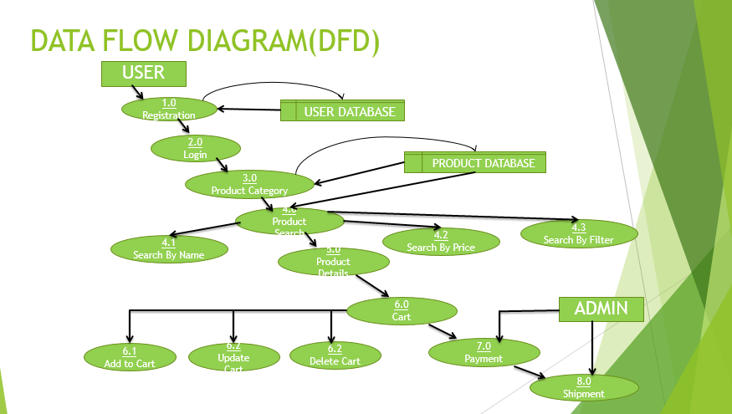

Figure 3 : Dataflow Diagram

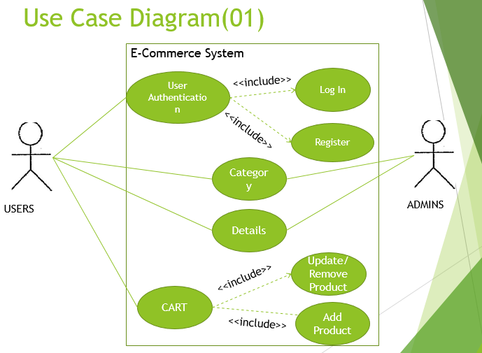

Figure 4 : Use case Diagram

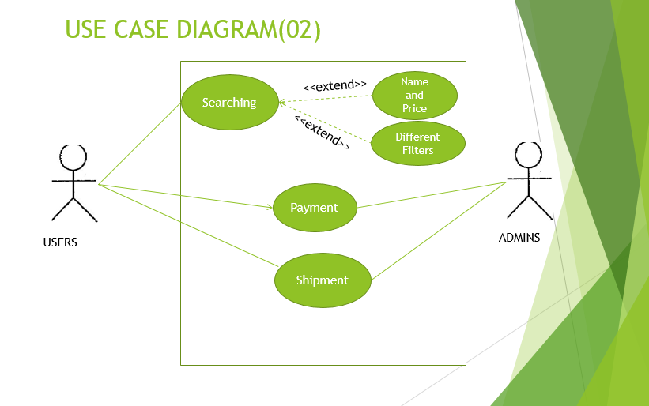

Figure 5 : Use case Diagram

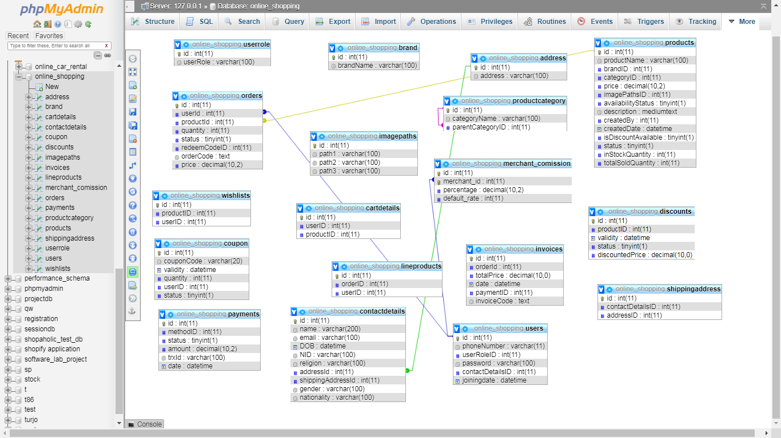

Figure 6 : ER Diagram

Chapter 3

# Deployment

1. Overview Of The System In Cloud :

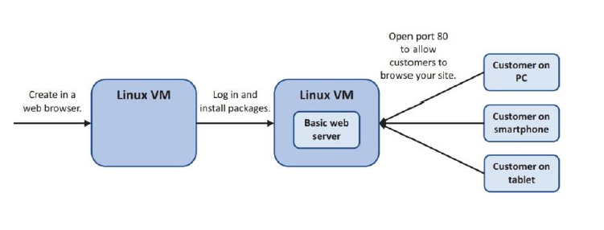 Figure 7 : System Overview

Creating a virtual machine inside Azure portal via a resource group. Later installing LAMP server. Then opening port 80 from azure bash shell.

1. Public Key Authentication :

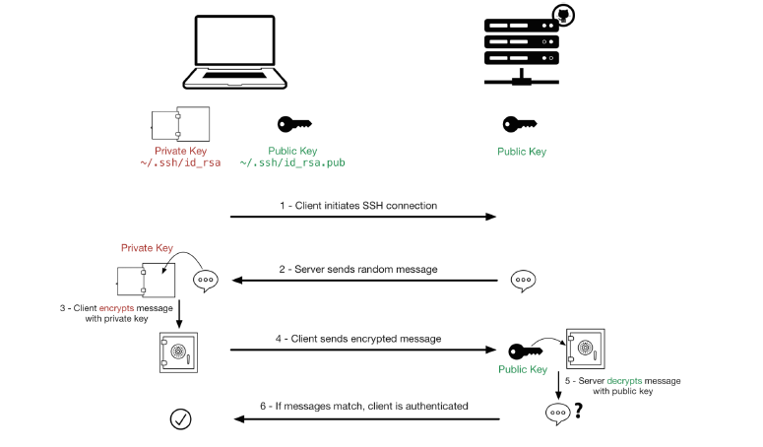

Figure 8 : Public Key Authentication

Public key authentication is a way of logging into an SSH/SFTP account using a cryptographic key rather than a password.

If you use very strong SSH/SFTP passwords, your accounts are already safe from brute force attacks. However, using public key authentication provides many benefits when working with multiple developers.

1. Commands :

Web Server Setting Command : sudo apt-get update && sudo apt install –y lamp-server^

Port Open Command : az vm open-port --resource-group myResourceGroup --name myVM --port 80

Phpmyadmin Install Command : sudo apt-get install phpmyadmin –y

Privilege Command : sudo mysql –p –q root;

User Creation Command In Database : CREATE USER ‘username’@’%’ IDENTIFIED BY ‘password’;

User Privilege Command : GRANT ALL PRIVILEGES ON *.* TO ‘username’@’%’ WITH GRANT OPTION;

1. FileZilla : Using FileZilla client, uploading the project file. From terminal,

sudo mv /home/user_name/project_folder_name var/www/html

this command moves the project file into html directory.

By using public IP/Directory_Name the project can be accessed.

1. API Used In Project : SSL Commerz Sandbox testing environment API.

Chapter 4

# Conclusion

There are many reasons building a website requires that we obtain the right tools and resources.

Standardization is one factor. When we use the right tools, we are assured that our pages would be standard and acceptable to every visitor.

By using standard resources and tools, our visitors are able to view our web pages no matter what browser they use. Our pages would load faster and we would also be able to maintain the pages we have created with ease.

Using the right resources for our web design jobs will make our websites contemporary. They can easily integrate into current technologies and software. Our users would derive added value from our websites and contribute to its growth.

# References

1. <https://azure.microsoft.com/en-us/features/azure-portal/>
2. <https://developer.sslcommerz.com/doc/v4/>
3. <https://www.javatpoint.com/virtualization-in-cloud-computing>
4. <https://www.educba.com/cloud-computing-vs-virtualization/>