Zach Turk

Caleb Stanley

1. attack text re-assigned from method extension in all subclasses to a field in the constructor. Attack text is now called in the normal attack method in DungeonCharacter.

Offending code:

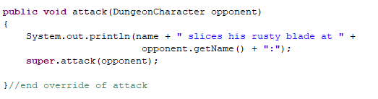

2. Monster subclasses Gremlin(), Ogre(), Skeleton() refactored into single class for cohesion. Previously, the monster subclasses Skeleton, Gremlin, and Ogre, only served to override the attack method with one single different part of the string.

Offending code:

3. Monster factory created to replace switch statement in Dungeon.java

4. Special Attack in hero classes moved to Special Attack interface with three inheriting classes: Heal(), SurpriseAttack(), and CrushingBlow(). Every hero class now has a special attack instance as a field.

Offending code (example):

5. BattleChoices class moved up to hero class which implements the attack and special attack fields.

6. Hero classes Theif(), Warrior(), Sorceress() refactored into a single class Hero() with attack override resolved to a field called AttackRattle, just like the monster class, as the hero subclasses no longer serve to override anything.

Offending code:

7. HeroFactory() class created to replace switch method to generate switch case hero character in Dungeon.java.

Offending code:

8. useless field in choosehero removed, which was unused.

Offending code: (example)



9. fields refactored in Monster, Hero, and DungeonCharacter to private, getters and setters instead used.

Offending code: (example)

