JUBAIL INDUSTRIAL COLLEGE
Department of Computer and Information Technology
Graduation Project Final Report
Project Title: MyStudies (Smart Academic Organizer)
Semester: 471
Section: 3
Students Names & IDs:
- Asim Alzahrani — 421900453
- Mustafa Al Qattan — 441101247
- Majed Almutairi — 431900118
- Abdulaziz Alghamdi — 421901508
- Turki Alshaikh — 422100018
Supervisor Name: Mohhamed Yassine El Amrani
Date: 12, 2025

2. TABLE OF CONTENTS
1.TITLE PAGE 1
2. TABLE OF CONTENTS 2
3. INTRODUCTION 4
4. SOFTWARE REQUIREMENTS SPECIFICATION 5
4.1 User Requirements (User Stories) 5
4.2 Functional Requirements 5
4.3 Non-Functional Requirements 6
5. SOFTWARE DESIGN 7
5.1 System Architecture 7
5.2 Behavioral Design 7
5.3 Static Structure and Data Model 9
5.4 User Interface Design 11
6. SOFTWARE IMPLEMENTATION 12
6.1 Development Approach 12
6.2 Process Used During SRS & Design Development 12
6.3 Hardware, Software, and Network Environment 12
6.4 Verification and Validation (Testing) 12
7. CONCLUSION 13
7.1 System Status 13
7.2 Future Enhancements 13
7.3 Professional Development 13
A. Technical Development 13
B. Behavioral Development 14
C. Obstacles and Solutions 14
8. APPENDIX 15
8.1 List of Files 15
1) Core (shared infrastructure) 15
2) Calendar Feature 16
3) GPA Feature 17
4) Notifications Feature 18
5) Resources Feature 18
6) Schedule Feature (PDF import + manual entry) 19
7) Settings & App Shell 20

3. INTRODUCTION
Managing academic responsibilities has become increasingly complex for college students. Class schedules are often distributed as static PDF files, important dates must be manually copied into personal calendars, and course resources are scattered across multiple platforms. This fragmented workflow creates inefficiencies, increases the likelihood of missed deadlines, and places an unnecessary burden on students.
MyStudies is a mobile application designed to unify these academic processes into a single, integrated platform. The application transforms institutional schedules (PDFs) into interactive calendars, captures assignment and exam details from Blackboard announcements using OCR (Optical Character Recognition), calculates GPA (current GPA and target prediction), and centralizes course resources. By consolidating these tools, MyStudies reduces manual data entry, improves organization, and enhances the overall student academic experience compared to the current approach where students rely on multiple disconnected tools.

4. SOFTWARE REQUIREMENTS SPECIFICATION

4.1 User Requirements (User Stories)
- As a student, I want to import my class schedule from a PDF so I don’t have to enter it manually.
- As a student, I want to scan Blackboard announcements to automatically add exams and assignments to my calendar.
- As a student, I want to view all my classes and deadlines in a single, unified calendar.
- As a student, I want to calculate my GPA and predict the grades I need to reach a specific target.
- As a student, I want to export my academic events to external calendar apps.

4.2 Functional Requirements
FR-1: Schedule Import
The system parses PDF schedule files to extract course names, times, days, and locations, then creates an interactive schedule.
FR-2: OCR Deadline Capture
The system extracts text from screenshots/photos of Blackboard announcements to create calendar events with title, date, and reminder.
FR-3: GPA Calculator
The system calculates Semester GPA and predicts required grades to reach a user-defined target CGPA.
FR-4: Centralized Resources
The system provides quick-access links to course groups (e.g., Telegram) and shared materials.
FR-5: Export to iCal
The system generates static .ics files compatible with RFC 5545, allowing manual import into Google Calendar / Apple Calendar.
FR-6: Manage Events
The system allows users to manually add, update, or delete academic events.

4.3 Non-Functional Requirements
Performance: PDF parsing ≤ 5 seconds; OCR processing ≤ 3 seconds (excluding network latency if a backend is used).
Reliability: Auto-save prevents data loss.
Security: Data stored locally in an encrypted SQLite database; any external requests use HTTPS.
Usability: Simple UI aligned with Material Design principles.
Portability: Android 10+ and iOS 16+.

5. SOFTWARE DESIGN

5.1 System Architecture
The application employs a Layered Architecture using the BLoC (Business Logic Component) pattern to separate presentation (UI), business logic, and data access. A central calendar/state manager synchronizes events, timetable entries, and reminders across all views.

5.2 Behavioral Design
Use Case Diagram:
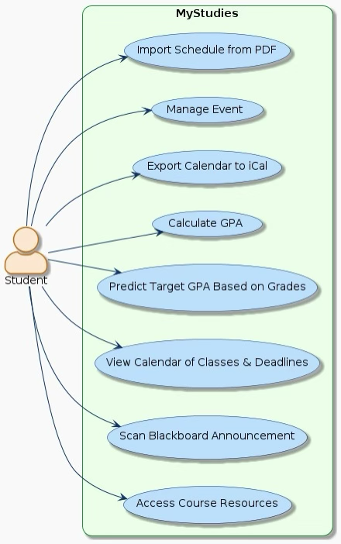
Figure 5.1 Use Case Diagram
The diagram illustrates the core functions available to the student, including importing schedules, scanning deadlines, managing events, calculating GPA, exporting calendars, and accessing resources.
Sequence Diagram – OCR Deadline Capture:
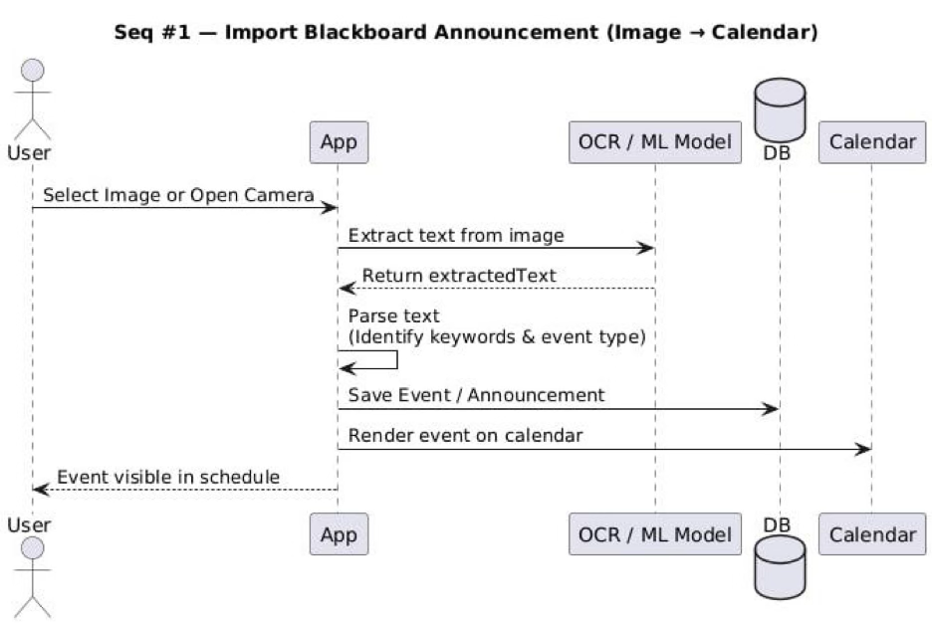
Figure 5.2 OCR Sequence Diagram
This details interaction between the App, OCR engine, and local database, including user confirmation before saving the event.Sequence Diagram – PDF Schedule Import:
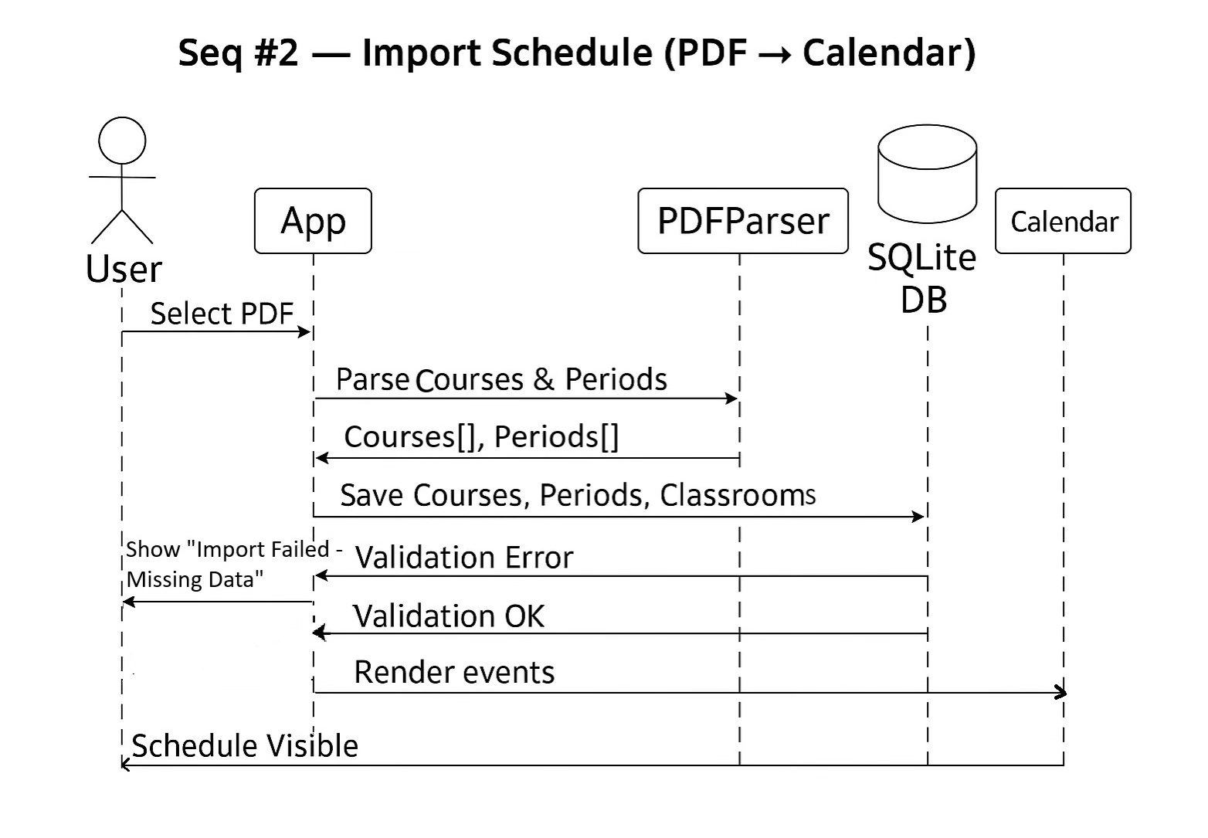
Figure 5.3 PDF Import Sequence Diagram
This models the data flow from the PDF parser to the local database, then to the calendar UI.

5.3 Static Structure and Data Model
Class Diagram:
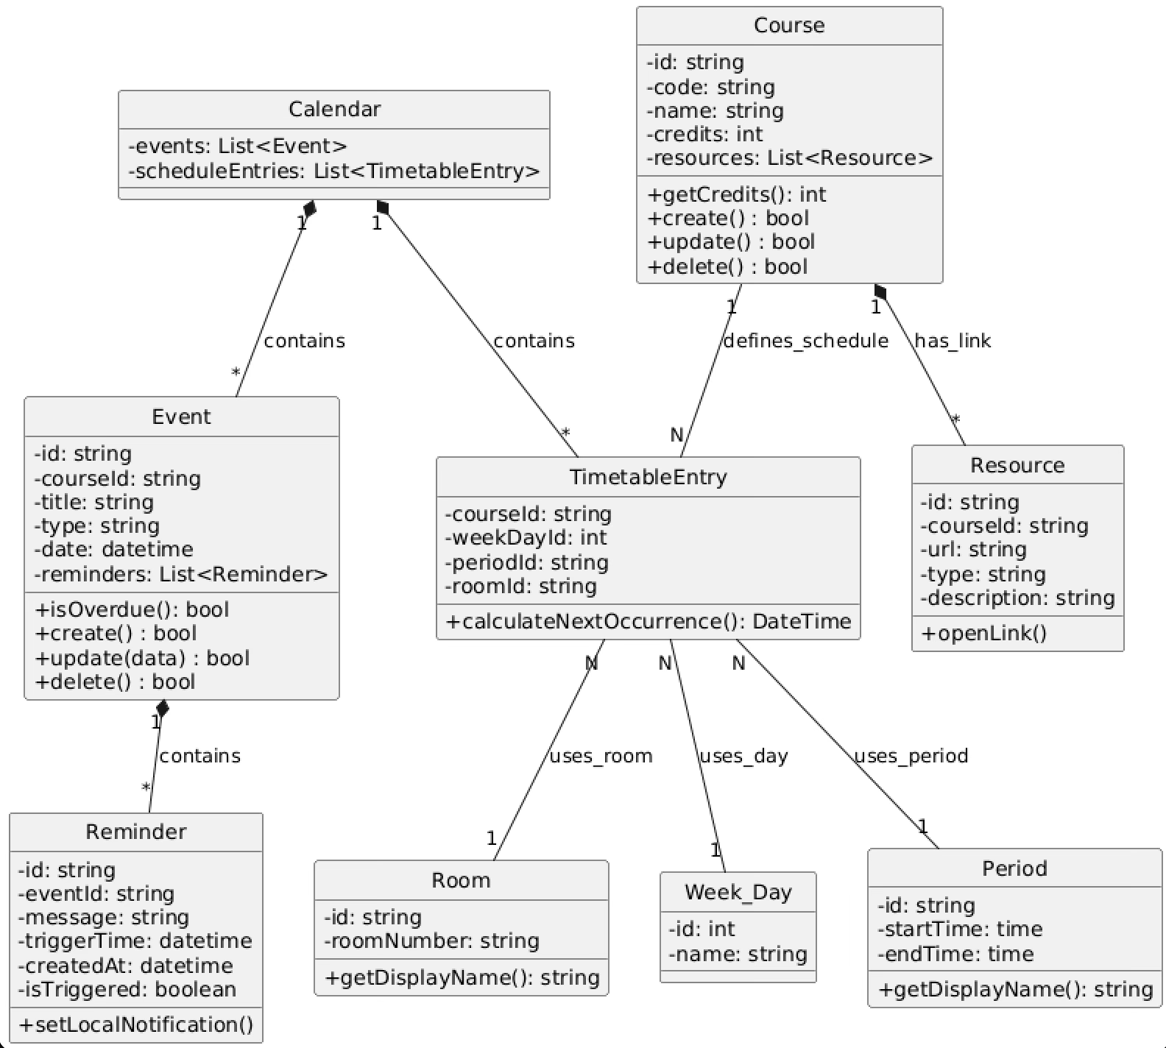
Figure 5.4 Class Diagram
Defines object structure, showing the calendar/state manager controlling collections of Events and Timetable Entry objects.

ERD:
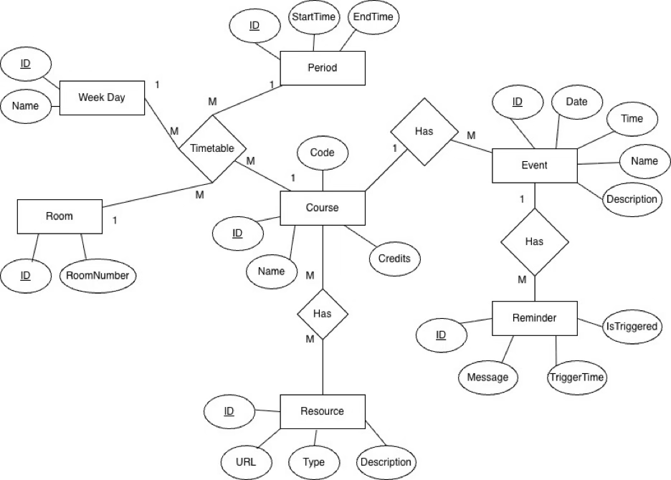
Figure 5.5 Entity Relationship Diagram
The database schema uses a Timetable junction structure to handle recurring schedules and relationships between courses and events.

5.4 User Interface Design
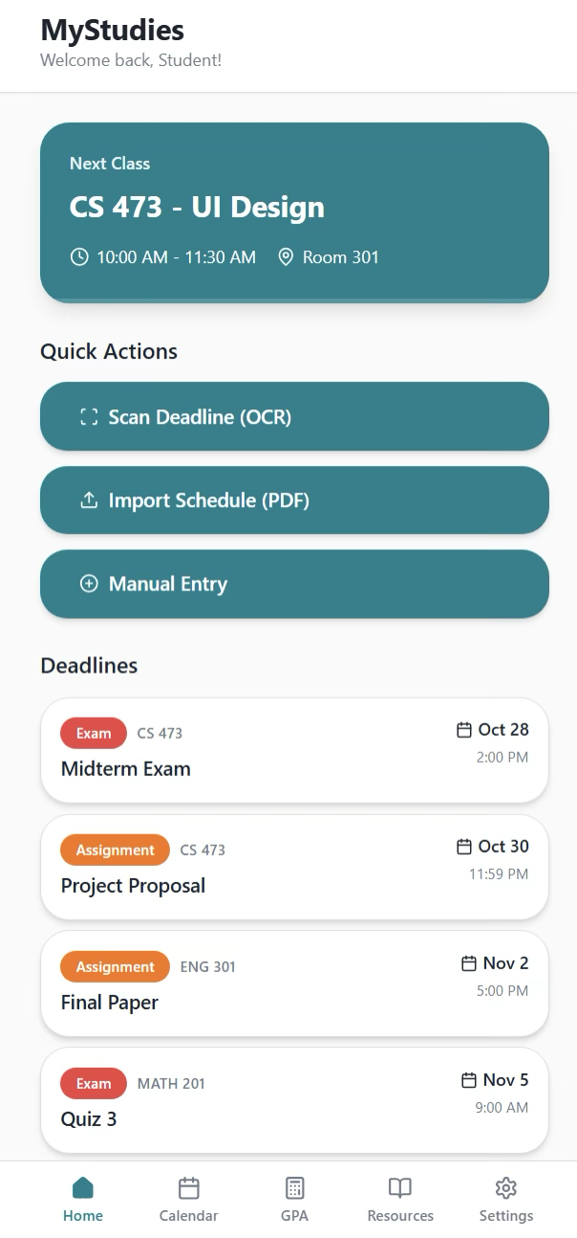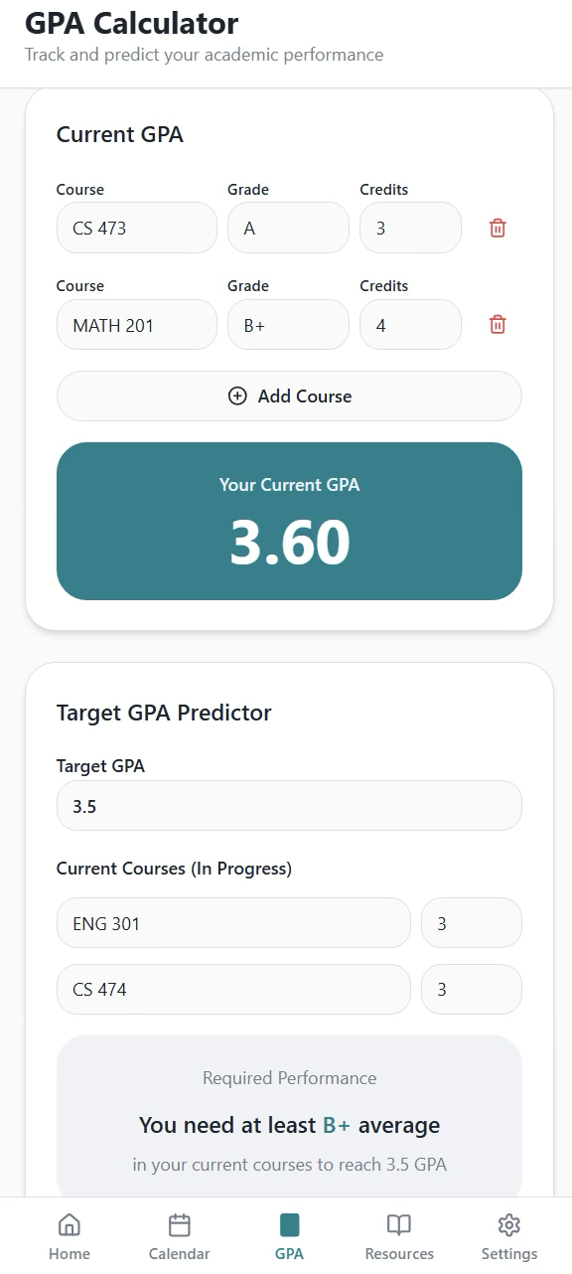
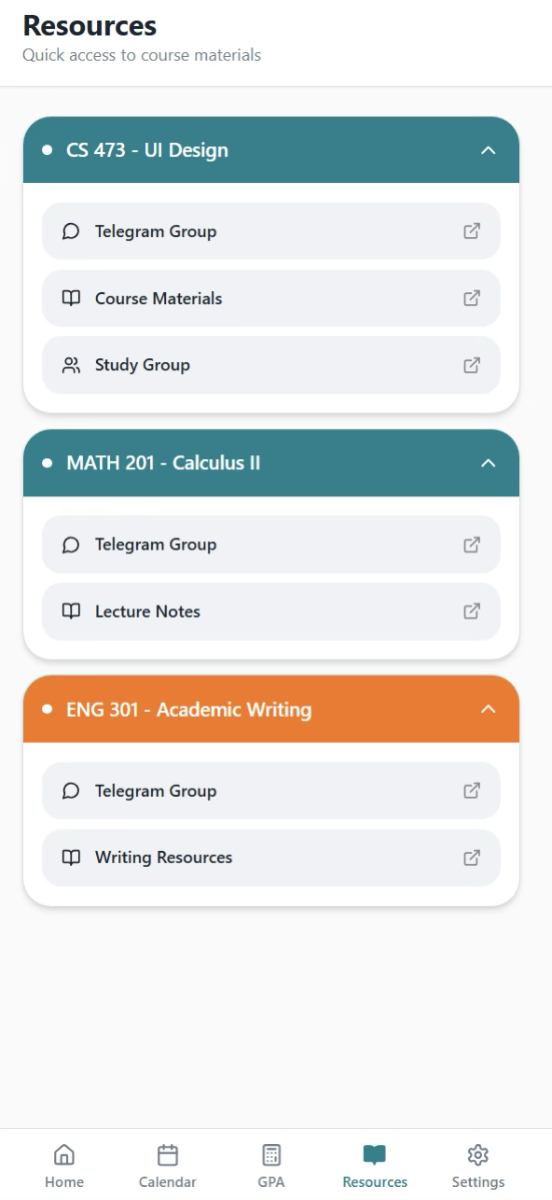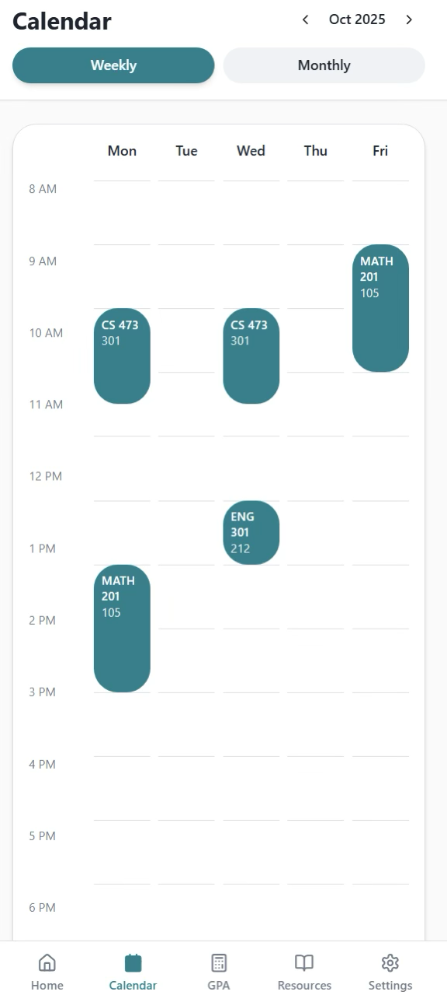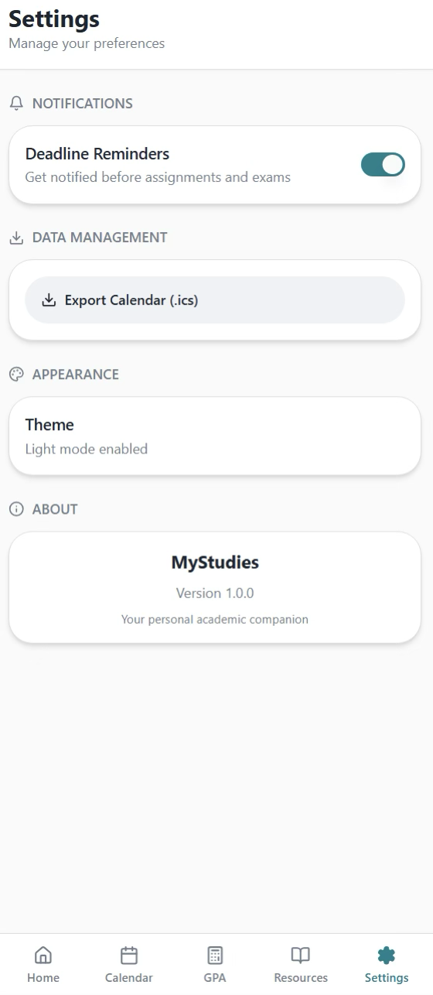
Figure 5.6 UI Mockups

6. SOFTWARE IMPLEMENTATION

6.1 Development Approach
We adopted the Agile Development Methodology to manage complexity and allow iterative improvements. Development was organized into sprints, enabling early validation of UI/flows and continuous refinement of parsing and GPA logic.

6.2 Process Used During SRS & Design Development
- Conducted internal team meetings to confirm scope, prioritize features, and refine user stories.
- Reviewed and revised the SRS and design documents multiple times as implementation revealed practical constraints.
- Validated key flows (schedule import, OCR capture, GPA calculation, export) through iterative testing and peer review inside the team.

6.3 Hardware, Software, and Network Environment
- Flutter & Dart: chosen to build Android and iOS apps from a single codebase with strong UI capabilities.
- SQLite (sqflite): chosen for offline-first storage and fast local access.
- Google ML Kit: chosen for on-device OCR speed and privacy.
- PDF Parsing: implemented to extract schedules from university PDF formats; when local parsing is inaccurate for complex layouts, parsing can be handled by a backend service and returned as structured data.

6.4 Verification and Validation (Testing)
- Unit Testing: tested Target GPA prediction logic and edge cases (e.g., impossible target GPAs).
- Integration Testing: tested schedule import end-to-end and OCR end-to-end.
- User Acceptance Testing (UAT): tested real student schedules and announcements to confirm the calendar output matches official documents and deadlines.

7. CONCLUSION

7.1 System Status
The MyStudies application has been implemented and satisfies the main functional requirements defined in the SRS. The system supports schedule import, OCR-based deadline capture with user verification, GPA calculations (current and target prediction), manual event management, resource linking, and iCal export. The overall integration between UI, state management, and local database is stable. Current limitations are mainly related to input quality and format variability.

7.2 Future Enhancements
- Cloud Sync: add authentication and cloud database to sync data across multiple devices.
- Resource Sharing: allow students to share notes and materials linked to courses.
- Major-Specific Study Plans: integrate official degree plans and prerequisite tracking.
- Transcript Import: Enable importing the official transcript to auto-fill completed courses/grades for accurate CGPA tracking and better planning.
- Blackboard Integration: Connect with Blackboard to fetch announcements automatically and create deadlines/events by default.
- Expanded Academic Resources: add links to libraries, practice exam archives, and learning content.

7.3 Professional Development

A. Technical Development
- Improved Flutter/Dart development skills and advanced state management using BLoC/Cubit.
- Implemented SQLite persistence and reliable CRUD workflows.
- Integrated Google ML Kit OCR and handled async recognition pipelines.
- Developed and refined PDF extraction logic for academic schedules.

B. Behavioral Development
- Practiced Agile planning, sprint-based delivery, and prioritization.
- Strengthened teamwork through task division, reviews, and shared responsibility.
- Improved adaptability by responding to technical limitations and updating design/implementation accordingly.

C. Obstacles and Solutions
Obstacle: PDF parsing accuracy in Dart
Overcome: The initial PDF parsing approach in Dart was not accurate for complex timetable tables, so we migrated schedule extraction to a Python backend using pdfplumber, which provided more reliable table/text extraction and returned structured data to the app.
Obstacle: OCR misreads (dates/course codes)
Overcome: added a confirmation/edit step before saving events.
Obstacle: state synchronization bugs early on
Overcome: enforced separation of concerns using BLoC, making UI rebuilds depend only on explicit state changes.

8. APPENDIX
8.1 List of Files

1) Core (shared infrastructure)
Constants
- lib/core/constants/app_sizes.dart
- lib/core/constants/app_spacing.dart
Database
- lib/core/database/app_database.dart
- lib/core/database/courses_db_repository.dart
- lib/core/database/events_db_repository.dart
- lib/core/database/notifications_db_repository.dart
Errors
- lib/core/errors/custom_exception.dart
- lib/core/errors/failure.dart
Notifications
- lib/core/notifications/notification_service.dart
Theme & Utilities
- lib/core/theme/app_theme.dart
- lib/core/utils/color_utils.dart
- lib/core/utils/date_utils.dart
- lib/core/utils/navigation_utils.dart
Reusable Widgets
- lib/core/widgets/app_buttons.dart
- lib/core/widgets/app_cards.dart
- lib/core/widgets/app_dialog.dart
- lib/core/widgets/app_snackbar.dart
- lib/core/widgets/ios_time_picker_dialog.dart

2) Calendar Feature
Models
- lib/features/calendar/data/models/calendar.dart
- lib/features/calendar/data/models/event.dart
- lib/features/calendar/data/models/reminder.dart
State Management (Cubits/States)
- lib/features/calendar/presentation/cubits/calendar_cubit.dart
- lib/features/calendar/presentation/cubits/deadline_scan_cubit.dart
- lib/features/calendar/presentation/cubits/deadline_scan_state.dart
- lib/features/calendar/presentation/cubits/reminder_cubit.dart
- lib/features/calendar/presentation/cubits/reminder_state.dart
Screens
- lib/features/calendar/presentation/screens/calendar_screen.dart
Widgets
- lib/features/calendar/presentation/widgets/calendar_add_event_dialog.dart
- lib/features/calendar/presentation/widgets/calendar_edit_event_dialog.dart
- lib/features/calendar/presentation/widgets/calendar_event_list.dart
- lib/features/calendar/presentation/widgets/calendar_manage_sheets.dart
- lib/features/calendar/presentation/widgets/calendar_monthly_view.dart
- lib/features/calendar/presentation/widgets/calendar_view_selector.dart
- lib/features/calendar/presentation/widgets/calendar_weekday_header.dart
- lib/features/calendar/presentation/widgets/calendar_weekly_time_grid.dart
- lib/features/calendar/presentation/widgets/calendar_weekly_view.dart
- lib/features/calendar/presentation/widgets/course_meeting_sheet.dart
- lib/features/calendar/presentation/widgets/event_detail_modal.dart
- lib/features/calendar/presentation/widgets/event_reminder_list.dart
- lib/features/calendar/presentation/widgets/reminder_picker_dialog.dart
- lib/features/calendar/presentation/widgets/upcoming_events_modal.dart

3) GPA Feature
Constants
- lib/features/gpa/constants/gpa_constants.dart
Calculators & Models
- lib/features/gpa/data/calculators/target_gpa_calculator.dart
- lib/features/gpa/data/models/target_plan.dart
State Management (Cubit/State)
- lib/features/gpa/presentation/cubit/gpa_cubit.dart
- lib/features/gpa/presentation/cubit/gpa_state.dart
Screens
- lib/features/gpa/presentation/screens/gpa_screen.dart
Widgets
- lib/features/gpa/presentation/widgets/current_gpa_tab.dart
- lib/features/gpa/presentation/widgets/expected_course_tile.dart
- lib/features/gpa/presentation/widgets/gpa_summary_card.dart
- lib/features/gpa/presentation/widgets/gpa_widgets.dart
- lib/features/gpa/presentation/widgets/target_gpa_tab.dart
- lib/features/gpa/presentation/widgets/target_input_card.dart

4) Notifications Feature
Model
- lib/features/notifications/data/models/notification_item.dart
State Management
- lib/features/notifications/presentation/cubit/notifications_cubit.dart
Screen
- lib/features/notifications/presentation/screens/notifications_screen.dart
Widgets
- lib/features/notifications/presentation/widgets/notification_card.dart
- lib/features/notifications/presentation/widgets/notification_empty_state.dart

5) Resources Feature
Models & Static Data
- lib/features/resources/data/models/resource.dart
- lib/features/resources/data/models/room.dart
- lib/features/resources/data/static_resources.dart
State Management
- lib/features/resources/presentation/cubit/resources_cubit.dart
- lib/features/resources/presentation/cubit/resources_state.dart
Screen
- lib/features/resources/presentation/screens/resources_screen.dart
Widgets
- lib/features/resources/presentation/widgets/add_resource_dialog.dart
- lib/features/resources/presentation/widgets/resource_card.dart
- lib/features/resources/presentation/widgets/resource_course_section.dart
- lib/features/resources/presentation/widgets/resources_empty_state.dart

6) Schedule Feature (PDF import + manual entry)
Data Sources / Services
- lib/features/schedule/data/datasources/pdf_processing_service.dart
- lib/features/schedule/data/datasources/schedule_import_service.dart
Models
- lib/features/schedule/data/models/course.dart
- lib/features/schedule/data/models/course_meeting.dart
- lib/features/schedule/data/models/period.dart
- lib/features/schedule/data/models/schedule_data.dart
- lib/features/schedule/data/models/timetable_entry.dart
- lib/features/schedule/data/models/week_day.dart
Mappings & Repositories
- lib/features/schedule/data/period_mapping.dart
- lib/features/schedule/data/repos/schedule_repository.dart
- lib/features/schedule/data/repos/schedule_repository_impl.dart
State Management
- lib/features/schedule/presentation/cubits/schedule_cubit.dart
- lib/features/schedule/presentation/cubits/schedule_state.dart
Screens
- lib/features/schedule/presentation/screens/home_screen.dart
- lib/features/schedule/presentation/screens/import_schedule_screen.dart
- lib/features/schedule/presentation/screens/manual_entry_screen.dart
- lib/features/schedule/presentation/screens/scan_deadline_screen.dart

Widgets
- lib/features/schedule/presentation/widgets/add_course_bottom_sheet.dart
- lib/features/schedule/presentation/widgets/add_event_bottom_sheet.dart
- lib/features/schedule/presentation/widgets/course_preview_tile.dart
- lib/features/schedule/presentation/widgets/home_deadline_card.dart
- lib/features/schedule/presentation/widgets/home_deadlines_section.dart
- lib/features/schedule/presentation/widgets/home_info_chip.dart
- lib/features/schedule/presentation/widgets/home_next_class_card.dart
- lib/features/schedule/presentation/widgets/home_quick_access_item.dart
- lib/features/schedule/presentation/widgets/home_quick_access_section.dart

7) Settings & App Shell
Settings
- lib/features/settings/presentation/cubit/export_cubit.dart
- lib/features/settings/presentation/cubit/export_state.dart
- lib/features/settings/presentation/cubit/theme_cubit.dart
- lib/features/settings/presentation/screens/settings_screen.dart
Splash
- lib/features/splash/presentation/screens/splash_screen.dart
App Entry & Navigation
- lib/main.dart
- lib/navigation/main_navigation.dart

