I used the data from two sources

find below the data sources

<https://data.worldbank.org/indicator>

[World Bank Projects & Operations | Data Catalog](https://datacatalog.worldbank.org/dataset/world-bank-projects-operations)

*Extract data from CSV files

[Rural population (percentage of total population)](https://data.worldbank.org/indicator/SP.RUR.TOTL.ZS?view=chart)

[Permanent cropland (percentage of land area)](https://data.worldbank.org/indicator/AG.LND.CROP.ZS?view=chart)

[Access to electricity (percentage of population)](https://data.worldbank.org/indicator/EG.ELC.ACCS.ZS?view=chart)

<https://search.worldbank.org/api/projects/all.xls>

* transform data

Cleaning the data:

Remove the first row in tables

Remove the columns contains a lot of null values

Rename the columns

Join the data:

combining multi tables from datasets together

Query in MYSQL server

* Delete the first row:

use 'schema name';

Delete from 'table name' where 'Column name'=""

* Find the null values in every column:

SELECT * FROM 'Schema name'.'Table name'

where 'Column name'=""

* Delete the columns:

use schema name

Alter table 'table name' drop column 'column name';

* Rename the column name:

use 'schema name'

Alter table 'table name' rename column 'column name' to new column name;

* Create view :

VIEW `bankproj`.`new_view` AS

SELECT

`tbl1`.`CountryName` AS `CountryName`,

`tbl1`.`IndicatorName` AS `IndicatorName1`,

`tbl2`.`IndicatorName` AS `IndicatorName2`,

`tbl3`.`IndicatorName` AS `IndicatorName3`

FROM

(((`bankproj`.`rural_population` `tbl1`

JOIN `bankproj`.`electricity_access_percent` `tbl2` ON ((`tbl1`.`CountryName` =`tbl2`.`CountryName`)))

JOIN `bankproj`.`permanent_cropland` `tbl3` ON ((`tbl3`.`CountryName` = `tbl1`.`CountryName`)))

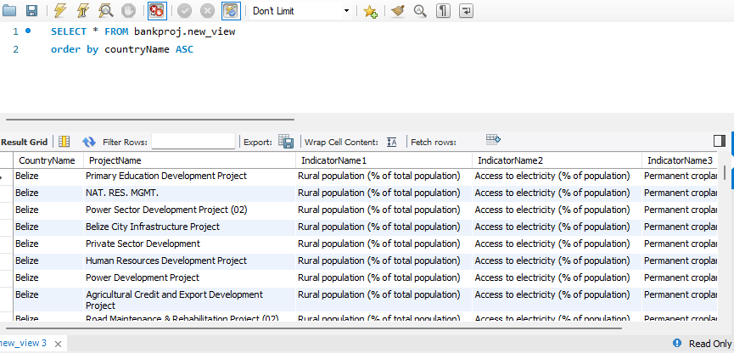JOIN `bankproj`.`bankprojects` `tbl4` ON ((`tbl4`.`CountryName` = `tbl1`.`CountryName`)))