2020. A survey on automatic speech recognition systems for Portuguese language and its variations

Even though ASR systems still comprise of language-specific models, recent research is showing that multi-language models are not
only feasible but can also be used to bootstrap models for low or under-resourced languages. It is possible to argue that human languages
are, in fact, not that different from each other when it comes to computational modelling (Tong et al., 2017; Vu et al., 2014). Despite this,
it is of high importance to focus on specifics of the main spoken languages that are still under-investigated, such as Portuguese.

Works that focus on the state of the art of automatic speech recognition systems usually comprises several components, each
contributing to the overall ability to incorporate knowledge from acoustic or phonetic modelling, language modelling, and lexical
or pronunciation modelling. In fact, for a long time, the most common approach for proposing new models involved trying to
take advantage of knowledge from different sources to improve the model efficiency (Chebotar and Waters, 2016).

Public representative databases are essential for any research in speech recognition. In this area, when referring to a database, the authors use the terminology “Corpus” (or “Corpora”) (Robin, 2018). During this research, we did not found works that used a 1large set of structured sentences, that is, a text corpora. Therefore, all datasets presented in this section are speech corpora, a collection of voice recordings.

Cross-lingual
This approach depends on the assumption that different languages have a typical structure, a mapping function that can correctly associate one to another (Schultz and Kirchhoff, 2006). From that, it is possible to train an acoustic model with a corpus that contains n-languages, while the presence of a target language is optional. However, the amount of data for the target language is usually low, and actually, none in some cases (Vesel et al., 2012), as well as (M u
€ ller et al., 2017) with a
African idiom. The model was trained on 10 languages, including Portuguese, and further improved in (M uT. Aguiar de Lima and M. Da Costa

2019 . THE MGB-5 CHALLENGE: RECOGNITION AND DIALECT IDENTIFICATION OF DIALECTAL ARABIC SPEECH

MFCC + CNN + LSTM

This paper describes the fifth edition of the Multi-Genre
Broadcast Challenge (MGB-5), an evaluation focused on
Arabic speech recognition and dialect identification. MGB-5
extends the previous MGB-3 challenge in two ways: first
it focuses on Moroccan Arabic speech recognition; second
the granularity of the Arabic dialect identification task is
increased from 5 dialect classes to 17, by collecting data
from 17 Arabic speaking countries. Both tasks use YouTube
recordings to provide a multi-genre multi-dialectal challenge
in the wild. Moroccan speech transcription used about 13
hours of transcribed speech data, split across training, devel-
opment, and test sets, covering 7-genres: comedy, cooking,
family/kids, fashion, drama, sports, and science (TEDx).

2019. Survey on Deep Neural Networks in Speech and Vision Systems

“Deep Boltzmann Machine” vs “Stacked Auto Encoder”
Variational Auto Encoder
GAN
TextToSpeech : GAN for Speech = Wavenet, WaveGLOW, SpeechEnhancementGAN,
RNN/LSTM
Attention
Neural Architecture Search ( LSTM finds params of CNN layers)

2019.ROBUST RECOGNITION OF REVERBERANT AND NOISY SPEECH USING COHERENCE-BASED PROCESSING.08682581

This paper describes a combination of techniques for improving speech recognition accuracy using two microphones in reverberant and noisy environments.

Interaural Time Differences
One proposed solution for the dereverberation problem has been the use of inverse filtering to reduce early reverberant components followed by spectral subtraction for later-arriving components. A similar solution was proposed in but with the addition of spatio-temporal averaging.

With the popularity of deep neural networks, the use of deep autoencoders for dereverberation has also yielded promising results. One technique used in the present study is based on human auditory processing and emulates some attributes of the “precedence effect” (The precedence effect or law of the first wavefront is a binaural psychoacoustical effect. When a sound is followed by another sound separated by a sufficiently short time delay (below the listener's echo threshold), listeners perceive a single auditory event; its perceived spatial location is dominated by the location of the first-arriving sound)

The precedence effect describes the phenomenon in which directional cues representing the first-arriving wavefront (which correspond to the direct component) are given greater perceptual weighting than those cues that arise as a consequence of subsequent reflected sounds. The algorithm called Suppression of Slowly-varying components and the Falling edge of the power envelope (SSF) [8, 9] was motivated by this principle and has been successful in improving ASR accuracy in reverberant environments.

It has long been believed that modulation frequency playsan important role in human hearing. For example, it is observedthat the human auditory system is more sensitive to modulationfrequencies less than20Hz (e.g.[6, 7]). On the other hand, veryslowly changing components (e.g.less than 5 Hz) are usuallyrelated to noise sources (e.g.[8, 9, 10]). Based on these obser-vations, researchers have tried to utilize modulation frequencyinformation to enhance the speech recognition performance innoisy environments. Typical approaches use highpass or band-pass filtering in either the spectral, log-spectral, or cepstral do-mains (e.g.[11]).

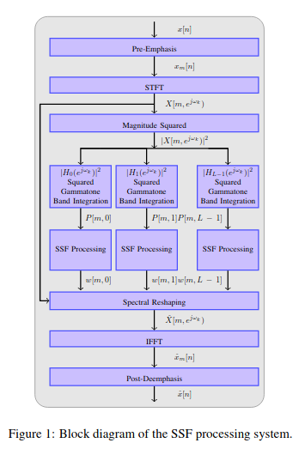

(2010.Nonlinear Enhancement of Onset for Robust Speech Recognition.bf0a07cf705d2a00d9af68dcdaaa7522af03)

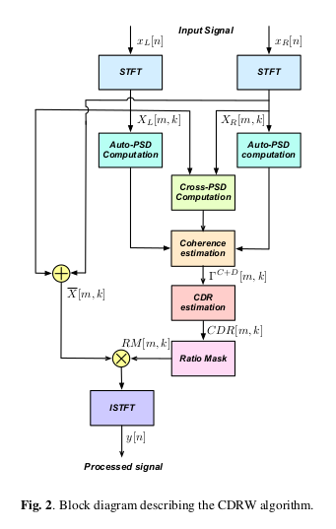

(2019.ROBUST RECOGNITION OF BINAURAL SPEECH SIGNALS USINGTECHNIQUES BASED ON HUMAN AUDITORY PROCESSING.MenonThesis PHD Thesis)

2019.Overview of the CLEF-2019 CheckThat! Lab: Automatic Identification and Verification of Claims. Task 1: Check-Worthiness.Mohtarami-CLEF2019

LSTM is the winner.

2019.Overview of Automatic Speech Recognition, Approaches and Challenges: Way the Future to Turkish Speech Recognition.10.29109-gujsc.562111-878499

Genel bilgiler.

2019.MCE 2018: The 1st Multi-target Speaker Detection and Identification Challenge Evaluation.SuwonShon3_Interspeech-2019

Denoising AutoEncoder is used.

2019.Large-scale Speaker Retrieval on Random Speaker Variability Subspace.SuwonShon2_Interspeech-2019

This paper describes a fast speaker search system to retrieve
segments of the same voice identity in the large-scale data. A
recent study shows that Locality Sensitive Hashing (LSH) en-
ables quick retrieval of a relevant voice in the large-scale data
in conjunction with i-vector while maintaining accuracy. In
this paper, we proposed Random Speaker-variability Subspace
(RSS) projection to map a data into LSH based hash tables. We
hypothesized that rather than projecting on completely random
subspace without considering data, projecting on randomly gen-
erated speaker variability space would give more chance to put
the same speaker representation into the same hash bins, so we
can use less number of hash tables. Multiple RSS can be gen-
erated by randomly selecting a subset of speakers from a large
speaker cohort. From the experimental result, the proposed ap-
proach shows 100 times and 7 times faster than the linear search
and LSH, respectively.

2019.Improving Low Resource Turkish Speech Recognition with Data Augmentation and TTS.08893184

Google Text To Speech ile speech üretip data yı augment etmişler, GRU ile speech to text yapıyorlar %14 kazanmışlar.

2019.EXPLICIT ALIGNMENT OF TEXT AND SPEECH ENCODINGSFOR ATTENTION-BASED END-TO-END SPEECH RECOGNITIONJDrexler_ASRU-19

used adversarial training to create a shared embedding space from unpaired speech and text

In this work, we present a novel training procedure for attention-based end-to-end automatic speech recognition.
Our goal is to push the encoder network to output only linguistic information, improving generalization performance particularly in low-resource scenarios.
We accomplish this with the addition of a text encoder network, which the speech encoder is encouraged to mimic.
Our main innovation is the comparison of the attention-weighted speech encoder outputs to the outputs of the text encoder - this guarantees two sequences of the same length that can be directly aligned.
We show that our training procedure significantly decreases word error rates in all experiments and has the biggest absolute impact in the lowest resource scenarios.

2019.END-TO-END ANCHORED SPEECH RECOGNITION.08682866

The anchored segment refers to the
wake-up word part of an audio stream, which contains valuable
speaker information that can be used to suppress interfering speech
and background noise. Attention Encoder/Decoder Arch.

2019.DOMAIN MISMATCH ROBUST ACOUSTIC SCENE CLASSIFICATION USING CHANNEL INFORMATION CONVERSION.SuwonShon3_ICASSP-2019

