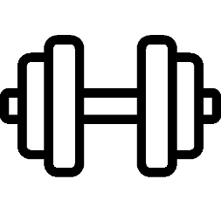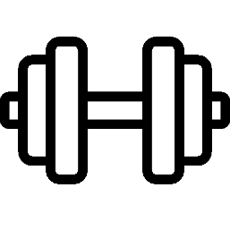Matt’s Gym

For this project I created my own gym. With it, I created a website that gives great information about the gym and what we have to offer over our competitors. The target audience for both the gym and the website is anybody who wants to better their life through fitness, whether it be to lose weight, pack on muscle, or simply achieve a level of fitness once thought unimaginable for the individual. Not enough people participate in fitness and those who give it more than a second thought, this project is for them. My website goes over membership prices, different amenities we have to offer, the different coaching and class options we have, and even an about page providing who’s responsible for the gym and why our passion will ultimately lead to the consumer to live life in their best shape. Our website should be the deciding factor on why you pick Matt’s Gym over the competitors and I designed the website with that in mind, for the consumer to choose this gym over others. We hope to see you come on down to Matt’s Gym where your goals are our priority!

Website Page Layout

Home Page

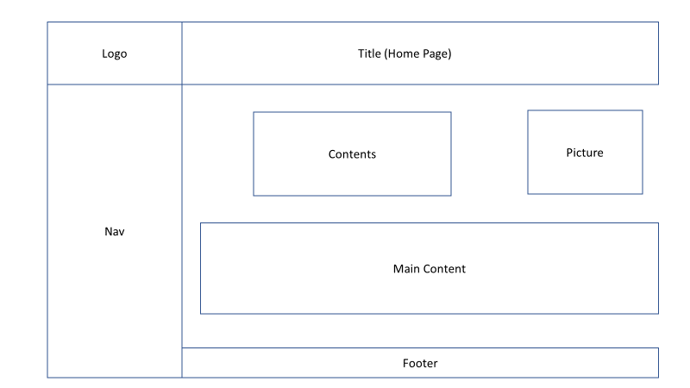

Amenities

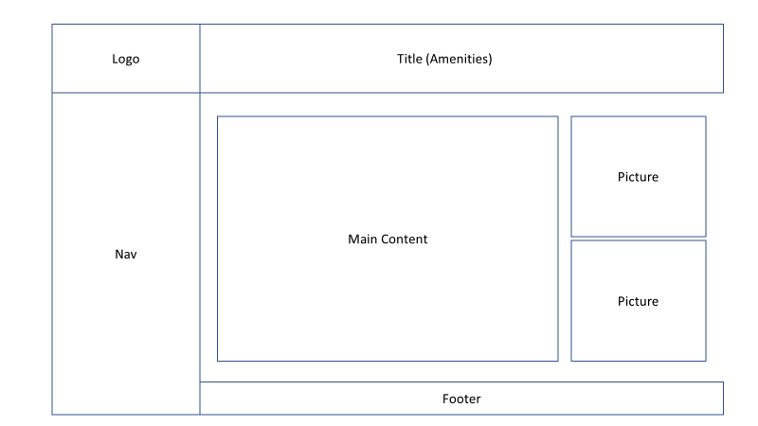

Membership

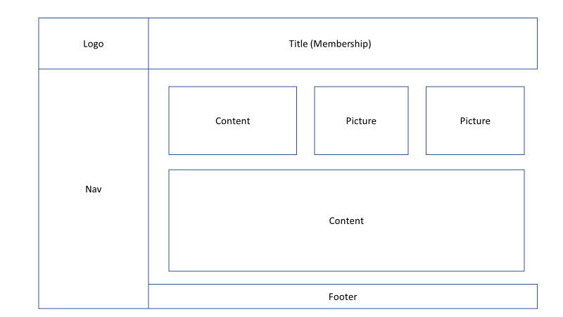

Coaching

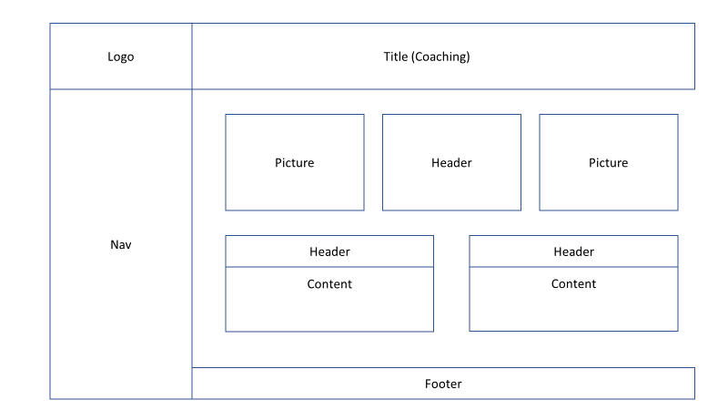

Membership

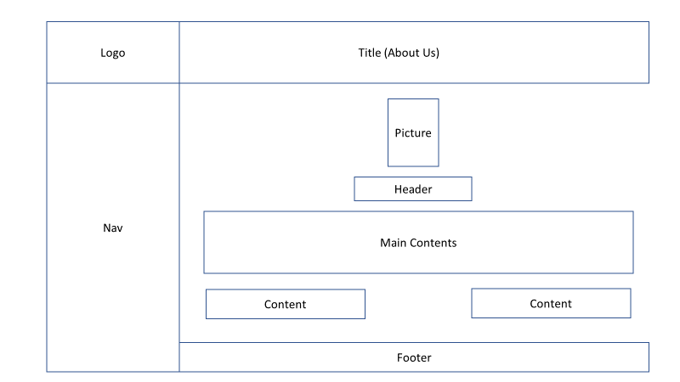

Website Site Map

