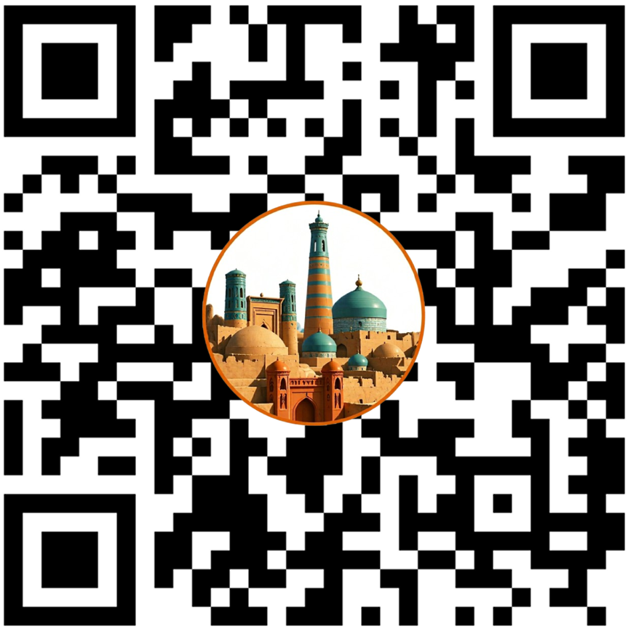
UZ: Ibn Sino (980–1037) — tabib, faylasuf.
RU: Ибн Сина (980–1037) — врач, философ.
ENG: Ibn Sina (980–1037) — physician, philosopher.

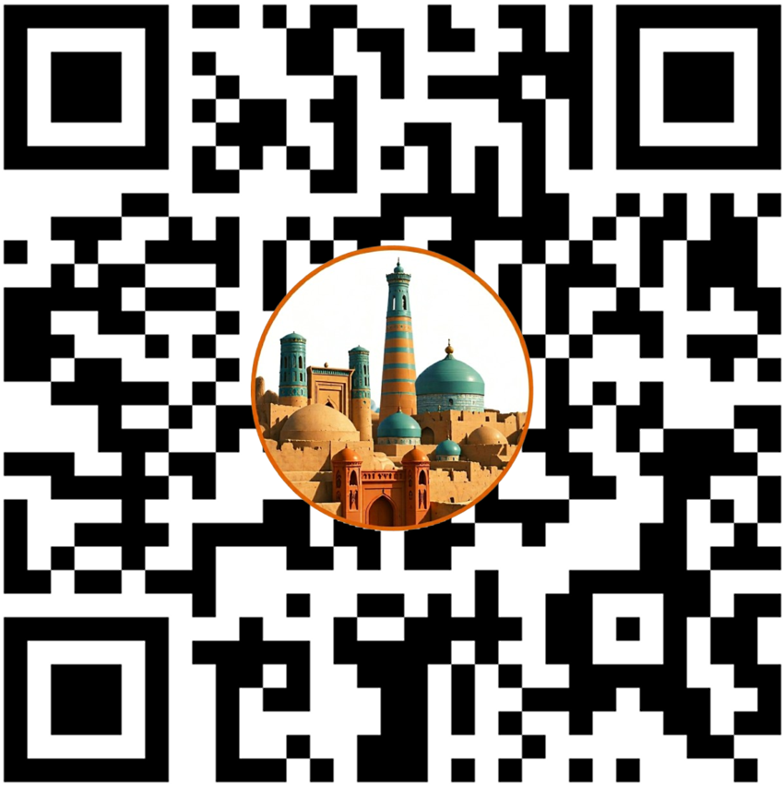
UZ: Beruniy (973–1048) — qomusiy olim.
RU: Беруни (973–1048) — энциклопедист.
ENG: Beruni (973–1048) — polymath.
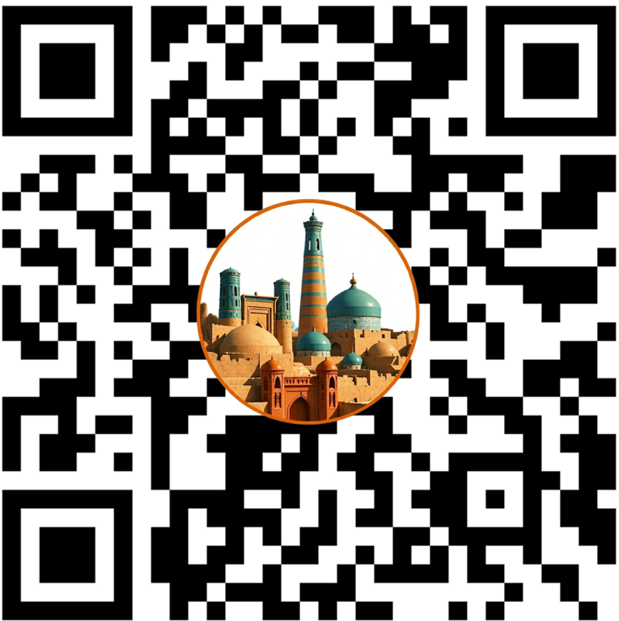
UZ: Xorazmiy (783–850) — matematik.
RU: Хорезми (783–850) — математик.
ENG: Khwarizmi (783–850) — mathematician.
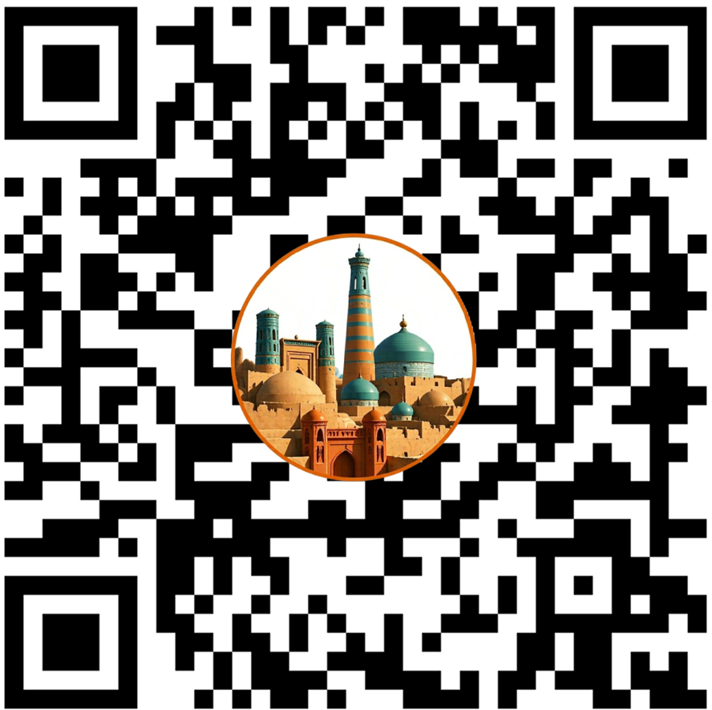
UZ: Zamaxshariy (1075–1144) — tilshunos.
RU: Замахшари (1075–1144) — лингвист.
ENG: Zamakhshari (1075–1144) — linguist.

