
“Well, Prince, so Genoa and Lucca are now just family estates of the Buonapartes. But I warn you, if you don’t tell me that this means war, if you still try to defend the infamies and horrors perpetrated by that Antichrist — I really believe he is Antichrist — I will have nothing more to do with you and you are no longer my friend, no longer my ‘faithful slave,’ as you call yourself! But how do you do? I see I have frightened you — sit down and tell me all the news.”
It was in July, 1805, and the speaker was the well-known Anna Pávlovna Schérer, maid of honor and favorite of the Empress Márya Fëdorovna. With these words she greeted Prince Vasíli Kurágin, a man of high rank and importance, who was the first to arrive at her reception. Anna Pávlovna had had a cough for some days. She was, as she said, suffering from la grippe; grippe being then a new word in St. Petersburg, used only by the elite.
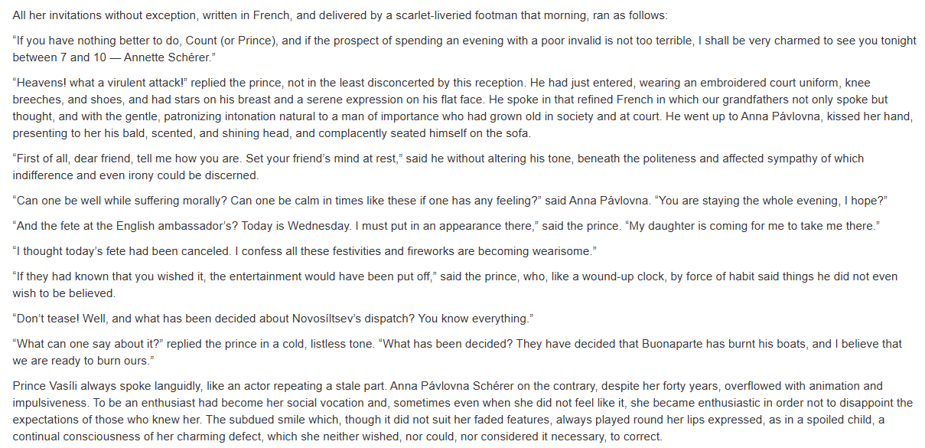
“Oh, don’t speak to me of Austria. Perhaps I don’t understand things, but Austria never has wished, and does not wish, for war. She is betraying us! Russia alone must save Europe. Our gracious sovereign recognizes his high vocation and will be true to it. That is the one thing I have faith in! Our good and wonderful sovereign has to perform the noblest role on earth, and he is so virtuous and noble that God will not forsake him. He will fulfill his vocation and crush the hydra of revolution, which has become more terrible than ever in the person of this murderer and villain! We alone must avenge the blood of the just one.... Whom, I ask you, can we rely on?... England with her commercial spirit will not and cannot understand the Emperor Alexander’s loftiness of soul. She has refused to evacuate Malta. She wanted to find, and still seeks, some secret motive in our actions. What answer did Novosíltsev get? None. The English have not understood and cannot understand the self-abnegation of our Emperor who wants nothing for himself, but only desires the good of mankind. And what have they promised? Nothing! And what little they have promised they will not perform! Prussia has always declared that Buonaparte is invincible, and that all Europe is powerless before him.... And I don’t believe a word that Hardenburg says, or Haugwitz either. This famous Prussian neutrality is just a trap. I have faith only in God and the lofty destiny of our adored monarch. He will save Europe!”
She suddenly paused, smiling at her own impetuosity.
“I think,” said the prince with a smile, “that if you had been sent instead of our dear Wintzingerode you would have captured the King of Prussia’s consent by assault. You are so eloquent. Will you give me a cup of tea?”
“In a moment. À propos,” she added, becoming calm again, “I am expecting two very interesting men tonight, le Vicomte de Mortemart, who is connected with the Montmorencys through the Rohans, one of the best French families. He is one of the genuine émigrés, the good ones. And also the Abbé Morio. Do you know that profound thinker? He has been received by the Emperor. Had you heard?”
“I shall be delighted to meet them,” said the prince. “But tell me,” he added with studied carelessness as if it had only just occurred to him, though the question he was about to ask was the chief motive of his visit, “is it true that the Dowager Empress wants Baron Funke to be appointed first secretary at Vienna? The baron by all accounts is a poor creature.”
Prince Vasíli wished to obtain this post for his son, but others were trying through the Dowager Empress Márya Fëdorovna to secure it for the baron.
Anna Pávlovna almost closed her eyes to indicate that neither she nor anyone else had a right to criticize what the Empress desired or was pleased with.
“Baron Funke has been recommended to the Dowager Empress by her sister,” was all she said, in a dry and mournful tone.
As she named the Empress, Anna Pávlovna’s face suddenly assumed an expression of profound and sincere devotion and respect mingled with sadness, and this occurred every time she mentioned her illustrious patroness. She added that Her Majesty had deigned to show Baron Funke beaucoup d’estime, and again her face clouded over with sadness.
The prince was silent and looked indifferent. But, with the womanly and courtierlike quickness and tact habitual to her, Anna Pávlovna wished both to rebuke him (for daring to speak as he had done of a man recommended to the Empress) and at the same time to console him, so she said:
“Now about your family. Do you know that since your daughter came out everyone has been enraptured by her? They say she is amazingly beautiful.”
The prince bowed to signify his respect and gratitude.
