

**HADHRAMOUT UNIVERSITY**

**COLLEGE OF ENGINEERING & PETROLEUM**

**COMPUTER ENGINEERING DEPARTMENT**

**WEB PLATFORM**

**STUDENT ATTENDANCE SYSTEM**

**A FINAL PROJECT SUBMITTED IN PARTIAL FULFILMENT OF THE REQUIREMENTS FOR THE DEGREE OF BACHELOR OF ENGINEERING IN COMPUTER ENGINEERING**

**By**

**Anas Taleb Awadh Rooeshd**

**Hala Mohammed Omer Al-Madhi**

**Salim Mohammed Al-Somahy**

**Turky Ahmed Salim Al-Gothmy**

**SUPERVISOR**

**Dr. Khaled Fawzy**

**ALMUKALLA**

**MARCH 2023**

**Supervisor Certificate**

I certify that the preparation of this project entitled:

Student attendance system platform

And prepared by:

1- Anas Taleb Awadh Rooeshd.

2- Hala Mohammed Omer Al-Madhi

3- Salim Mohammed Al-Somahy.

4- Turky Ahmed Salim Al-Gothmy

Was made under my supervision at computer engineering department in partial fulfillment of the requirements of the degree of bachelor of engineering in computer engineering.

Signature:

Name: ……………………………………………………….

Date:

# DEDICATION

For our mom, no one has ever been given more loving and unconditional support than we have given by you. we love you, too.

For our dad, without your unconditional love, your unwavering guidance and support, all of this could never have happened.

To all who give us consolation, advice, and help us we dedicate our efforts product.

To all who step with us in our work step by step and what we produced

To them we dedicate this work.

# ACKNOWLEDGEMENTS

Alhamdulillah, praise to Allah the most gracious and merciful for giving us the strength and wisdom in finishing this research, at last after period of time, have completed our project. Fist and foremast, we would like to express my hearties gratitude to our supervisor, Dr.Khaled Fawzy and understand and professional way in assisting and giving us encourage, guidance, comment and ideas that are useful towards in the development of our project.

Very special thanks also to our dearest family especially to my parent, for being supportive and pray for us. moreover, we are so thankful especially to everyone for helping us to accomplish this project successfully.

To all our friends, thanks you very much. lastly, to those who have been involve direct or indirectly.

# DECLARATION

We here declare that the work in this project is our own except for quotations and summaries which have been duly acknowledged.

Date:

|  |  |  |
| --- | --- | --- |
| Name | Registration number | Signature |
| Anas Taleb Awadh Rooeshd | 18020501036 |  |
| Hala Mohammed Omer Al-Madhi | 18020501070 |  |
| Salim Mohammed Al-Somahy | 18020501004 |  |
| Turky Ahmed Salim Al-Gothmy | 18020501032 |  |

TALBLE OF CONTENT

DEDICATION ii

ACKNOWLEDGEMENTS iii

DECLARATION iv

ABSTRACT 1

CHAPTER 1 2

INTRODUCTION 2

1.1 Introduction 2

1.2 Problem Statement 3

1.3 Objectives 3

1.4 Project Scope 3

1.5 Structure of the Project 4

CHAPTER 2 5

LITERATURE REVIEW 5

2.1 Introduction 5

2.2 Related Work 5

2.2.1 Student Attendance System 5

2.2.2 Student Attendance with RFID and GPS 6

2.2.3 Student Attendance System using QR Codes 7

2.3 Background 7

2.3.1 SQL SERVER 8

2.3.2 C# programming language 8

2.3.3 Microsoft Visual Studio 8

2.3.4 HTML 8

2.3.5 CSS 9

2.3.6 ASP.NET MVC 9

2.3.7 Server 9

2.3.8 Jquery 10

2.3.9 Bootstrap 10

2.3.10 Javascript 10

2.3.11 Visual Studio Code 10

Chapter 3 11

RESEARCH METHODOLOGY 11

3.1 Introduction 11

3.2 System Requirements 11

3.2.1 Functional Requirements 11

1) Login 11

**2)** Mange Users 12

3) Add Subjects to Student 12

4) Add Subjects to Teachers 12

5) Manage College: 12

6) Manage Department 13

7) Create Reports 14

8) Mange Level 14

9) Manage Student 15

10) Manage Teachers 15

11) Manage Subjects 16

12) Attendance 16

13) Edit Attendance 17

14) Change Password 17

3.2.2 Nonfunctional Requirements 18

• Performance and scalability 18

• Consistency 18

• Availability 18

• Usability 18

3.3 System Analysis and Design 18

3.3.1 Use Case Diagrams 18

3.3.2 Data Flow Diagram 21

The Context Diagram 21

ER Diagram 22

Database design 23

CHAPTER 4 24

CONCLUSION AND FUTURE WORK 24

4.1 Conclusion 24

4.2 Future Work 25

Reference 26

**LIST OF FIGURES**

Figure 2. 1 Student Attendance System 5

Figure 2. 2 Student Attendance with RFID and GPS 6

Figure 2. 3 Student attendance system using QR codes 7

Figure 3. 1 login interface 11

Figure 3. 2 User Management Interface 12

Figure 3. 3 Collage Management Interface 13

Figure 3. 4 Department Management Interface 13

Figure 3. 5 Reports Management Interface 14

Figure 3. 6 Level Management Interface 14

Figure 3. 7 Student Management Interface 15

Figure 3. 8 Teacher Management Interface 15

Figure 3. 9 Subjects Management Interface 16

Figure 3. 10 Attendance Management Interface 16

Figure 3. 11 Change Password Interface 17

Figure 3. 12 Use case Admin 19

Figure 3. 13 Use case Observer 20

Figure 3. 14 Use case Teacher 20

Figure 3. 15 Data Flow diagram 21

Figure 3. 16 ER diagram 22

Figure 3. 17 Database design 23

# 

# ABSTRACT

This project is about designing and developing a Student's Attendance Web application that will record the attendance of student in Hadhramout University using to authenticate every student in order to get more accurate record than the paper, provides security and efficiency to both lecturers and students.

The developing Web application using Software Development Life Cycle (SDLC) as the methodology. This system using internet browser that is run under different devices and platform and develop using C# language, Microsoft visual studio and Sql server. This system uses the questionnaire method in order to analyze the user acceptance among respondents. In conclusion, this is Important to provide the reliable and efficient record.

# CHAPTER 1

# INTRODUCTION

## Introduction

Student attendance is an essential aspect of the learning process on the university. by attending class, student able to get valuable information from the lecturer, so that the student able to improve knowledge and understanding towards a particular field or even some skills . each university is implementing its attendance system to make record student’s presence for tracking and administration purpose. the most common attendance record is using a manual approach. below are two common ways for presence record can be found on today universities:

1) Lecturers call students one by one and record into attendance paper.

2) Students sign attendance paper on their own.

Of the two attendance record approaches, there are several shortcomings, including:

• It takes a long time to call the names of students one by one.

• Student can easily falsify their friends' signatures.

• Attendance record paper can be easily lost if not properly stored and managed by the university administration.

Keeping track of students’ attendance in the classroom and students’ attendance in the exam solve problem the attendance sheet revolves around the classroom while a teacher is giving the lecture.

This Web application is developed to obtain daily student attendance information and attendance a student in exam the techniques included are Microsoft visual studio for this C# application in the language besides SQL Server for mange Database , HTML language , CSS and ASP.NET MVC technology this Web application provides less time and easy access to student attendance records.

## 1.2 Problem Statement

Traditionally, student’s attendance is taken manually by using attendance sheet given by lecturer in class and not a system. with this manual system, there are some cases that student can cheat by asking their friends to tick or sign for him. lecturer can’t monitor for all students in the class and it is difficult for lecturer to record the attendance of students accurately and efficiently. lecturers are responsible to monitor all the student’s attendance for the whole semester. because of this problem, a system may be needed in order to records the attendance of the students more accurately without have to trace manually by lecturers. this system will record the attendance of students when the class begins.

## Objectives

The objectives of the project are as follows:

* To build web application for student attendance in lecture and exam.
* To have a server for database management.
* To have all information of class and students for each lecturer and exam.
* View attendance statistics of student and by period

## 1.4 Project Scope

* The scopes of this project are the students , classes , laps , exams and lecturers .
* The implementation will be in hadhramout university at college of engineering & petroleum.

## 1.5 Structure of the Project

This has been organized into four chapters. The content for each chapter is briefly explained as follows:

**Chapter 1:**

This chapter is an introduction and overview of this project. it presents the problem statements, objectives, scope.

**Chapter 2:**

This chapter describes the literature review and an overview of the components used to build web application .

**Chapter 3:**

Describes the methodology followed to describe analysis and design stages, implementation stage and discusses the results.

**Chapter 4:**

Contains the conclusion and future directions that can be further taken from this work.

# CHAPTER 2

# LITERATURE REVIEW

## 2.1 Introduction

This chapter presents some previous projects relating to attendance students. the chapter also represent the software tools used in this project.

## 2.2 Related Work

Here we will show three related projects that are:

**2.2.1 Student Attendance System**

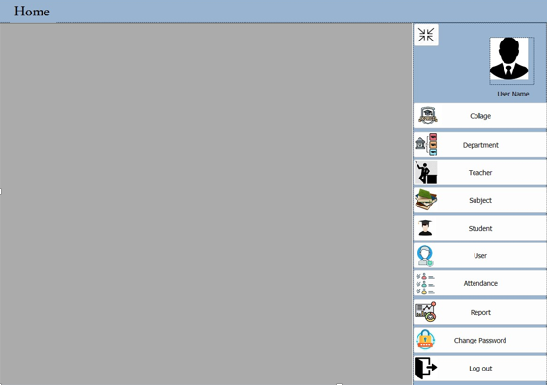First, this is our mini project for the past year it was designed by c# language and sql language, unfortunately, it was exclusive to one platform only (windows), that is why we developed our previous project and changed the development environment to be available to more than one platform that supporting browsing

Figure 2. Student Attendance System

## 2.2.2 Student Attendance with RFID and GPS

Nowadays, the usage of smartphones keeps increasing day by day and it is also can be used effectively to increase the security along with search and rescue. To maintain the attendance records, several schools and universities are depending on paper-based attendance manually recorded attendance for the students has produced problems that related to information accuracy and workforce performance efficiency. Applications and systems that can be used by the students to monitor their attendance using RFID and GPS. The outcome of this survives getting knowledge on various techniques that used to record and monitor student attendance.[1]

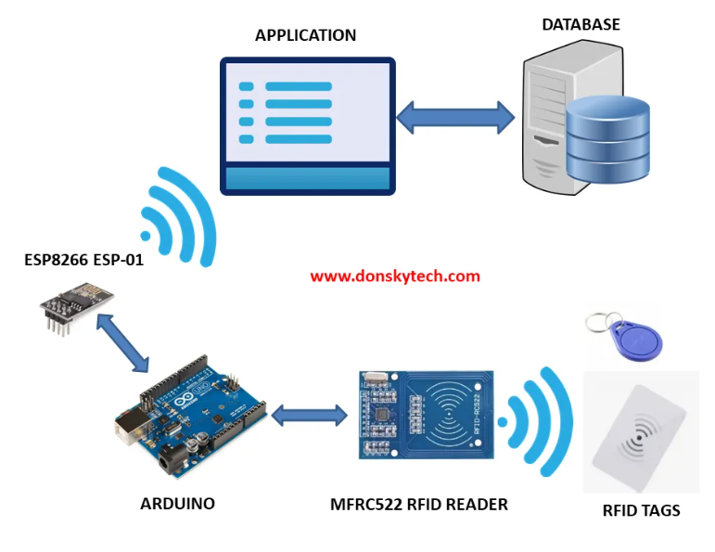

Figure 2. Student Attendance with RFID and GPS

## 2.2.3 Student Attendance System using QR Codes

A system that takes down students attendance using Qr code. Every student is provided with a card containing a unique Qr code. Students just have to scan their cards in front of webcam and the system notes down their attendance as per dates. Each Qr code contains a unique id for students. System then stores all the students’ attendance records and generates defaulter list. It also generates an overall report in excel sheet for admin.  Such type of application is very useful in school as well as in college for daily attendance.[2]

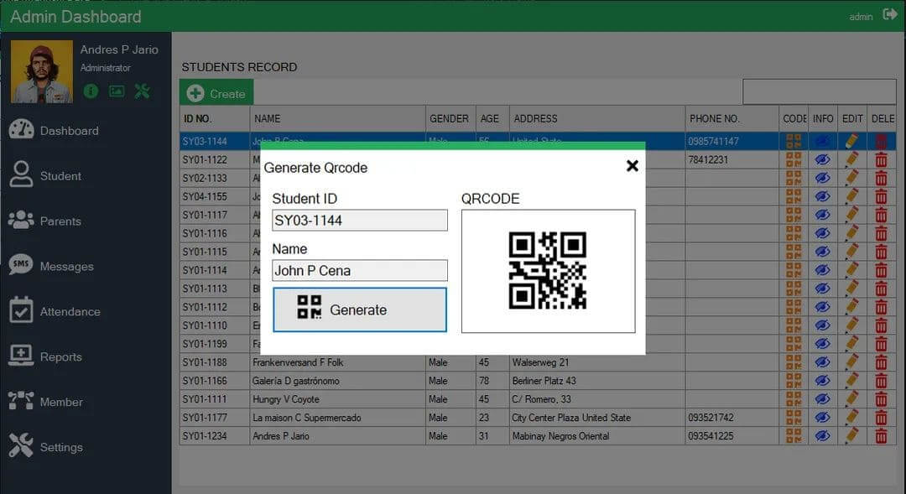

Figure 2. Student attendance system using QR codes

# 2.3 Background

This sections describes the hardware and software tools that are used in the project. The tools are C# language, Microsoft visual studio , SQL server for database management , HTML language for describes the structure of a Web application , Cascading Style Sheets ( CSS) and ASP.NET MVC technology.

## 2.3.1 SQL SERVER

Microsoft SQL Server is a relational database management system developed by microsoft. As a database server, it is a software product with the primary function of storing and retrieving data as requested by other software applications which may run either on the same computer or on another computer across a network (including the Internet). Microsoft markets at least a dozen different editions of Microsoft SQL server, aimed at different audiences and for workloads ranging from small single-machine applications to large internet-facing applications with many concurrent users. [3]

## 2.3.2 C# programming language

C# is a general-purpose, multi-paradigm programming language. C# encompasses static typing, strong typing, lexically scoped, imperative, declarative, functional, generic, object-oriented (class-based), and component-oriented programming disciplines . [4]

## 2.3.3 Microsoft Visual Studio

Microsoft visual studio is an integrated development environment (IDE) from Microsoft. It is used to develop computer programs, as well as websites, web apps, web services and mobile apps. Visual studio uses Microsoft software development platforms such as windows API, windows forms, windows presentation foundation, windows store and Microsoft silverlight. It can produce both native code and managed code. [5]

**2.3.4 HTML**

Hypertext markup language (HTML) is the most basic building block of the web. It defines the meaning and structure of web content. Other technologies besides HTML are generally used to describe a web page's appearance presentation (CSS) or functionality behavior ( JavaScript ).[6]

**2.3.5 CSS**

**Cascading style sheets**(**CSS**) is a style sheet language used to describe the presentation of a document written in HTML or XML (including XML dialects such as SVG, MathML or XHTML). CSS describes how elements should be rendered on screen, on paper, in speech, or on other media.[7]

**2.3.6 ASP.NET MVC**

ASP.NET is a free web framework for building websites and web applications on .NET framework using HTML, CSS, and JavaScript. ASP.NET MVC 5 is a web framework based on model-view-controller (MVC) architecture. Developers can build dynamic web applications using ASP.NET MVC framework that enables a clean separation of concerns, fast development.[8]

## 2.3.7 Server

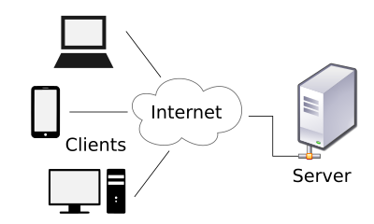In computing, a **server** is a piece of computer hardware or software (computer program) that provides functionality for other programs or devices, called "clients". This architecture is called the client–server model. Servers can provide various functionalities, often called "services", such as sharing data or resources among multiple clients, or performing computation for a client. A single server can serve multiple clients, and a single client can use multiple servers. A client process may run on the same device or may connect over a network to a server on a different device. Typical servers are database servers, file servers, mail servers, print servers, web servers, game servers, and application server. [9]

## 2.3.8 Jquery

jQuery is a JavaScript library designed to simplify HTML DOM tree traversal and manipulation, as well as event handling, CSS animation, and Ajax. It is free, open-source software using the permissive MIT License. As of Aug 2022, jQuery is used by 77% of the 10 million most popular websites. jQuery is a JavaScript library designed to simplify HTML DOM tree traversal and manipulation, as well as event handling, CSS animation, and Ajax. It is free, open-source software using the permissive MIT License. As of Aug 2022, jQuery is used by 77% of the 10 million most popular websites. [10]

## 2.3.9 Bootstrap

Bootstrap is a free and open-source CSS framework directed at responsive, mobile-first front-end web development. It contains HTML, CSS and JavaScript-based design templates for typography, forms, buttons, navigation, and other interface components. [11]

## 2.3.10 Javascript

JavaScript, often abbreviated as JS, is a programming language that is one of the core technologies of the World Wide Web, alongside HTML and CSS. As of 2022, 98% of websites use JavaScript on the client side for webpage behavior, often incorporating third-party libraries. [12]

## 2.3.11 Visual Studio Code

****Visual Studio Code, also commonly referred to as VS Code, is a source-code editor made by Microsoft with the Electron Framework, for Windows, Linux and macOS. Features include support for debugging, syntax highlighting, intelligent code completion, snippets, code refactoring, and embedded Git. [13]

**Chapter 3**

# RESEARCH METHODOLOGY

# Introduction

In this chapter, we’ll describe system analysis and design diagrams: Use Case Diagram, Data Flow Diagram, Database Design and, Entity Relationships Diagram.

The proposed of project, Student attendance Web application .We will work on the design of student attendance Web application for the Hadhramaut University. So, this project will solve many of the problems related to attendance effectiveness.

# System Requirements

Comprising of Functional and Non-Functional Requirements.

## Functional Requirements

1. **Login**

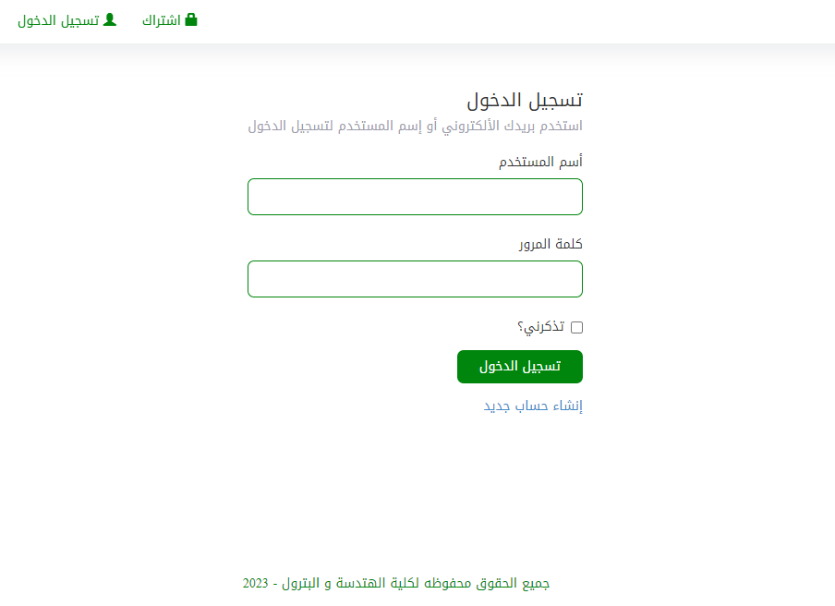The system Administrator and teachers can login to the Web application each One with its user name and password.

Figure 3. login interface

1. **Mange Users**

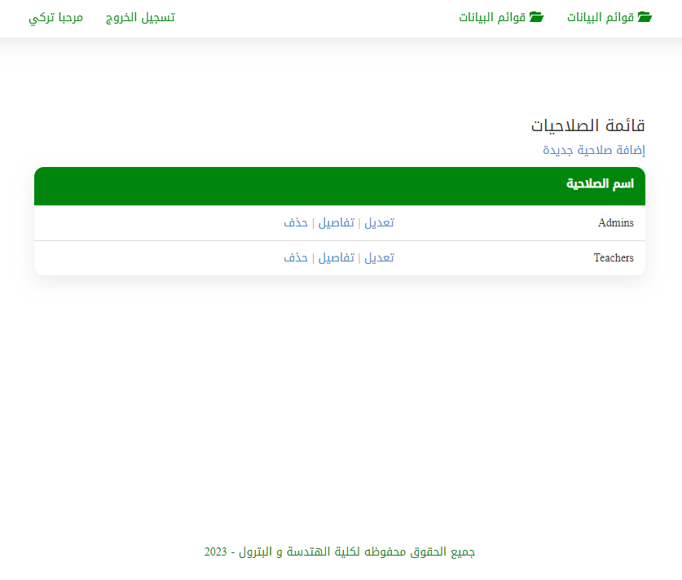User have all validity to manage every think in the Web application

Figure 3. User Management Interface

## Add Subjects to Student

The administrator is able to register each student to the prescribed subjects, in order for the student to carry out the attendance process without any problems.

## Add Subjects to Teachers

The administrator can also register each teacher in the subjects related to him, so that he can start the attendance of the course to all students.

## Manage College:

In order for the Web application to be effective and not exclusive to specific college, the administrator can add, modify and delete colleges.

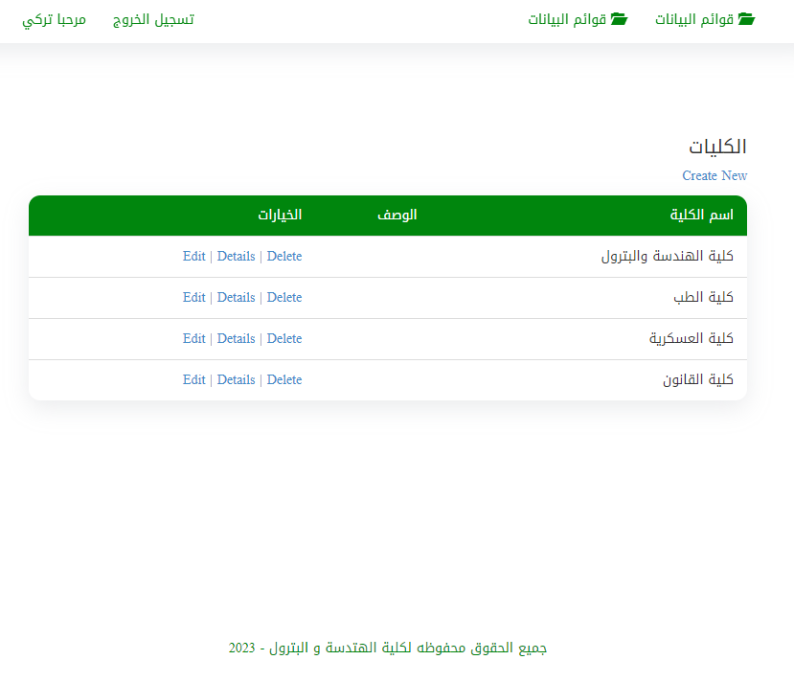

Figure 3. Collage Management Interface

## Manage Department

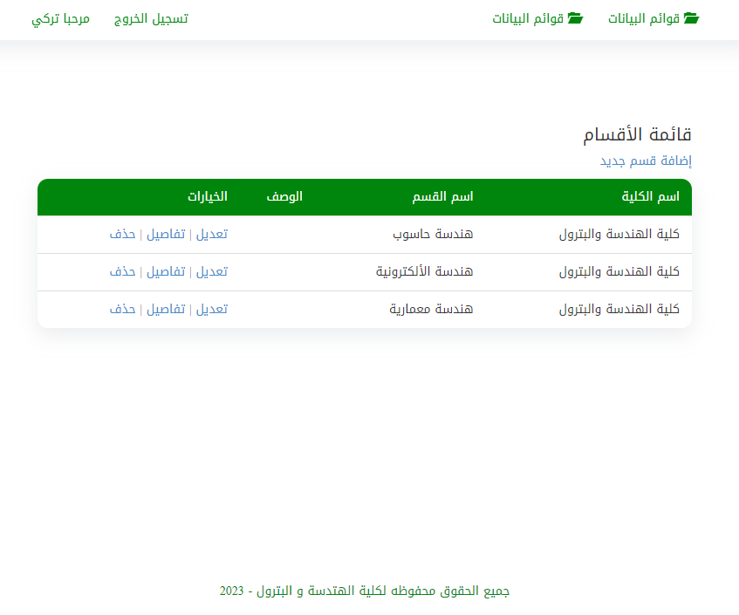The admin can also Add, Edit and Delete departments in the Collages.

Figure 3. Department Management Interface

## Create Reports

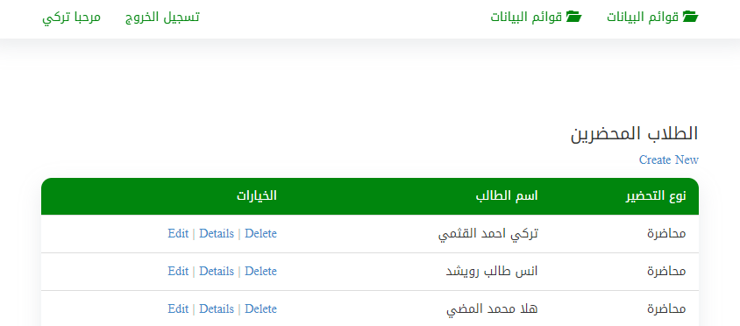The administrator and the teacher can create reports for each lecture, where the creation of the report requires specifying the date and name of the lecture.

Figure 3. Reports Management Interface

## Mange Level

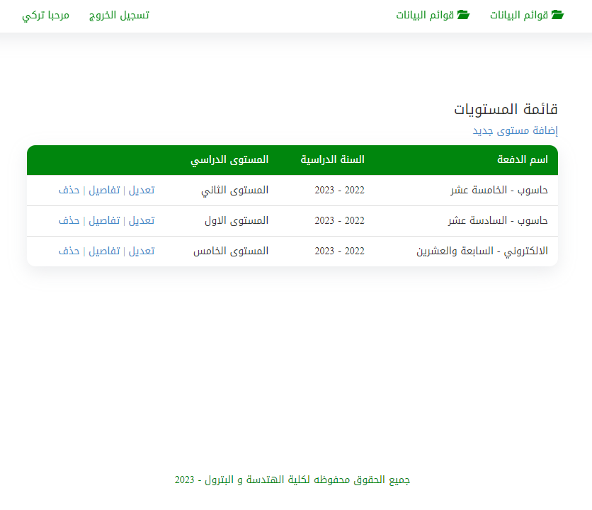The administrator can manage levels of the department.

Figure 3. Level Management Interface

## Manage Student

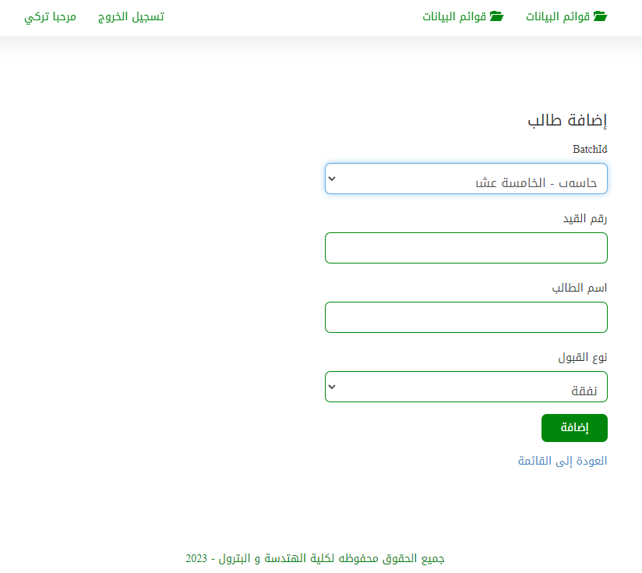The administrator can manage students by adding a new student, deleting a student, or modifying their information.

Figure 3. Student Management Interface

## Manage Teachers

The system administrator can manage the teachers by adding a new teacher, deleting a

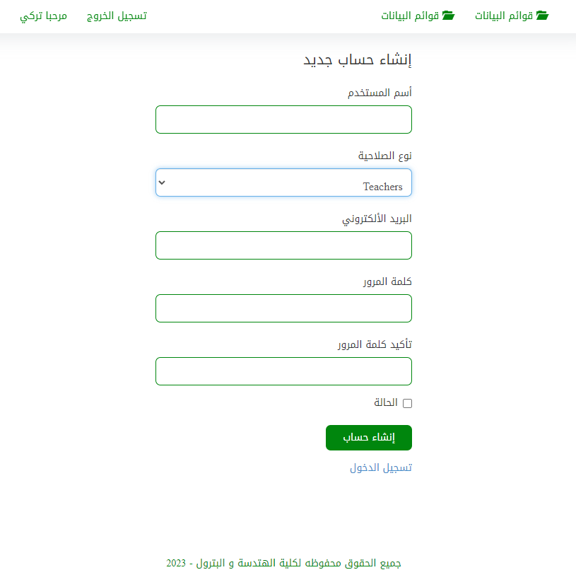teacher, or modifying their information.

Figure 3. Teacher Management Interface

## Manage Subjects

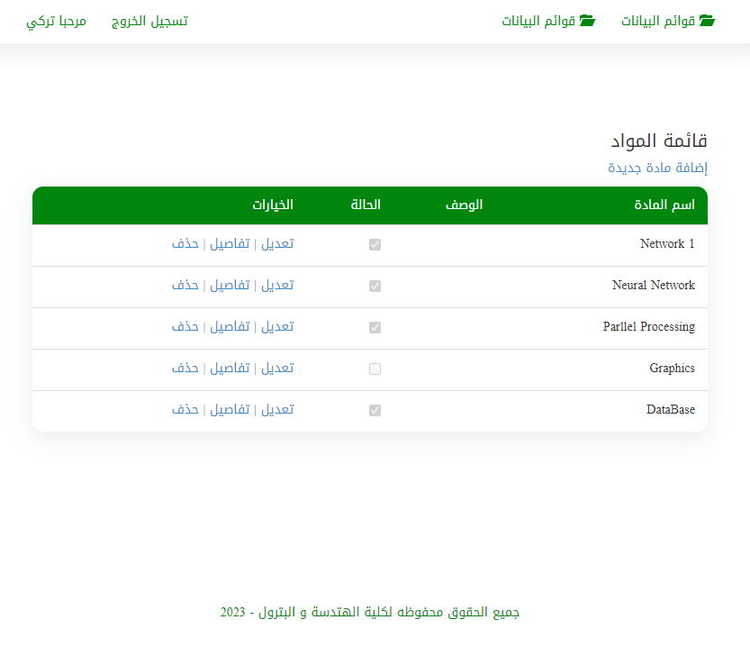Only the administrator can manage the process in the Web application such as: Add: The admin can insert or add subjects to the database.

Figure 3. Subjects Management Interface

## Attendance

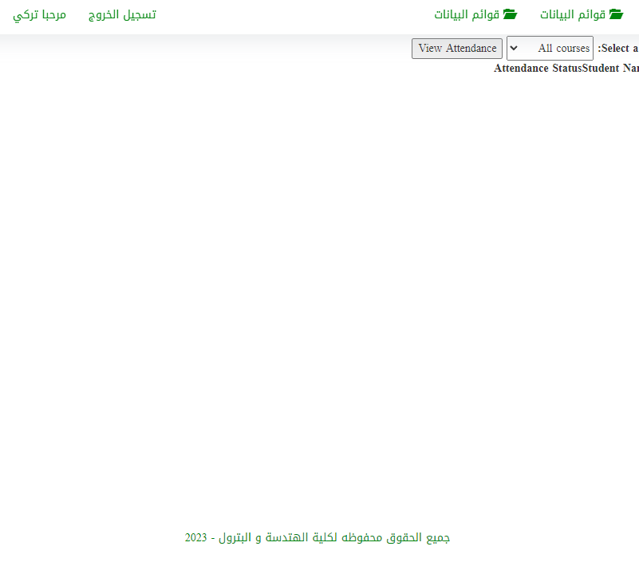the teacher can attendance the students in the class.

Figure 3. Attendance Management Interface

## Edit Attendance

Only the teacher can modify attendance of the students .

## Change Password

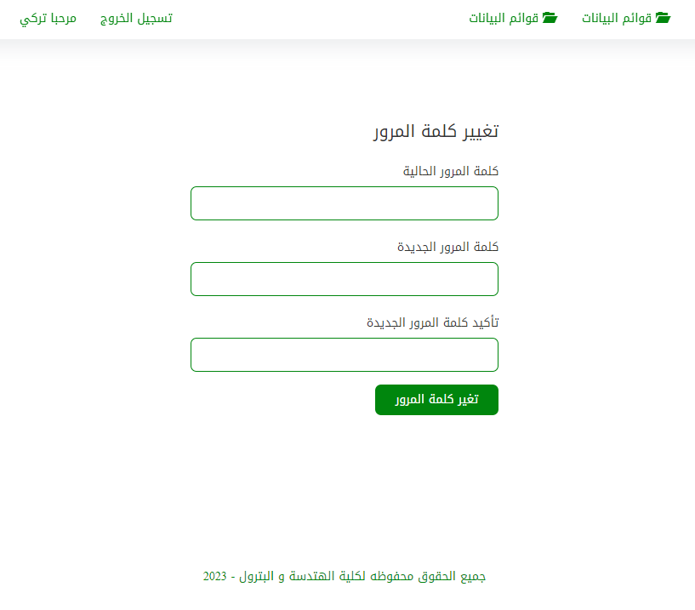The admin has the power to control and change all user data, whethe . The teacher also has the ability to change his password through the application.

Figure 3. Change Password Interface

## Nonfunctional Requirements

The following are non-function requirements of the student attendance Web application :

## Performance and scalability

The Web application works with high performance without any problems.

## Consistency

The student attendance Web application provides consistency to user interface design to the end-user. The designs of the screen standardize and consistent to make the end-user to feel comfortable to use it.

## Availability

The system is available to all teachers at the same time and works with any device has internet browser without any problems, the system works only on a local network and not on the Internet.

## Usability

The use of the Web application is easy for all users. the system administrator can add

Delete and modify data easily and without complication.

# System Analysis and Design

The analysis of system can be done as in sections below:

## Use Case Diagrams

Use case diagram consists of actors and their relationships. these diagrams are especially important in organizing and modeling the behaviors of systemizing.

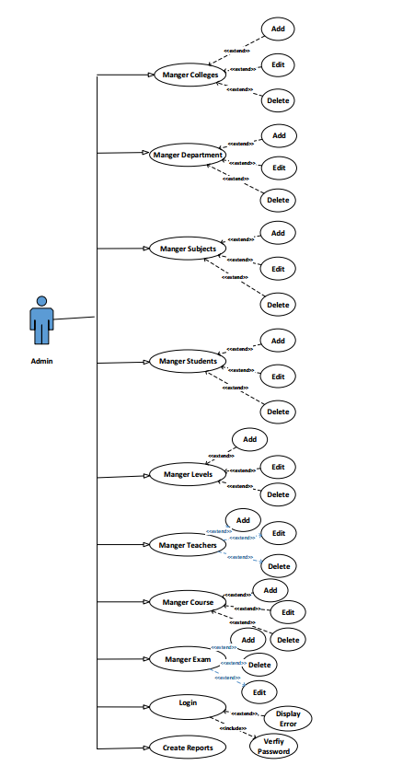

Figure 3. Use case Admin

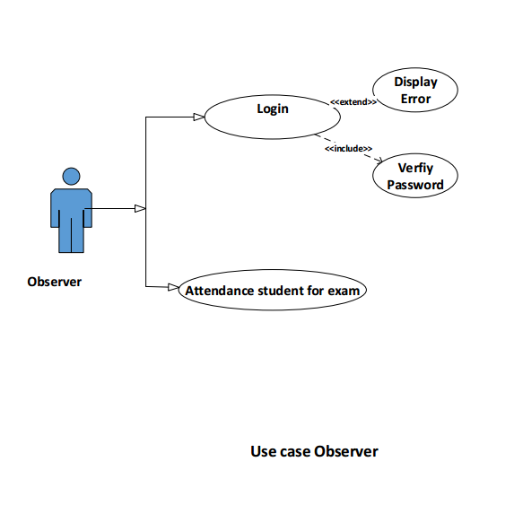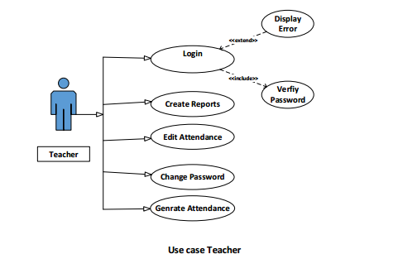

Figure 3. Use case Observer

Figure 3. Use case Teacher

# 3.3.2 Data Flow Diagram

## The Context Diagram

The context diagram for student attendance Web application is shown in figure the three entities are

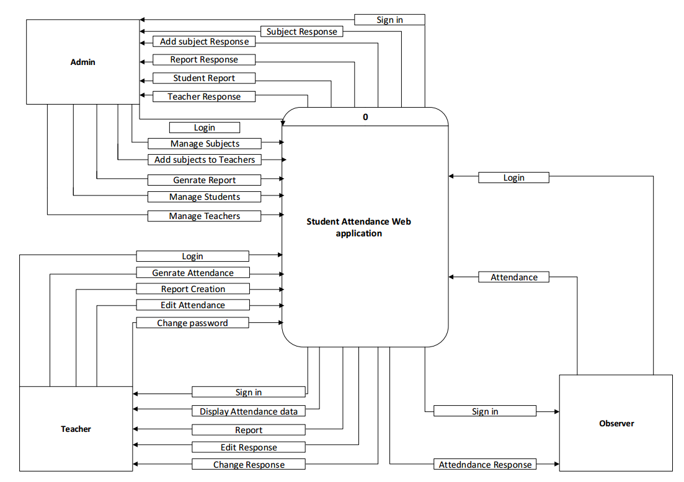(Admin & Teacher & Observer) are interaction among central process &entities involves different data flow.

Figure 3. Data Flow diagram

**ER Diagram**

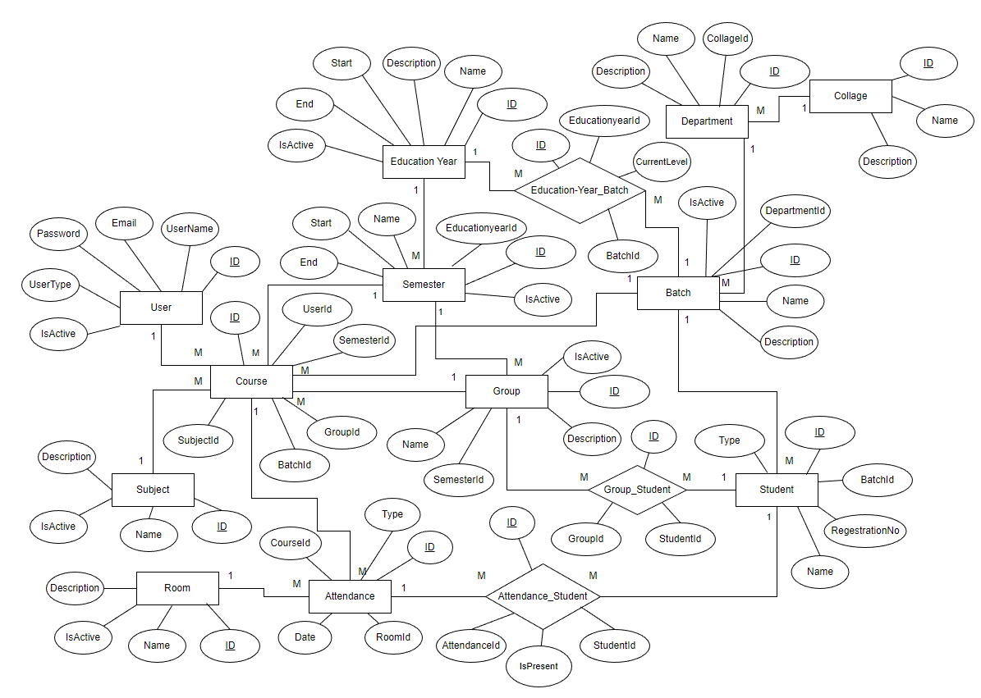An Entity Relationship (ER) Diagram is a type of flowchart that illustrates how “entities” such as people, objects or concepts relate to each other within a system.

Figure 3. ER diagram

## Database design

Database design is the organization of data according to a database model.

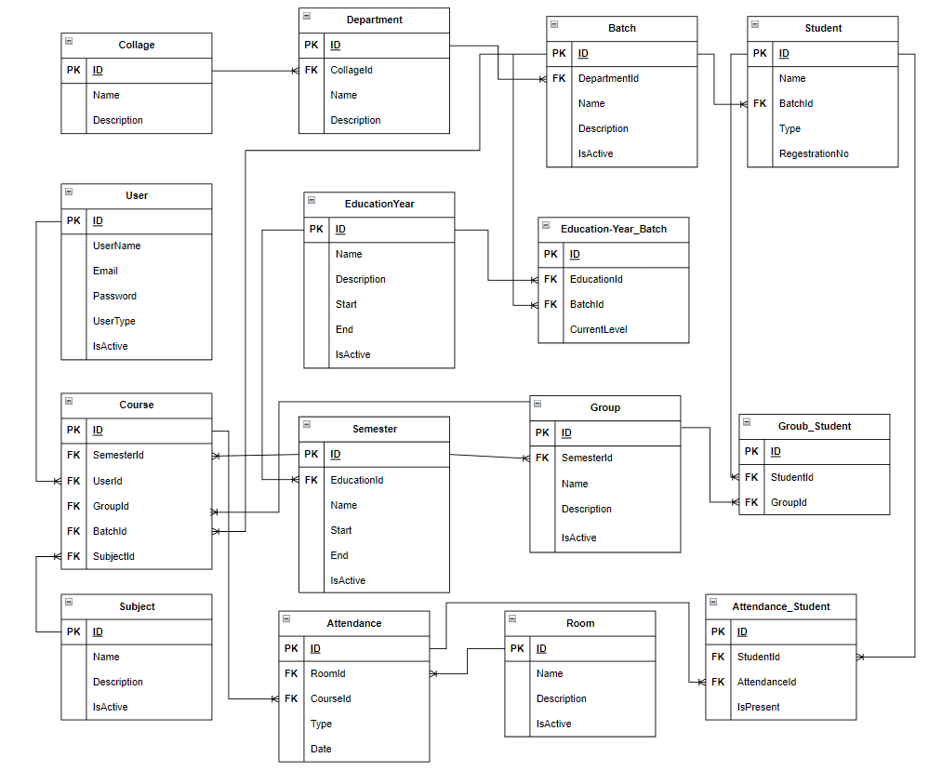

Figure 3. Database design

# CHAPTER 4

# CONCLUSION AND FUTURE WORK

## Conclusion

The project of Student attendance Web application was designed for educational organizations . This project mainly comprised of development of attendance management. This project presented a framework in which attendance management was made automated.

This system was developed to work in a specific range on a local network and does not need an Internet connection in order to carry out the tasks required of it.

One of the key benefits of the system is that it reduces the workload of teachers and administrators. With the automated attendance tracking feature, teachers no longer need to spend time taking attendance manually, which frees up more time for teaching and other administrative tasks and also helps in preparing Reports at the required time and ease to downloaded automatically the reports into the device.

Teachers by using mobile can access to take attendance records from their mobile devices. This would be particularly useful for teachers who frequently move between classrooms or who teach classes in different buildings.

The system was tested at the University of Hadhramout for College of Engineering & Petroleum.

## Future Work

In the future, the system can be improved by adding more features including:

* Alert the student who has a high absenteeism rate and may lead to being deprived of the exam.
* Improve the design of the report so that it becomes clearer.
* Admins and teachers can make monthly reports and final reports by the end of each term very easily. Also Create reports of students whose absence exceeds the number allowed by the university in the course.
* Allow the student to make quires that enable him to know the number of absences he has in any course.

**Reference**

[1] A. R. Ruchendar and G. T. Mardiani, "Attendance Application Development Using RFID With Android Based Gps In Pt. Dinus Cipta Mandiri", 2013.

[2] A. Manori, N. Devnath, N. Pasi and V. Kumar, "QR Code Based Smart Attendance System", *Int. J. Smart Bus. Technol.*, vol. 5, no. 1, pp. 1-10, Jul. 2017.

[3] Rsocol,"Microsoft SQL Server," Wikipedia, 15/3/2022. [Online].

Available: https://en.wikipedia.org/wiki/Microsoft_SQL_Server.

[4] Shvahabi, "C#(programming language)," Wikipedia, 30/6/2014. [Online].

Available: https://en.wikipedia.org/wiki/C_Sharp(programming language).

[5] C. a. T. Chinese, "Microsoft Visual Studio," Wikipedia, 12 3 2022. [Online]. Available: https://en.wikipedia.org/wiki/Microsoft_Visual_Studio .

[6]  "HTML5, one vocabulary, two serializations" Retrieved February 25, 2009.

[7] Meyer, Eric A. (2006). [Cascading Style Sheets: The Definitive Guide](https://shop.oreilly.com/product/9781565926226.do) (3rd ed.). O'Reilly Media, Inc. [ISBN](https://en.wikipedia.org/wiki/ISBN_(identifier)) [0-596-52733-0](https://en.wikipedia.org/wiki/Special:BookSources/0-596-52733-0). [Archived](https://web.archive.org/web/20140215041138/https:/shop.oreilly.com/product/9781565926226.do) from the original on 2014-02-15. Retrieved 2014-02-16.

[8] "Nuget package Microsoft.AspNet.Mvc". Retrieved 10 January 2019.

[9] Comer,Douglas and Stevens, "server," 24 4 2011. [Online]. Available: https://en.wikipedia.org/wiki/server. [Accessed 14 7 2022].

[10] https://en.wikipedia.org/wiki/JQuery

[11] https://en.wikipedia.org/wiki/Bootstrap_(front-end_framework)

[12] https://en.wikipedia.org/wiki/JavaScript

[13] https://en.wikipedia.org/wiki/Visual_Studio_Code

**شهادة المشرف**

أشهد بأن إعداد هذا المشروع الموسوم:

" **موقع تحضير الطلاب** "

والمعد من قبل الطلاب:

انس طالب رويشد

تركي احمد القثمي

سالم محمد السومحي

هلا محمد المضي

قد تم تحت إشرافي في قسم هندسة الحاسوب - كلية الهندسة والبترول في جامعة حضرموت وهو جزء من متطلبات نيل درجة **بكالوريوس الهندسة في هندسة الحاسوب.**

**الاسم :**

**التوقيع:**

**التاريخ:**



**جامعة حضرموت**

**كلية الهندسة والبترول**

**قسم هندسة الحاسوب**

**موقع تحضير الطلاب**

**مشروع مقدم كجزء من متطلبات نيل درجة بكالوريوس الهندسة في هندسة الحاسوب**

**إعداد**

**انس طالب رويشد**

**تركي احمد القثمي**

**سالم محمد السومحي**

**هلا محمد المضي**

**إشراف**

**د .خالد فوزي**

**المكلا**

**يوليو-2023**