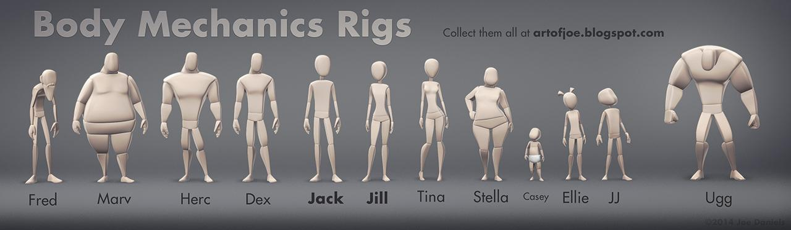

**Body Mechanics Rigs**

Designed and built by Joe Daniels

[josephsdaniels@gmail.com](mailto:josephsdaniels@gmail.com)

[artofjoe.blogspot.com](http://artofjoe.blogspot.com/)

**The Rigs:**

These rigs are simple and lightweight, allowing the animator to focus on refining the body mechanics and acting, without having to worry about facial expression. They have all the usual stuff, IK/FK everything, bend attributes on the arm and leg controls to adjust the flow of the limbs (ex: Forearm Bend X and Y attributes on the wrist control). Poses can be further refined with animatable Proxies that allow you to reshape the forms as desired. The shaders are built to look really nice, whether in Viewport 2.0 or rendered in Mental Ray.

The “BodyMech Rig” menu that appears when the rig is opened has an IK/FK matching action for seamlessly switching between IK and FK modes. Just select a single control on the limb you want to match and run the command from the menu. The controls are also keyed in the new position automatically.

For selecting controls, there is a quick select set that will select all the rig’s controls, and I have also created the included [AnimSchool Picker](http://www.animschool.com/pickerInfo.aspx) that can be used with any character (only works when character is referenced into your scene). The picker has a number of features, one of which is a Reset Pose button that zeroes the rig out to the default settings.

The uv's are the same for all the characters, with all the parts laid out into one square. This means you can paint a single texture map for the whole body and use that on any rig.

**Extra Features:**

All the rigs except Casey and Tina have an option to toggle on bare feet. I would like to add things like hairstyles to some of the rigs, as well as corrective blendshapes to improve deformation, though this is dependent on how well funded the project is. *Tell your friends and instructors!*

If there is an update to the rig, I will send out a message through Gumroad, notifying you of the changes.

If a given rig has any special features, this will be toggleable on the placement (or “Character”) control. Be sure to check out both the Sumo and Santa clothes on Marv's placement control. :)

Happy animating!

~Joe

**Version History**

1.0 - 8/29/2014 Initial release.

1.1 - 10/4/2014 Rigs rebuilt with TSM2. Added seamless FK/IK switching, scalable body parts, and Autostretch IK that avoids IK pop as the limbs straighten. NOTE: these rigs have different naming conventions from the previous version, so your old animation files should not reference these new versions of the rigs, or animation data will be lost. This will only be an issue if you overwrite your old rigs, downloaded previous to the 1.1 release. For new projects, using these rigs is the way to go!

1.2 - 12/16/2014 Bug fixes, plus new Santa mod for the Marv rig! Fixed issues include ik foot orientation offset on all rigs, and Dex and Ugg had issues receiving new shaders. This should be resolved.