ARCHITECTURE & OPERATING MODEL
Power BI AI
Analysis Agent
A metadata-driven, scope-aware pipeline that converts a Power BI semantic model into concurrent descriptive summaries and evidence-backed investigative insights.

1. Executive overview
PROJECT PURPOSE Turn a governed Power BI semantic model into decision-ready narrative analysis while preserving scope, numeric fidelity and an auditable evidence trail.
The project automates the analytical work that normally sits between a Power BI model and a management narrative. It reads model metadata, identifies usable measures and dimensions, determines the valid comparison population, executes controlled DAX queries, and produces two complementary outputs in the same run.
Descriptive report. The summary stream explains what the numbers are, using model-aware DAX, fresh-fact selection and a compact report format suited to business readers.
Investigative report. The insight stream examines what contributed to movement, combining deterministic statistical candidates, reusable evidence and tightly budgeted follow-up probes before an LLM writes the narrative.
The full product lives in powerbi-summary-agent/. The root pbi_agent.py remains a small authentication and DAX proof-of-concept that established the headless access pattern reused by the product.

What makes the solution distinctive
- Model-driven operation. Measures, dimensions and scan targets are derived from semantic-model metadata instead of a hard-coded, model-specific query list.
- Two concurrent perspectives. The graph fans out into summary and insight branches, then waits at an explicit barrier before final delivery.
- Deterministic guardrails. Metadata validation, comparable-scope enforcement, provenance contracts, row caps and probe budgets constrain generative steps.
- Continuity across runs. Summary and insight memory suppress routine repetition and preserve dated history without confusing observed activity with findings actually delivered to users.
- Deployment flexibility. The same entry point supports local interactive execution and unattended Azure Container Apps Jobs with managed identity and optional Blob delivery.

Intended audience
This overview is for product sponsors, analytics leaders, solution architects, security reviewers and engineers who need to understand the system's role, structure and operating guarantees without reading the node-level implementation.

2. Solution architecture
The architecture separates model interpretation and baseline evidence from report generation. Shared structural decisions happen once before the fork; the two branches then work independently and reconverge only after both have completed or taken their branch-specific failure path.
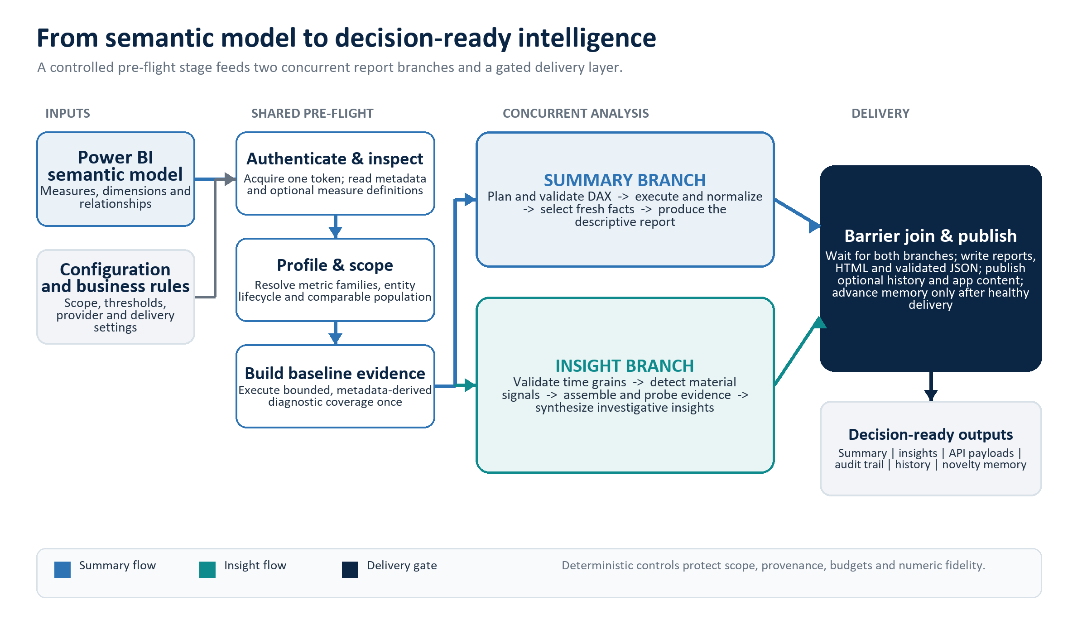
Figure 1. High-level architecture and execution model.

Architectural principles
- Shared truth before generation. Metadata, business rules, entity scope and baseline evidence are resolved before the graph creates competing narratives.
- Independence after the fork. A failure in one report branch does not erase a valid output from the other branch.
- Barrier-controlled delivery. The final save stage runs only after both branch barriers, preventing duplicate or racing writes.
- Evidence before explanation. The insight narrative is downstream of deterministic detection, evidence contracts, reuse checks and investigation budgets.

3. End-to-end operating lifecycle
- Load configuration and business policy. The run resolves dataset identifiers, model and provider settings, operational limits, optional business rules and output destinations.
- Authenticate and read the model. Local runs use interactive MSAL once and then a persisted refresh-token cache; Azure runs can use managed identity or service-principal credentials without touching the local cache.
- Build a semantic profile and valid scope. The system identifies metric families, candidate dimensions, entity lifecycle and the comparable population, with code-enforced treatment of current-only and excluded entities.
- Create the shared evidence baseline. A bounded portfolio of metadata-derived queries establishes totals, movers, concentration, trends and other reusable facts before the report branches start.
- Run the two analysis branches concurrently. The summary branch produces a concise descriptive view; the insight branch validates temporal grains, detects material signals, fills genuine evidence gaps and writes an investigative view.
- Validate, publish and commit continuity state. Reports and machine payloads are written first. Optional cloud publication and history follow. Memory advances only under the corresponding health and delivery conditions.

Summary branch at a glance
The summary path uses LLM assistance for intent planning, DAX authoring and narrative generation, but code validates every referenced object and comparison scope. Invalid or failed generated DAX receives one repair attempt. The current fresh-summary path then resolves the reporting period, builds candidates, applies novelty rules, generates a compact draft and validates its structured facts before writing the report.

Insight branch at a glance
The insight path normalizes the shared data, validates usable period and business-day axes, detects period, recent-window and daily incidents when the model supports them, and creates deterministic candidate findings. A structured LLM selects among eligible material candidates; evidence is reused first, then only missing dimensions receive bounded DAX probes. The final report uses contribution and correlation language rather than unsupported claims of causality.

4. Major components
The repository contains a small proof-of-concept and a production-oriented agent package. The table below groups the implementation into reader-friendly layers rather than listing individual graph nodes.
Table 1. Major solution components
Layer | Primary implementation | High-level responsibility
Foundation | pbi_agent.py | Proves headless authentication and a single Power BI DAX round-trip.
Orchestration | LangGraph state graph | Coordinates shared preparation, concurrent branches, failure routing and the final barrier.
Semantic intelligence | Metadata reader, profiler and scope baseline | Discovers model structure, metric families, business dimensions and comparable populations without hard-coded model names.
Descriptive analysis | Summary branch | Plans, validates and executes DAX, then selects fresh facts and produces the report summary.
Investigative analysis | Insight branch | Tests temporal and business signals, assembles evidence, spends bounded probes and synthesizes material findings.
Delivery and continuity | Output, history and memory tools | Writes human and machine outputs, supports Azure publication and prevents routine findings from repeating across runs.

Technology foundation
- Workflow and agents: Python, LangGraph, LangChain and Pydantic structured outputs.
- Data access: Power BI REST executeQueries for local JSON responses and executeDaxQueries with Apache Arrow for unattended headless operation.
- Authentication: MSAL for local interactive access; Azure Identity for managed identity or service-principal execution.
- Language models: Azure OpenAI, OpenAI or Anthropic selected through configuration.
- Cloud persistence: Optional Azure Blob Storage for public payloads, immutable history and private dataset-scoped memory.

Repository support assets
Prompt files define role-specific LLM instructions; replay scripts verify deterministic scanners, detectors, evidence assembly, history and memory without live authentication; the Dockerfile packages the product as a non-root Python 3.11 job. A separate KPI benchmark utility exercises configured semantic-model measures independently so one broken measure does not mask the rest.

5. Trust, control and failure model
CONTROL OBJECTIVE Use generative reasoning where it adds value, while keeping scope, query safety, evidence provenance, materiality and delivery state under deterministic control.

Authentication and secret handling
Local authentication is headless after the first browser sign-in because both the MVP and the full agent share the repository-root MSAL token cache. The cache, .env file, real dataset configuration, business rules, outputs and memory are gitignored. In Azure, the executor resolves to managed identity or service principal and does not read or write the local token cache. Optional Fabric measure-definition enrichment uses a separate audience and fails softly so it cannot hang an automated run.

Query and scope safeguards
Generated DAX is cross-checked against model metadata and the resolved comparable population. Queries using prior or change metrics must prove the correct entity filter. Excluded and current-only entities cannot leak into comparable denominators. Broad scans, gap scans and investigator calls are bounded by query, dimension, row and round budgets.

Evidence integrity
Every reusable table is cataloged with population, grouping, metric roles, filters, truncation, completeness and a DAX hash. Metadata templates are not LLM-repaired because a free-form rewrite would break their construction-time provenance. Partial or ambiguous evidence can support a fact, but it cannot close a drill dimension as complete evidence.

Fault isolation and honest degradation
Only metadata failure is fatal before the fork. After the fork, branch-specific failures remain isolated. Temporal and daily analysis self-disable when a trustworthy business-time axis is unavailable or stale, and the report carries the resulting caveat. The save stage still writes explicit stub artifacts for a missing report so downstream operators can distinguish failure from absence.

Memory and delivery ordering
The system separates what was observed from what was actually reported. Insight observations can advance when the underlying analysis completes, but story records are marked seen only when a real report exists. Summary memory is committed only after its report, payload, history and configured publication paths are healthy. Cloud writes use conditional or non-overwriting behavior to protect immutable history and prevent silent state loss during overlapping executions.

6. Deployment and operations

Local development
Create local copies of the environment, configuration and optional business-rules templates, install dependencies, then run the package as a module from powerbi-summary-agent. The first interactive authentication may open a browser; later runs are silent while the cached refresh token remains valid.
cd powerbi-summary-agent
pip install -r requirements.txt
python -m src.main
python -m src.main --config path/to/config.json

Azure Container Apps Job
The Docker image runs as a non-root user and starts through src.container_entrypoint. Runtime configuration can be mounted or injected through environment variables and encoded secrets. The recommended scheduled shape is one replica and one completion per execution; no HTTP listener is required. Managed identity, the Arrow query API and optional Azure Blob publication support unattended production runs.

Configuration layers
- Target and runtime: tenant, workspace, dataset, output folder, authentication mode and query wire format.
- AI routing: provider, model, endpoint credentials and output-token ceiling.
- Analysis controls: summary size, row caps, scan budgets, signal limits, materiality thresholds and temporal settings.
- Business policy: optional rules file plus machine-enforced comparable and excluded entity lists.
- Delivery and continuity: API payloads, history, local or cloud memory, Azure Blob destinations and tenant app-content projection.

Operational observability
Each node writes intermediate artifacts so partial progress can be inspected. run_log.txt records node activity, branch-finished timestamps and errors; the two branch markers also provide a practical check that the concurrent paths overlapped. Production exit status remains non-zero when required cloud memory or configured client publication cannot complete safely.

7. Outputs and downstream use
The agent writes its analysis in several complementary forms. Human reports are the primary product; machine payloads, evidence artifacts, history and memory make the same run usable by applications, operators and later executions.
Table 2. Output families
Audience | Format | Purpose
Human-readable | Markdown and HTML | Descriptive summary and investigative insight report, with optional visual tiles.
Application-facing | Validated JSON | Report summary and KPI insight payloads for downstream UI or API consumers.
Evidence and audit | JSON artifacts and run log | Metadata profile, DAX plans, raw and normalized results, contracts, signals, investigation trails and errors.
Continuity | History and novelty memory | Dated history feeds and dataset-scoped memory for unseen-finding and fresh-summary behavior.
Cloud delivery | Azure Blob and client projection | Optional immutable history, latest payloads and tenant-specific app-serving content.

8. Verification and acceptance
Deterministic components can be verified offline using replay scripts for metadata scanning, statistical detection, novelty filtering, evidence assembly, history, memory and API projection. A focused live scan validates Power BI connectivity and the metadata-built coverage portfolio. The complete acceptance test is an end-to-end run against a permitted semantic model, followed by review of both reports, structured payloads and the run log.
- Offline quality gate. Compile the source and run the relevant replay scripts without authentication or LLM calls.
- Live integration gate. Confirm Execute Queries is enabled, the identity has read/build access, and the metadata/coverage scan succeeds.
- End-to-end acceptance. Verify both report branches, numeric fidelity, caveats, API schemas, output history and memory behavior on a real model.

9. Current boundaries
- The product is a scheduled analysis job, not an HTTP service; serving applications consume its published artifacts.
- Insight narratives explain measured contribution and correlation. They do not claim causal proof without model evidence.
- Fine-grained temporal analysis requires a genuine, current business-day axis and safely disables itself when that requirement is not met.
- The full live pipeline depends on external Power BI permissions, configured LLM access and, when enabled, Azure storage connectivity.
- The repository does not currently include a license file; distribution terms should be established before external release.

Source basis
This document reflects the repository as inspected on 28 July 2026, primarily using the root and product READMEs, src/graph.py, src/main.py, src/tools/powerbi_executor.py, config/config.example.json, Dockerfile, requirements.txt and the replay utilities. It is intentionally a high-level project overview rather than a replacement for code-level or schema-specific documentation.

