

Practices for Secure Software Report

Table of Contents
Document Revision History 3
Client 3
Instructions 3
Developer 4
1. Algorithm Cipher 4
2. Certificate Generation 4
3. Deploy Cipher 4
4. Secure Communications 4
5. Secondary Testing 4
6. Functional Testing 4
7. Summary 4
8. Industry Standard Best Practices 4

Document Revision History

Version | Date | Author | Comments
1.0 | October 17, 2026 | Ashton Sells | Initial draft

Client



Instructions

Submit this completed practices for secure software report. Replace the bracketed text with the relevant information. You must document your process for writing secure communications and refactoring code that complies with software security testing protocols.

- Respond to the steps outlined below and include your findings.
- Respond using your own words. You may also choose to include images or supporting materials. If you include them, make certain to insert them in all the relevant locations in the document.
- Refer to the Project Two Guidelines and Rubric for more detailed instructions about each section of the template.

Developer
Ashton Sells

Algorithm Cipher

I recommend Artemis Financial to use SHA-256 to generate a checksum for the data. SHA-256 is part of the SHA-2 family and produces a fixed 256-bit digest, normally displayed as 64 hexadecimal characters. The input can be any length, but the output length stays the same. A small change in the input should produce a different digest, which makes a cryptographic hash useful for checking whether data has changed.

SHA-256 has functions that produce a 256-bit digest of any input. The key properties are determinism, preimage resistance, collision resistance, and the “avalanche effect”. The “avalanche effect” dictates that one small change, such as a character change, will result in a completely different digest (Burdalo, 2026).

A hash function is not an encryption cipher: it does not use an encryption key and there is no decryption operation that restores the original data. It is also not a substitute for a digital signature or message authentication code when the application needs to prove who supplied the data. For this project, SHA-256 is appropriate for demonstrating a checksum.

Secure random values are important to modern protocols because predictable keys or nonces can undermine protection. Random number generators deliver unpredictable sequences of random numbers when needed. TLS uses asymmetric cryptography and certificate validation during connection setup, key agreement to establish shared session secrets, and symmetric encryption for efficient protection of application traffic. Symmetric keys are shared secrets; asymmetric systems use a public/private key pair. The local certificate in this coursework is self-signed, so it is suitable for a localhost demonstration but is not equivalent to a certificate issued and validated by a trusted public certificate authority.

Older algorithms such as DES and obsolete protocol versions are no longer recommended for new systems. AES was selected by NIST in 2000 as the replacement for older encryption standards and was standardized in FIPS 197 in 2001. AES and modern TLS configurations are widely used today. SHA-1 and MD5 should not be chosen for new collision-resistant integrity checks; SHA-256 remains a common, appropriate hash choice. Security also depends on correct configuration, key protection, certificate validation, and maintenance of dependencies.

Certificate Generation

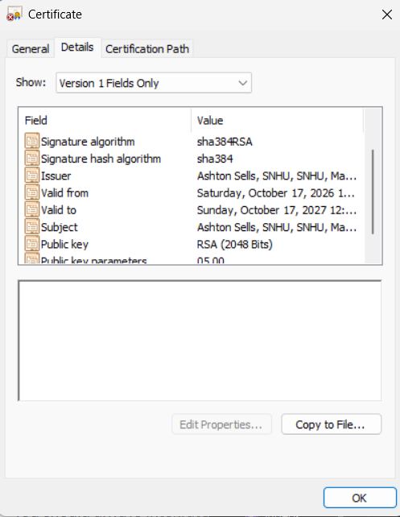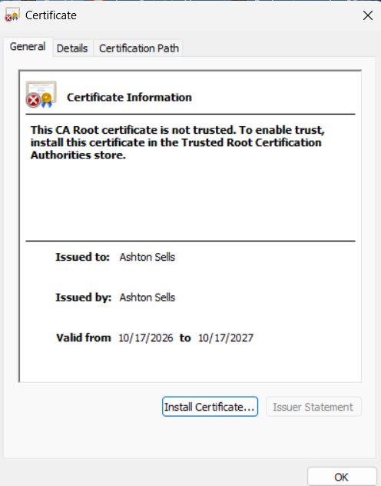

Deploy Cipher

Checksum Verification via HTTP port
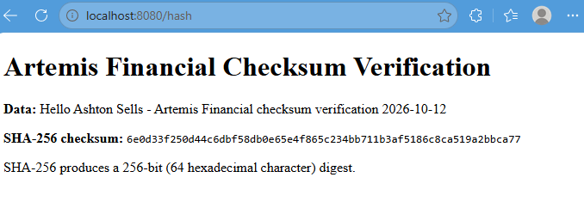

Secure Communications

Checksum Verification via HTTPS port

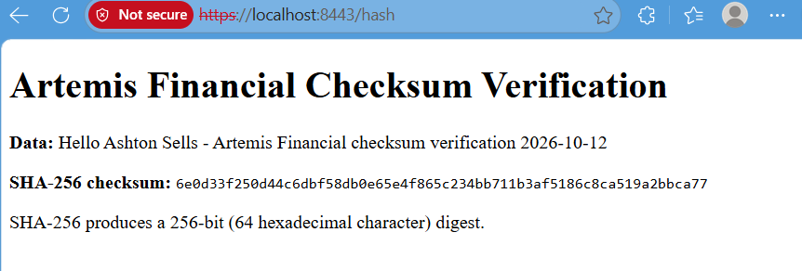

Secondary Testing

application.properties

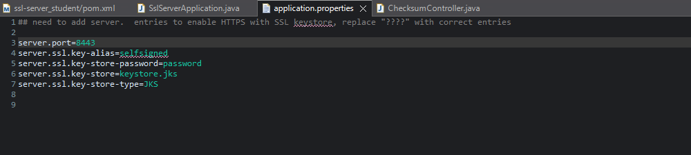

ChecksumController.java successfully running
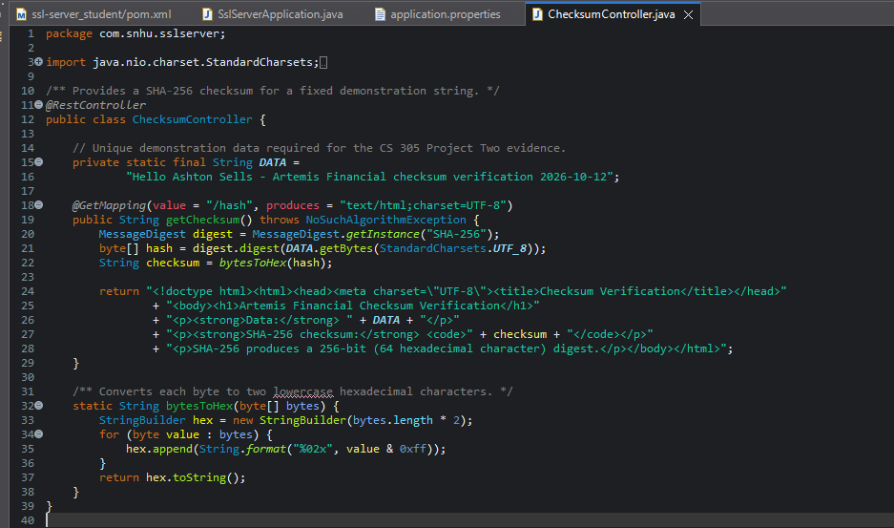
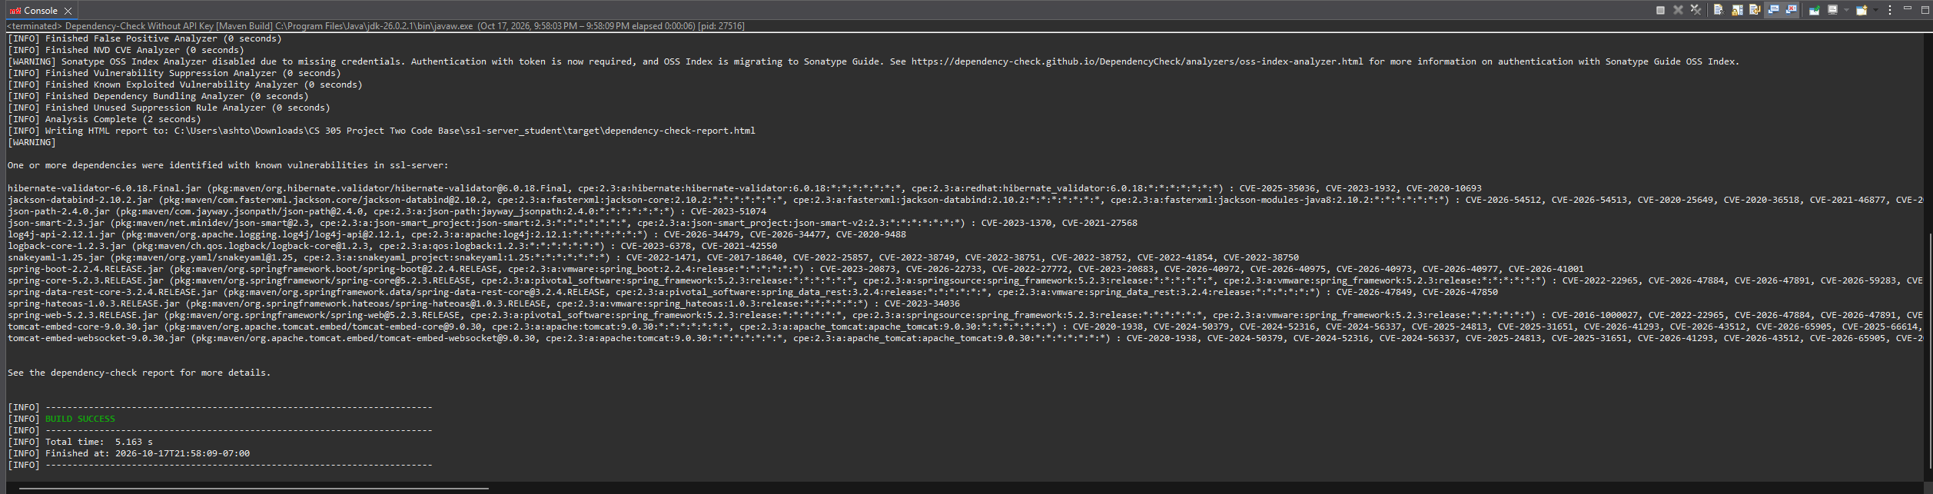

Dependency Check Report w/o API key, no suppression
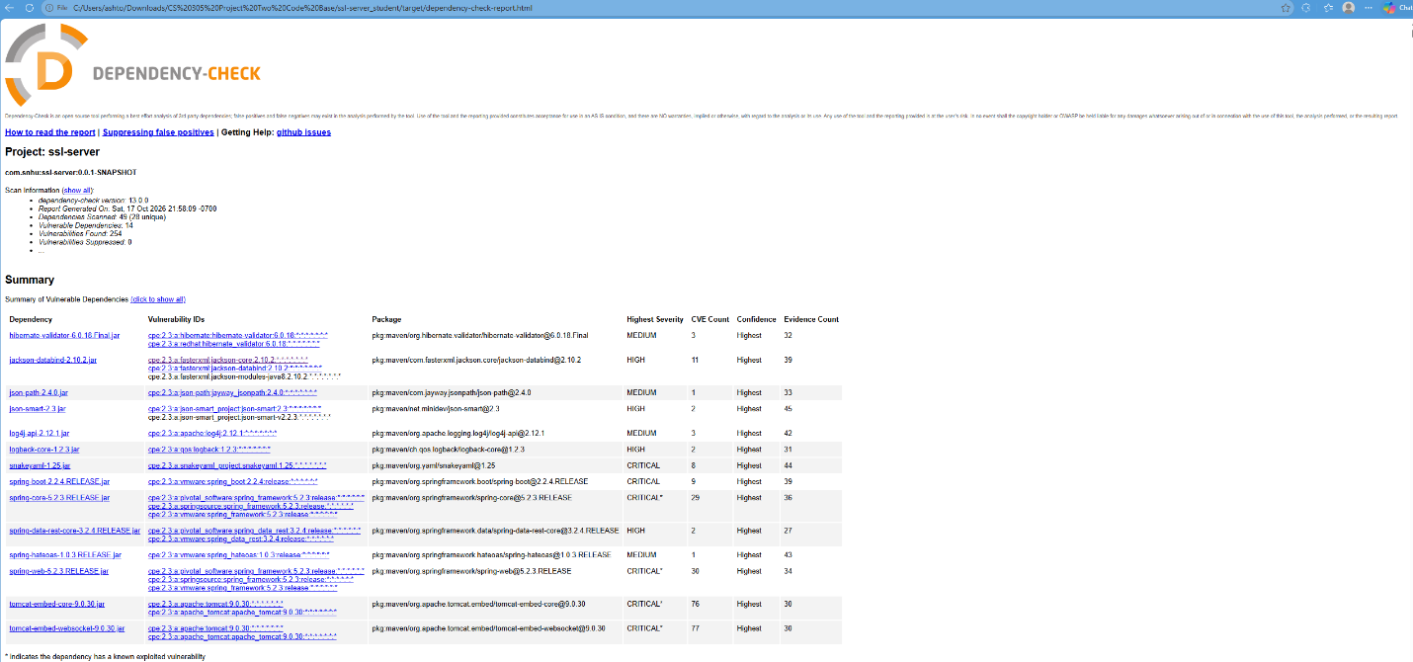

Functional Testing

ChecksumController.java running w/o errors (refactored code)
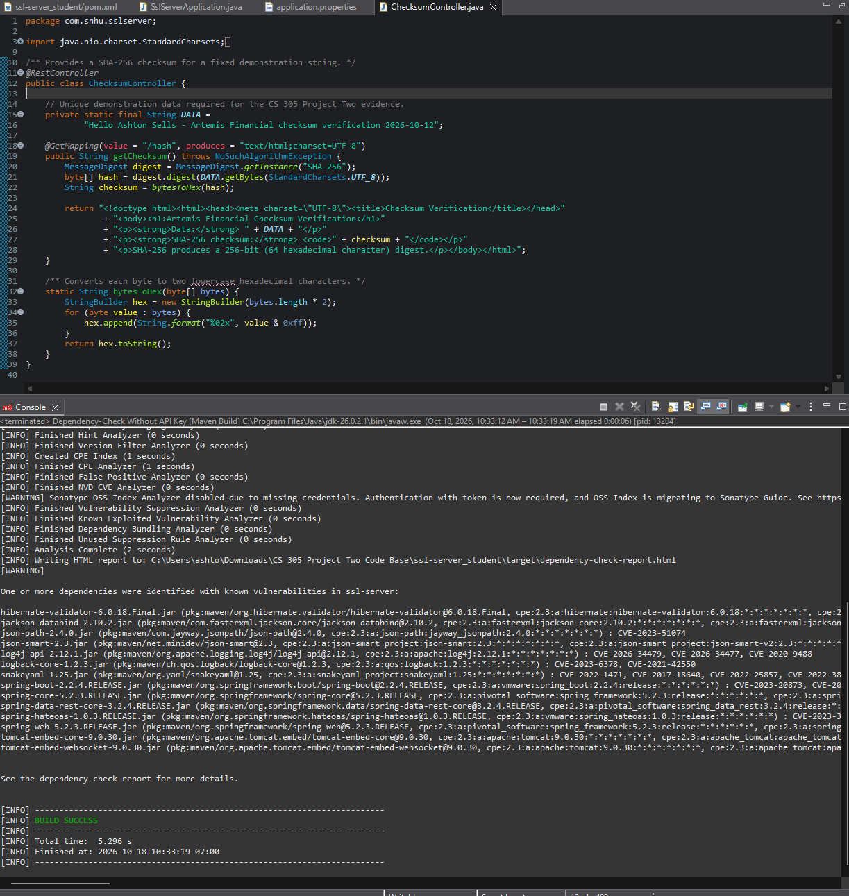

pom.xml w/suppression files
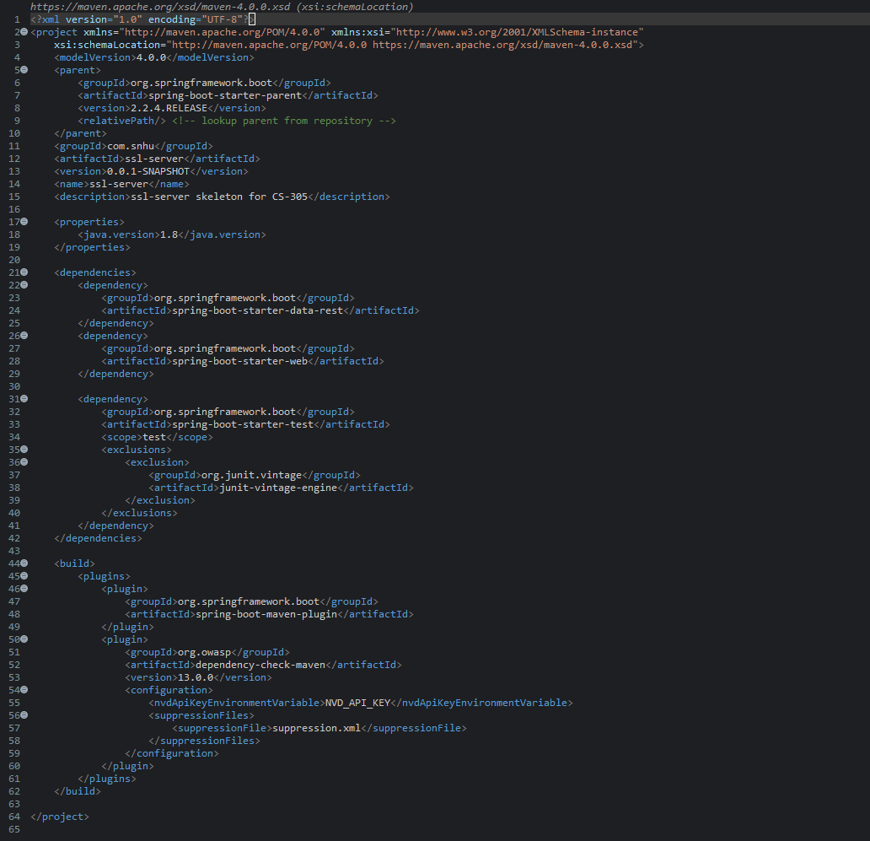

Suppression.xml
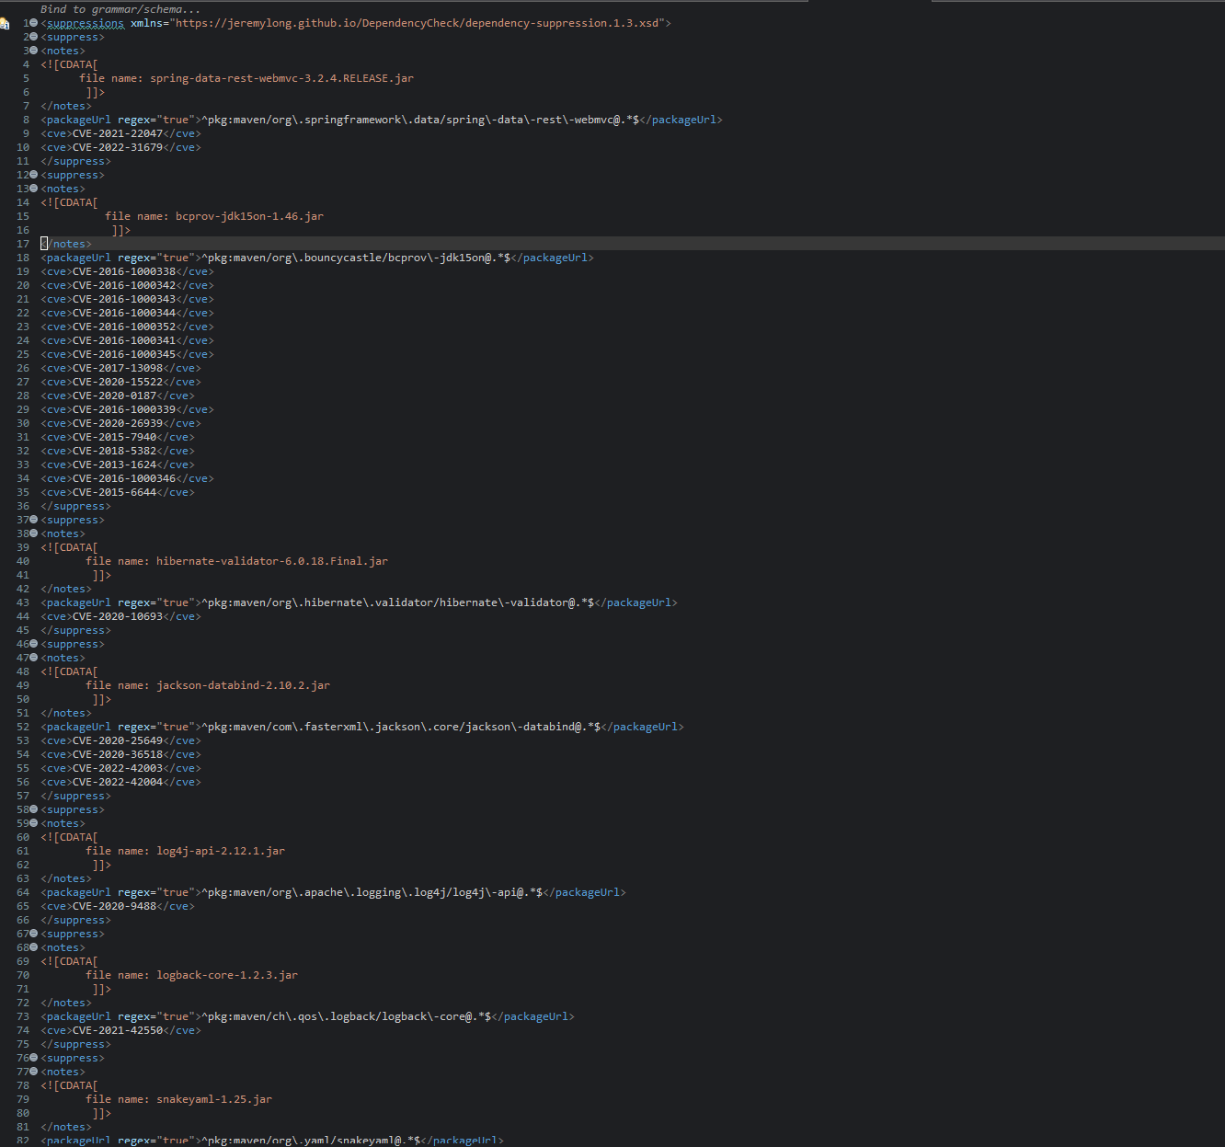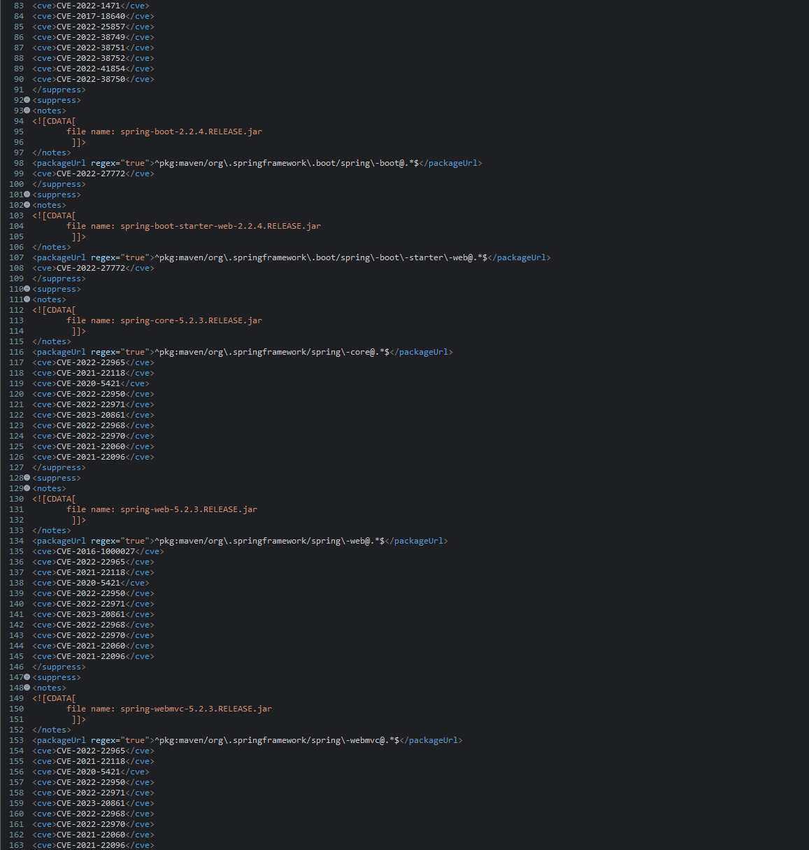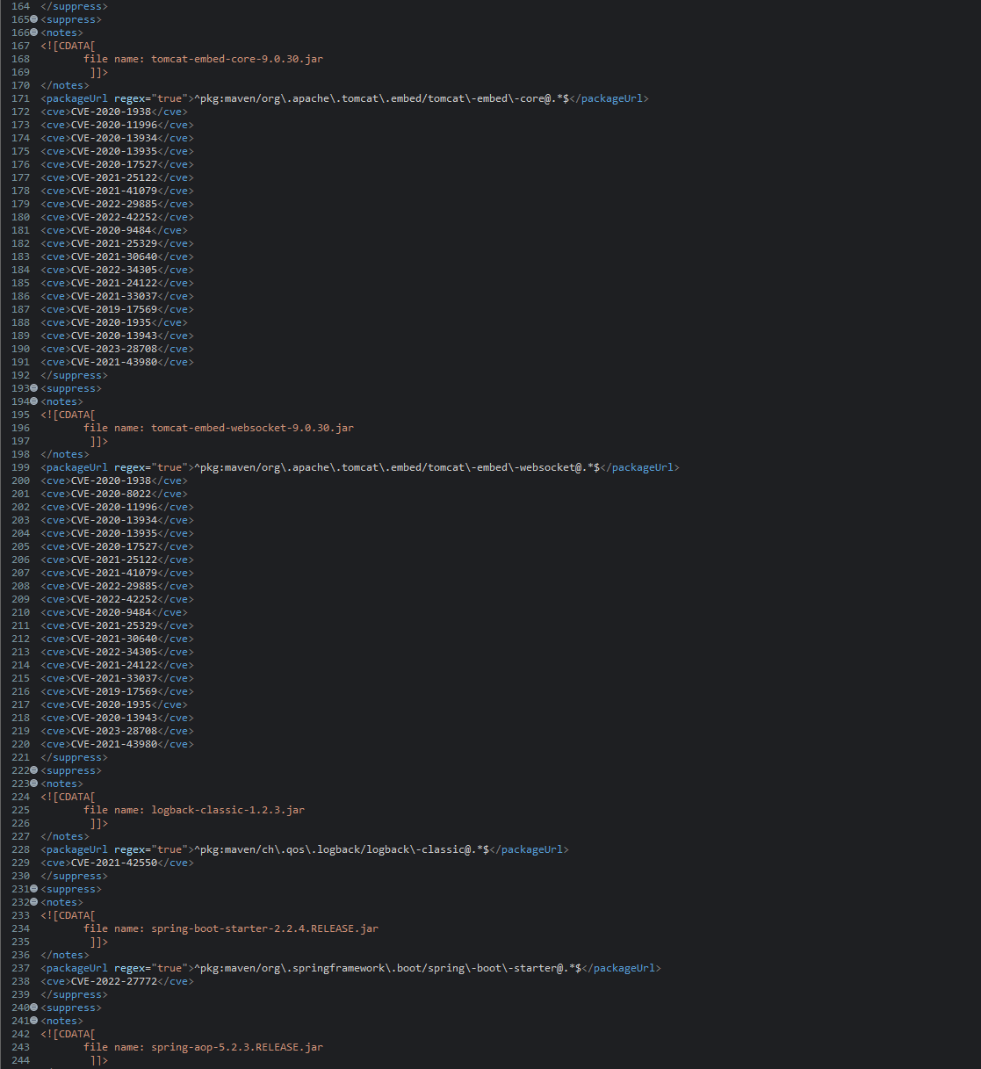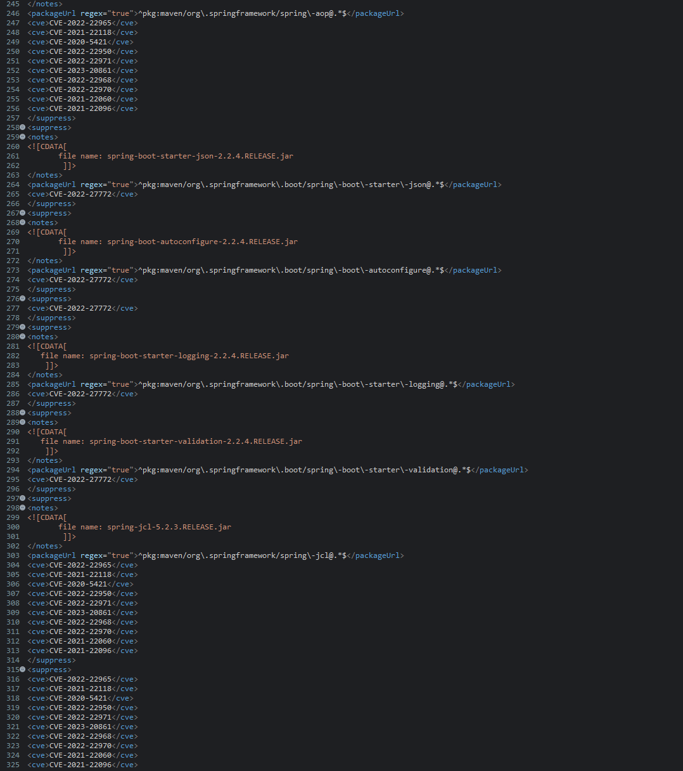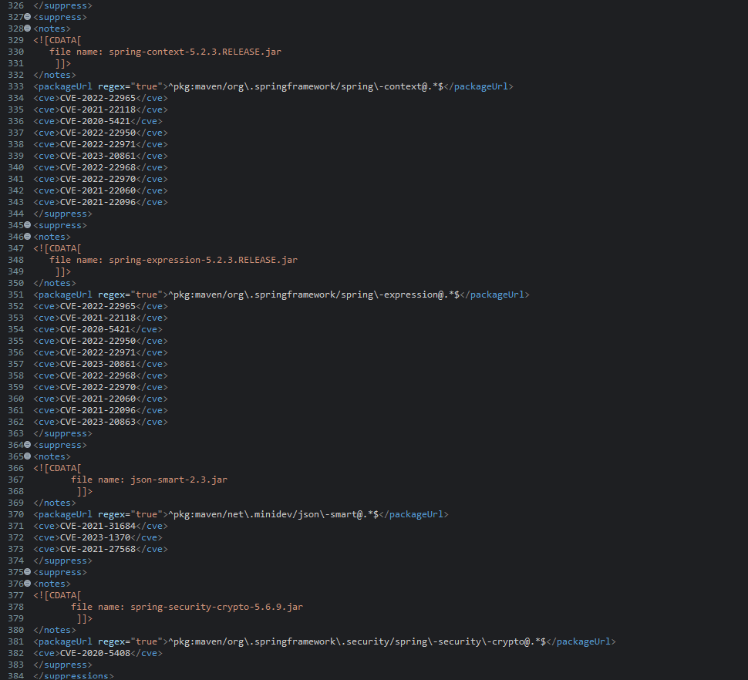

Summary

When refactoring the code, I added a ChecksumController class to address the vulnerabilities surrounding secure coding. The class contains a secure RestController that serves as the secure controller for the hash RESTful endpoint. I refactored the Artemis Financial application by adding a SHA-256 checksum endpoint and configuring the application to use HTTPS with an SSL keystore.

The checksum endpoint uses Java's MessageDigest class to generate a 256-bit hash of static data and converts the result into a hexadecimal string. The application uses HTTPS on port 8443 so that communication between the browser and the server can be encrypted. However, the connection is still viewed as insecure due to utilizing a self-signed certificate. A certificate from a certificate authority would address the security issue.

During the code review, I checked the syntax and logic of the new checksum functionality and reviewed how the application processes and displays data. I also considered potential security weaknesses, such as improper HTML output handling if the data were ever supplied by a user. For secure communications, I configured the SSL properties and keystore so the application could use HTTPS rather than transmit data over an unencrypted HTTP connection.

I used multiple layers of security instead of relying on a single safeguard. HTTPS protects data while it travels between the client and server, while SHA-256 provides a checksum that can be used to verify data integrity. Manual code review helps identify programming mistakes and potential vulnerabilities, and OWASP Dependency-Check provides an additional layer of testing by identifying known vulnerabilities in third-party dependencies and suppressing false positives or vulnerabilities not applicable to the project.

Industry Standard Best Practices

I applied industry standard secure coding practices by using Java's built-in MessageDigest class to generate a SHA-256 checksum, explicitly using UTF-8 encoding, and converting the resulting bytes into a consistent hexadecimal string. Using established Java security libraries instead of creating my own hashing algorithm helps reduce the chance of introducing errors. I also configured the Spring Boot application to use HTTPS with an SSL keystore to protect communication between the client and server. These changes help maintain the application's existing security while adding data integrity verification and encrypted communication.

I also used manual code review and OWASP Dependency-Check as part of the security testing process. The manual review helped me examine the syntax, logic, and potential security weaknesses in the code I added. Dependency-Check provided another layer of testing by identifying known vulnerabilities in third-party dependencies. I reviewed the generated report to evaluate the findings. In a production environment, I would run the scan with current vulnerability data and remediate applicable findings before deployment. From the dependency check report, I suppressed CVEs and CPEs that were false positives due to dependency versions not being listed in the vulnerability, mismatching between the package URL and actual artifact, incorrect CPE mapping, or not being applicable to the project.

Following secure coding best practices benefits Artemis Financial by reducing the likelihood of security incidents, protecting sensitive financial information, and supporting customer trust. A security breach could result in financial losses, regulatory consequences, reputational damage, and costly recovery efforts. Using encryption, established cryptographic libraries, code reviews, and dependency scanning helps the company identify and address risks earlier in the development process. These practices also support maintainability because future developers can review the security controls and repeat the testing process as the application changes.

References

National Institute of Standards and Technology. (2015, August). Secure Hash Standard (SHS) https://nvlpubs.nist.gov/nistpubs/FIPS/NIST.FIPS.180-4.pdf

Picazo Búrdalo, A. (2026, May 11). What is SHA-256: Hash function, real uses and comparison. Secra; Secra Solutions. https://secra.es/en/blog/what-is-sha256

