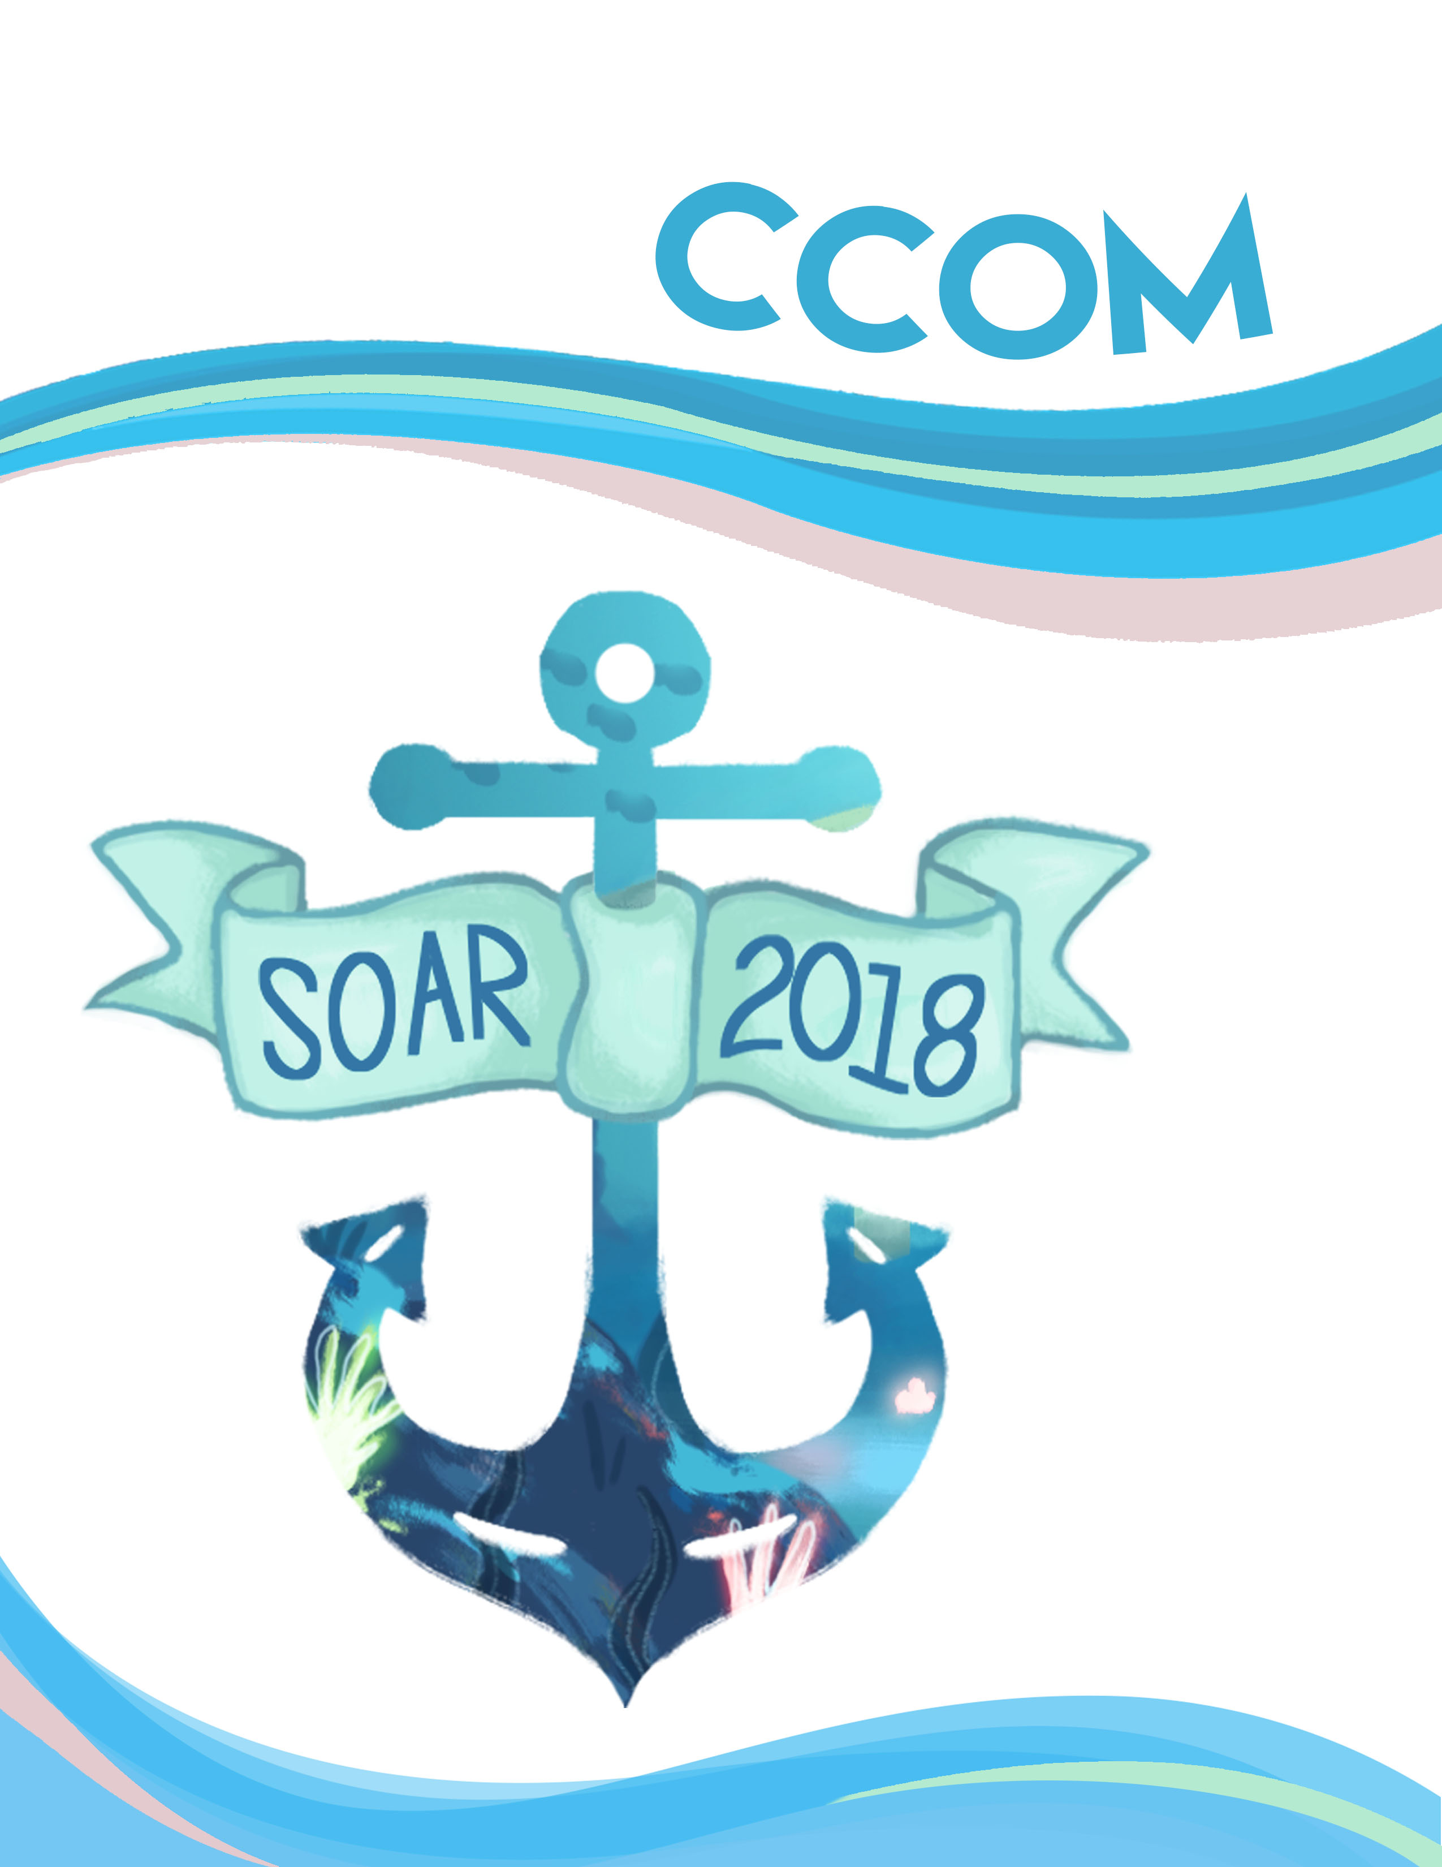

**SOAR 2018 CCOM Application**

SOAR (Suddenly Opportunities Are Reachable) is a leadership conference for students in grade 7 and 8 enrolled in the Peel District School Board. The aim of this conference is to ease students’ transition to high school and make a difference to the school and local community by providing the necessary tools to enhance confidence, drive and inner leadership skills.

SOAR is looking for the help of dedicated and passionate students to make SOAR 2018 as impactful and meaningful as possible to all attendees. CCOM are responsible for helping with clean up, set up, serving meals, and helping the conference run as smoothly as possible. All applicants are expected to make SOAR a priority and perform their role to the best of their ability – which includes attending all training sessions.

All grade 9, 10, 11 and 12 students attending **Turner Fenton Secondary School** are eligible to apply for this position. Students are allowed to apply for a maximum of **two** volunteer positions. Students are prohibited from mentioning their name, school, grade or anything identifiable in the app in order to maintain an impartial selection process. Failure to do so will result in an automatic withdrawal of your application from the selection process. If you have any further questions feel free to personally contact the SOAR executive team or email the Heads of CCOM at **soar.ccomsec@gmail.com**.

The conference will take place on May 26th, 2018. Students interested in a CCOM position are required to fill out all forms and complete all the questions on this application, and submit it to room 227 before 3:00 PM on February 28th, 2018. The application may also be handed in to any SOAR Executive member before the due date. Digital copies will not be considered; a hard copy must be submitted. If you have any questions or concerns, please feel free to contact us. We look forward to hearing from you and hope to see you on the 2018 Volunteer team!

With our regards,

**Simran Bakshi                                   Nishant Sarkar**simmibakshi@gmail.com nsrk01@gmail.com

**Heads of CCOM**

**Declarations**

**Student Declaration**

I, _______________________, understand that if accepted to be part of the SOAR Conference as a member of the CCOM Team, I must remain dedicated to making conference a success. In addition, I will make SOAR a priority and attend training dates accordingly. I accept the responsibilities, and am aware that failure to do so may result in termination of my position.

Student Signature: ______________________ Date: ______________________

**Parent Declaration**

I give permission to _______________________; my son/daughter to be part of the SOAR Conference as a member of the CCOM Team and permission to attend SOAR Conference on May 26th, 2018. I understand that failure to meet the responsibilities and expectations may result in his/her termination of position.

Parent Signature: _____________________ Date: ______________________

**Image Release Form**

This form must be filled out completely by each student. For good and valuable consideration, the receipt of which is hereby acknowledged, I hereby consent to the photographing of myself and the recording of my voice and the use of these photographs and/or recordings singularly or in conjunction with other photographs and/or recordings for advertising, publicity, or commercial purposes. I understand that the term “photograph” as used herein encompasses both still photographs and motion picture footage. I further consent to the reproduction and/or authorization by SOAR 2018 of said photographs and recordings of my voice, for use in all domestic and foreign markets. I hereby release SOAR 2018, from all claims of every kind on account of such use. Furthermore, all photographs and recordings are property of the hired agency during SOAR 2018, and I understand that I may be liable for unauthorized use unless I am explicitly permitted to copy, reproduce, or share these photographs with other parties.

Student Signature: __________________ Date: ______________________

Parent Signature: ___________________ Date: ______________________

**Questionnaire**

Student Number: __________________

**Before you begin, make sure to fill out the information form at** <https://goo.gl/forms/bnZzIhGGwa0nYIVc2>

*Please do not disclose any information about your gender, age or school you attend in your questionnaire responses.*

1. SOAR is all about teaching students in grade 7 and 8 to get out of their (sea)shells and adjust for the high school experience. Talk about a time where you broke out of your shell and explain how it impacted you as a person. (150 words)
2. You and your fellow CCOM members are busy preparing for the delegates’ lunch. There’s a lot to be done! However, disaster strikes! When you open the fridge, you find a stray beluga whale has swallowed all of the food. You remember that you have 7 dollars in your pocket. How do you feed a group of 20 delegates a nutritious meal using the money, your amazing cooking skills and exceptional creativity? (150 words)
3. All aboard! The whole team embarks on their epic voyage aboard a magnificent ship, the S.S. SOAR. All of a sudden, the ship starts to spin and thunder and lightning strike from the sky. Seems like Poseidon is upset! The S.S. SOAR drifts into the Bermuda Triangle and water comes rushing into the ship. How do you keep the delegates calm while the LDs are busy dealing with the leak? (200 words)