

|  |  |  |  |
| --- | --- | --- | --- |
| **Subject** | Digital Technologies | **Task Name** | CSS Project |
| **Semester** | 1 | **Task Number** | 2 |
| **Teacher** | Mr Henley | **Type** | Digital Project |
| **Due date** | 13 May 2021 | **Authorship** | Individual |
| **Context** | | | |
| Oceanic Airlines is a new airline servicing the Australia, New Zealand, and the Pacific Islands. Oceanic Airlines requires a website to be built to promote their brand. A technical proposal outlining the requirements for the website has been supplied. | | | |
| **Task Description** | | | |
| Develop the CSS for a website according to the requirements outlined in the provided technical proposal for this client. Document the problem-solving process and demonstrate the functionality of the website by building a working website | | | |
| **Conditions/Submissions** | | | |
| * You have three weeks to complete this task * The task is to be completed individually * Class time provided to work on your task * Draft is due one week before final submission | | | |
| **Think about** | | | |
| How will you demonstrate each of the criteria in the standards elaborations? | | | |

**Technical Proposal**

**Introduction**

Your client has contracted you to design a website that has a consistent look and feel. Currently they have a HTML-only site that lacks visual appeal and as a result is difficult to navigate. The client wants you to add CSS to make the site visually more appealing and more functional as a result. The home page has been sent to you so you can work on the design.

Your website must contain the following elements:

* A colour scheme that matches the Oceanic Airlines logo
* A navigation bar styled with CSS
* A complete home page containing links to content pages within the website. The other pages need a statement that the site is under construction
* Consistent styling (e.g., for hearings, paragraphs, background colours, image size etc.)

The client has sent an artist’s impression for what they home page may look like. You can see this below:

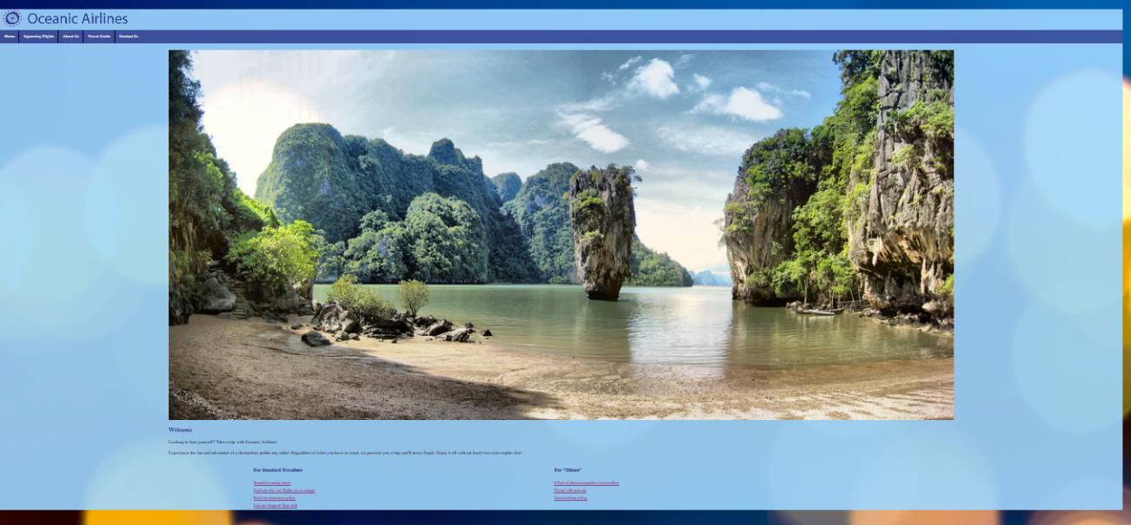

**Client**

Oceanic Airlines is a charter airline servicing the Pacific. They want their website that have a consistent colour scheme and a layout that makes navigation easier for its customers.

**Target Audience**

Oceanic Airlines target audience is wealthy individuals who first class service to remote pacific islands not serviced by the major airlines.

**Explain the benefits of separating HTML from CSS**

(100 words)

* It is a common practice to keep an HTML document (“index.html”) in the root of a website’s directory, and a CSS document located at “(root)\styles”. This can be for a variety of reasons, including personal choice, but one of the main reasons for this structure is that HTML webpages often link to other HTML files, which may need similar CSS styling. Using a separate CSS document allows for shared “id” and “class” attributes that can be applied to HTML elements across the entire directory. When managing a web structure, it can be helpful to have a style sheet shared between all pages. This saves space, allows for easier perusal of HTML files, and lets the website have a consistent theme or colour scheme. Multiple HTML pages can share a single CSS sheet by linking to the same CSS file, using the “@import” function. Using a single line of code per HTML document avoids the need to edit multiple lines in many files to perform simple changes. In the above example, HTML documents could share a style sheet by each including a line of code that says “<style> @import URL(‘styles/styles.css’); </style>”.

**Evaluation**

(100 words)

(Is there any risk involved with your solution? How sustainable is it? Could the website be improved so it provided more functionality for users?)

* There is no risk involved because there is no personal information stored on the website. There are no login details such as email addresses, usernames, or passwords.
* The website is very sustainable because of its use of a separate CSS document; that is, the two files “index.html” and “styles\index.css”. This means that more HTML pages could be created and linked to and use the same “id” and “class” attributes, thus sharing the same CSS styling.
* If this were really a website for an airline company, there would be a lot left to do because currently, the only existent HTML document is for the homepage. The homepage has ‘broken’ links to other pages; clicking them gives a JS alert that the site is under construction. For an airline company to use this website, they would need to create more pages with information about their destinations, policies, flight times, and payment options. This is currently not the case.

## Years 9 and 10 Digital Technologies standard elaborations

|  | | A | B | C | D | E |
| --- | --- | --- | --- | --- | --- | --- |
|  | | The folio of a student’s work has the following characteristics: | | | | |
| Knowledge and understanding | Representation of data | comprehensive explanation of:   * why content data are separated from presentation | detailed explanation of:   * why content data are separated from presentation | explanation of:   * why content data are separated from presentation | description of:   * why content data are separated from presentation | statements about:   * why content data are separated from presentation |
| Processes and production skills | Generating and designing;  producing and implementing | systematic testing and prediction of results and proficient implementation of digital solutions | reliable testing and prediction of results and effective implementation of digital solutions | testing and prediction of results and implementation of digital solutions | partial testing and prediction of results and partial implementation of digital solutions | fragmented testing and prediction of results or fragmented implementation of digital solutions |
| Evaluating | discerning evaluation of information systems and their solutions in terms of risk, sustainability and potential for innovation and enterprise | informed evaluation of information systems and their solutions in terms of risk, sustainability and potential for innovation and enterprise | evaluation of information systems and their solutions in terms of risk, sustainability and potential for innovation and enterprise | explanation of information systems and their solutions | description of information systems and their solutions |

|  |  |
| --- | --- |
| Key | shading emphasises the qualities that discriminate between the A–E descriptors |