Audio Game Project – Scrum Logs & Charts

Daily Scrum Log
Day 1:
• What was done: Kick-off, requirements confirmed, repo created.
• Blockers: No blockers
Day 2:
• What was done: Core tone generation implemented.
• Blockers: Needed to tweak sound library settings.
Day 3:
• What was done: Game loop and input blocking completed.
• Blockers: Timing alignment required testing.
Day 4:
• What was done: Tutorial system added, tested.
• Blockers: None.
Day 5:
• What was done: High score system and polish.
• Blockers: Minor file write permissions issues fixed.
Day 6:
• What was done: Documentation and testing.
• Blockers: None.
Day 7:
• What was done: Final packaging and review.
• Blockers: None.

Project Timeline
The chart below shows the planned task execution timeline.
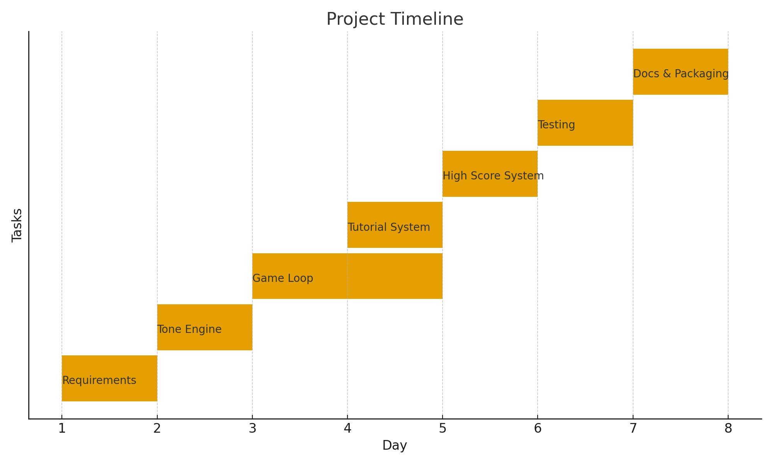

All team members participated in sprint planning, backlog grooming, and testing across sprints to ensure shared knowledge and equal collaboration.

Workload Distribution
The bar chart below represents approximate committed effort per role.
