**Start of the problem:**

We had some power issues but sorted these out, and the laser was running but TDLWintel did crash. The chiller had “pump fail”. The flow switch was still blue we think. We soon after noticed fluid at the back and opened the QCLAS box, to see that the tubing was melted. We don’t know what order things happened, either:

* The lasers heated up, melting the tubing and causing the “pump fail” on the chiller
* The pump on the chiller failed, causing the lasers to heat up and melt the tubing

We don’t know why the flow switch didn’t prevent this, or if it is still working fine or not. From the spray patterns of coolant fluid, it seems like it really sprayed out rather than just leaked, indicating the pump was working at this point.

At around the same time, fuses blew on the attached TREX unit, which was off but plugged in, so this seems to indicate a power surge. We aren’t sure if the QCLAS problems could have caused the power surge or if the power surge could have caused the QCLAS problems. The QCLAS was plugged into a UPS so shouldn’t really be involved in the power surge anyway.

**Diagnosis of the problem:**

We replaced the melted tubing and installed a different chiller. We turned the chiller on and tested it. The chiller is now working fine and keeping the set temperature of 14 C. We turned the QCLAS on and noted that the fans in the lower computer part turned on.

* The **flow switch** indicator turned on once but other times it flashed and then didn’t turn on. At no point was the flow switch indicator red.

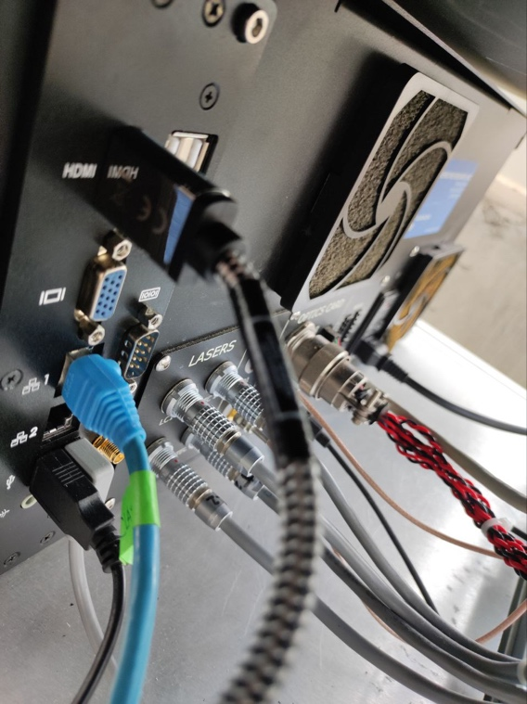 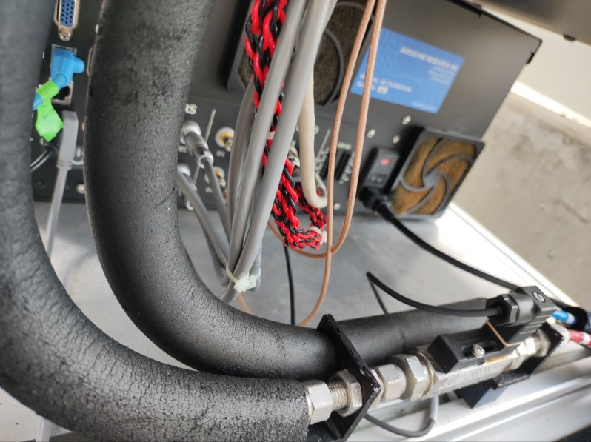

* There is a lot of **condensation** in the QCLAS box, on the lasers, on the tubes. The chiller is set to 14 C. Is this too cold? Is it a problem to have so much condensation?

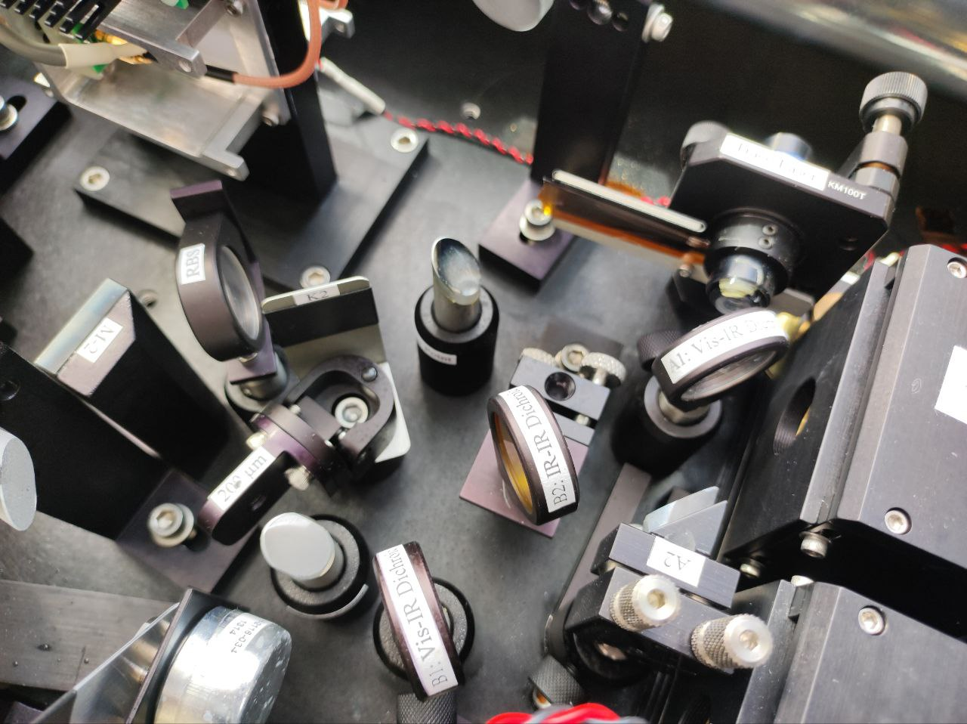

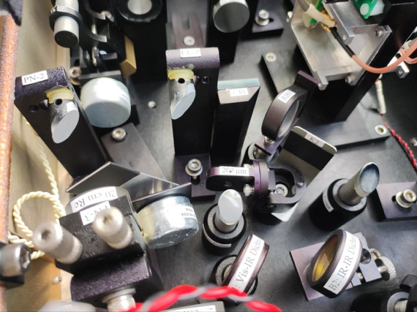 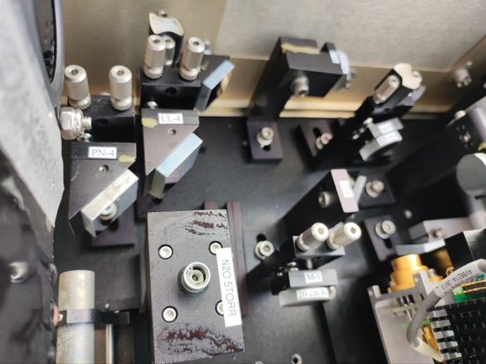

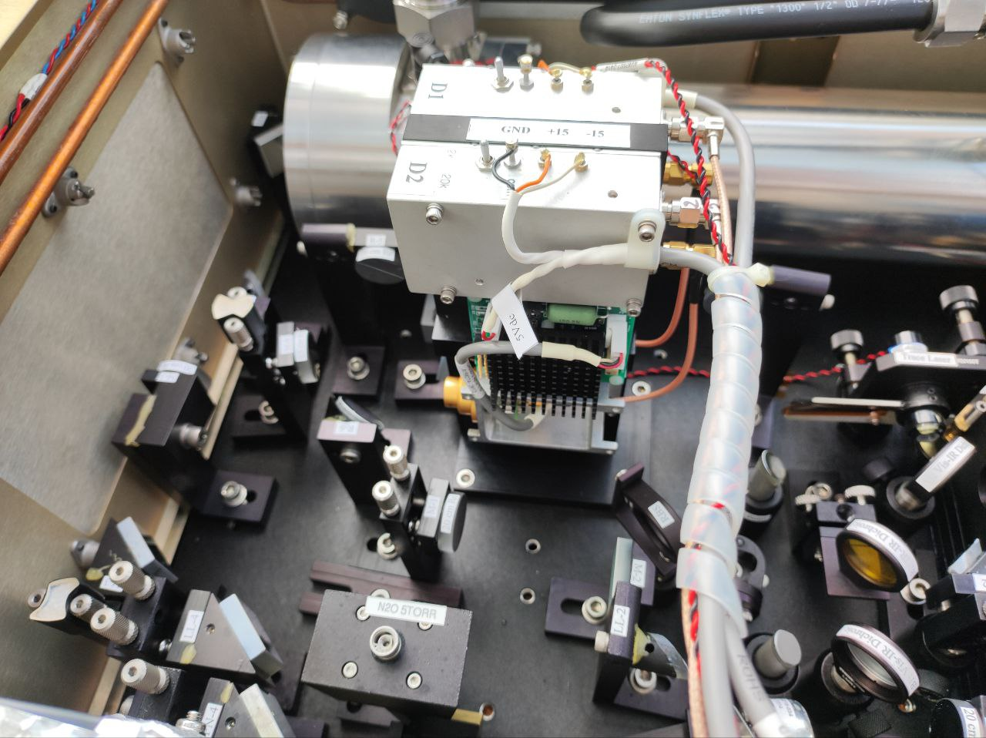

* **Smoke** was coming out of the electronics board. We think this probably got wet as the coolant sprayed out and needs replacing. Smoke came from where I put the red circle in this photo:

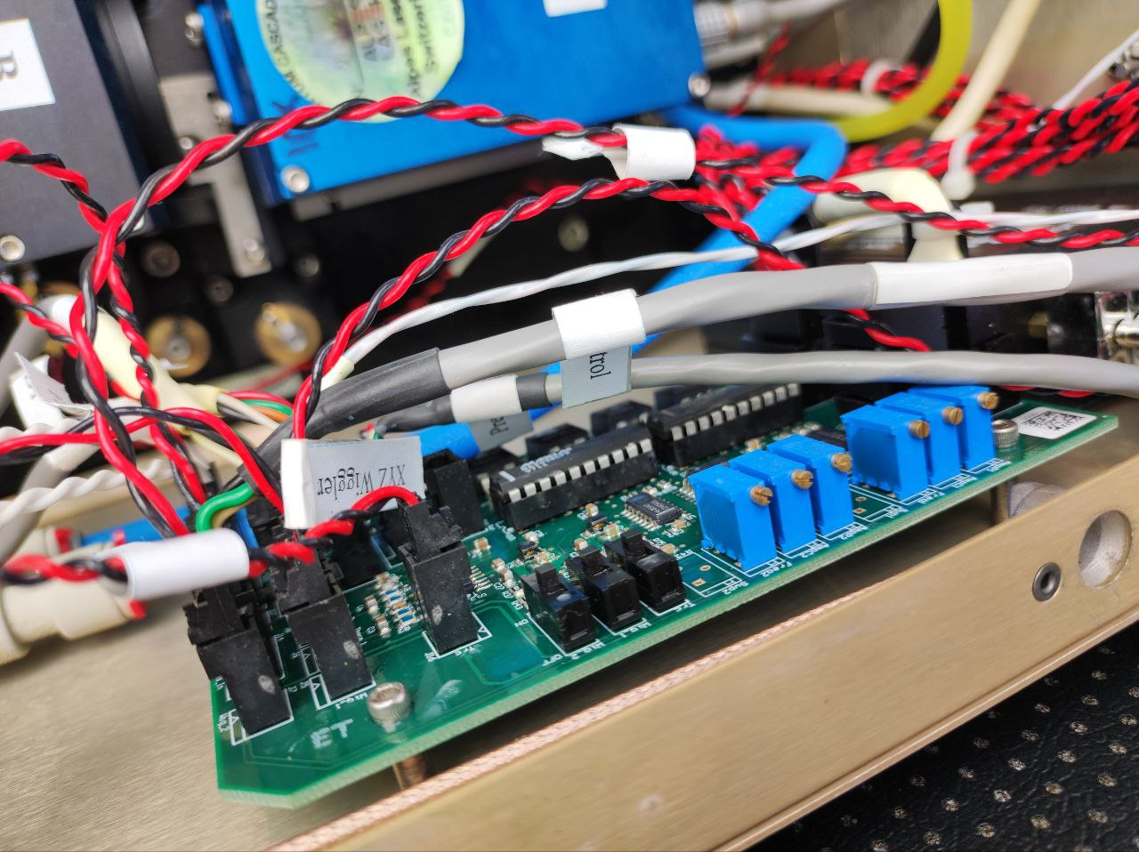



* There are also burn marks on the electronics board:

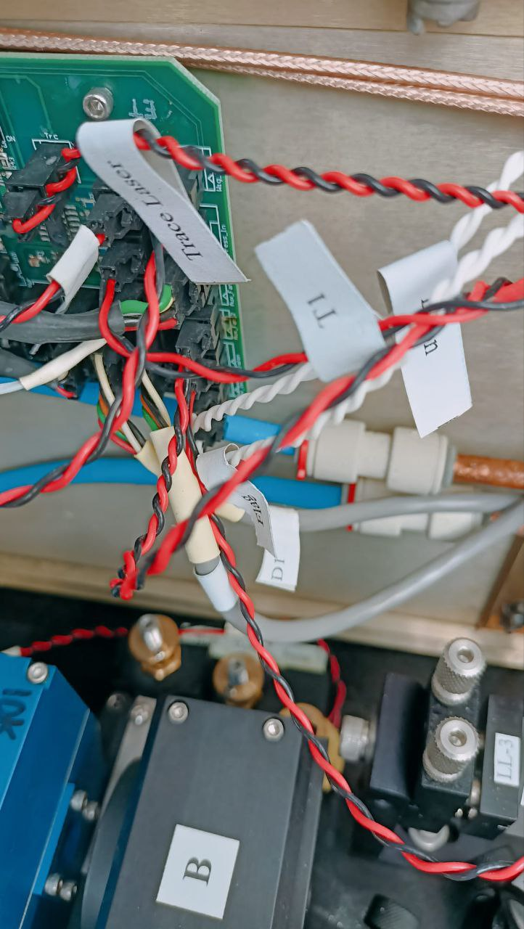

* There is no visible problem on or near the lasers but a strange observation: When we turn the QCLAS on, a light comes only from laser 2, at the window where the laser should come out (circled in the second photo). There is no light in laser 1 at this point. We have no signal from the computer, TDL Wintel is not on, and no lights on the laser indicators.

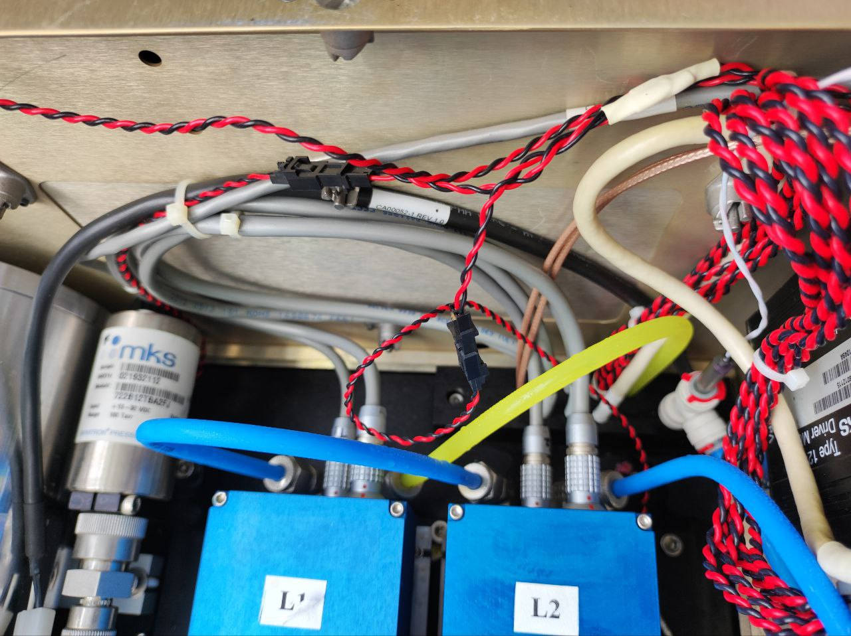

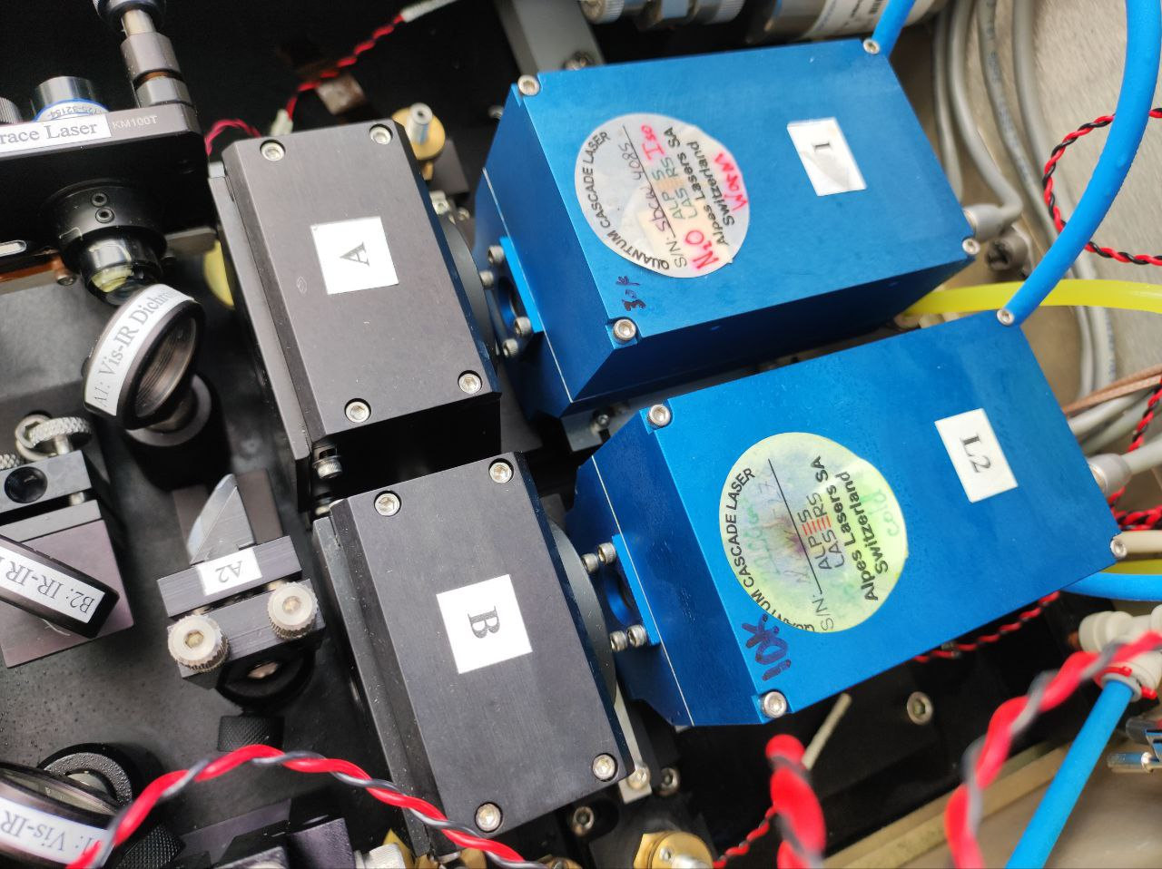



**Next steps:**

* We have the same type of laser unit in the lab at ETHZ so we can take some parts from it. *Which of these parts do you think we could try to take from the other laser, and which could we order from you?*
  + We would plan to take the electronics board from the ETHZ lab laser and replace it into this laser, and redo the connections, as this appears to be damaged from the fluid.
  + We are not sure if there are problems with the flow switch, which we could also replace with the one from the ETHZ lab laser.
  + We don’t know why the computer is not turning on, and if it needs replacing. We replaced it about 9 months ago and see no visible issues if we take it out and look at it, but we get no signal at the monitor.
* We are unsure if there are problems with either of the lasers or peltiers, and we cannot diagnose this until we can turn the computer on and try the lasers.
* What else can you recommend at this point?