**INTERNATIONAL LIVESTOCK AND RESEARCH INSTITUTE (ILRI) SOLAR POWER NETWORK CLOSED CIRCUIT TELEVISION (CCTV) CAMERA INSTALLATION**

ILRI contracted Megatech solutions limited to supply and install solar CCTV camera at University of Eldoret Outreach and International Student Center. The aim for installation was to monitor research equipment’s on the field and on the truck placed on the research field.

**INSTALLATION PROCESS**

Two SanDisk 128Gb memory card and 2 Safaricom Pin less Sim cards were installed to the 2 Hikvision Solar powered network CCTV camera. Local recording, updating firmware to the latest version and remote viewing via mobile application was configured.

The 2 cameras were mounted on already installed black metallic fitted with 1 foot wood on the top. The solar were screwed on the wood using Gypsum screwed and firmly tightened with hose clips.

The solar powered cameras were aligned as follows: -

**Camera 1 ->** it was aligned from the back of the field truck to capture all movements towards entry door of the truck, objects around the truck and movements around the road near the truck.

**Camera 2 ->** it was aligned facing front side of the field track to capture all movements in and out of the selected area field.

The 2 Hikvision CCTV camera model numbers are: -

|  |  |  |  |
| --- | --- | --- | --- |
| Item name | Model number | Serial Number | Verification code |
| Hikvision solar powered camera | DS-2XS2T41G0-ID/4G/C04S05 | G81877790 | QCOTAM |
| Hikvision solar powered camera | DS-2XS2T41G0-ID/4G/C04S05 | J54317558 | SWAIZQ |
| SanDisk ultra 128Gb | MicroSDXC UH-I Card class10 | 350059189876 | - |
| SanDisk ultra 128Gb | MicroSDXC UH-I Card class10 | 350059143676 | - |

**Camera 1 Sim card details**

PIN :0078

IMSI: 1233075656

Serial no. 8925402134230756568

**Camera 2 Sim card details**

PIN :8796

IMSI: 1233075669

Serial no. 8925402134230756691

**Pictures taken during installation.**

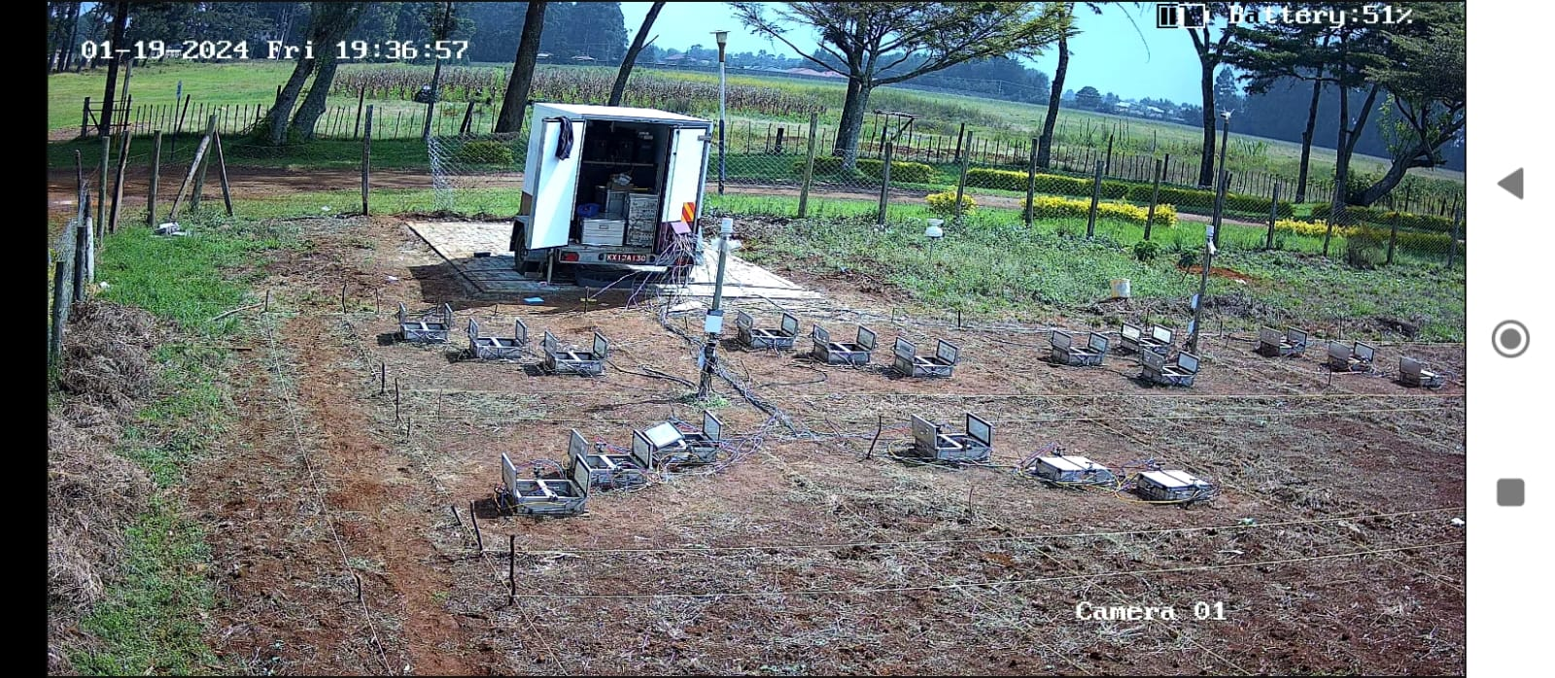

Picture 1:Screenshot of Camera 1 View after installation

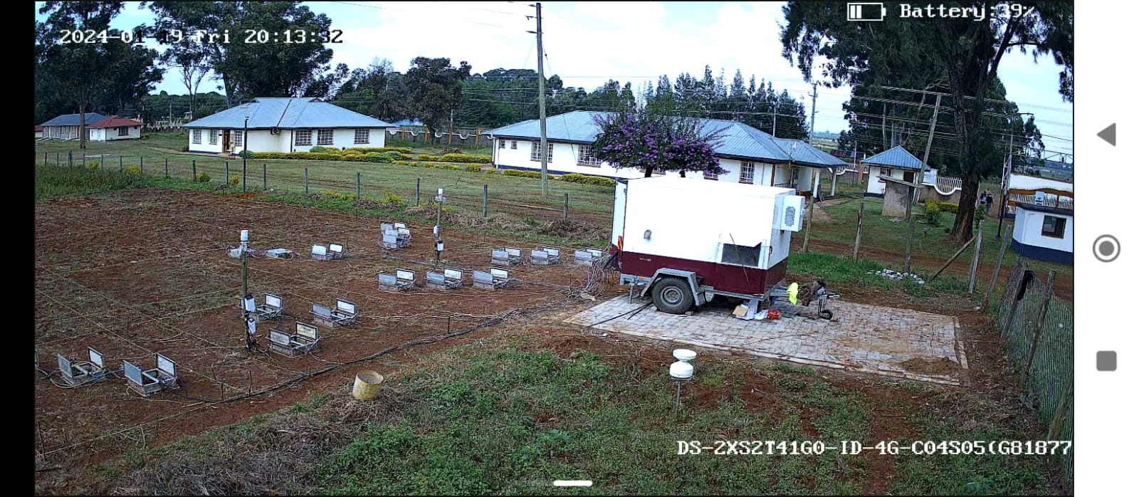

Picture 2:Screenshot of camera 2 view after installation

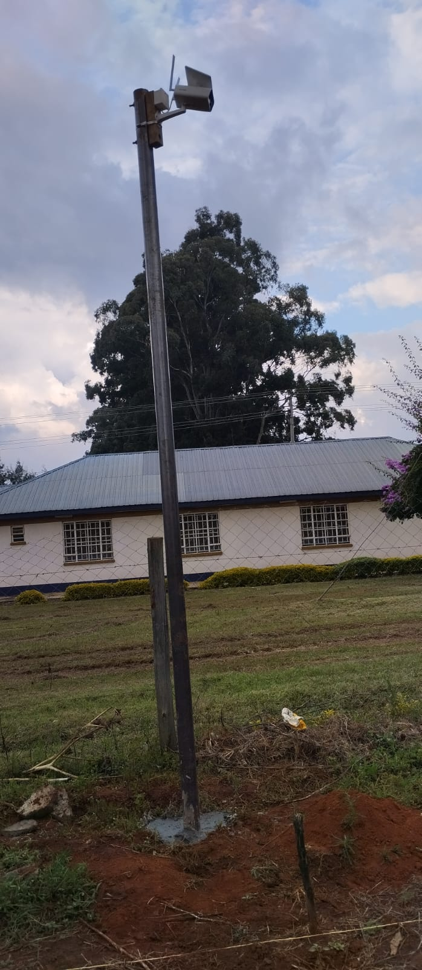

Picture : Camera 1 after installation

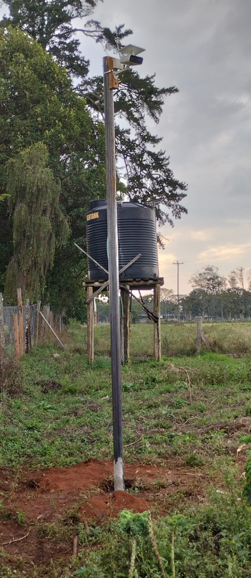

Picture : Camera 2 after installation

**CONCLUSION AND RECOMMENDATION**

The Solar powered network CCTV cameras installation, activation and testing was successfully completed and 1 camera was left reachable online however, since one Sim card was not activated, 1 Camera was left recording locally but sim card inserted on the camera whereby after activation the camera will automatically go online.