# Communication between QCLAS and TREX

## Setting the folder sharing on the QCLAS PC

* 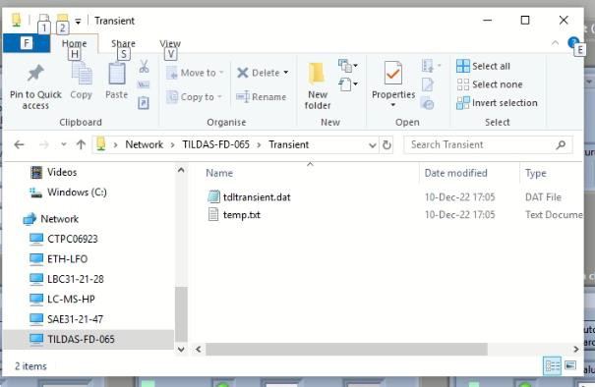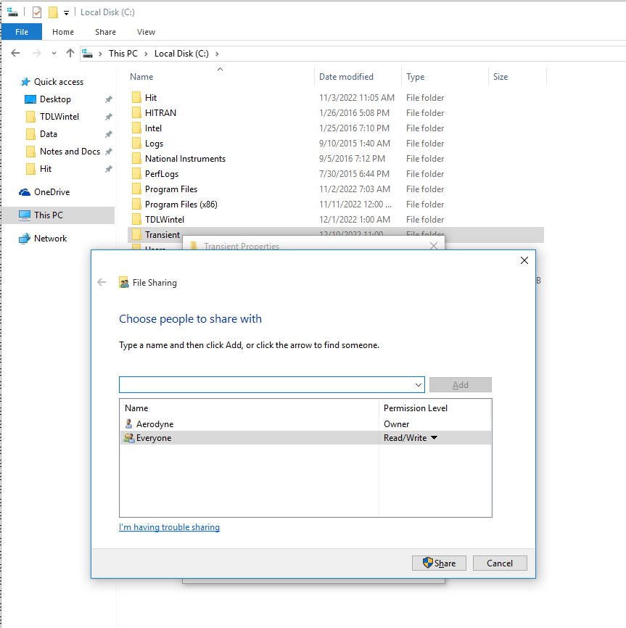File Explorer – C:\Transient – right click – Properties
* On the Sharing tab, click on Share and set it for Everyone with Read/Write rights

On the TREX laptop, go to File Explorer and type in \\TILDAS-FD-065\Transient and press Enter.

*For the newer computer, this will be \\DESKTOP-9NVU3OR\Transient*

* Wait a while, a Windows credentials windows should pop up after some time.
* Type in “ISG Account” and “abcd.1234” (Windows credentials on the QCLAS PC)
* *Type in “CAES” and “abcd.1234” for the newer computer.*
* The Transient folder should be now accessible on the TREX laptop.

## Setting it up in TrexOS

* While the software is running, rewrite the “transient file – path” on the CONTROL tab to \\TILDAS- FD-065\Transient\tdltransient.dat

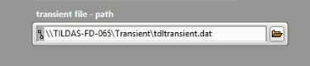

* *For the newer computer this will be \\DESKTOP-9NVU3OR\transient\source.txt*
* Exit the software by clicking on “EXIT” on the right bottom side and then the red circle button on the LabVIEW top left bar (“Abort execution …”). Like this, the path is saved to the initialization file and it will be loaded during next start
* 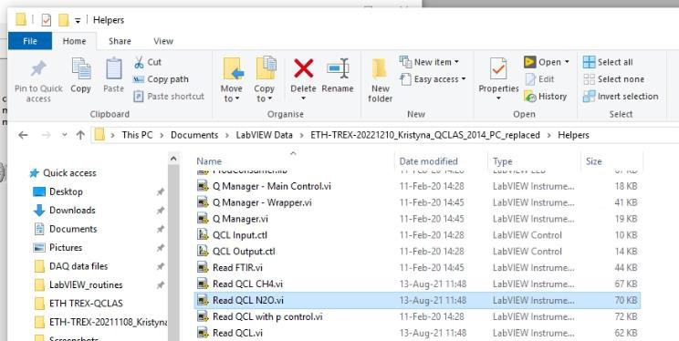In File Explorer, open the TrexOS folder and under Helpers, open the “Read QCL N2O.vi” file
* Right-click on the “QCLAS readout” item and check if the order of variables is correct, if not, modify and save the VI

**How to modify the Array:**

1. Create a new TrexOS folder by copying the old version and renaming it.
2. In the newly created folder, open Helpers>”Read QCL N2O.vi” file>right click on QCLAS readout>select edit items>Enum properties
3. Check your source text or Transient.dat file to compare the **values** that appear in the array. (Ignore the labels on the array as these may be wrong)
4. Check again in the stc and str file to compare the values and be careful to note down the labels corresponding to these values.
5. Now in the Edit items window you need to align the values by position. You will see the names of the variables and then a values column that shows you the position. Remember the array starts numbering from 0. Again, ignore the labelling on the Array window and move the variables names/lables up and down in the edit items window until they mirror the values in the exact order as they are in the Array window. Save the output and run the .vi file again.

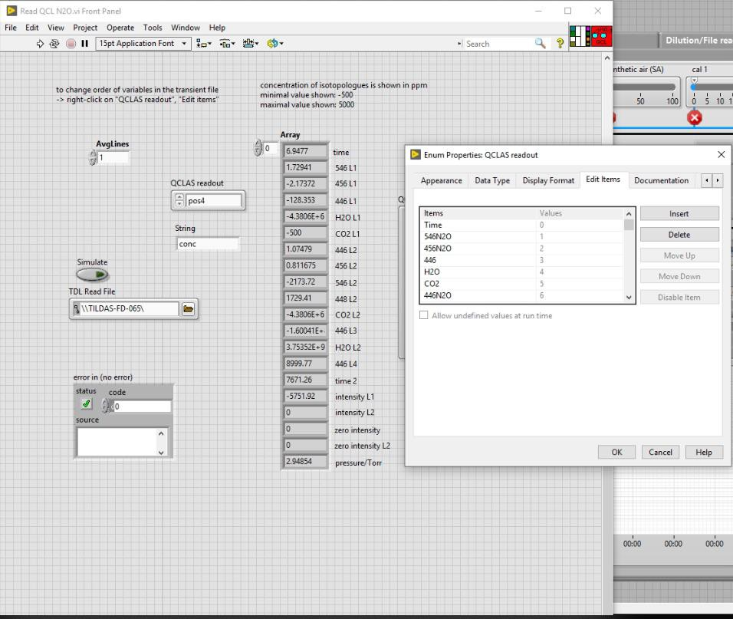

* Run the software again and check on the “MAIN CONTROL” tab that the values in the QCLAS readout window are correct

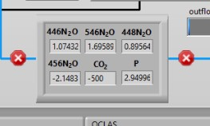

* If the values refresh **very slowly**, delete the tdltransient.dat file in the Transient folder, it is probably too big and it takes LabVIEW a long time to process it.

## Trouble shooting Turry edit 7th Feb 2023

**Issue:** The values in the array in Read QCL N2O.vi and in the QCLAS display do not correspond to each other.

**Solution:**

1. Check that data saving is activated in TDLWintel. This produces the transient file from which TrexOS reads out the values.
2. Check the QCLAS PC and switch off as many processes as possible as these can make it freeze.
3. Check that the internet/network connection of the QCLAS PC is working.
4. Check the size of the transient source.txt file. It could be that the TrexOS is having trouble reading it fast. I fit is too big, delete the source.txt file on the QCLAS PC. This should be done regularly to ensure that TrexOS can read the data fast.

* If reducing running processes does not help, you may consider restarting the PC. And then do not forget to log into the QCLAS PC in the TREX laptop such that it can access the Transient folder.
* On the TREX laptop, you can log in again because it sometimes forgets to connect so TrexOS cannot read out the transient file. The QCLAS PC freezing and unfreezing can also cause the dropping of the reading out.

**Issue 2: WaitForCellPressure command does not seem to work.** Turry edit 21st Sep 2023

Solution:

1. Go through the solutions for **issue 1.**
2. On the QCLAS readout ensure that the order of the variables in the data are aligned correctly. The values for pressure should ideally be in the"pressure/Torr". Have you made some changes recently? The fields have probably shifted.
3. Check that the order of the items in the transient file has not changed since the last version. Have you changed the spectral fit in TDLWintel? If yes, then the order of items in the QCLAS readout array would have changed, too.