Rhizon Soil Moisture Sampler (SMS) Proposal

1. Introduction

Rhizon soil moisture samplers (SMS) have been used in numerous soil and soil mesocosm studies (for example, Argo, et al., 1997; Song, et al., 2003; Seeberg-Elverfeldt, et al., 2005; Sigfusson, et al., 2006; Lind, et al., 2012; Ibánhez & Rocha, 2014; Chen, et al., 2015; Steiner, et al., 2018). Rhizon soil moisture samplers (SMS) consist of a hydrophilic micropore tube (pore size 0.1 or 0.15 µm) supported by a plastic or metal rod, connected to a polyvinyl chloride (PVC) sampling port with a Leur-lock male connector. Typical dimensions are 4.5 or 2.5 mm in diameter and 5 to 10 cm long for the macro and micro rhizon sizes (Figure 1). The rhizon sampling principle is based on the hydrodynamic response of a porous substance when negative pressure is applied. Several instruments, such as syringes, vacuum tubes, or peristaltic pumps can apply negative pressure (Argo, et al., 1997; Seeberg-Elverfeldt, et al., 2005; Falcon-Suarez, et al., 2014; Ibánhez & Rocha, 2014).

The rhizon sampler can measure a range of trace metals, nutrients, and gases as it directly samples soil porewater (Seeberg-Elverfeldt, et al., 2005). Seeberg-Elverfeldt (2005) reviewed the use of rhizon samplers in a mesocosm and field study in intertidal sediments. The researchers highlighted several benefits of rhizon use; low soil structural disturbance (tube diameter: 2.5 mm), low dead volume (0.5 ml including standard tubing), minimal absorption processes in the inert polymer tube, and no degradation during long-term use. Furthermore, the tube pore size (0.1 µm) ensures microbial and colloidal-free solutions are extracted. Rhizon samplers allow repeatable, spatially reproducible, in situ, and nonion-specific sampling.

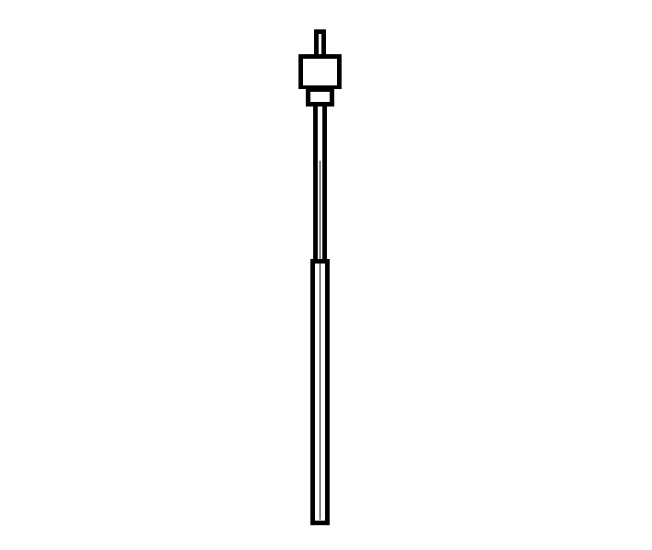

**4.5 / 2.5 mm**

**5-10 cm**

**Hydrophilic microtube**

**Support rod**

**PVC tube**

**Leur-lock**

Figure 1: Rhizon SMS schematic: 4.5 and 2.5 mm represent the macro and micro diameter sizes, respectively.

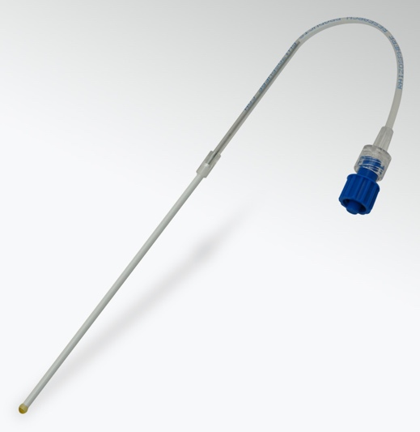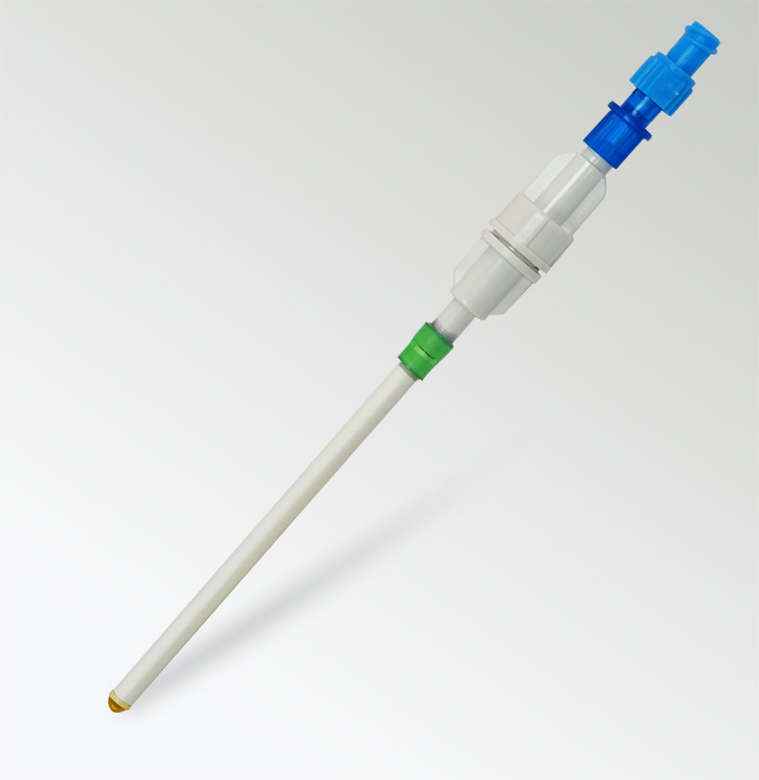

a)

b)

Figure 2: Example of a) Macro rhizon SMS; b) Micro rhizon SMS

2.0 Methodology

2.1 Rhizon SMS Installation

The rhizon samplers can be installed directly into the soil either vertically (at a 30 to 40° angle – to prevent rainwater flow directly along the membrane) or horizontally, depending on the requirement of different sampling depths. However, vertical depth sampling requires more extensive planning and results in greater soil disturbance. Before rhizon installation, a thin rod should be driven into the soil to detect obstacles in the soil (which can damage the rhizon) and provide a clear channel for insertion (Moreno-Jiménez, et al., 2011). After installation, the rhizon samplers should be allowed to equilibrate for at least two weeks before sampling. Soil porewater sampling can then be conducted using a simple suction device, such as a syringe. It should be noted that the amount of porewater volume collected by the sampler is heavily dependent on the soil moisture but generally ranges from 2 to 10 ml.

2.2 Porewater Analysis

The rhizon samplers directly sample and filter, owing to the membrane pore sizes (0.1 or 0.15 µm), the soil porewater. This allows direct analysis of the porewater sample for nutrients, cations or dissolved organic carbon (DOC) using a variety of common analysis techniques; however, the only limitation is the actual amount of sample available (2 to 10 ml) and the analysis technique should require a relatively low sample volume.

3.0 Expense

Rhizon samplers are sold in quantities of 10. Rhizosphere Research Products have provided a quote for the available macro and micro types (Table 1) (Rhizosphere Research Products, 2024). A €45 delivery cost to Switzerland also needs to be considered.

Links to the products and photos:

* Macro rhizons: <https://www.rhizosphere.com/rhizons/macrorhizons/>
* Micro rhizons: <https://www.rhizosphere.com/rhizons/microrhizons/>

Table 1: Product description and price of the various macro and micro rhizon types sold by Rhizosphere (Rhizosphere Research Products, 2024).

|  |  |  |  |
| --- | --- | --- | --- |
| Product No. | Product Description | Currency | Price |
| 19.21.35 | MacroRhizon soil moisture sampler, 9 cm porous membrane, 0.15 µm pore size, female luer, 10/pkg | € | 140,00 |
| 19.21.36 | MacroRhizon soil moisture sampler, 9 cm porous membrane, 0.15 µm pore size, mount on 90 cm PVC pipe 5/8”, 2-way stopcock, female luer, 10/pkg | € | 280,00 |
| 19.21.38 | MacroRhizon soil moisture sampler, 9 cm porous membrane, 0.15 µm pore size, mount on 30 cm PVC pipe 5/8”, 2-waystopcock, female luer, 10/pkg | € | 246,00 |
| 19.21.39 | MacroRhizon soil moisture sampler, 9 cm porous membrane, 0.15 µm pore size, mount on 60 cm PVC pipe 5/8”, 2-way stopcock, female luer, 10/pkg | € | 263,00 |
| 19.21.81 | MicroRhizon soil moisture sampler, 8 mm porous membrane, 0.15 µm pore size, glued on 12 cm PEEK tube, silicon connector for syringe with tip, 10/pkg | € | 166,00 |
| 19.21.82 | MicroRhizon soil moisture sampler, 8 mm porous membrane, 0.15 µm pore size, glued on 12 cm PEEK tube, PEEK guide tubing, silicon connector for syringe with tip, 10/pkg | € | 193,00 |

# References

Argo, W. R. et al., 1997. Evaluating Rhizon Soil Solution Samplers as a Method for Extracting Nutrient Solution and Analyzing Media for Container-grown Crops. *HortTechnology,* 7(4), p. 404–408.

Seeberg-Elverfeldt, J., Schlüter, M., Feseker, T. & Kölling, M., 2005. Rhizon sampling of porewaters near the sediment-water interface of aquatic systems. *Limnology and Oceanography: Methods,* Volume 3, p. 361–371.

Falcon-Suarez, I., Rammlmair, D., Juncosa-Rivera, R. & Delgado-Martin, J., 2014. Application of Rhizon SMS for the assessment of the hydrodynamic properties of unconsolidated fine grained materials. *Engineering Geology,* Volume 172, pp. 69-76.

Ibánhez, J. S. P. & Rocha, C., 2014. Porewater sampling for NH4+ with Rhizon Soil Moisture Samplers (SMS): potential artifacts induced by NH4+ sorption. *Freshwater Science,* 33(4), pp. 1195-1203.

Chen, M., Lee, J.-H. & Hur, J., 2015. Effects of Sampling Methods on the Quantity and Quality of Dissolved Organic Matter in Sediment Pore Waters as Revealed by Absorption and Fluorescence Spectroscopy. *Environmental Science and Pollution Research,* Volume 19, pp. 14841-14851.

van Haesebroeck, V., Boeye, D., Verhagen, B. & Verheyen, R. F., 1997. Experimental investigation of drought induced acidification in a rich fen soil. *Biogeochemistry,* Volume 37, p. 15–32.

Fisher, M. & Reddy, K., 2013. Soil Pore Water Sampling Methods . In: R. DeLaune, K. Reddy, C. Richardson & J. Megonigal, eds. *Methods in Biogeochemistry of Wetlands, Volume 10.* Maidson, Wisconsin : Soil Science Society of America Book Series , pp. 55-70.

Moreno-Jiménez, E. et al., 2011. Field sampling of soil pore water to evaluate trace element mobility and associated environmental risk. *Environmental Pollution,* 159(10), pp. 3078-3085 doi: j.envpol.2011.04.004.

Rhizosphere Research Products, 2024. *Rhizons.* [Online]   
Available at: https://www.rhizosphere.com/rhizons  
[Accessed 31 01 2024].

Song, J., Luo, Y. M., Zhao, Q. G. & Christie, P., 2003. Novel use of soil moisture samplers for studies on anaerobic ammonium fluxes across lake sediment-water interfaces. *Chemosphere,* 50(6), pp. 711-715.

Lind, L. P. D., Audet, J., Tonderski, K. & Hoffmann, C. C., 2013. Nitrate removal capacity and nitrous oxide production in soil profiles of nitrogen loaded riparian wetlands inferred by laboratory microcosms. *Soil Biology and Biochemistry ,* Volume 60 , pp. 156-164 doi: https://doi.org/10.1016/j.soilbio.2013.01.021.