Welcome to Smart Turtle!

This Python application is designed for educational and figure-creation purposes and is accessible for both seasoned mass spectrometrists and curious novices alike. I created this program as a visual aid for my own Ph.D. research. It has since become a valuable tool for training new lab members and for creating helpful visualizations during presentations.

This app features many optional settings, highlighting different aspects of mass spectrometry- particularly in the realm of isotopic labeling.

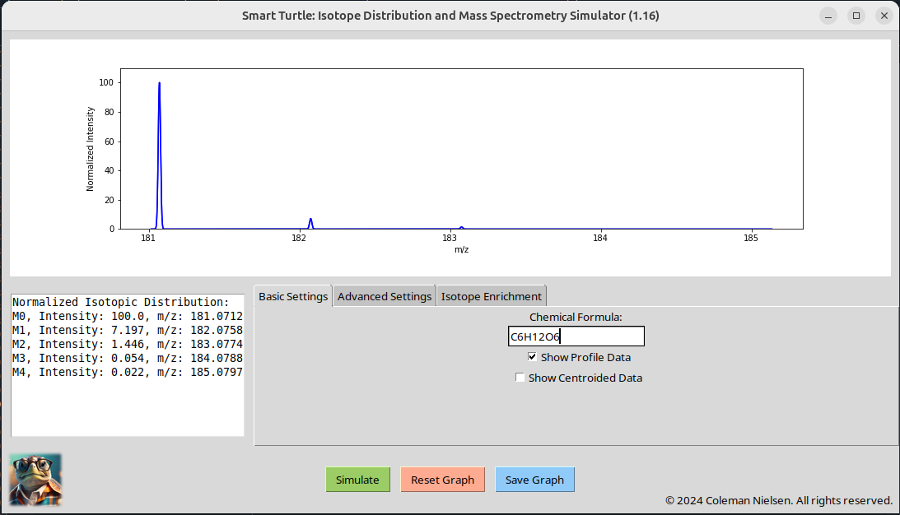
When starting up the application you will notice 4 sections: The plot (top), the text output (center-left), the settings (center-right), and the controls (center-bottom).

To use:
1. Enter your chemical formula where indicated. The program will accept any combination of elements, so long as they are written in standard notation, and without any sort of delimitation (see the extreme example on page 4).

2. Click enter and you will notice an isotopic distribution appear. On the left you will see the text-form of the isotopic distribution with relative intensities and m/z values.

3. Make a change to the graph or reset it. Many researchers are interested in the change in isotopic distribution over time due to increased incorporation of deuterium, C-13 or other heavy isotopes over time. In the “Isotope Enrichment” tab, you can change the relative abundance of these isotopes, and see how they affect the isotopic distribution. The same changes can be made to the relative noise level (% Baseline), mass resolution and chemical adducts (examples below).

Effect of increasing Deuterium enrichment by 2% sequentially (Note: Fixing the graph, combined with simple power point animations can produce a highly effective visual describing isotope incorporation over time. A high resolution image of the graph can be saved at each step).

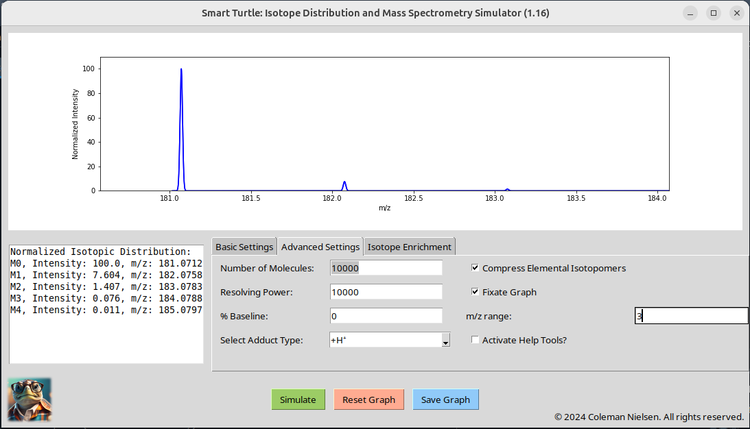
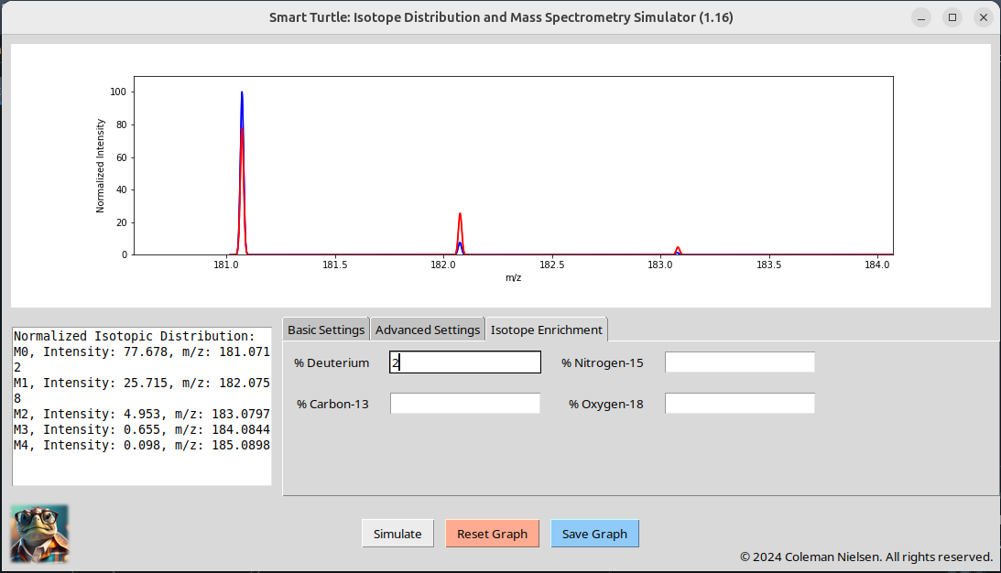

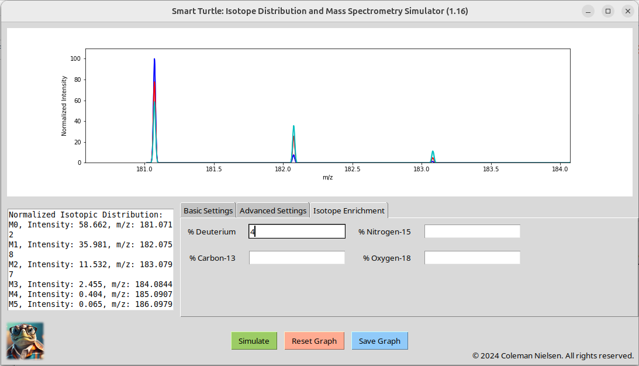

A similar experiment done with adducts (graph not fixed):

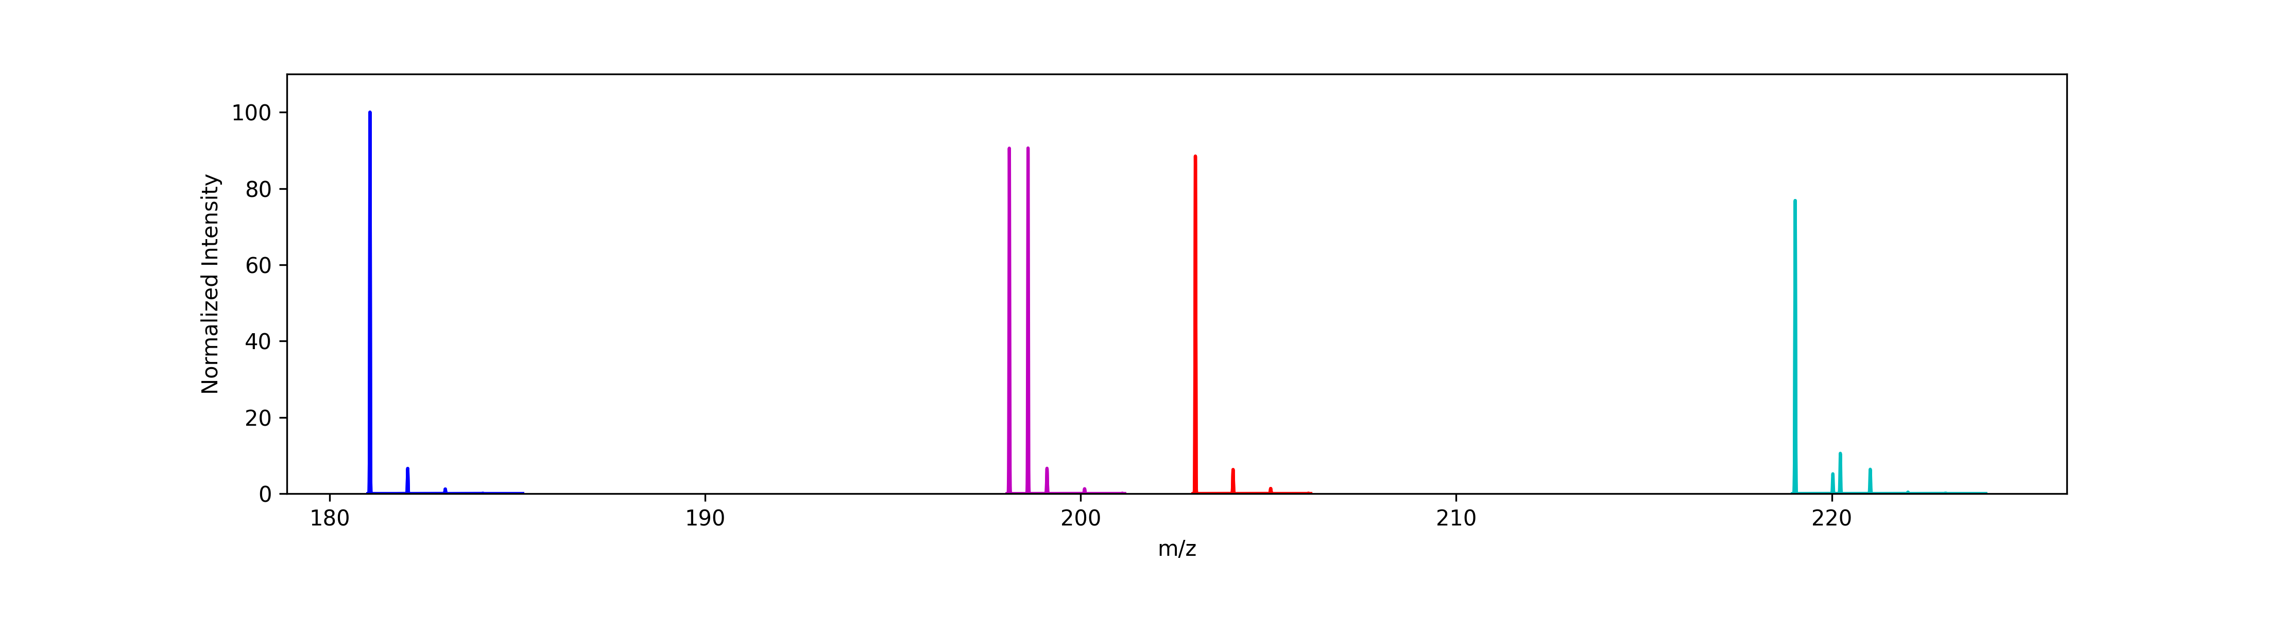
And with mass resolution:

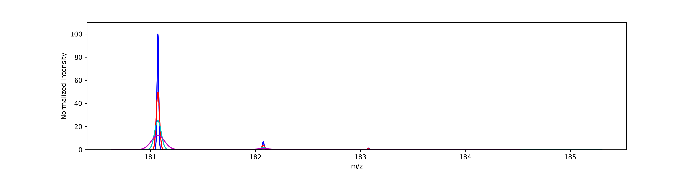

An extreme example of accepted chemical formula results:
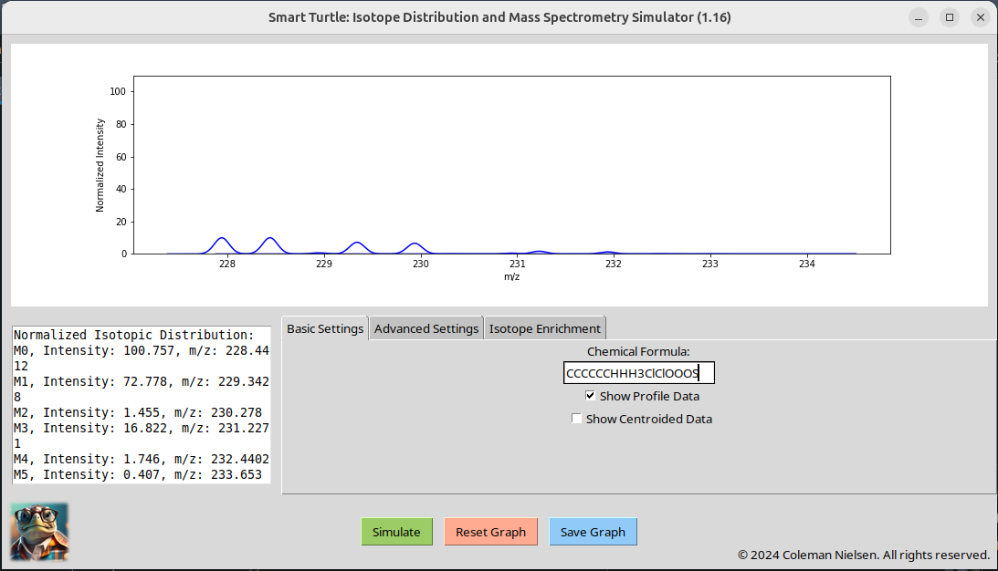
I hope you enjoy using this application! It is quite useful, yet far from complete. I am always open to suggestions as far as correctness, performance, accessibility an style goes. Please feel free to contact me on LinkdIn if you have any (https://www.linkedin.com/in/coleman-nielsen-798251137?lipi=urn%3Ali%3Apage%3Ad_flagship3_profile_view_base_contact_details%3B2eLJfZOiT5CFMzgXBgbJIg%3D%3D).

Acknowledgments and Copyright claim:

I would like to acknowledge Scientific Instrument Services for compiling the isotopic information used in this program. SCIENTIFIC INSTRUMENT SERVICES_df.csv is a copy-and-paste of the information found at: https://www.sisweb.com/referenc/source/exactmas.htm

I would also like to acknowledge the assistance of AI in writing portions of this code. As a functional and object-oriented programmer, I find the process to be much lighter if I have Chat GPT 3.0 write many of my simple functions and Classes. I then implement said functions and classes after proof-reading and testing for accuracy.

Adobe Photoshop image generator was also used to create the initial image of the turtle which is the icon for this app.

License
This project is licensed under the GNU General Public License (GPL) v3.0.

What This Means:
- Freedom to Use and Modify: You are free to use, modify, and distribute this software, provided that all copies and substantial portions of the software include the same license and copyright notice.
- Copyleft: Any derivative work or modified version of this software must also be distributed under the GPL v3.0 license. This ensures that all modifications and extensions to the code remain free and open-source.
- No Warranty: This software is provided "as is", without warranty of any kind. See the GNU GPL v3.0 for more details on licensing terms and conditions.

Copyright
Copyright © 2024 Turtle-Savant. All rights reserved.
By using this software, you agree to comply with the terms of the GPL v3.0. For full license text, please refer to the LICENSE file in this repository.

