Maximum profit of **$371,122,027.55 per day** achieved with:

**399.60 kg of M per second** going into a **10.0 m diameter** tank at **600.0 °C**.

Optimization

I set up a function to calculate for the profit per day of this process based on the three given independent variables. This function takes in steady state flow rate, reactor diameter, and temperature and outputs the calculated profit. This function is evaluated for flow rates between 10 and 10,000 kilograms per second, diameters between 4 and 10 meters, and reactor temperatures between 25 and 600 degrees Celsius. As the profits are calculated, the program keeps track of the current maximum and prints it to output. Since this project represented a steady state process with an equilibrium, I set a minimum of 1 hour of residence time to allow for equilibrium to be reached.

The composition of the output stream was solved for with the equilibrium expression.

$$\frac{\left[P\right]}{{\left[M\right]}^{2}}=k, k=e^{-\frac{ΔH}{RT}}$$

$$\frac{x}{{\left({\left[M\right]}_{0}-2x\right)}^{2} }=k$$

$$\left[P\right]=x=\frac{-\left(\sqrt{8k{\left[M\right]}_{0}+1}-4k{\left[M\right]}_{0}-1\right)}{8k}, k=e^{-\frac{ΔH}{RT}}$$

Using this concentration, I calculated for the mass flow rate of P, and then the revenue generated by selling P. The other costs were calculated using the geometry of the reactor, and the enthalpies of reaction and heating the compounds.

Assumptions

My biggest assumption is that the reaction follows the equilibrium set forth in the project description. This assumes that the composition of the output stream is not dependent on residence time or size of the reactor and only the temperature. To correct for this, I set a minimum residence time as stated above.

I assumed that the output stream was of the same composition as the entire tank. This follows the steady-state CSTR assumption. This simplifies calculations greatly and allows for the analysis I did. A more accurate prediction would require partial differential equations.

I assumed that both M and P would remain in the liquid phase even at high temperatures. If either compound were to evaporate, much of the reactor would be taken up by vaporized compounds which would greatly reduce the residence time. This would drastically decrease the extent of reaction and therefore the profit.

I assumed that since M dimerizes like ethylene oxide, P would resemble dioxane, the dimer of ethylene oxide. This gave me a density for P and allowed for the calculation of the volumetric flowrate of my output stream.

Safety

I limited the reactor diameter to 10.0 meters. A larger reactor would allow for processing of more M per second and increase profit, but seemed unreasonably large after 10.0 m.

I limited the input flow rate to 1,000 kg M per second. Faster flow rates require more pressure to push, so restricting the flow rate reduces the danger of transportation.

Separation Process

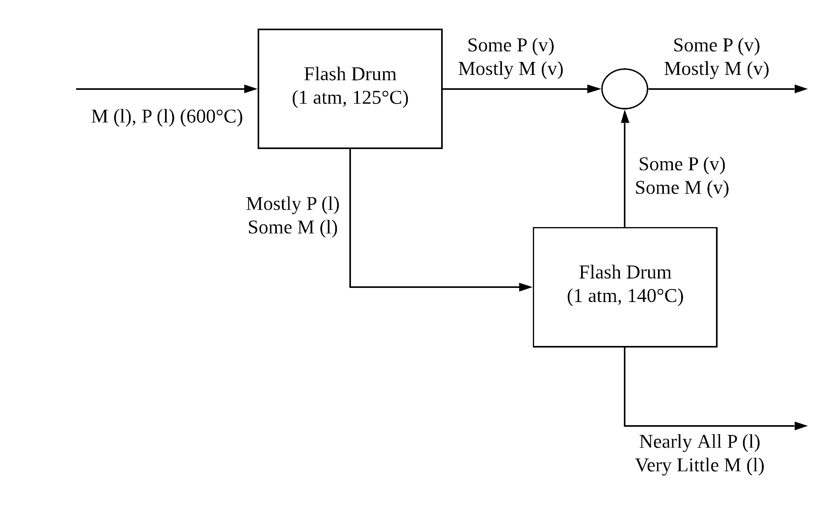

P is the desired product, so I wanted the stream with P to be of high purity. I ran the output through a flash drum at 125 °C to produce a liquid stream composed of mostly P that also kept the majority of P as a liquid. This liquid stream was then heated in another flash drum to 140 °C to achieve even higher purities. Further increasing the temperature would result in a better separation, but I decided that would not be desirable. Since the goal is to sell a large volume of pure P, I chose a temperature with some distance from the boiling point of P. This allows a greater fraction of the total solution to remain as the desired liquid while also driving off as much M as possible.