# User Guide for “Rename Files” Spreadsheet/Script

## TOC

User Guide for “Rename Files” Spreadsheet/Script

TOC

”Interface” Sheet Field Descriptions

Top Folder URL

List Folders? [yes/no]

List Files? [yes/no]

Folder Levels [1]

Replace Special? [yes/no]

Only show if different? [yes/no]

Save Previous List? [yes/no]

Menus

Rename-Files -> Get List

Rename-Files -> Rename List

Rename-Files -> Undo Rename

“RenameList” Sheet Columns

Level

ParentFolder

CurrentName

NewName

Link

Renamed

Advanced Section

Match Pattern [RegEx]

Replace Pattern [Replace]

First Time Use

Authorize Prompt

Choose Account Prompt

Advanced Prompt

Script That Wants Access

Review Access

## ”Interface” Sheet Field Descriptions

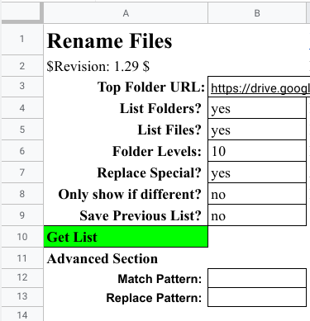

### Top Folder URL

[<https://drive.google.com/drive/folders/ID>]

Go to the “top” folder that you want to rename. I.e. the folder above all the folders and files that you might want to rename. Now copy the URL in the browser’s field, and paste the URL in the “Top Folder URL” cell.



### List Folders? [**yes**/no]

Default: “yes”

If this is no, then folders won't be listed.

### List Files? [**yes**/no]

Default: “yes”

If this is no, then files won't be listed. Note: List Folders and List Files both cannot be “no”, because nothing would be matched.

### Folder Levels [**1**]

Default: “1”

How many folder levels do you want to see (i.e. folders in folders)? Put "1" if only the top folder.

### Replace Special? [**yes**/no]

Default: “yes”

Allowed characters in names: 'a-zA-Z0-0_.-' All other characters will be replaced with '_'. If this is “no” then the “CurrentNames” will be copied to the “NewName” column, so that you can make some manual rename change.

### Only show if different? [yes/**no**]

Default: “no”

If “Replace Special” is “yes” and this is “yes” then only list folders and files where the new name is different from the old name.

### Save Previous List? [yes/**no**]

Default: “no”

Save the “RenameList” sheet before doing any of the Rename-File commands. This is especially recommended after doing a "Rename List" so that you will have a record of what was renamed.

## Menus

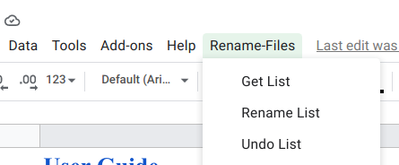

### Rename-Files -> Get List

Fill out the fields in the “Interface” sheet tab. Only change the values in column “B”. **Do not add any columns or rows to the Interface sheet that would change the cell locations for B2:B13.**

When you have defined the desired options, select the menu: **Rename-Files -> Get List**.

The list of files that match your settings will be put in the “RenameList” sheet. You can do this as many times as you want, changing the top folder URL and the other options until you have a list of folders and files that you want to rename. *Get List does not change anything.*

You can remove rows for the files that you don’t want to rename. Also, you can changes the names in the NewName column to names you would prefer. If you need to change a number of names for files that are similar, look at the “Advanced Section” for ways to make more automatic changes.

### Rename-Files -> Rename List

Select "Rename List" in the "Rename-Files" menu to rename the files in the RenameList sheet. Only changes to the "Save Previous List" field will be looked at; all other fields are ignored.

### Rename-Files -> Undo Rename

Select "Undo Rename" in the”Rename-Files” menu to reverse the renames in the RenameList sheet. The names will be reverted to the names in the CurrentNames column. Only changes to the "Save Previous List" field will be looked at; all other fields are ignored.

## 

## 

## “RenameList” Sheet Columns

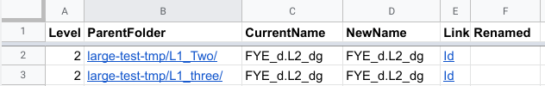

### Level

The folders under the top folder will be level 1. The folders within those folders will be level 2, etc.

### ParentFolder

The is the folder that a file or a folder is in. For level 1, the name will be the folder “path” (starting with the top folder) that the file or folder is in.

### CurrentName

This column will be the list of folders and files that match the settings in the Interface sheet. Changing these names will have no effect on what is renamed.

### NewName

This column will list the CurrentNames renamed using the “Rename Special” rules and the Advanced Section rules. You can then change these names to whatever you want. However, the Rename Special rule will define names that can be more easily used in scripts and batch files.

### Link

These hyperlinks will take you to the folder or file listed in the CurrentName column. DO NOT change this cell or nothing will be done, or worse you could reference other unknown files.

### Renamed

This will be blank when you do a “Get List”. After you run “Rename List”, this column will be set to “yes”, so that you will know these files have been renamed. If you want to undo the rename for all or some of the files, you should delete the rows that are “OK”, then run “Undo List” to revert the names back to the CurrentName values; a “no” will then be put in the Renamed column.

## 

## 

## Advanced Section

These are applied after Replace Special changes (if that was set to “yes”). If you don’t understand “regular expressions” then leave these fields blank. The JavaScript regular expression rules will be used. See: [JavaScript RegExp Reference](https://www.w3schools.com/jsref/jsref_obj_regexp.asp) for details.

### Match Pattern [RegEx]

Default: blank

Regular Expression (TBD)

### Replace Pattern [Replace]

Default: blank

Replace with match text (TBD)

## First Time Use

The first time you try to use one of the “Rename-Files” menus, you will be prompted to give the script access to certain areas of your account.

### Authorize Prompt

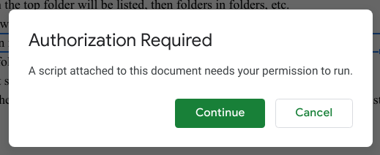

Select “**Continue**”.

### Choose Account Prompt

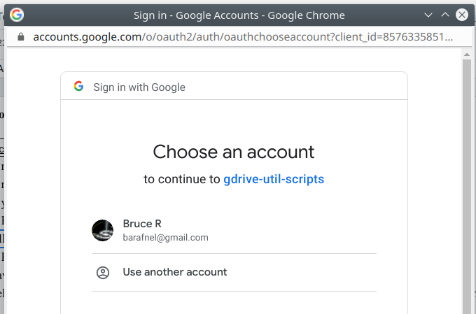

Select the google account you want the script to use. Then select “**Continue**”.

### Advanced Prompt

Now you will see a scary message:

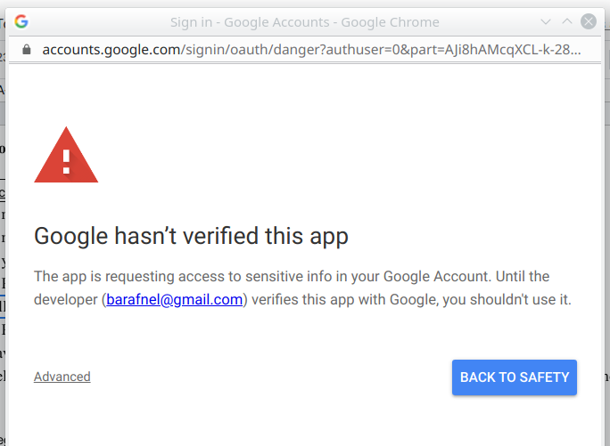

If you know and trust me, then click on “**Advanced**”. You will have more chances to not accept.

### 

### Script That Wants Access

One more time you’ll be asked if you want to continue. But this time it will list the name of the script that wants access.

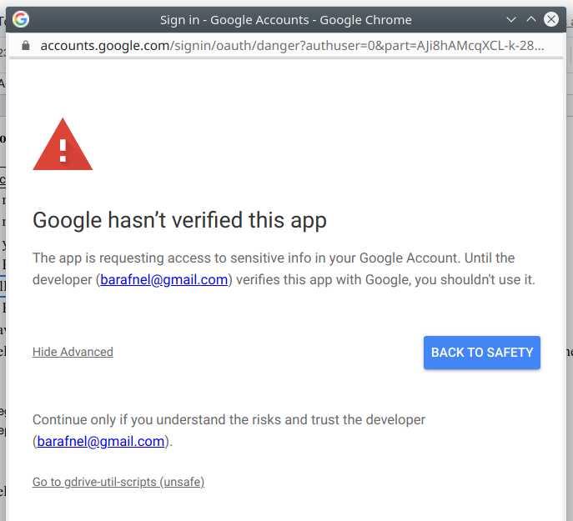

Click on “**Go to gdrive-util-scipts (unsafe)**” to review what the script would like to access.

### Review Access

This is the review screen:

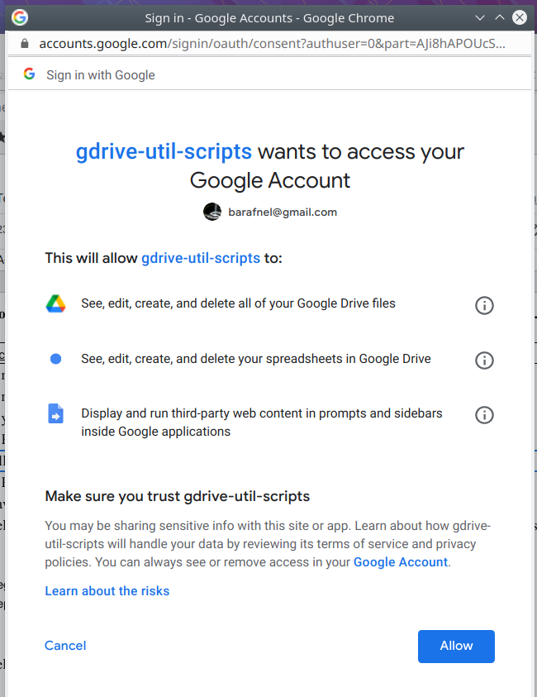

Here is why the script needs access to these areas:

* “See, edit, create, and delete all of your Google Drive files.”

That is the whole point of the script--it will be renaming files. It will list files in the area you specify and you control what is changed and when to do it.

* “See, edit, create, and delete your spreadsheets in Google Drive”

This script is attached to Google Spreadsheet and it will only be modifying that sheet.

* “Display and run third-party web content in prompts and sidebars inside Google Application.”

This is mainly needed so that the script can create custom menus and pop-up notifications in the spreadsheet.

Select “**Allow**” if you are OK with these accesses. If you select “**Cancel**” you will be able to view what someone else has done, but you will not be able to use the script. If after trying the script you don’t want to use it, you can remove its access. Visit <https://myaccount.google.com/permissions> and click on “**gdrive-util-scipts**”, then “**REMOVE ACCESS**”.