Software Requirements Specification
Interactive Turing Machine


CptS 322 Spring 2017

Author:
Kenneth M. Murry

Last Updated: 4/25/2017

Table of Contents
1. Introduction 7
2. Background 7
2.1 Representation of Turing Machine 8
3. Overview 9
3.1 Recognize or accept language 10
3.2 Tape Head 10
3.3 Finite States 10
3.4 Transition Function 10
4. Environment 12
4.1 Input and Output Devices 12
4.2 Turing Machine Definition File 13
4.2.1 States: 13
4.2.2 Input_Alphabet: 13
4.2.3 Transition_Function: 13
4.2.4 Initial_State: 13
4.2.5 Blank_Character: 13
4.2.6 Final_States: 14
4.3 Input String File 14
5. Environment 14
5.1 Invocation 14
5.1.1 Command Line: 14
5.1.2 Configuration Settings: 14
5.1.3 Opening Turing Machine: 15
5.1.3.1 Valid file definition 15
5.1.3.2 TM is successfully loaded 15
5.1.3.3 Application maintain status of TM 15
5.2 Commands 15
5.2.1 Help User 16
5.2.2 Show Status 16
5.2.3 View Turing Machine 16
5.2.4 List Input Strings 17
5.2.5 Insert Input String 17
5.2.6 Delete Input String 17
5.2.7 Set Transitions 17
5.2.8 Truncate Instantaneous Descriptions 17
5.2.9 Run Turing Machine 17
5.2.10 Quit Turing Machine 18
5.2.11 Exit Application 18
5.3 Termination 19
5.3.1 Closing Turing Machine 19
6 References 19

Document Revision History
Revision Number | Revision Date | Description | Rationale
1.0 | 3/9/2017 | Initial Revision | Formally specifying requirements
1.1 | 4/25/2017 | Added Reference Page | Formally specifying References

List of Figures
Figure # Title Page #
2-1 Input & Output Tape 8
3-1 Starting State 10
3-2 Static Turing Machine 11
3-3 Dynamic Turing Machine 11
3-4 Boundary Of Application 12

List of Tables
Table # Title Page #
3-1 Language 9
3-2 Lambda 9

Introduction
The purpose of this document is to give a user a quick reference guide and the outline of what is required for the interactive Turing Machine. This document will be divided into sections giving detailed information about the background, overview, environment, and operation.
The background section of this document will describe a Turing machine as an abstract mathematical mode of a computer and a formal specification of a Turing Machine. The overview section will describe the purpose of the Turing Machine, the hardware, and software environment for the development and installation of the application. The environment section of this document will describe the input and output devices and text files used by the Turing machine application. The operation section will dive detailed information about the actions that will be performed by the Turing machine application at the beginning and end of operation.
- Background
A Turing machine (TM) is said to decide a language if it is always able to determine whether a given input string is contained in a certain language or not. Therefore, the machine usually has two special states marked as Accept and Reject. A TM is a finite-state abstract mathematical model of a computer which consists of an infinite length tape divided into cells on which input is given. It consists of a head which reads the input tape. The tape is used for input and working storage (see Figure 2-1).
A finite control stores the state of the Turing machine. The finite control and the tape of the Turing machine are connected by a reading/writing head, which points over the tape, has the ability to move left or right along the tape, and reads the tape one square at a time. The position of the reading head is the cell it is currently reading. If the TM reaches a final state, the input string is accepted or otherwise rejected.
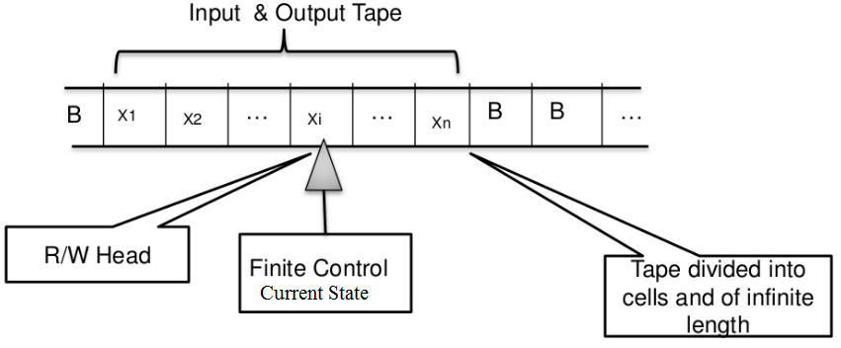
Figure 2-1 Input & Output Tape

  - Representation of Turing Machine
A Turing machine is represented by
M = (Q, Σ, Г, δ, q_{0,} B, F)
Where
Q is a finite set of states
Σ ⊆ (Г –{B}) is a finite input alphabet
Г is a finite tape alphabet
δ is a transition function from Q x Г → Q x Г x {L, R}
q_{0 є Q is the initial state}
_{B є Г is the blank space}
F ⊆ Q is the set of final states
λ is empty string or null string

- Overview
This Turing machine (TM) application shall be a console application running in UBUNTU Linux environment. The TM application will be compiled and linked using the GNU C++ compiler. The TM application shall be implemented in C++ language using only the C++ standard library as its primary library. The purpose of the TM is to allow user to interactively trace operation of the TM application on an input string.
This TM shall recognize a language using strings as inputs to accepts or reject a give user input string. Alphabet, denoted by ∑, is a finite set of characters or symbols used to construct strings
(e.g. ∑ = {a, b}). Strings are a finite sequence of character from ∑. Language is a set of strings over ∑, possibly infinite. Languages are referred to as formal languages, only concerned with format or syntax of strings.
Table 3-1 Language
L₁ = {aa, ab, ba , bb} | Finite language
L₂ = {a²,b² | n≥ 1} | L₂ = {ab, aabb, aaabbb,…}

In this TM application λ is an empty string or null string were λ has no characters in string.
Table 3-2 Lambda
L₃ = 0 | Language containing no strings
L₄ = {λ} | Language contains a null strings
L₃ ≠ L₄

∑* is a language and is infinite unless ∑ = 0, ∑* = {λ} if ∑ = 0.

  - Recognize or accept language
Each tape cell contains one character from the tape alphabet input string is stored in left most cell of tape at beginning of operation.
Input Alphabet | Tape Alphabet
∑ = {a, b} | Г = {a, b, -, X, Y}
The remaining cells contain blank character, such as ‘–‘the input alphabet is a subset of tape alphabet, and doesn’t contain blank characters.
  - Tape Head
The tape head is able to read a character on the tape, write a character over it, and move one cell left or one cell right. Tape head starts at first cell and may never move left from the first cell.
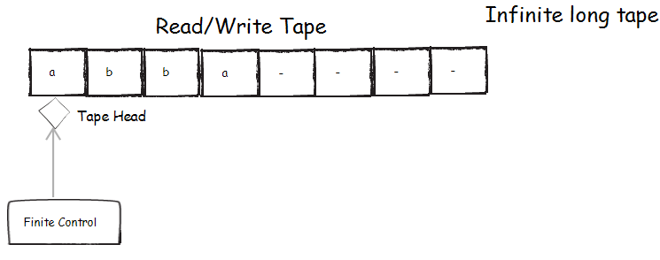
Figure 3-1 Starting State

  - Finite States
The Turing machine (TM) contains a finite set of states, one of which is the start state. TM has 0 or more final states which cause it to halt when entered and accept original input state.
  - Transition Function
The transition function is based on current state of the Turing machine and character in current cell. It provides next state of TM, character to write in current cell, and direction to move tape head left or right.

TM accepts language over ∑ = {a, b} consisting of strings where b is second character.
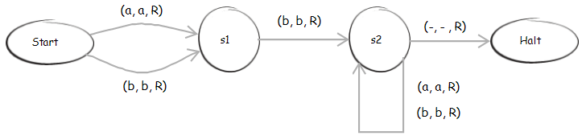
Figure 3-2 Static Turing Machine

The TM first start in the Start state, tape head reads a ‘a’ writes a ‘a’ and moves to the ‘R’ight, now the TM is in state s1. Now in s1 the tape head reads a ‘b’ writes a ‘b’ and moves to the ‘R’ight, TM now in state s2. TM now in s2 reads an ‘a’ writes an ‘a’ and moves to the ‘R’ight, TM stay in state s2. TM still in s2 reads ‘-‘ writes a ‘-‘ and moves to the ‘R’ight, now TM is in the halt state. TM now in halt state stop and accepets input string as part of the alphabet (see Figure 3-3).
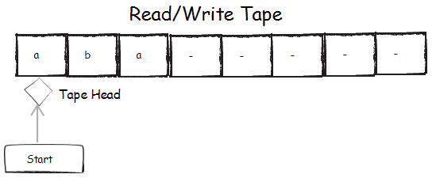
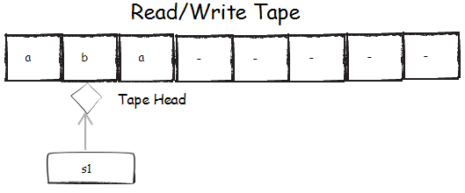
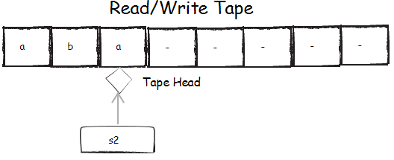
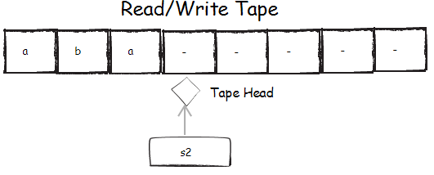
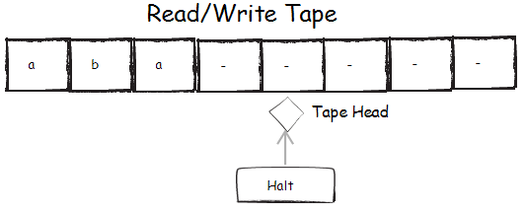
Figure 3-3 Dynamic Turing Machine
- Environment
This section shall cover the Environment in which the Turing machine (TM) will run in. This TM application will be a console application running in UBUNTU Linux environment. The primary sources of input and output devices will be: keyboard, monitor, TM definition File, and input string file (see Figure 3-4).
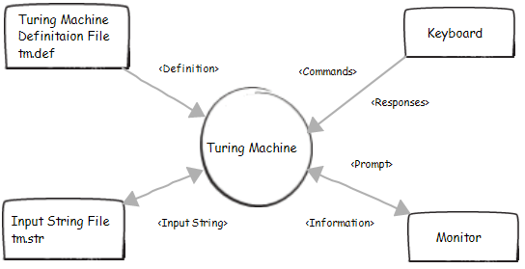
Figure 3-4 Boundary Of Application
  - Input and Output Devices
The primary source of user interaction shall be the input device of the keyboard and the output device of the monitor. The purpose is to allow the user to interactively trace operation of a TM on an input string through the use of eleven different commands.

  - Turing Machine Definition File
The Turing machine (TM) will be specified TM specified a M = (Q, Σ, Γ, δ, q_{0,} B, F). The file will have an extension of “.def” and created with a text editor. If any problem with file, application will provide appropriate error messages on monitor to user, and will then exit This application will not use erroneous definition file and all error shall be printed to the monitor. All error messages shall be meaning full. The TM definition file shall use key words to identify parts of the TM. These keywords may appear in upper or lowercase or in any combination. The file format can and may be a free format file. The definition file shall use whitespace as a delimiter between groups of characters. Tabs, spaces, newlines in any combination are considered to be whitespaces. To allow description of TM within file, all text up to appearance of first keyword STATES: will be ignored in parsing file. The lines of text comprising description must be retained in original form for viewing TM.
4.2.1 States:
The Keywords indicating parts of TM must appear in the file in order. Underscore and colon are part of keywords (e.g. States:). State in Q is named as a string of upper or lowercase, digits, or underscore. State name is case sensitive and must be unique. Having no limit of length of state name or number of states.
    - Input_Alphabet:
The Alphabets Σ and Г shall consist of printable characters from ASCII character set. Excluding white space (whitespaces are delimiters) white spaces excluded from Σ and Г. Five characters will be excluded from alphabet and reserved \ [ ] < > and cannot be in alphabet. Every character in Σ and Г must be unique and every character in Σ must be in Г, as well blank symbol B must not be in Σ.
    - Transition_Funcation:
Any number of transition may be defined in δ. Transitions undefined from Q x Г will cause TM to crash during execution. Each transition must user STATES in Q and tape character in Г. Transition must also define direction to move tape head Left or Right, using the characters L or R in upper or lower case. At most one transition from a given STATE on a given tape character may be defined, since this model of the TM is deterministic.
    - Initial_State:
The initial state q₀ must be a state in Q and there shall be only one initial state.
    - Blank_Character:
The blank symbol B must be a taper character in Г, but not in input alphabet Σ.

    - Final_States:
Any state in Q may be defined to be a fine state F. There shall not be any duplicate finale states (e.g. Final_States: s4 s4).

  - Input String File
This file shall have input strings from Σ* for use during operation of TM are stored in input string file. This file if it exists, has the same name as the definition file excepts for extension of “.str”. Each line of input string file is considered to be an input string composed of character from Σ. λ is specified by the reserved character \ appearing on a line by itself (λ is the empty string).
An empty or blank line is an error condition and the line shall be discarded. Other errors (aaa b) (\\) (aaab ) (ac) discard any of these lines in the “.str” file. If any other line is empty or contains a character not in Σ, application will discard line, providing an appropriate error message on monitor to user. Duplicate input strings are also discarded. There shall be No Limit of length of an input string or the number of input string. The Input strings are maintained in a list by the application. Entire list of input string will be written to input string file when application is terminated only if list is changed during operation. In that case, any original file is replaced only write the accepted strings back to the input string file.
- Operation
This section will describe how a user will be able to execute the Turing Machine. In detail this section will do over the different command that shall be used by the user.
  - Invocation
    - Command Line
The ‘$’ will be the command line prompt for this document. The name of the application runnable command shall be tm. In order the run the application from the command line $tm [filename].
    - Configuration Settings
There shall be two configuration settings. A maximum number of transitions to perform with a default value is 1. As well as a maximum number of cells to the left and right of the tape head to display in instantaneous descriptions(ID) with a default value is 32 that displays 32 characters to the left and right of tape head. Configuration settings may be changed during operation, but are not saved when application is terminated.

    - Opening Turing Machine
This application is able to perform operations on a TM when valid definition file is read. The file is specified through a command line argument (e.g. $tm anbn). If other than 1 argument, an application usage message is displayed and execution is terminated. Full or relative path, without extension of “.def” (append the .def to the file). Name of files formed by appending “.def” or “.str” to the command line. The input string file “.str” does not necessarily exist at the beginning of operation. If definition file with appended extension does not exist or contain a valid TM definition, appropriate error messages are provided to user and execution is terminated. If an error is in the definition those need to be printed before terminating.

5.1.3.1 Valid file definition
If TM is successfully loaded from definition file, any description of TM is saved for viewing TM by use and a message is print to the screen. If input string file exists”.str”, all valid input strings from this file are loaded into list of input strings If input string file does not exist or does not contain any valid input strings, list is initially empty.
If not specified in requirements, developer may decide upon appearance for displaying information to the user. The information displayed must be readable and complete. The prompts for input shall be concise and meaningful. Prompts should look like Command: Response entered through keyboard is invalid if it contains more than one item. There shall be no message on blank response. On any other response, feedback shall be provided to user

5.1.3.2 TM is successfully loaded
Once a TM is successfully loaded, commands are available to perform on TM until user exits the application. Operation are performed through single character command entered by user in upper or lower case in response to prompt “Command:” The command structure shall be flat. All commands appear at top level rather than grouped in to menus according to topics. Command must be provided by this application, where underlined character in each command is the single character used to select that command (see top of this document).

5.1.3.3 Application maintain status of TM
The TM application shall maintain three application status. TM has not been run on an input string during session, TM is currently running on an input, TM has completed operation on an input string during this session.
  - Commands
Delete Delete input string from list
Exit Exit application
Help Help user
Insert Insert input string into list
List List input strings
Quit Quit operation of TM on input string
Run Run TM on input string
Set Set maximum number of transitions to perform
Show Show status of application
Truncate Truncate instantaneous descriptions
View View TM
5.2.1 Help User
Command: H
Help command displays list of commands with single character and brief description
(e.g. (H)elp). Only display then go back to command prompt.
    - Show Status
Command: W
Course:
Semester:
Year:
Instructors Name
Author:
Version:
Configuration Settings
Maximum number of transitions to perform
Maximum number of cells to left and right of tape head to display ID
Name of TM (without extension of “.def)
Status of TM, one of
TM has not been run on an input string
TM is currently running on an input string
TM has completed operation on an input string
If TM is running,
display input string
Number of transitions performed so far on input string
If TM has completed operation on input string
Last input string
Whether it was accepted, rejected, or operation was terminated by user
Total number of transition performed
No retention of information when user exits the application.
    - View Turing Machine
Command: V
Display definition of currently load TM on monitor in form readable by user
Description of TM in exact form from definition file
Followed by formal specification of TM as M = (Q, Σ, Г, δ, q_{0,} B, F) in order

    - List Input Strings
Command: L
Displays list of input strings upon which TM may be run at the given time
Each input string on its own line
Numbered sequentially starting a 1 (Line numbers)
If list is empty, message should be displayed

    - Insert Input String
Command: I
Allows user to enter an input string into the list from Σ*
Append to list
If already in list, display error message (Already in the list)
If contains a character not in Σ error message, discard string
No error if no input string entered
    - Delete Input String
Command: D
Allows users to delete an input string from the list, which causes renumbering of the list
Input String is to delete is selected by number
    - Set Transitions
Command: E
Allows user to change setting for the maximum number of transitions to perform at a time during the operation of the TM on an input string
Value of this setting must be a positive integer
Current value must be displayed in prompting for this setting
User may leave it unchanged by typing enter
    - Truncate Instantaneous Descriptions
Command: T
Allows user to change setting for maximum number of cells to left and right of tape head to display in ID during operation of TM on an input string
Value of setting must be a positive integer
Current Value must be displayed in prompting for setting
User may leave it unchanged by typing enter
    - Run Turing Machine
Command: R
Allows user to trace the operation of the TM on an input string selected from list
If TM is not already running on an input string
User is prompted for the number of input string upon which to run TM
No error if no number entered
Non-existent number, error message and command is terminated.
If valid number entered display initial instantaneous description(ID)
αqα ID
q₀X initial ID
Each ID is numbered with total number of transitions performed up to that point
In displaying ID, q (current state) must be enclosed within [ and ]
α₁ and α₂ may be truncated using setting for maximum number of cells to left and right of tape head
< is displayed at beginning of ID if α₁ truncated
> is displayed at end of ID if α₂ is truncated.

If newly selected input string is not accepted at that point (initial state is not final state), transitions may be performed to trace operation of TM on input string until it accepts or rejects input string, or user quits running TM

If in middle of operation on an input string, transition may be performed.
No prompt for input string number, just continuing where we left off.

After performing up to maximum number of transitions specified by our setting, current ID is displayed to the user.

Number of transition performed may be less than the maximum for this iteration of the run command if the input string is accepted or rejected.

If TM accepts input string, ID includes a final state, message indicates string is accepted with total number of transition getting to this point.

If TM rejects input string, ID displayed caused TM to crash, message indicates string is rejected with total number of transition performed to get to that point
Accept or reject message must include original input string
    - Quit Turing Machine
Command: Q
Terminates operation of TM on input string before completion
Message should be displayed indicating that TM has no accepted or rejected input string
Display input string and total number of transition perform to get to this point
If the TM is not running or in the middle of an input string, error message displayed
    - Exit Application
Command: X
No opportunity to confirm or cancel operation
Command will terminate application

  - Termination
    - Closing Turing Machine
If input strings were discarded at the very beginning of operation of application, or any insertions or deletions from input string list during operation by command (Insert or Delete), entire list is written to input string file, replacing any original file
Error message if file cannot be written
If successful in writing file, message indicating success

- References
- Neil Corrigan – General lecture and notes

