|  |  |  |
| --- | --- | --- |
| **Requirements** | **Best Pattern** | **Reasons/ features obtained** |
| To calculate values stored in the given row and column combination of cell | We use Composite Pattern | For its recursively getting values from another cell and continue calculating operation. |
|  |  |  |
|  |  |  |
|  |  |  |

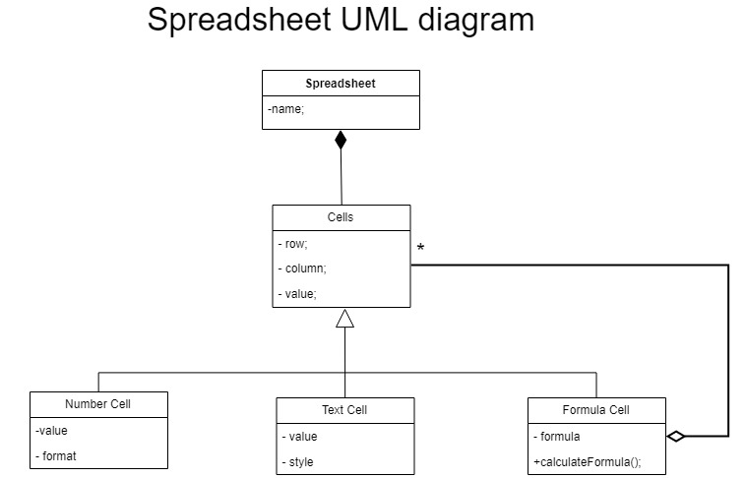**Spread sheet Project – Sprint #1**

**Modeling with Design and Patterns**