**Background information:**

Finnish National Gallery consist of three museums: Ateneum Art Museum, Museum of Contemporary Art Kiasma and Sinebrychoff Art Museum. As stated by Finnish National Gallery’s website: “Responsibility for the augmentation and management of the collection is divided between three museums. The Sinebrychoff Art Museum houses old international art from the 14th to the early 19th century, the Ateneum Art Museum has Finnish art up to 1969 as well as international art from the 19th and 20th centuries, and the Museum of Contemporary Art Kiasma is responsible for Finnish and international art from 1960 onwards.”[1]. The collections include works of art, objects and archive materials. Art historical archive material is stored and managed by the National Gallery´s Collections Department. Finnish National Gallery offers its digitised collections online and their API is publicly available. Collections are also available through [Finna](https://www.finna.fi/) and [Europeana](https://www.europeana.eu/portal/en) and through their APIs.

**Project:**

Our visualizations represent the digitised material from the Finnish National Gallery. These visualisations give some inside of the acquisition types included into digitised collections, the geographical location of the donators and donated collections before their entries to the museum, timeline of acquisitions and how much material has been digitised by the Finnish National Gallery.

Our whole group project can be found here: <https://github.com/artsncoding/methods4DigitalHumanities>

My focus has been on making visualisations about the different acquisition types found from the FNG API and about the division of digitised entries between the museums. My main goal was to find out how many items have been digitised by the Finnish National Gallery and by each museum individually. These visualisations will give some insight about the way some of the digitised items have entered the collections and since each museum has its own focus ranging from old masters to contemporary art, it can possibly tell us something about the digitisation priorities of National Gallery.

**Working with FNG API:**

Dataset of Finnish National Gallery metadata for the whole digitized collection was downloaded from the Finnish National Gallery (FNG) API.

Finnish National Gallery API: <http://kokoelmat.fng.fi/api/v2support/docs/#/download>

The dataset was given as Dublin Core JSON, each item in the description set contained: Title of the item, artwork type, identifier, creator, publisher (containing collection and museum), date of creation and date of acquisition, subject of the piece, format, relation to other items and its previous usage in exhibitions.

Dublin Core standard is a data structure standard developed for metadata. Each Dublin Core JSON description list contains a list of predetermined items, details of which can be found from footnote.[2] Each of these items contain a list of values for that item.   
  
The dataset was parsed into two smaller datasets using Python and Regex (Code provided).   
As not all the information was required, Python was used to parse item title, museum and acquisition date for dataset 1 and item title, museum unit, collection, and acquisition date for dataset 2. Acquisition type and donator location data were added to the dataset manually in the next phase of data handling, as described below.

Regex was used to extract the year from acquisition time, as the acquisition time was provided in E52 time span format. Both datasets were saved in CSV format to be used in visualizations.

For dataset 2, the metadata provided by the API did not contain all the required information. This information was acquired by research, as described below. The acquired information on the collection type of each collection and the location of the donator of each collection was added to the dataset.  
  
We divided the object entries into different acquisition types/categories based on the way that object or group of objects had entered the collection. Acquisition types/categories are the following: “hankinta” (purchase), “lahjoitus” (donation), “talletus” (deposition), “testamentattu valtiolle” (devised to government by last will), “testamenttilahjoitus” (devised to the museum by last will), “unknown” and “valtion talletus” (deposited by government).

These categories were mostly based on the categorization used by Finnish National Gallery. Some of the categories had some overlapping and were combined before making the visualisations. These categories were found by searching Finnish National Gallery “Collection” page for each collection.[3] Information provided on the page of each item contains information on how the item was acquired or information about the collection it belongs to. Usually collections are named after the donators. If this information was not provided, it was marked on our dataset under the category ‘unknown’ or completed by doing google search with the name of the collection. Some information was found from Finnish National Gallery’s Collection Strategy pdf[4], books and some from the articles focusing on the collections or donations.

Geographical information was taken from Wikipedia and other internet resources, books and newspaper articles found by googling the name of the collections or donators. Location was been chosen by the place of death of the person named in the collection or last known place of residence or known workplace (for example in case of living artists who have donated their works to museum). If there is two people mentioned in the name of the collection, we have solely taken the first location we could find, assuming that especially couples have most likely lived together. If we could find any reliable looking information on location, we marked it as “unknown”.

**Analysis and visualisations:**

Number of object entries collected from the FNG API: 19809.

According to National Gallery’s website the number of art works in their collection is around 40,000 objects. On top of this they have large amount of archive materials and other objects.[5] It becomes obvious that only small part of the collections has been digitised and can be accessed online.

Figure 1 Visualisation 1.

My first visualisation lists the number of items digitised in each acquisition category in FNG collection.[6] Most of the items come from the “lahjoitus” (donations) or “testamenttilahjoitus” (devised to the museum by last will) categories. 735 items have no known origin or could not be located to any specific donation or donator. This includes 482 items included into Ahlström’s collection. According to FNG´s Collection Strategy person named Rafael A. Ahlström (1877–1918) donated both money for the City of Helsinki and some of this money has later been used for acquisitions of new works.[7] In theory these items could have been included into “hankinta” category but since there is two Ahlström’s collection listed in the “LIITE A: Kokoelmakartan tiivistelmä” (Summary of Collections), we decided to play it safe and place it under the category “unknown”.[8]

Visualisation 2. focuses on presenting the same data but now divided between three museums.[9] It excludes items listed in dataset as being placed in unknown unit, and one item listed as being located at Tampere Art Museum. This one odd item has most likely been deposited to Tampere Art Museum, but is still owned by the National Gallery. It becomes obvious from visualisation 2. that the Sinebrychoff Art Museum has most items included in the “testamenttilahjoitus” (devised to the museum by last will). Sinebrychoff’s digitised collections also include most of the items listed under the acquisition category “hankinta” (purchased). Kiasma has 0 items listed under this category in their digitised collections. This could be interpreted as the sign that Finnish National Gallery purchases less contemporary art than old masters, but since rather small percentage of the overall items in the collections have 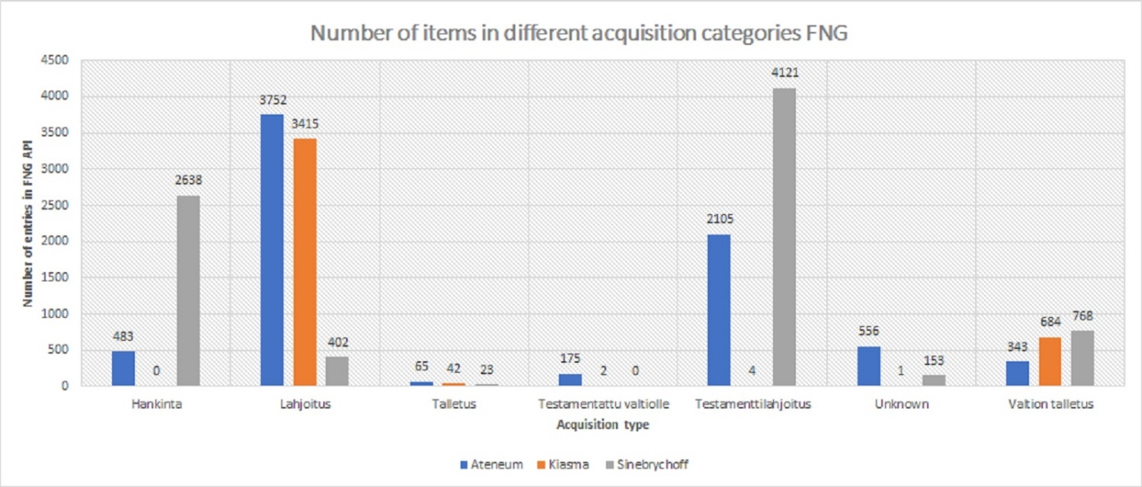been digitised this assumption would be based on too small sample size.

Figure 2 Visualisation 2.

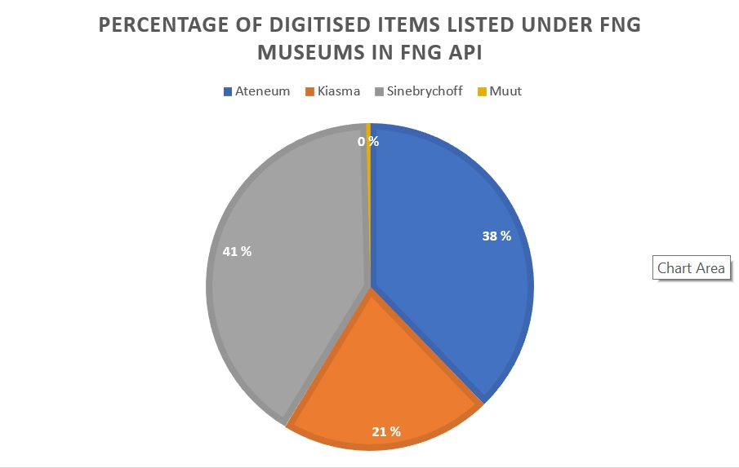

Figure 3 Visualisation 3.

Visualisation 3. focuses on visualising the percentage of items each museum has in the digitised collection. Of all 19809 collected object entries, 41% belong to Sinebrychoff Art Museum, 38 to Ateneum and 21% to Kiasma. Location “Muut” (Others) includes all the unknown locations and that one item located in Tampere Art Museum. This portion is so small in comparison that it gets rounded to zero in the pie chart. The fact that only 21% items found from digitised collections belong to Kiasma Museum, tells a story about how underrepresented contemporary art is in Finnish National Gallery’s digitised collections. In comparison the Sinebrychoff Art Museum focusing on “old masters” has digitised almost twice as many items as Kiasma. This tells an interesting story about digitisation priorities of Finnish National Gallery. It seems that Finnish National Gallery’s focus is on digitising its “old masters” and “Finnish golden era” artworks and contemporary collection has been given less of a priority.

**Pipeline biases and and other problems:**

In order to better understand the overall structure of Finnish National Gallery’s collections we should have most of the items from its collections available in digitised format. Also, the unclearly written acquisition categories and sometimes missing information made the analysing of the data difficult and may have caused unnecessary mistakes. Especially when the labelling of the items required finding information from the multiple outside sources. This use of multiple resources and the special knowledge needed for understanding the different ways objects enter the museums makes the reproducing of the dataset challenging.

**Further research:**

It would be interesting to study further what kind of artworks have been given priority when digitising collections. Research could include information of gender division of the artists or the semantic analysis of the artworks included in the digitised collections**.**

**Bibliography:**

Kinanen, P. & Pettersson, S. 2010. *Suomen museohistoria*. Helsinki: Suomalaisen

Kirjallisuuden Seura.

Jyrkkiö, T. & Liukkonen, E. 2010. *Kokoelmalla on tekijänsä!:Ateneumin kokoelmatoiminnan vaikuttavuus*. Helsinki: Valtion taidemuseo.

**Web sources:**

Ateneum, Tuomo Sepon lahjoitus (Donation by Tuomo Seppo[Finnish only]):<https://ateneum.fi/kuukauden-vieras/kerailija-tuomo-sepon-jaettu-ilo/> [Accessed Nov. 2018].

Finnish National Gallery API:<http://kokoelmat.fng.fi/api/v2support/docs/#/overview> [Accessed Nov. 2018]

Finnish National Gallery Collections:<https://www.kansallisgalleria.fi/en/kokoelmat/>

Finnish National Gallery Collection Strategy (Finnish only):<https://www.kansallisgalleria.fi/wp-content/uploads/2014/04/20048_VTM_kokoelmastrategia_2012.pdf> [Accessed Nov. 2018].

1. FNG website: Collections.
2. http://www.dublincore.org/documents/2000/07/16/usageguide/generic/
3. Refer to web sources.
4. Ibid.
5. FNG website: Collections
6. Sheet 3 in dataset.
7. Finnish National Gallery Collection Strategy p.34.
8. Ibid p. 28 and 34.
9. Data sheet 2.