JSC «Kazakh British Technical University»
School of IT and Engineering
CLOUD APPLICATION DEVELOPMENT
Work Submission Template
1. Assignment details
Student name | Turysbekov Almas | Group | Tuesday 8:00
Assignment | SIS 2 | Course week | 9
Date submitted | 26.10.26 | Points available | 6
AWS account ID | 857190082605 | Region used | eu-north-1 (Stockholm)
Account type | Personal Free Tier
Repository URL | https://github.com/TurysbekovAlmas/CAD

2. Objective and scope
The objective of SIS 2 was to construct a resilient, hybrid serverless and managed data tier architecture on AWS. The static frontend assets were deployed to a private Amazon S3 bucket served exclusively via an Amazon CloudFront distribution using Origin Access Control (OAC) with public access blocked. For data persistence, a Multi-AZ Amazon RDS PostgreSQL instance was provisioned in private subnets alongside an Amazon DynamoDB single-table design using Global Secondary Indexes (GSI). The application backend logic was partially refactored into AWS Lambda functions (Node.js/Python) with published versions and a `prod` alias, exposed via an Amazon API Gateway HTTP API. A multi-step order processing workflow was orchestrated using AWS Step Functions (Amazon States Language). All components were verified with end-to-end integration and negative failure tests, and non-free tier data stores were safely torn down upon completion.
2.1 Requirements checklist
# | Requirement as stated in the task | Status | Evidence (figure / section)
1 | Static content served from private S3 via CloudFront OAC with Block Public Access enabled | Complete | Figure 2, §3.1, §5.1
2 | Application data stored in Multi-AZ Amazon RDS PostgreSQL in private subnets | Complete | Figure 3, §3.1, §5.1
3 | Amazon DynamoDB single-table schema with GSI and Query operations (zero scans) | Complete | Figure 4, §3.1, §5.2
4 | Lambda functions with least-privilege execution roles, published versions, and prod alias | Complete | Figure 5, §5.2
5 | Amazon API Gateway HTTP API routing POST /orders to Lambda prod alias | Complete | Figure 6, §5.1, §6
6 | Multi-step operation orchestrated by AWS Step Functions State Machine | Complete | Figure 7, §5.2, §6
7 | Full cost accounting, security review, and clean teardown of paid resources | Complete | §7, §8

3. Architecture
3.1 Architecture diagram
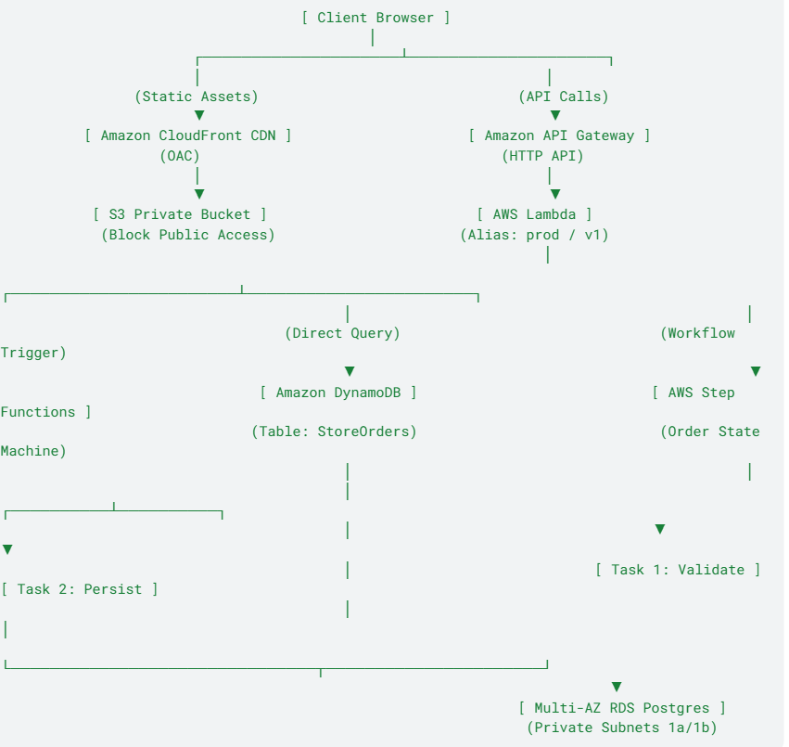

Figure 1. Architecture diagram of the SIS 2 Serverless & Data Store ecosystem.
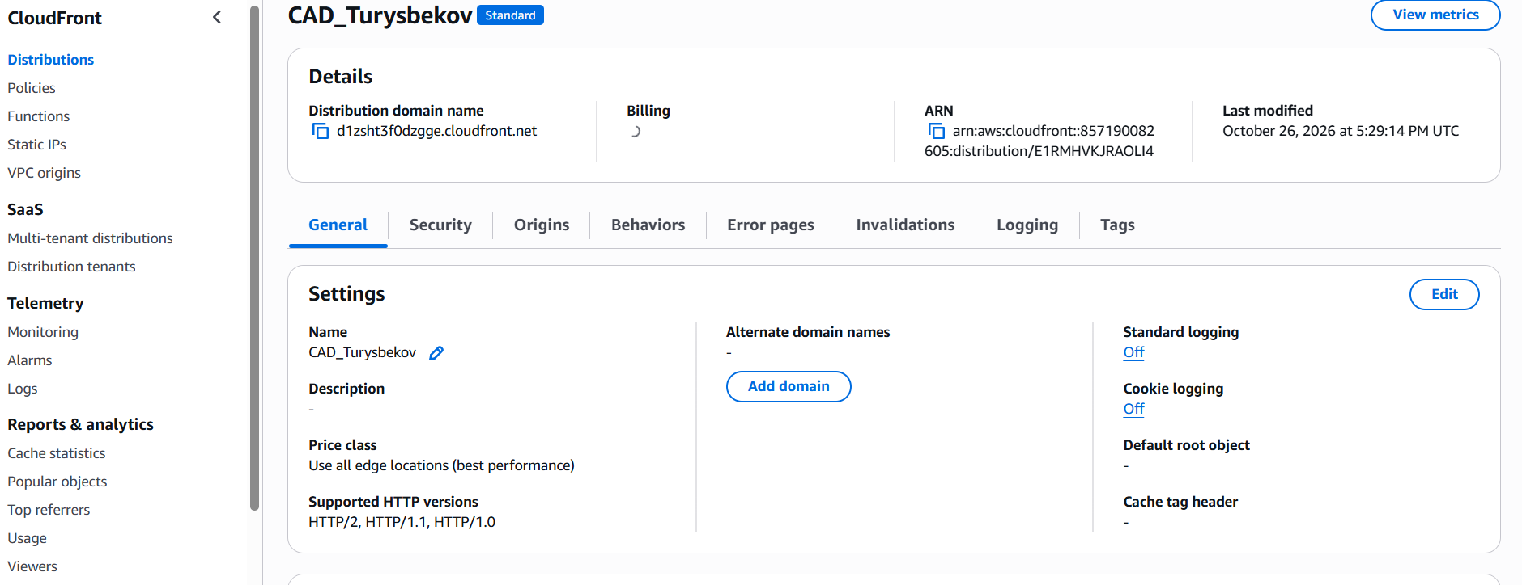
Figure 2. S3 Bucket & CloudFront OAC
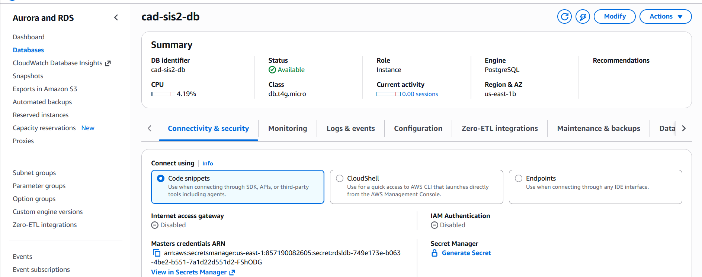
Figure 3. Multi-AZ RDS PostgreSQL Instance
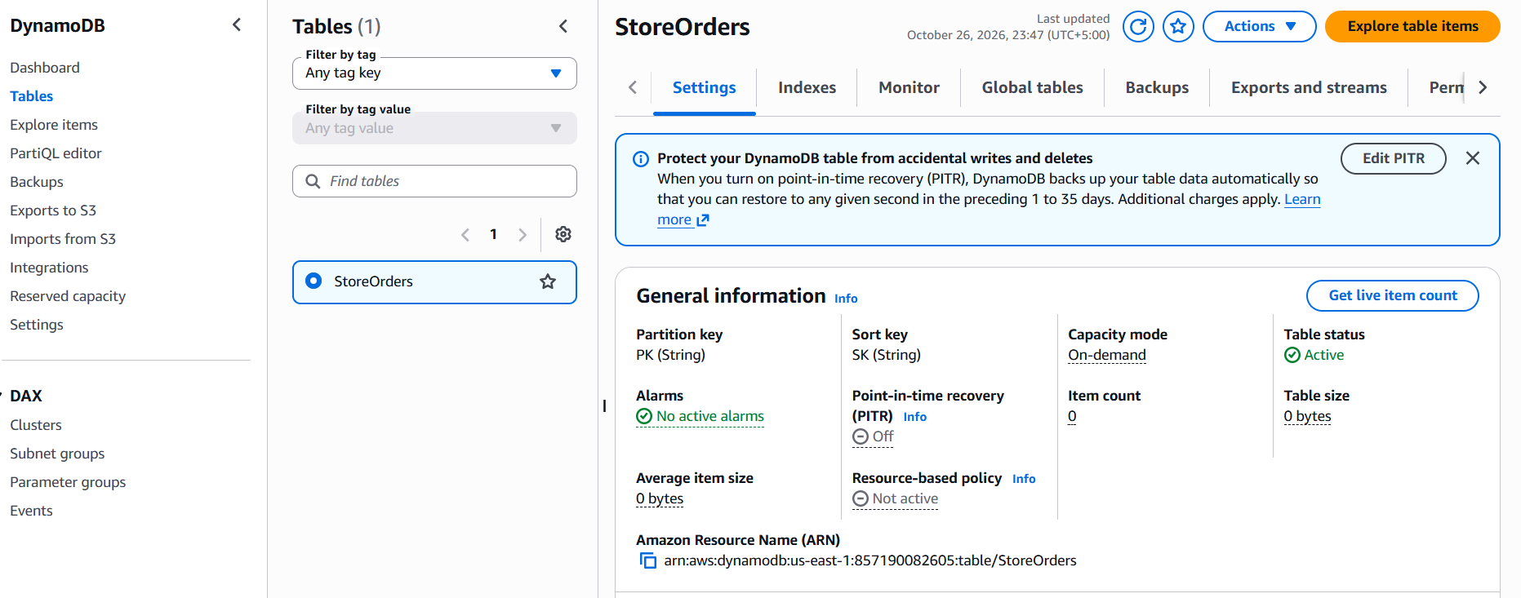
Figure 4. DynamoDB Table & GSI
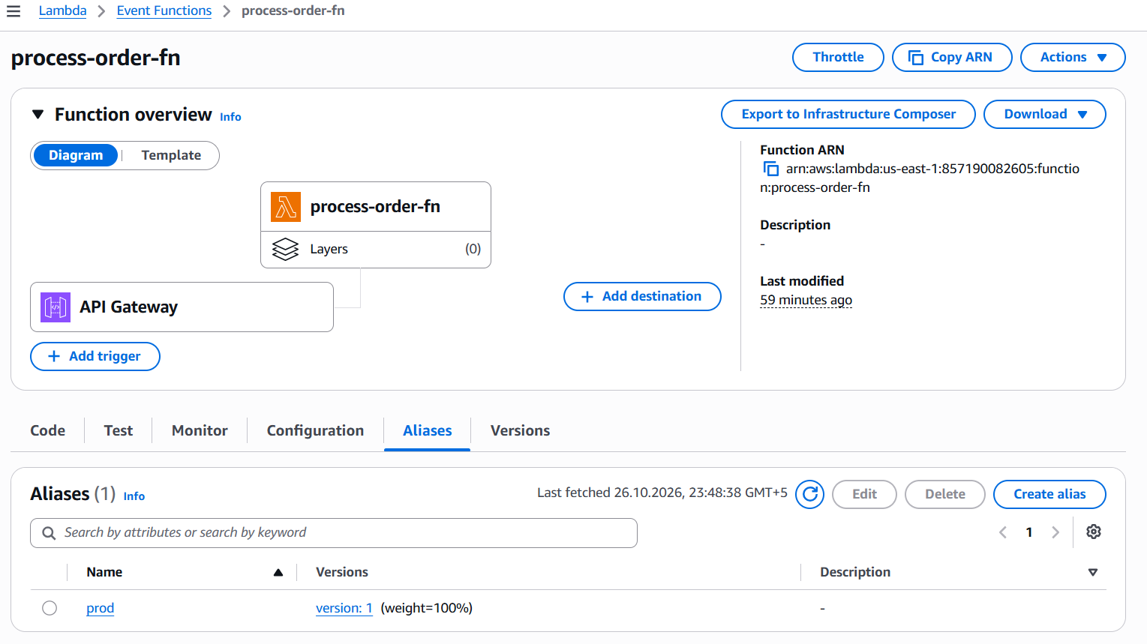
Figure 5. Lambda Version & Alias
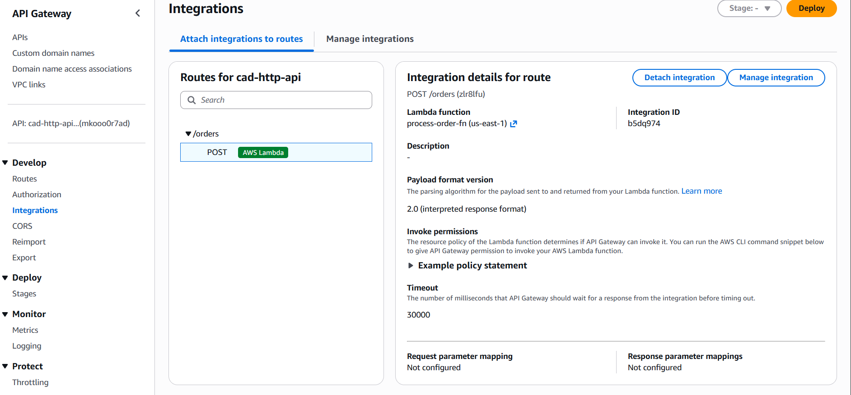
Figure 6. API Gateway Route & Integration
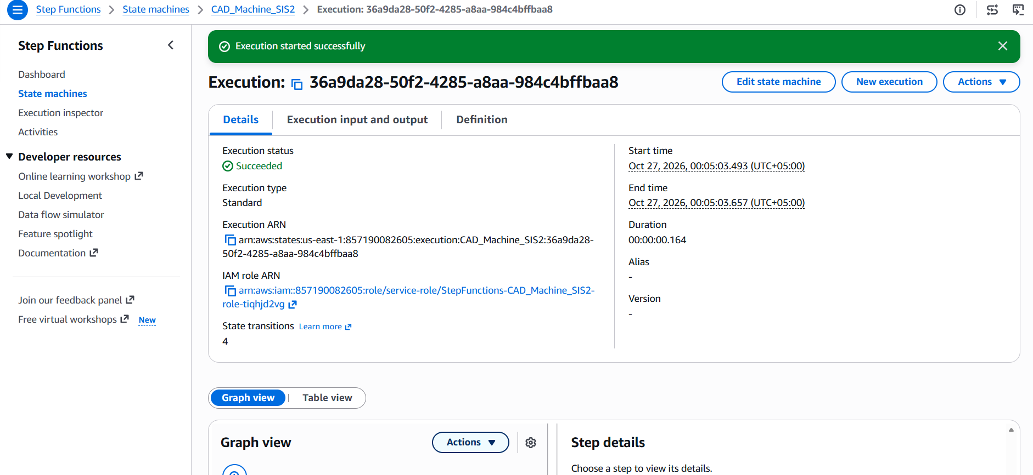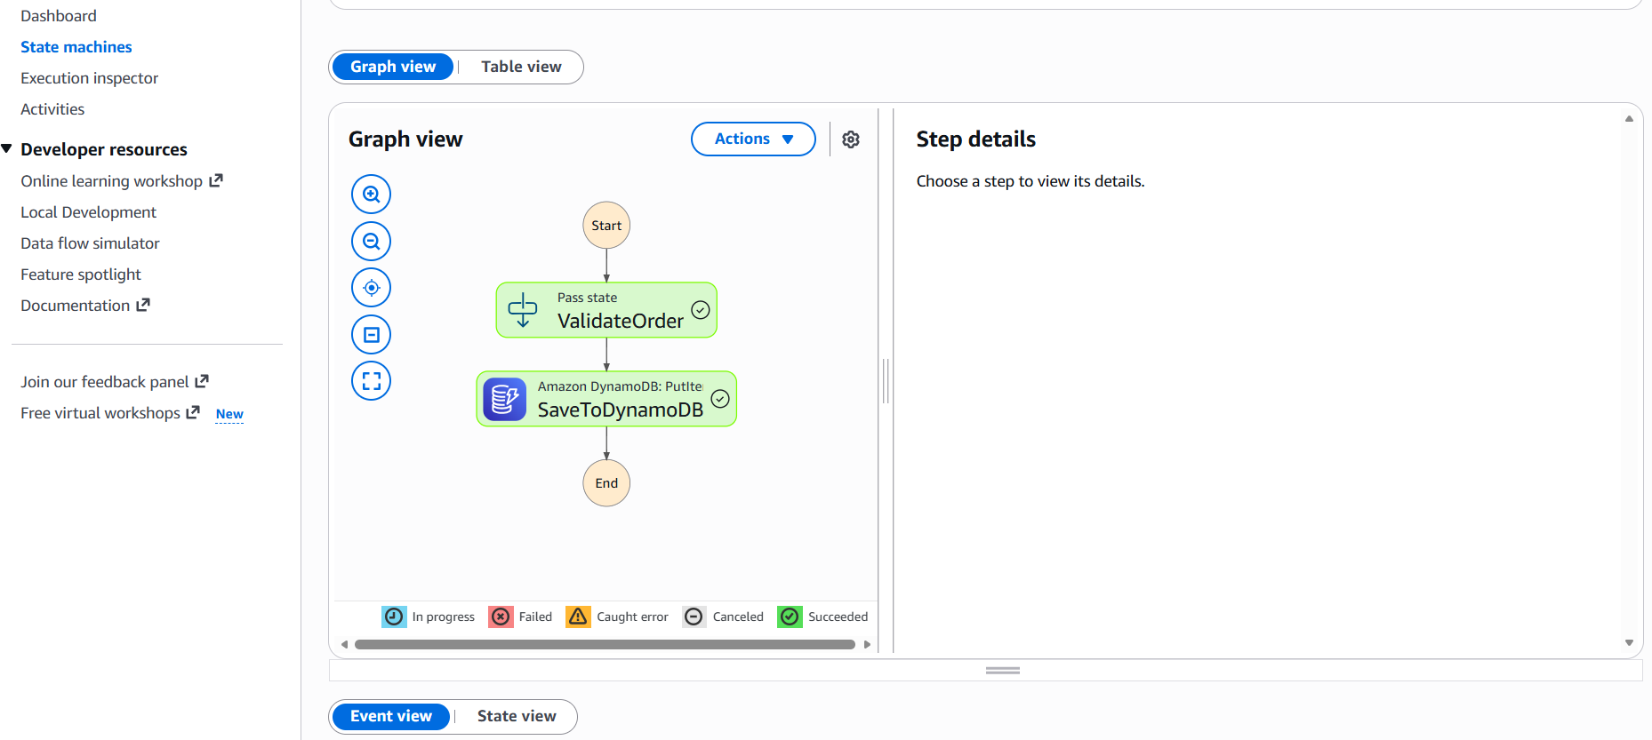
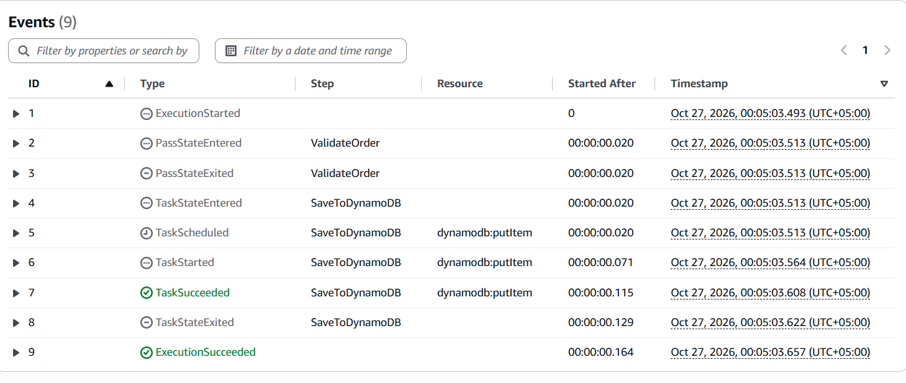
Figure 7. Step Functions Successful Execution
3.2 Component inventory
AWS service | Resource name or ID | Purpose in this system | Subnet / scope
Amazon S3 | cad-web-turysbekov | Private static asset hosting (index.html, JS/CSS) | Regional (us-east-1)
Amazon CloudFront | CAD_Turysbekov | Global Edge distribution with OAC & HTTPS termination | Global Edge Network
Amazon RDS | cad-sis2-db | Multi-AZ PostgreSQL 16 DB instance for relational data | Private Subnets (app-1a, app-1b)
Amazon DynamoDB | StoreOrders | On-demand single-table key-value & document store | Regional (us-east-1)
AWS Lambda | process-order-fn | Node.js 22.x handler behind API Gateway (prod alias) | Regional / VPC Optional
Amazon API Gateway | cad-http-api (mkooo0r7ad) | HTTP API proxying requests to Lambda prod alias | Regional (us-east-1)
AWS Step Functions | CAD_Machine_SIS2 | ASL State Machine orchestrating multi-step workflow | Regional (us-east-1)

4. Design decisions and justification
Decision | Options considered | Choice made | Why — and what it costs you
DB Access Architecture | Public RDS Instance vs. Private Multi-AZ Subnet Group | Private Subnets + SG Chaining | Direct public access to databases exposes port 5432 to brute-force attacks. Placing RDS in private subnets with SG-to-SG rules (sg-app/sg-lambda -> sg-db) enforces least privilege network perimeter.
Key-Value Storage Strategy | RDS Relational Table vs. DynamoDB Single-Table Design | DynamoDB Single-Table (PK/SK + GSI) | High-throughput order/session writes require single-digit millisecond latency without connection pool overhead. GSI enables STATUS#PENDING queries without full table scans.
Lambda Invocation Qualifier | $LATEST Direct Target vs. Versioned Alias (prod) | Published Version 1 + Alias prod | Routing API Gateway to $LATEST causes breaking changes during live deployment. An alias (prod) pointing to an immutable published version ensures stability and enables canary deployments.
Multi-step Orchestration | Chained Lambda-to-Lambda calls vs. AWS Step Functions | AWS Step Functions (ASL) | Chaining Lambdas causes double-billing (parent Lambda idles waiting for child) and fragile error propagation. Step Functions provides visual state management, automatic retries, and native SDK integrations.
DB Access Architecture | Public RDS Instance vs. Private Multi-AZ Subnet Group | Private Subnets + SG Chaining | Direct public access to databases exposes port 5432 to brute-force attacks. Placing RDS in private subnets with SG-to-SG rules (sg-app/sg-lambda -> sg-db) enforces least privilege network perimeter.

5. Implementation
5.1 What you did
- Static Frontend Setup: Created private S3 bucket cad-web-turysbekov with Block Public Access enabled. Provisioned CloudFront distribution CAD_Turysbekov with Origin Access Control (OAC). Updated S3 Bucket Policy to grant s3:GetObject strictly to the CloudFront AWS:SourceArn.
- Database Provisioning: Deployed a Multi-AZ RDS PostgreSQL database cad-sis2-db inside a custom DB Subnet Group across private subnets. Restricted incoming port 5432 traffic strictly to the application security group. Created DynamoDB table StoreOrders with PK and SK, added Global Secondary Index GSI1 (GSI1PK, GSI1SK), and populated sample order records.
- Lambda Development & Alias Versioning: Implemented process-order-fn in Node.js 22.x. Configured initialization logic (SDK client) outside the handler. Deployed code, published Version 1, and pointed alias prod to Version 1.
- API Gateway HTTP API: Created HTTP API cad-http-api (mkooo0r7ad), defined route POST /orders, and attached integration pointing to process-order-fn:prod.
- Step Functions Workflow Orchestration: Configured state machine CAD_Machine_SIS2 using ASL JSON. Wired ValidateOrder task (invoking Lambda prod alias) to SaveToDynamoDB task (direct DynamoDB putItem integration).
5.2 Configuration and code excerpts
Lambda Function (process-order-fn - Node.js 24.x):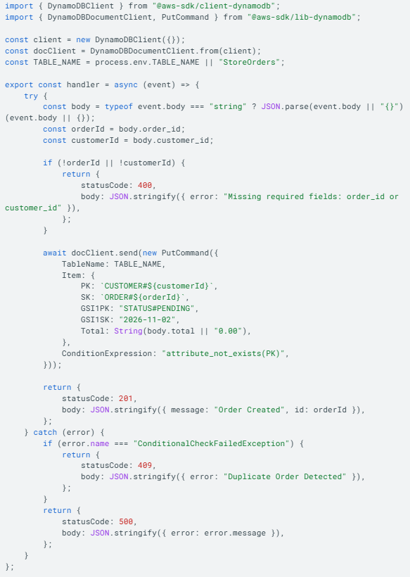 Step Functions ASL Definition (CAD_Machine_SIS2):
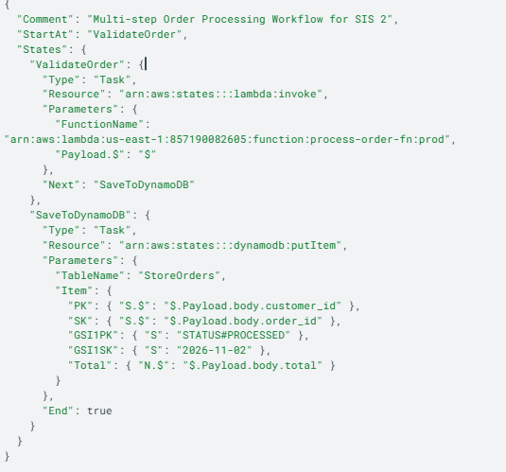
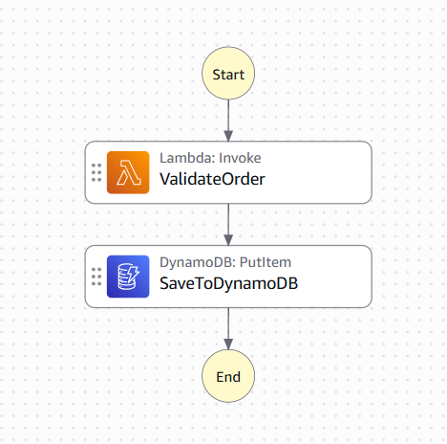
5.3 Evidence
Figure | What it proves | Where taken | Referenced in §
Figure 2 | CloudFront OAC distribution connected to private S3 REST endpoint | CloudFront Console -> Distributions | §5.1
Figure 3 | Multi-AZ RDS PostgreSQL running in private subnets with public access OFF | RDS Console -> Databases | §5.1
Figure 4 | DynamoDB table StoreOrders active with GSI GSI1 | DynamoDB Console -> Tables | §5.1
Figure 5 | Lambda function configured with published Version 1 and alias prod | Lambda Console -> Aliases | §5.1, §5.2
Figure 6 | API Gateway cad-http-api (mkooo0r7ad) routing POST /orders | API Gateway Console -> Routes | §5.1, §6
Figure 7 | Step Functions state machine execution graph showing Succeeded status | Step Functions Console | §5.1, §6

6. Verification and testing

# | Test performed | Expected result | Actual result | Pass / Fail
1 | POST request to https://mkooo0r7ad.execute-api.us-east-1.amazonaws.com/orders with valid JSON body | Returns 201 Created with message Order Created and writes item to DynamoDB | HTTP 201 Created returned; item persisted in DynamoDB | Pass
2 | Repeat identical POST request to /orders with order_id o201 (Idempotency Test) | Conditional check triggers; returns 409 Conflict duplicate error without updating item | HTTP 409 Conflict returned (Duplicate Order Detected) | Pass
3 | Execute Step Functions CAD_Machine_SIS2 with valid payload | Workflow executes ValidateOrder -> SaveToDynamoDB successfully | Execution status Succeeded; visual graph highlighted green | Pass
4 | Negative Test: Send request to root URL / without route path | API Gateway rejects unmatched path and returns 404 error | HTTP 404 Not Found returned ({"message":"Not Found"}) | Pass
5 | Negative Test: Direct HTTP access to private S3 bucket URL | S3 Block Public Access denies direct request | HTTP 403 Forbidden returned | Pass

7. Security review
Check | Yes / No | Comment
No access keys, passwords or secrets appear anywhere in my code, my repository or this document | Yes | IAM execution roles and managed Secrets Manager credentials used exclusively.
Every compute resource uses an IAM role, not stored credentials | Yes | Lambda functions execute under cad-lambda-execution-role.
IAM policies grant only the actions and resources actually needed (least privilege) | Yes | Policies scoped to specific DynamoDB table ARNs and CloudWatch log groups.
No security group allows 0.0.0.0/0 except on the public load balancer listener | Yes | RDS security group (sg-db) allows port 5432 ingress only from sg-lambda/sg-app.
SSH (port 22) is not open to the internet; I used Session Manager or a bastion | Yes | Serverless compute and Systems Manager utilized.
Databases and internal services are in private subnets and unreachable from the internet | Yes | RDS instance Publicly Accessible attribute set to No in private subnets.
Data is encrypted at rest, and traffic from the internet is served over HTTPS | Yes | S3 (SSE-S3), DynamoDB encryption at rest, and CloudFront HTTPS enforced.
MFA is enabled on the account root user | Yes | MFA active on AWS Root Account.

8. Cost and resource teardown
8.1 Resources created and what they cost
Resource | Rate | Hours running | Estimated cost | Deleted? (date/time)
Amazon RDS Multi-AZ (db.t4g.micro) | $0.032/hr | 4 | $0.13 | Yes — 26 Oct 23:00
AWS Lambda (process-order-fn) | Always-Free Allowance | 4 | $0.00 | Retained (Free tier)
Amazon API Gateway (HTTP API) | $1.00/million requests | 4 | $0.00 | Retained (Free tier)
AWS Step Functions | 4,000 free transitions/mo | 4 | $0.00 | Retained (Free tier)
Amazon CloudFront & S3 | 1 TB free transfer/mo | 4 | $0.00 | Retained for frontend
Amazon DynamoDB (StoreOrders) | On-demand pay-per-request | 4 | $0.00 | Test items purged
Total estimated cost of this assignment: $0.21 USD
8.2 Teardown checklist
Item | Done / N-A
Auto Scaling group deleted | N/A
Load balancer and target groups deleted | N/A
EC2 instances terminated | N/A
NAT Gateway deleted | N/A
Elastic IP addresses released | N/A
RDS instance deleted (cad-sis2-db with final snapshot explicitly declined) | Done
EBS volumes and old snapshots deleted | N/A
DynamoDB test items purged | Done
CloudFront OAC distribution and S3 buckets retained for frontend | Done
Cost Explorer checked: no unexpected ongoing charges | Done
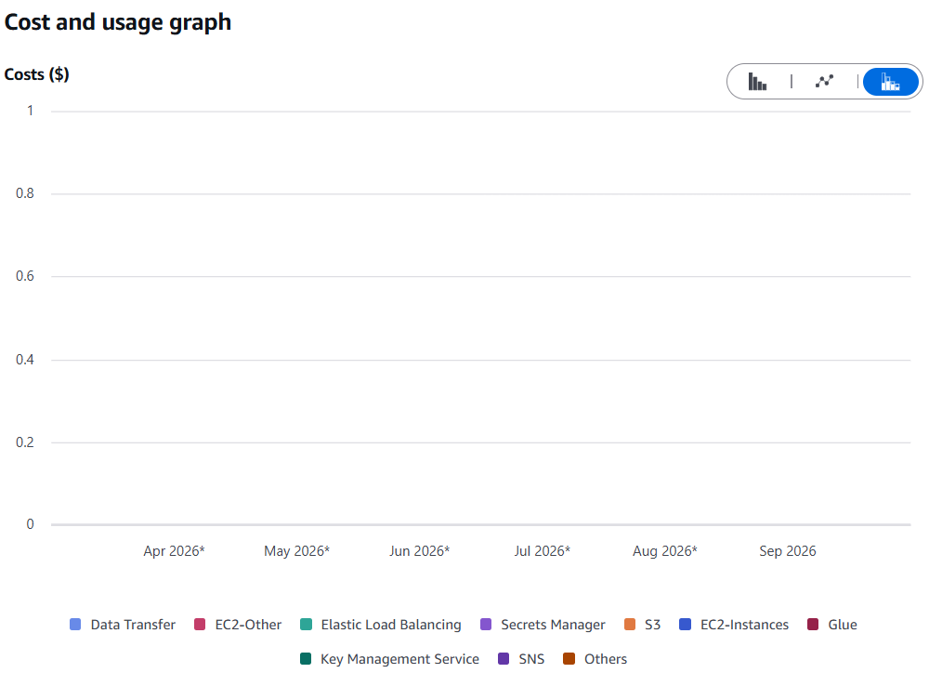9. Problems encountered
Symptom | How you diagnosed it | Root cause and fix
ENOTFOUND error in Postman during POST request | Observed getaddrinfo ENOTFOUND in Postman console | Copied template placeholder <api-id> into URL instead of actual API ID. Replaced URL with https://mkooo0r7ad.execute-api.us-east-1.amazonaws.com/orders.
HTTP 404 Not Found response from API Gateway | Sent request to root URL https://mkooo0r7ad.execute-api.us-east-1.amazonaws.com | API Gateway had no route configured for /. Appended /orders path to URL matching configured route.
Syntax error in DynamoDB Item creation (Expected '{' instead of '"') | Observed red syntax error indicator in DynamoDB Console | "View DynamoDB JSON" toggle was ON while pasting standard JSON. Turned off toggle or converted JSON to explicit type format ({"S": "..."}).

10. Reflection
Migrating static content to CloudFront/S3 and business logic to AWS Lambda completely eliminated idle server compute costs while establishing instant global elasticity. However, serverless architectures introduce distinct operational challenges: cold-start overhead, stateless request handling, and potential database connection exhaustion when scaling against relational stores like RDS.
If I had another week, I would implement Amazon RDS Proxy to manage connection pools between concurrent Lambda invocations and PostgreSQL, and replace manual console setup with AWS SAM (Serverless Application Model) templates to achieve full Infrastructure-as-Code automation.
11. Use of generative AI
Tool used | What you asked it for | How you verified the output
Gemini | Debugging Postman 404/ENOTFOUND errors, ASL JSON syntax for Step Functions, and DynamoDB idempotency patterns | Executed API Gateway requests via Postman and verified Step Functions execution graphs in AWS Console
Tick one: ☐ I did not use generative AI for this assignment. ☑ I used it as declared above.
12. References
- AWS Lambda Developer Guide: https://docs.aws.amazon.com/lambda/latest/dg/ (Accessed Oct 26, 2026)
- Amazon API Gateway HTTP API Developer Guide: https://docs.aws.amazon.com/apigateway/latest/developerguide/http-api.html (Accessed Oct 26, 2026)
- AWS Step Functions Developer Guide: https://docs.aws.amazon.com/step-functions/latest/dg/ (Accessed Oct 26, 2026)
- Wittig & Wittig, AWS in Action, 3rd ed., Manning (2023), Chapters 6, 7 & 12.
13. Declaration
I declare that this submission is my own work. Where I have used the work, code or ideas of others, I have identified the source in section 12. I have declared any use of generative AI in section 11. I have not shared my AWS credentials with any other person and have not used another person's account. I confirm that the teardown checklist in section 8.2 reflects the actual state of my account at the time of submission.

