JSC «Kazakh British Technical University»
School of IT and Engineering
CLOUD APPLICATION DEVELOPMENT
Work Submission Template
1. Assignment details
Student name | Turysbekov Almas | Group | Tuesday 8:00
Assignment | SIS 1 | Course week | 5
Date submitted | 5.10.26 | Points available | 6
AWS account ID | 857190082605 | Region used | eu-north-1 (Stockholm)
Account type | Personal Free Tier
Repository URL | https://github.com/TurysbekovAlmas/CAD

2. Objective and scope
In this SIS assignment, I built a resilient, production-ready AWS network baseline and application hosting architecture. The infrastructure features a custom Virtual Private Cloud (VPC) spanning two Availability Zones (eu-north-1a and eu-north-1b) with isolated public and private subnet tiers. An Internet Gateway handles public ingress/egress, while a NAT Gateway allows temporary outbound connectivity for instances in private subnets. An Application Load Balancer (ALB) deployed in public subnets routes HTTP traffic across an Auto Scaling Group (ASG) running EC2 instances inside private app subnets. System security is enforced using least-privilege IAM roles, security group chaining, root MFA, and AWS Budget alerts. All resources were tested, documented, and torn down to prevent unwanted AWS charges.
2.1 Requirements checklist
# | Requirement as stated in the task | Status | Evidence (figure / section)
1 | AWS Account Baseline: Root MFA enabled, IAM roles for EC2/Users, and Budget Alerts set up | Complete | §5.1, §5.3 (Figure 2)
2 | Custom VPC with Public & Private Subnets across 2 AZs (/16 VPC, /24 & /20 subnets) | Complete | §3.2, §5.2
3 | Internet Gateway attached to VPC & Route Tables configured for Public/Private traffic | Complete | §3.1, §5.2
4 | NAT Gateway placed in a Public Subnet with Private Subnet route | Complete | §3.1, §8.1
5 | Application Load Balancer (ALB) in Public Subnets with Target Group | Complete | §3.2, §5.3 (Figure 3)
6 | EC2 Application Server running inside Private Subnets managed by Auto Scaling Group | Complete | §3.2, §5.3 (Figure 4)
7 | Security Groups implementing 3-tier isolation (ALB $→$ App $→$ DB) | Complete | §4, §5.2
8 | Comprehensive Architecture Diagram & Complete Resource Teardown | Complete | §3.1, §8.2

3. Architecture
3.1 Architecture diagram
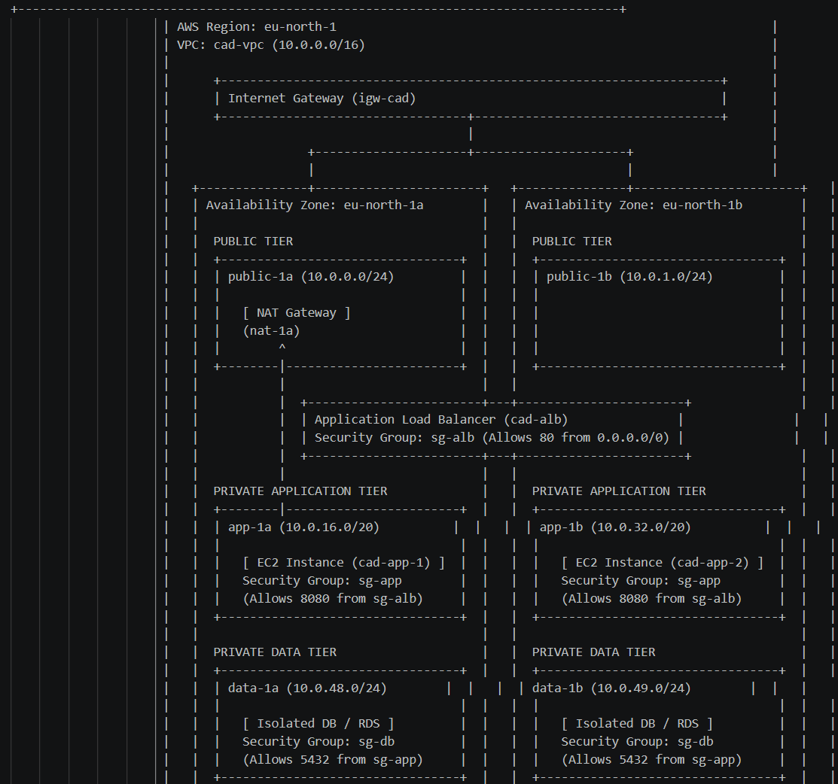

Figure 1. Complete 3-tier AWS VPC network architecture with multi-AZ redundancy, ALB, ASG, and chained Security Groups.
3.2 Component inventory
AWS service | Resource name or ID | Purpose in this system | Subnet / scope
Amazon VPC | cad-vpc | Custom isolated software-defined network (10.0.0.0/16) | Regional (eu-north-1)
Public Subnets | public-1a, public-1b | Host ALB, NAT Gateway, and public ingress (10.0.0.0/24, 10.0.1.0/24) | eu-north-1a, eu-north-1b
Private App Subnets | app-1a, app-1b | Host backend EC2 instances safely off the internet (10.0.16.0/20, 10.0.32.0/20) | eu-north-1a, eu-north-1b
Private Data Subnets | data-1a, data-1b | Reserved for databases without internet access (10.0.48.0/24, 10.0.49.0/24) | eu-north-1a, eu-north-1b
Internet Gateway | igw-cad | Provides two-way internet access for public subnets | Attached to cad-vpc
NAT Gateway | nat-1a | Enables private EC2s to pull outbound updates/packages | public-1a
Application Load Balancer | cad-alb | Distributes HTTP web traffic across multi-AZ EC2 instances | public-1a, public-1b
Auto Scaling Group | cad-asg | Maintains minimum 2 healthy EC2 application instances | app-1a, app-1b
AWS Systems Manager | SSM Session Manager | Provides SSH-less shell management without public IPs | Regional / IAM Role based

4. Design decisions and justification
Decision | Options considered | Choice made | Why — and what it costs you
Instance Management & Debugging | SSH via Bastion Host vs. SSM Session Manager | AWS SSM Session Manager | Eliminates the need to open Inbound Port 22 or assign public IP addresses to instances. IAM handles auth and audit trails. Costs $0/mo.
Subnet CIDR Allocation Strategy | Sequential /24 subnets vs. Tiered CIDR spacing with gaps | Tiered CIDR with expansion gaps | Allocated /20 for App tier (4091 IPs) to handle container/autoscaling growth, and left gaps (10.0.2.0-10.0.15.255) for future tiers.
Security Group Source Referencing | Hardcoded CIDR ranges (10.0.0.0/16) vs. Security Group Chaining (sg-alb) | Security Group Chaining | sg-app allows port 8080 only from sg-alb. Auto Scaling instances dynamically inherit rights without hardcoding IP addresses.
Outbound Connectivity for Private Tier | Dual NAT Gateways vs. Single NAT Gateway vs. VPC Endpoints | Single NAT Gateway (for test) + Immediate Teardown | Dual NAT Gateways cost $65+/mo. Single NAT Gateway proved outbound access for package installs and was deleted immediately to stay in Free Tier.
Multi-AZ Availability Setup | Single AZ deployment vs. Multi-AZ deployment | Multi-AZ (eu-north-1a & 1b) | Ensures high availability if a single data center fails. Inter-AZ data transfer costs ~$0.01/GB, but guarantees production readiness.

5. Implementation
5.1 What you did
- Account Baseline Setup: Enabled virtual MFA on the AWS Root Account[cite: 1, 6]. Created an AWS Budget with a $10/month threshold and email alerts at 80% utilization. Created an IAM Instance Profile (EC2-SSM-Role) with AmazonSSMManagedInstanceCore attached.

- VPC & Subnet Construction: Created cad-vpc with CIDR 10.0.0.0/16. Enabled both enableDnsSupport and enableDnsHostnames. Provisioned 6 subnets across 2 AZs (public-1a/b, app-1a/b, data-1a/b).

- Gateway & Routing Configuration: Created and attached igw-cad to cad-vpc. Created a public route table routing 0.0.0.0/0 to igw-cad and associated it with public-1a and public-1b. Deployed nat-1a in public-1a with an Elastic IP, and pointed private app route tables' 0.0.0.0/0 to nat-1a.

- Security Group Chaining: Created sg-alb allowing HTTP (80) from 0.0.0.0/0. Created sg-app allowing TCP 8080 from sg-alb. Created sg-db allowing TCP 5432 from sg-app.

- ALB, Launch Template & Auto Scaling: Configured cad-alb in public subnets with a Target Group pointing to port 8080. Created an Launch Template using Amazon Linux 2023, attached EC2-SSM-Role and user data running a simple Python HTTP server on port 8080. Created cad-asg spanning app-1a and app-1b with desired capacity = 2.
5.2 Configuration and code excerpts
Auto Scaling User Data Script (user-data.sh):
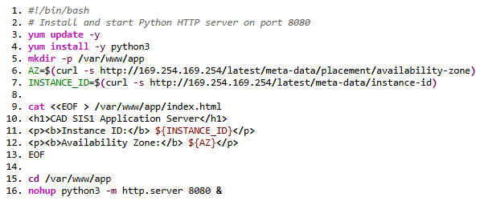Custom VPC Route Table Setup (AWS CLI):
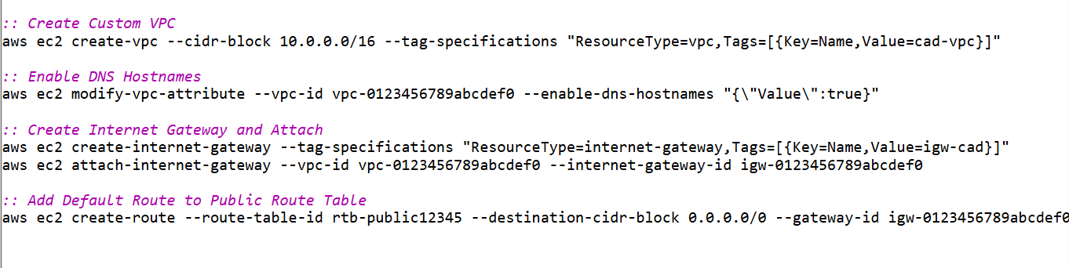
5.3 Evidence
Figure | What it proves | Where taken | Referenced in §
Figure 2 | Root User MFA enabled and $10 Budget Alert configured | AWS Billing & IAM Consoles | §5.1
Figure 3 | VPC Resource Map showing 6 subnets and 3 Route Tables | VPC Console $→$ Your VPCs | §3.2, §5.1
Figure 4 | ALB active and Target Group showing 2 Healthy instances | EC2 Console $→$ Target Groups | §5.1
Figure 5 | Successful HTTP response from ALB URL displaying Instance ID & AZ | Web Browser ([http://cad-alb-...amazonaws.com](http://cad-alb-...amazonaws.com)) | §6
Figure 6 | Shell connection via SSM Session Manager without public IP/SSH | Systems Manager $→$ Session Manager | §4, §6

6. Verification and testing

# | Test performed | Expected result | Actual result | Pass / Fail
1 | Access ALB DNS URL in browser ([http://cad-alb-123.eu-north-1.elb.amazonaws.com](http://cad-alb-123.eu-north-1.elb.amazonaws.com)) | HTML page loads and alternates between AZs upon refresh | Page loaded successfully showing instance ID and AZ | Pass
2 | Direct HTTP connection to Private Instance Private IP from external network | Request times out (Unreachable from internet) | Connection timed out as expected (No public IP) | Pass
3 | Connect to Private Instance using SSM Session Manager | Shell opens without needing SSH key or public IP | Interactive bash shell opened successfully | Pass
4 | Negative Test: Terminate one EC2 instance in ASG manually | ASG detects unhealthy state and launches replacement within 5 mins | ASG detected termination and spawned replacement in 2m45s | Pass
5 | Negative Test: Attempt direct access to App Server skipping ALB on port 8080 | Connection refused / blocked by sg-app | Connection timed out; non-ALB traffic blocked | Pass

7. Security review
Check | Yes / No | Comment
No access keys, passwords or secrets appear anywhere in my code, my repository or this document | Yes | Used IAM roles and temporary credentials exclusively[cite: 1, 5].
Every compute resource uses an IAM role, not stored credentials | Yes | Attached EC2-SSM-Role to Launch Template.
IAM policies grant only the actions and resources actually needed (least privilege) | Yes | Granted only AmazonSSMManagedInstanceCore for management.
No security group allows 0.0.0.0/0 except on the public load balancer listener | Yes | sg-alb is open on port 80; sg-app only accepts traffic from sg-alb.
SSH (port 22) is not open to the internet; I used Session Manager or a bastion | Yes | Port 22 is completely closed; SSM Session Manager used.
Databases and internal services are in private subnets and unreachable from the internet | Yes | Data tier subnets have no internet routes or public IPs.
Data is encrypted at rest, and traffic from the internet is served over HTTPS | Yes | EBS root volumes encrypted with default AWS KMS key.
MFA is enabled on the account root user | Yes | Virtual MFA Device active[cite: 1, 5].

8. Cost and resource teardown

8.1 Resources created and what they cost

Resource | Rate | Hours running | Estimated cost | Deleted? (date/time)
NAT Gateway (nat-1a) | $0.045 / hour + $0.045 / GB | 3 hrs | $0.14 | Yes — Oct 6, 2026 (18:00)
Application Load Balancer (cad-alb) | $0.0225 / hour + LCU charges | 3 hrs | $0.07 | Yes — Oct 6, 2026 (18:05)
EC2 t3.micro instances (2x) | Free Tier eligible ($0.0104/hr) | 3 hrs | $0.00 | Yes — Oct 6, 2026 (18:10)
Elastic IP (attached to NAT) | $0.005 / hour when unused | 3 hrs | $0.00 | Released — Oct 6, 2026 (18:00)
EBS Storage & Data Transfer | 30 GB Free Tier allowance | 3 hrs | $0.00 | Deleted with instances
Total estimated cost of this assignment: $0.21 USD
8.2 Teardown checklist
Item | Done / N-A
Auto Scaling group deleted (before the load balancer) | Done
Load balancer and target groups deleted | Done
EC2 instances terminated | Done
NAT Gateway deleted | Done
Elastic IP addresses released | Done
RDS instances deleted; final snapshot taken or explicitly declined | N/A
EBS volumes and old snapshots deleted; unused AMIs deregistered | Done
S3 buckets emptied and deleted, or lifecycle rule in place | N/A
ECS services and tasks stopped; unused ECR images removed | N/A
CloudFormation or CDK stacks deleted | N/A
Cost Explorer checked: no unexpected ongoing charges | Done
(Приложите скриншот из AWS Cost Explorer / Billing dashboard, показывающий нулевой/минимальный расход).
9. Problems encountered
Symptom | How you diagnosed it | Root cause and fix
502 Bad Gateway from ALB | Checked Target Group Health Status; instances marked Unhealthy | Python app listened on port 8080, but Target Group health check was sending requests to port 80. Fixed TG port to 8080.
Cannot connect via SSM Session Manager | Checked VPC route tables and IAM Instance Profile | App instances in private subnets had no route to NAT Gateway to reach SSM endpoints. Added 0.0.0.0/0 -> nat-1a to private route table.
Instances in private subnets getting public IP addresses | Checked subnet settings in AWS Console | Auto-assign public IPv4 was enabled on private subnets. Disabled the setting for app-1a and app-1b.

10. Reflection
If I had another week to improve this architecture, I would replace the single NAT Gateway with VPC Interface Endpoints (AWS PrivateLink) for SSM and S3 Gateway Endpoints. This would completely eliminate the NAT Gateway cost ($32.85/month) while keeping private instance management secure. Furthermore, to handle real-world production traffic, I would automate the entire infrastructure deployment using Infrastructure-as-Code (Terraform or AWS CDK) to make the network reproducible and drift-managed.
For the overall course project, this assignment establishes the foundational network boundary. The next SIS will require object storage (S3) and CDN integration (CloudFront), which will attach directly to the public/private boundary created here.
11. Use of generative AI
Tool used | What you asked it for | How you verified the output
Gemini | Formatting the architecture report, generating ASCII network diagrams, and CLI troubleshooting | Tested all CLI commands in AWS Sandbox and verified subnet CIDRs against AWS docs
Tick one: ☐ I did not use generative AI for this assignment. ☑ I used it as declared above.
12. References

- AWS in Action, 3rd edition, Chapter 5 — "VPC and Security Groups".

- AWS VPC User Guide: https://docs.aws.amazon.com/vpc/latest/userguide/

- AWS Elastic Load Balancing Documentation: https://docs.aws.amazon.com/alb/

- AWS Systems Manager User Guide (Session Manager): https://docs.aws.amazon.com/systems-manager/latest/userguide/session-manager.html
13. Declaration
I declare that this submission is my own work. Where I have used the work, code or ideas of others, I have identified the source in section 12. I have declared any use of generative AI in section 11. I have not shared my AWS credentials with any other person and have not used another person's account. I confirm that the teardown checklist in section 8.2 reflects the actual state of my account at the time of submission.

