Design a web LoanApplication.htm

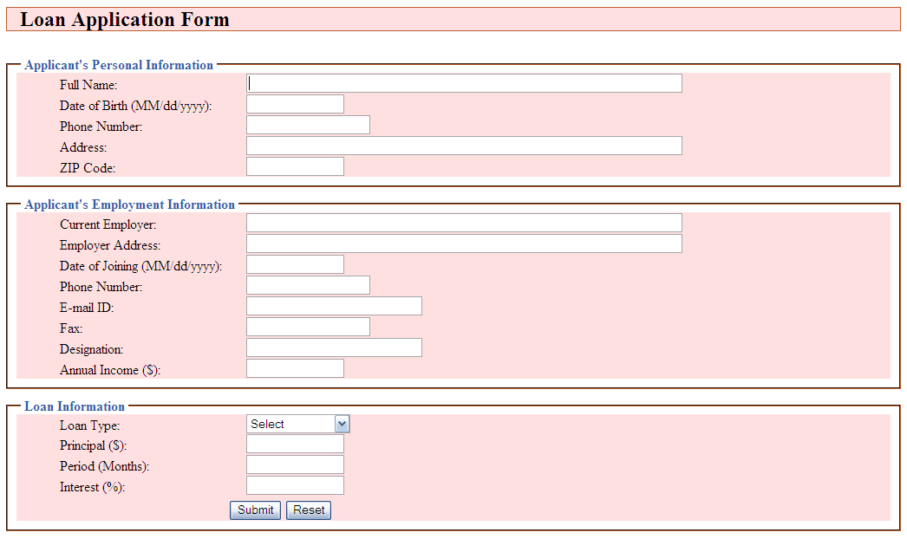

Requirements:

1. Values in the select field:

Select

Personal Loan

Home Loan

Vehicle Loan

Business Loan

Education Loan

1. All controls must not be left empty and must be selected if applicable.
2. Dates must follow the correct date format.
3. Email must be in the correct email format.
4. Full Name must contain at least one space.
5. Phone Number must have at least 10 characters.
6. Zip Code must follow the format: xxx-xxxx-xxx, where x is a digit.
7. Fax must follow the format: xxx-xxxxxxx.
8. Annual Income, Principal, and Period must be numeric values.