**Heroes of Pymoli – Code output and observations**

**Player Count**

* Total Number of Players

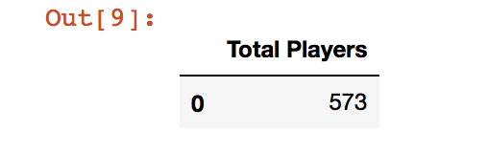

**Purchasing Analysis (Total)**

* Number of Unique Items
* Average Purchase Price
* Total Number of Purchases
* Total Revenue

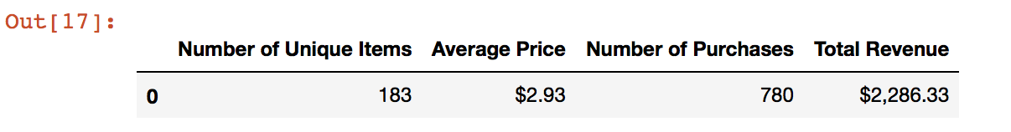

**Gender Demographics**

* Percentage and Count of Male Players
* Percentage and Count of Female Players
* Percentage and Count of Other / Non-Disclosed

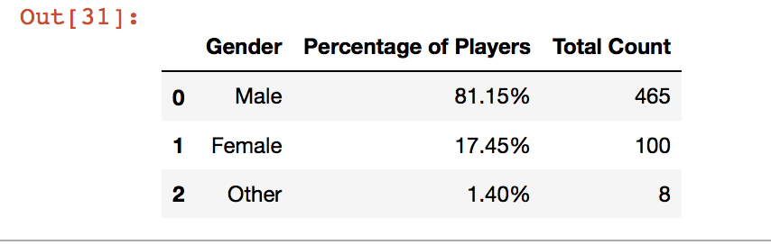

**Purchasing Analysis (Gender)**

* The below each broken by gender
  + Purchase Count
  + Average Purchase Price
  + Total Purchase Value
  + Normalized Totals

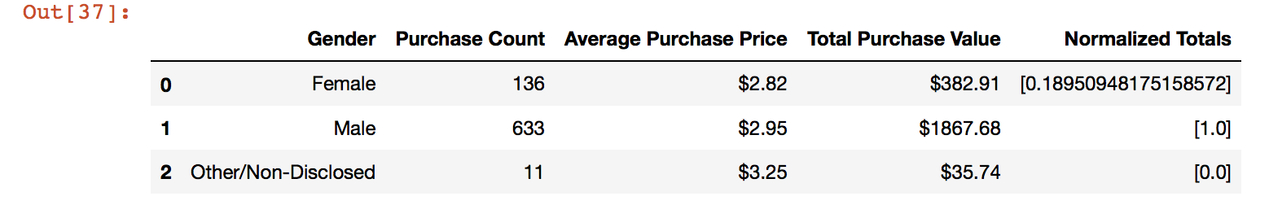

**Note:** Totals are normalized as:

* Max Value $1867.86 = 1, Min Value $35.74 = 0. $382.91 falls accordingly in the normalized data set of our new data range (0,1)

**Age Demographics**

* The below each broken into four (4) bins of 4 years (i.e. <10, 10-14, 15-19, etc.)
  + Age Demographics
  + Percentage of Players
  + Total Count

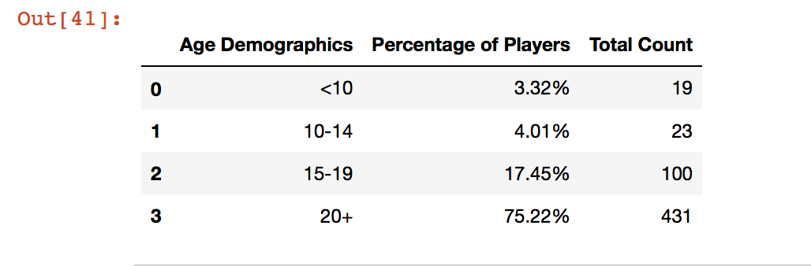

**Age Demographics (contd.)**

* The below each broken into four (4) bins of 4 years (i.e. <10, 10-14, 15-19, etc.)
  + Purchase Count
  + Average Purchase Price
  + Total Purchase Value
  + Normalized Totals

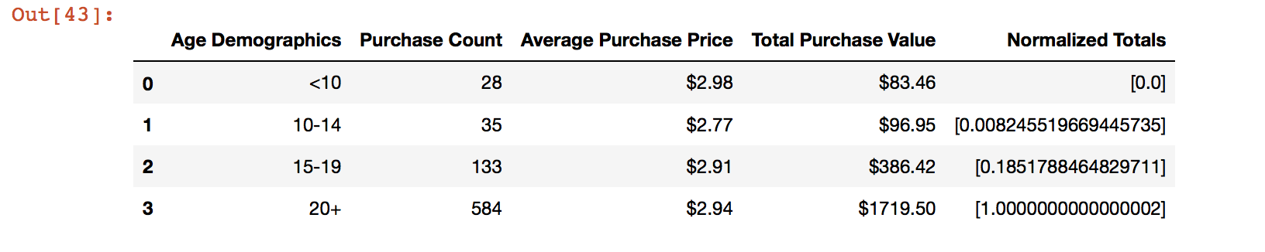

**Note:** Totals are normalized as:

* Max Value $1719.50 = 1, Min Value $83.46 = 0.
* $386.42 and $96.95 fall accordingly in the normalized data set of our new data range (0,1)

**Top Spenders**

* Identify the top 5 spenders in the game by total purchase value, then list (in a table):
  + SN
  + Purchase Count
  + Average Purchase Price
  + Total Purchase Value

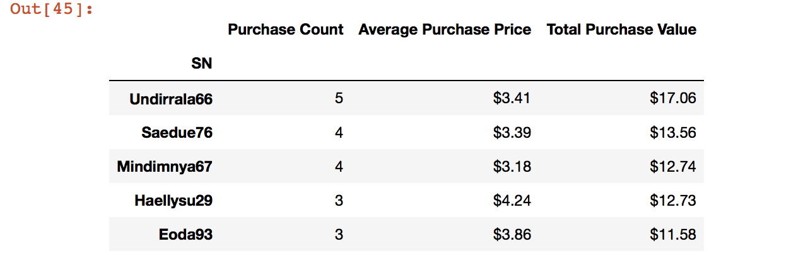

**Most Popular Items**

* Identify the 5 most popular items by purchase count, then list (in a table):
  + Item ID
  + Item Name
  + Purchase Count
  + Item Price
  + Total Purchase Value

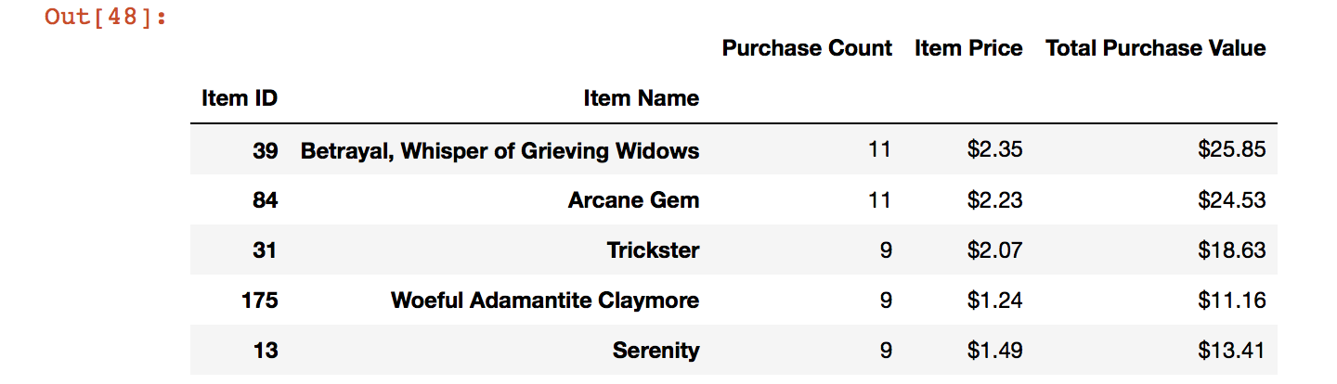

**Most Profitable Items**

* Identify the 5 most profitable items by total purchase value, then list (in a table):
  + Item ID
  + Item Name
  + Purchase Count
  + Item Price
  + Total Purchase Value

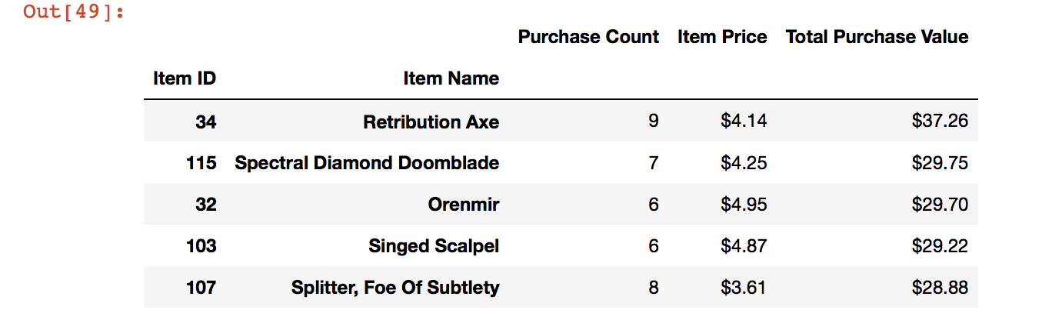

**Observations**

1. There are multiple observations that can be made with this data.
2. The sample size is 573 players – total.
3. 183 unique items were purchased, whereas total number of purchases were 780 resulting in a total revenue of $2286.33.
4. Of all the gamer population in our data set, males were 81.15+% and females were 17.45% (round off). This shows that there are much more males who are interested in this game as compared to females.
5. With our age demographics, we find the most of the players (more than 75%) are in 20+ years age group. Around 17.45% are in 15-19 years age group
   1. We can do much more analysis on data if we create additional bins for 20-30, 30-40 and 40+ age groups. I will do this later in the week just to see additional trends to further decipher the ‘75%’ population of 20+ age group players.
6. The most amount of money that people spent was $17.06. So mainly people spent less than $20.
7. The most popular item is Whisper of Grieving Widows, Betrayal, and the most profitable item is Retribution Axe